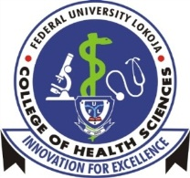
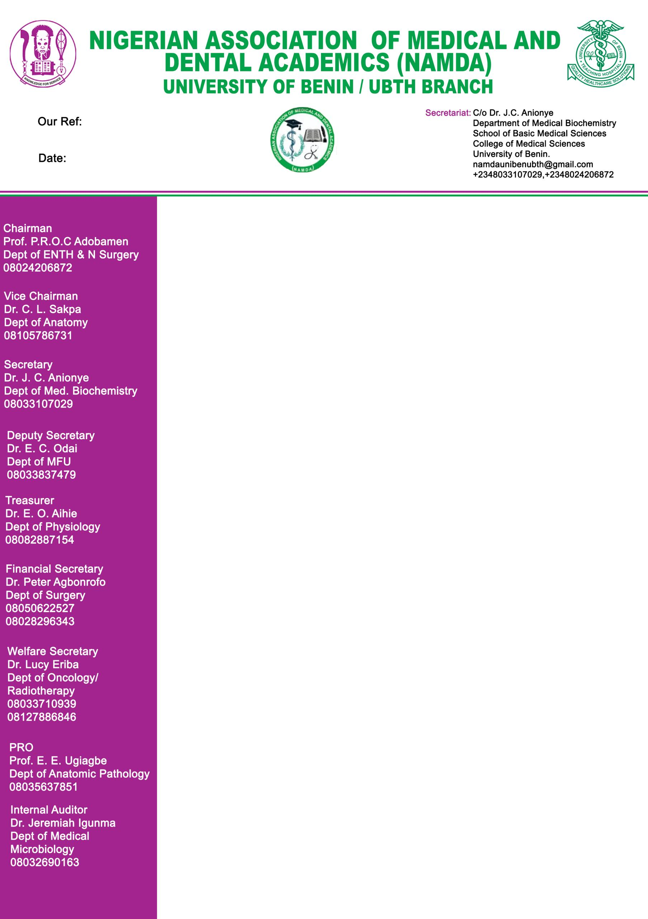

FEDERAL UNIVERSITY LOKOJA (FULOKOJA) BRANCH
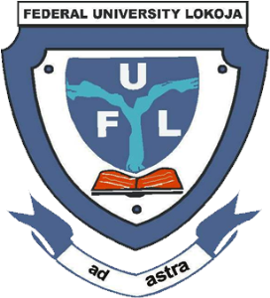
NIGERIAN ASOCIATION OF MEDICAL
AND DENTAL ACADEMICS
(NAMDA)

Our Ref: NAMDA/FUL/25/10/01
Date: 15/10/2025
Chairman
Prof. M.M.C. Anyakudo
Dept of Human Physiology
08052132778

Vice Chairman
Dr. M. Onoja (Mrs)
Dept of Community Medicine
O8072372136

Secretary
Dr. B.S. Ajilore
Dept of Med. Biochemistry
07033985272

Deputy Secretary
Dr. E.B. Akor
Dept of Anatomy

Treasurer
Dr. I.N. Onyeyili
Dept of Human Physiology
08035408222

Financial Secretary
Dr. C.J. Eze
Dept of Human Physiology
08068637467

Welfare Secretary
Dr. O.A. Fagbemi
Dept of Human Anatomy
08050800016

P.R.O.
Dr.
Dept. of
080

Internal Auditor
Dr. Charlse Esekhaigbe
Dept of Community Medicine
080

Ex-Officio I
Prof. M.O Ogirima
Dept of Orthopaedic Surgery
08033115542

The Vice Chancellor,
Federal University Lokoja,
Kogi State.
CLARIFICATION ON THE POSITION OF NAMDA MEMBERS REGARDING THE ON GOING STRIKE ACTION
On behalf of the Nigerian Association of Medical and Dental Academics (NAMDA), Federal University Lokoja Chapter, we write to respectfully inform you that our members are not on any strike action recently declared by ASUU
NAMDA remains a distinct academic association with its own leadership structure and decision-making processes. We wish to affirm our continued commitment to academic excellence, professionalism, and service delivery within the university system.
Accordingly, we assure the university management of NAMDA members’ willingness to continue with our regular academic, research and administrative duties as scheduled.
We appreciate your continued support and understanding. Please accept the assurances of our highest regards.
Attached to this letter are the Press Release from our National Executive and the list of members of NAMDA Fulokoja branch
Yours faithfully,

Prof. M.M.C. Anyakudo
Chairman

Cc: The Provost (FULCOHS)

