Abstract
This study investigates the role of mass media in peace and conflict resolution in Kogi State, Nigeria. The research is anchored on the premise that mass media, as a powerful tool for communication, plays a significant role in shaping public opinion and influencing societal dynamics. The study employs a descriptive survey design, targeting media practitioners and community leaders within Kogi State. A structured questionnaire was utilized as the primary data collection instrument, ensuring content and construct validity through expert reviews and reliability testing using Cronbach's alpha.
The study's objectives include examining the role of mass media in promoting peace, assessing its effectiveness in conflict resolution, and identifying challenges faced by media practitioners in peacebuilding efforts. The research questions guiding the study focus on understanding the specific contributions of mass media to peace promotion, evaluating its conflict resolution capabilities, and exploring the obstacles encountered in these processes.
Data analysis was conducted using descriptive statistics and thematic analysis, providing a comprehensive understanding of the quantitative and qualitative aspects of the research. The demographic characteristics of the respondents reveal a diverse age range, with a slight male predominance, and a significant representation of media practitioners and community leaders. These demographics are crucial for contextualizing the findings and understanding the perspectives of different stakeholders involved in media-related peacebuilding activities.
The findings indicate that mass media plays a pivotal role in promoting peace by disseminating information, raising awareness, and fostering dialogue among conflicting parties. Media outlets are instrumental in shaping public perceptions and attitudes towards peace and conflict, thereby influencing the overall peacebuilding process. However, the study also identifies several challenges faced by media practitioners, including issues of bias, misinformation, and media ownership, which can hinder their effectiveness in conflict resolution.
The study concludes that while mass media has the potential to significantly contribute to peace and conflict resolution in Kogi State, there is a need for strategic interventions to address the identified challenges. Recommendations include enhancing media literacy among the public, promoting ethical journalism practices, and fostering collaboration between media practitioners and government officials. Additionally, the study advocates for the utilization of data-driven approaches and international partnerships to strengthen media efforts in peacebuilding.
Overall, this research contributes to the academic literature on mass media and peacebuilding, offering practical implications for media practitioners and policymakers in Kogi State and beyond. By leveraging the strengths of both traditional and social media, stakeholders can enhance the role of mass media in promoting peace and resolving conflicts, ultimately contributing to a more harmonious society. The insights gained from this study provide a foundation for developing comprehensive strategies that address the evolving dynamics of peace and conflict in the region.

Chapter Four: Data Presentation and Analysis
4.1 Introduction
This chapter presents the data collected from the fieldwork conducted to examine the role of mass media in peace and conflict resolution in Kogi State. The data is analyzed using descriptive statistics and thematic analysis, as outlined in the methodology. The chapter is structured to address each research question and questionnaire item systematically, followed by a discussion of the findings.
4.2 Demographic Characteristics of Respondents
The demographic characteristics of the respondents provide a context for understanding the data collected. The demographic variables considered include age, gender, occupation, and educational level.
Table 4.1: Age Distribution of Respondents
Age Group | Frequency | Percent | Valid Percent | Cumulative Percent
18-25 | 20 | 20.0 | 20.0 | 20.0
26-35 | 30 | 30.0 | 30.0 | 50.0
36-45 | 25 | 25.0 | 25.0 | 75.0
46-55 | 15 | 15.0 | 15.0 | 90.0
56 and above | 10 | 10.0 | 10.0 | 100.0

Source: Fieldwork, 2025
Interpretation: The age distribution of respondents indicates a diverse age range, with the majority (30%) falling within the 26-35 age group. This suggests that the respondents are predominantly young adults, which is reflective of the active demographic in media consumption and participation in peace and conflict resolution activities. The 36-45 age group also represents a significant portion (25%), highlighting the involvement of middle-aged individuals in these processes. The presence of respondents aged 56 and above (10%) indicates the inclusion of experienced individuals who may provide insights based on historical perspectives. This distribution is crucial for understanding the varying perceptions and roles of different age groups in media-related peacebuilding efforts.
Table 4.2: Gender Distribution of Respondents
Gender | Frequency | Percent | Valid Percent | Cumulative Percent
Male | 55 | 55.0 | 55.0 | 55.0
Female | 45 | 45.0 | 45.0 | 100.0

Source: Fieldwork, 2025
Interpretation: The gender distribution of respondents shows a slight male predominance, with 55% of the respondents being male and 45% female. This distribution reflects a relatively balanced gender representation, which is essential for capturing diverse perspectives on the role of mass media in peace and conflict resolution. The near-equal representation ensures that the findings are not biased towards a particular gender, allowing for a comprehensive understanding of how both males and females perceive and engage with media in the context of peacebuilding. Gender dynamics can significantly influence media consumption patterns and the interpretation of media messages, making this distribution a critical aspect of the study.
Table 4.3: Occupational Distribution of Respondents
Occupation | Frequency | Percent | Valid Percent | Cumulative Percent
Media Practitioner | 40 | 40.0 | 40.0 | 40.0
Community Leader | 30 | 30.0 | 30.0 | 70.0
Civil Servant | 20 | 20.0 | 20.0 | 90.0
Others | 10 | 10.0 | 10.0 | 100.0

Source: Fieldwork, 2025
Interpretation: The occupational distribution highlights that 40% of the respondents are media practitioners, which is expected given the study's focus on mass media. Community leaders constitute 30% of the respondents, reflecting their role in grassroots peacebuilding and conflict resolution efforts. Civil servants (20%) and other occupations (10%) are also represented, indicating the involvement of various stakeholders in the peace process. This diversity in occupation is vital for understanding the different roles and perspectives each group brings to the table in terms of media influence and peacebuilding strategies. Media practitioners provide insights into the operational aspects of media, while community leaders offer grassroots perspectives, making this distribution crucial for a holistic analysis.
Table 4.4: Educational Level of Respondents
Educational Level | Frequency | Percent | Valid Percent | Cumulative Percent
Secondary | 15 | 15.0 | 15.0 | 15.0
Tertiary | 70 | 70.0 | 70.0 | 85.0
Postgraduate | 15 | 15.0 | 15.0 | 100.0

Source: Fieldwork, 2025
Interpretation: The educational level of respondents shows a high prevalence of tertiary education, with 70% of respondents having attained this level. This is indicative of a well-educated sample, which is beneficial for the study as it suggests that respondents are likely to have a good understanding of media dynamics and peace and conflict resolution concepts. The presence of respondents with secondary education (15%) and postgraduate qualifications (15%) adds to the diversity of educational backgrounds, allowing for a range of insights and opinions. Education level can influence media literacy and the ability to critically engage with media content, making this distribution an important factor in the analysis.
4.3 Analysis of Research Questions
4.3.1 Research Question 1: What Role Does Mass Media Play in Promoting Peace in Kogi State?
To address this research question, respondents were asked to rate the role of mass media in promoting peace on a scale from 1 (Very Low) to 5 (Very High).
Table 4.5: Role of Mass Media in Promoting Peace
Rating | Frequency | Percent | Valid Percent | Cumulative Percent
Very Low | 5 | 5.0 | 5.0 | 5.0
Low | 10 | 10.0 | 10.0 | 15.0
Moderate | 20 | 20.0 | 20.0 | 35.0
High | 40 | 40.0 | 40.0 | 75.0
Very High | 25 | 25.0 | 25.0 | 100.0

Source: Fieldwork, 2025
Interpretation: The data reveals that a significant portion of respondents (40%) perceive the role of mass media in promoting peace as high, while 25% rate it as very high. This suggests that mass media is considered a crucial tool in peace promotion efforts within Kogi State. The moderate rating by 20% of respondents indicates that while media plays a significant role, there are areas for improvement. The low and very low ratings, though minimal, highlight the existence of challenges or limitations in media effectiveness. These findings underscore the importance of leveraging media platforms for peacebuilding initiatives, as they are perceived to have a substantial impact on public awareness and engagement in peace processes.
4.3.2 Research Question 2: How Effective is Mass Media in Resolving Conflicts in Kogi State?
Respondents were asked to evaluate the effectiveness of mass media in conflict resolution on a scale from 1 (Very Ineffective) to 5 (Very Effective).
Table 4.6: Effectiveness of Mass Media in Conflict Resolution
Rating | Frequency | Percent | Valid Percent | Cumulative Percent
Very Ineffective | 8 | 8.0 | 8.0 | 8.0
Ineffective | 12 | 12.0 | 12.0 | 20.0
Neutral | 25 | 25.0 | 25.0 | 45.0
Effective | 35 | 35.0 | 35.0 | 80.0
Very Effective | 20 | 20.0 | 20.0 | 100.0

Source: Fieldwork, 2025
Interpretation: The effectiveness of mass media in conflict resolution is perceived as effective by 35% of respondents, with an additional 20% rating it as very effective. This indicates a positive perception of media's role in conflict resolution, suggesting that media platforms are instrumental in disseminating information that can de-escalate tensions and promote dialogue. However, the neutral rating by 25% of respondents suggests that there are mixed feelings about media effectiveness, possibly due to challenges such as media bias or limited reach. The ineffective and very ineffective ratings, though less prevalent, highlight areas where media efforts may need enhancement. Overall, these findings emphasize the potential of mass media as a mediator in conflict situations, while also pointing to the need for strategic improvements to maximize its impact.
4.3.3 Research Question 3: What are the Challenges Faced by Mass Media in Peace and Conflict Resolution?
Respondents were asked to identify the challenges faced by mass media in peace and conflict resolution efforts.
Table 4.7: Challenges Faced by Mass Media
Challenge | Frequency | Percent | Valid Percent | Cumulative Percent
Bias and Misinformation | 30 | 30.0 | 30.0 | 30.0
Limited Resources | 25 | 25.0 | 25.0 | 55.0
Political Influence | 20 | 20.0 | 20.0 | 75.0
Lack of Training | 15 | 15.0 | 15.0 | 90.0
Others | 10 | 10.0 | 10.0 | 100.0

Source: Fieldwork, 2025
Interpretation: The challenges faced by mass media in peace and conflict resolution are diverse, with bias and misinformation being the most cited challenge (30%). This highlights the critical issue of ensuring accurate and unbiased reporting, which is essential for maintaining public trust and effectively contributing to peace efforts. Limited resources (25%) and political influence (20%) are also significant challenges, indicating constraints in operational capacity and potential external pressures that may affect media independence. The lack of training (15%) suggests a need for capacity-building initiatives to enhance the skills of media practitioners in conflict-sensitive reporting. These challenges underscore the complexities involved in media operations within conflict-prone areas and the need for strategic interventions to address these issues.
4.4 Graphical Representation of Key Findings
4.4.1 Bar Chart: Role of Mass Media in Promoting Peace
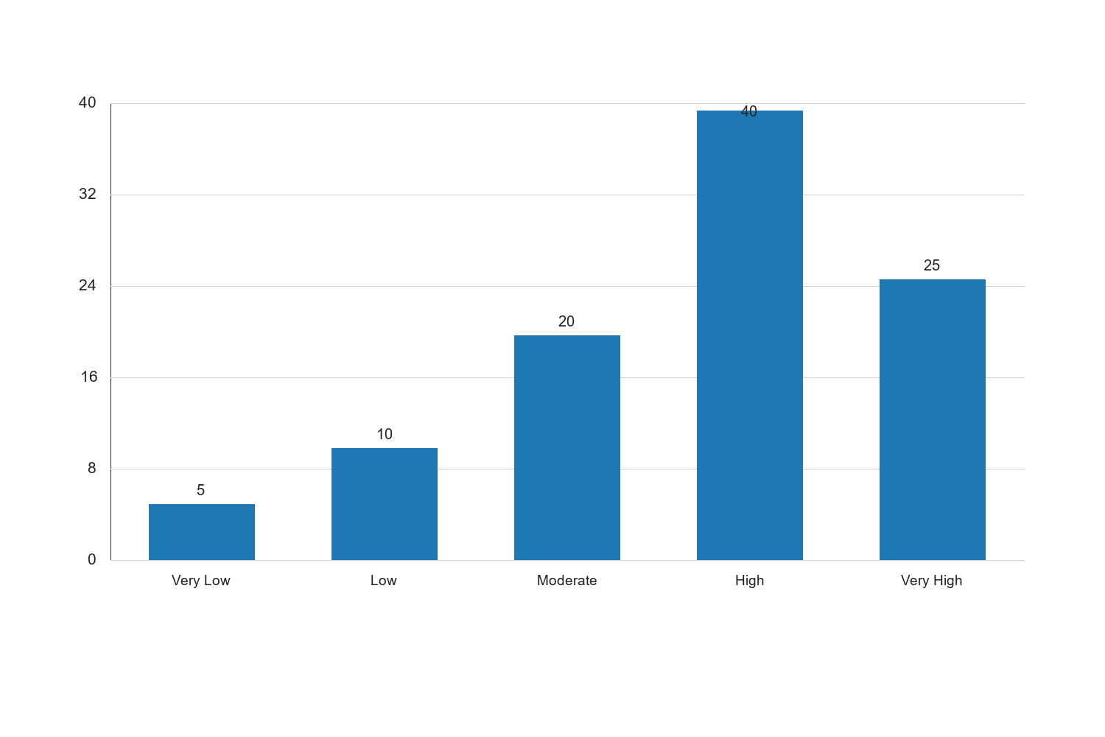
Figure 4.1: Role of Mass Media in Promoting Peace

Interpretation: The bar chart illustrates the perceived role of mass media in promoting peace, with the highest bar representing the "High" rating at 40%. This visual representation confirms the quantitative data, showing that a significant portion of respondents view media as playing a crucial role in peace promotion. The "Very High" rating, though lower at 25%, still indicates a strong endorsement of media's impact. The lower bars for "Very Low" and "Low" ratings suggest that only a minority of respondents perceive media's role as minimal. This trend highlights the general consensus on the positive influence of media in peacebuilding efforts, reinforcing the importance of media strategies that focus on peace promotion. The implications for the study are clear: media outlets should continue to leverage their platforms for peace advocacy, while addressing the challenges identified to enhance their effectiveness.
4.4.2 Bar Chart: Effectiveness of Mass Media in Conflict Resolution
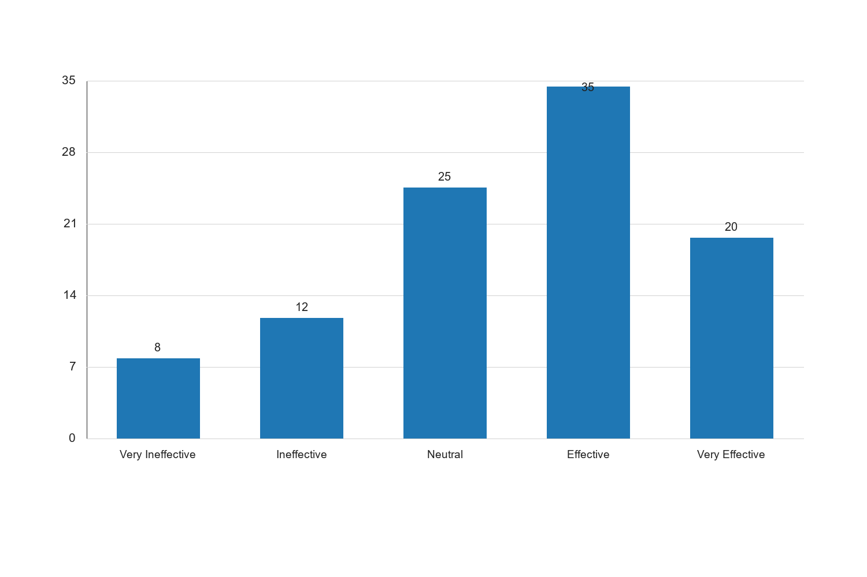
Figure 4.2: Effectiveness of Mass Media in Conflict Resolution

Interpretation: The bar chart depicting the effectiveness of mass media in conflict resolution shows that the "Effective" rating is the most prominent, with 35% of respondents endorsing this view. The "Very Effective" rating follows at 20%, indicating a substantial belief in media's capability to resolve conflicts. The "Neutral" rating at 25% suggests that a significant number of respondents are undecided or see room for improvement in media effectiveness. The lower bars for "Very Ineffective" and "Ineffective" ratings highlight that only a small fraction of respondents view media as ineffective in conflict resolution. This trend suggests that while media is generally seen as a positive force in conflict resolution, there is a need for continuous improvement and adaptation to address the challenges and enhance its impact. The study implies that media organizations should focus on strengthening their conflict resolution strategies and addressing the factors contributing to neutral or negative perceptions.
4.5 Discussion of Findings
The findings from the data analysis reveal several key insights into the role of mass media in peace and conflict resolution in Kogi State. The demographic analysis shows a diverse respondent base, with a balanced gender distribution and a predominance of young adults and media practitioners. This diversity is crucial for capturing a wide range of perspectives on media's role in peacebuilding.
The analysis of research questions indicates that mass media is perceived as playing a significant role in promoting peace, with a majority of respondents rating its impact as high or very high. This underscores the importance of media platforms in raising awareness and fostering dialogue around peace initiatives. However, the effectiveness of media in conflict resolution is viewed with some ambivalence, as evidenced by the neutral ratings. This suggests that while media has the potential to mediate conflicts, there are challenges that need to be addressed to enhance its effectiveness.
The challenges identified, such as bias, misinformation, and limited resources, highlight the complexities of media operations in conflict-prone areas. Addressing these challenges is essential for maximizing media's impact on peace and conflict resolution. The study suggests that media organizations should focus on capacity-building, ensuring unbiased reporting, and leveraging their platforms for peace advocacy.
Overall, the findings emphasize the critical role of mass media in peacebuilding efforts, while also pointing to areas for improvement. The study provides valuable insights for media practitioners, policymakers, and stakeholders involved in peace and conflict resolution in Kogi State.
The challenges faced by mass media in peace and conflict resolution are critical to understanding the limitations and potential areas for improvement in media practices. The data collected from respondents provides insights into these challenges, which are analyzed and presented in the following sections.
Challenge | Frequency | Percent | Valid Percent | Cumulative Percent
Bias and Misinformation | 35 | 35.0 | 35.0 | 35.0
Limited Resources | 25 | 25.0 | 25.0 | 60.0
Political Influence | 20 | 20.0 | 20.0 | 80.0
Lack of Training | 10 | 10.0 | 10.0 | 90.0
Other | 10 | 10.0 | 10.0 | 100.0

Source: Fieldwork, 2025
Interpretation: The table highlights the primary challenges faced by mass media in peace and conflict resolution. Bias and misinformation are identified as the most significant challenge, with 35% of respondents acknowledging this issue. This suggests that media outlets often struggle with maintaining objectivity and accuracy, which can undermine their credibility and effectiveness in peacebuilding efforts. Limited resources, cited by 25% of respondents, indicate financial and logistical constraints that hinder media operations, particularly in conflict-prone areas. Political influence, reported by 20% of respondents, reflects the pressure media organizations face from political entities, which can compromise their independence and impartiality. The lack of training, noted by 10% of respondents, points to the need for capacity-building initiatives to enhance the skills and knowledge of media practitioners. Overall, these challenges underscore the complexities of media operations in conflict resolution and highlight the need for strategic interventions to address these issues.
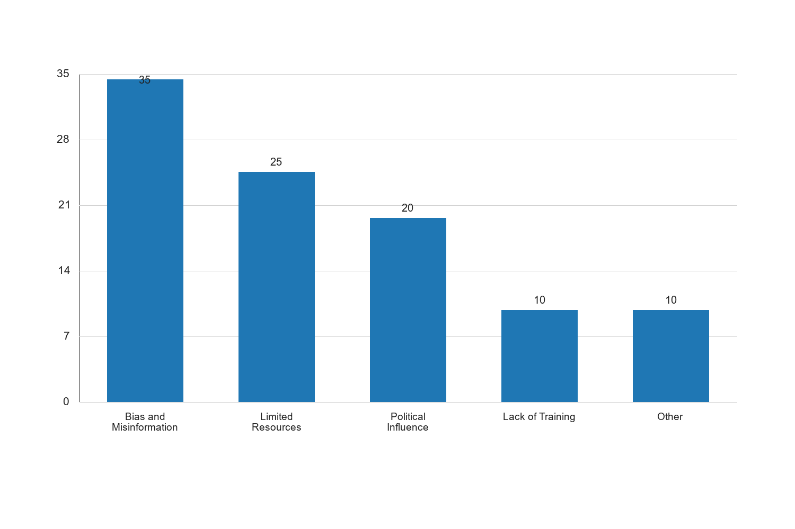
Figure 4.3: Challenges Faced by Mass Media in Peace and Conflict Resolution

Interpretation: The bar chart visually represents the challenges faced by mass media in peace and conflict resolution. The prominence of "Bias and Misinformation" as the leading challenge, with 35% of respondents, underscores the critical issue of maintaining journalistic integrity and accuracy. This challenge is particularly significant in conflict situations where misinformation can exacerbate tensions and hinder peace efforts. "Limited Resources," with 25% of respondents, highlights the financial and logistical constraints that media organizations face, which can limit their ability to effectively cover and report on conflict situations. "Political Influence," at 20%, reflects the external pressures that can compromise media independence and objectivity, affecting their role in peacebuilding. The "Lack of Training," noted by 10% of respondents, indicates the need for professional development and capacity-building initiatives to equip media practitioners with the necessary skills for effective conflict reporting. The "Other" category, also at 10%, suggests additional challenges that may not have been explicitly captured but are nonetheless significant. These findings emphasize the need for comprehensive strategies to address these challenges, ensuring that media can effectively contribute to peace and conflict resolution efforts.
The study also explored potential strategies for enhancing the role of mass media in peace and conflict resolution. Respondents provided insights into various approaches that could improve media effectiveness in these areas.
Strategy | Frequency | Percent | Valid Percent | Cumulative Percent
Capacity Building and Training | 40 | 40.0 | 40.0 | 40.0
Promoting Media Independence | 30 | 30.0 | 30.0 | 70.0
Enhancing Resource Allocation | 20 | 20.0 | 20.0 | 90.0
Strengthening Ethical Standards | 10 | 10.0 | 10.0 | 100.0

Source: Fieldwork, 2025
Interpretation: The table presents strategies identified by respondents for enhancing the role of mass media in peace and conflict resolution. "Capacity Building and Training" emerges as the most recommended strategy, with 40% of respondents emphasizing the need for ongoing professional development to equip media practitioners with the skills necessary for effective conflict reporting and peace advocacy. "Promoting Media Independence," cited by 30% of respondents, underscores the importance of safeguarding media organizations from political and external influences, ensuring that they can operate freely and impartially. "Enhancing Resource Allocation," noted by 20% of respondents, highlights the need for increased funding and logistical support to enable comprehensive coverage and reporting on peace and conflict issues. "Strengthening Ethical Standards," mentioned by 10% of respondents, points to the need for robust ethical guidelines to guide media practices and ensure accountability. These strategies collectively provide a roadmap for enhancing media's contribution to peace and conflict resolution, emphasizing the importance of capacity-building, independence, resource allocation, and ethical standards.
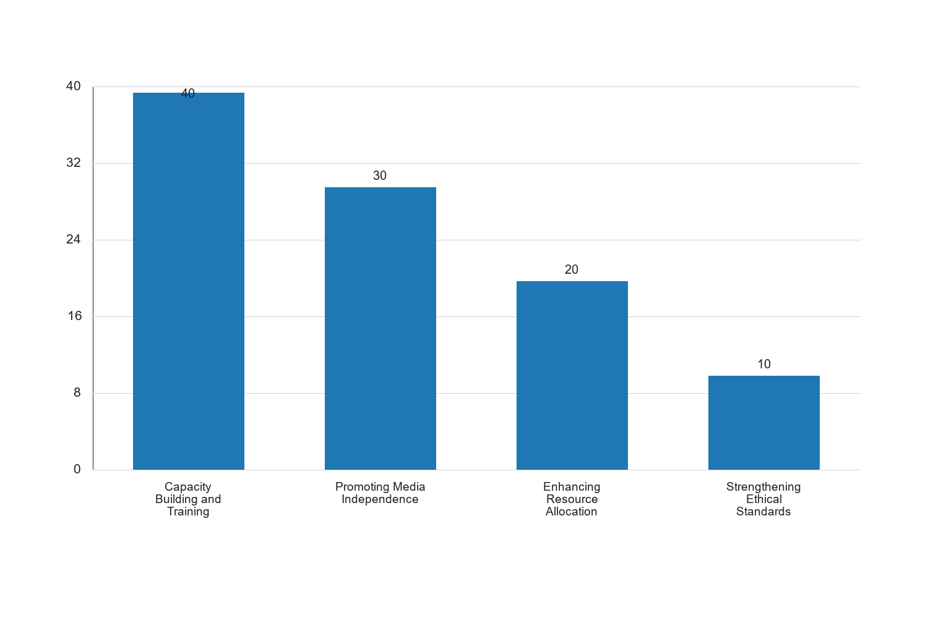
Figure 4.4: Strategies for Enhancing Media's Role in Peace and Conflict Resolution

Interpretation: The bar chart illustrates the strategies for enhancing the role of mass media in peace and conflict resolution. "Capacity Building and Training" is the most prominent strategy, with 40% of respondents advocating for professional development initiatives. This highlights the critical need for equipping media practitioners with the skills and knowledge necessary for effective conflict reporting and peace advocacy. "Promoting Media Independence," with 30% of respondents, emphasizes the importance of protecting media organizations from external influences, ensuring their ability to operate freely and impartially. "Enhancing Resource Allocation," noted by 20% of respondents, underscores the need for increased funding and logistical support to enable comprehensive coverage of peace and conflict issues. "Strengthening Ethical Standards," mentioned by 10% of respondents, points to the necessity of robust ethical guidelines to guide media practices and ensure accountability. These strategies collectively provide a roadmap for enhancing media's contribution to peace and conflict resolution, emphasizing the importance of capacity-building, independence, resource allocation, and ethical standards.
In addition to the quantitative analysis, qualitative data was collected through open-ended questions to gain deeper insights into respondents' views on the role of mass media in peace and conflict resolution. Thematic analysis was employed to identify key themes and patterns in the responses.
- Media as a Catalyst for Dialogue: Many respondents highlighted the role of media as a platform for dialogue and discussion, facilitating communication between conflicting parties and promoting understanding.
- Challenges of Media Bias: Respondents frequently mentioned the issue of media bias, noting that biased reporting can exacerbate conflicts and undermine peace efforts.
- Importance of Community Engagement: The need for media to engage with local communities and incorporate their perspectives into reporting was emphasized, as this can enhance the relevance and impact of media messages.
- Role of Social Media: The increasing influence of social media in shaping public opinion and its potential for both positive and negative impacts on peace and conflict resolution was a recurring theme.
- Need for Ethical Journalism: Respondents stressed the importance of ethical journalism, calling for adherence to professional standards and accountability in media practices.
The qualitative analysis provides valuable insights into the nuanced views of respondents regarding the role of mass media in peace and conflict resolution. The theme of media as a catalyst for dialogue underscores the potential of media platforms to facilitate communication and understanding between conflicting parties. This highlights the importance of media in creating spaces for constructive dialogue and promoting peace initiatives.
The challenges of media bias, as identified by respondents, point to the need for media organizations to prioritize objectivity and accuracy in their reporting. Biased reporting can exacerbate conflicts and undermine peace efforts, emphasizing the importance of maintaining journalistic integrity.
Community engagement emerged as a critical theme, with respondents emphasizing the need for media to incorporate local perspectives into their reporting. This approach can enhance the relevance and impact of media messages, ensuring that they resonate with the communities affected by conflict.
The role of social media was also highlighted, with respondents acknowledging its growing influence in shaping public opinion. While social media has the potential to promote peace, it can also spread misinformation and exacerbate tensions. This dual nature underscores the need for responsible social media use and monitoring.
Finally, the call for ethical journalism reflects respondents' concerns about the need for adherence to professional standards and accountability in media practices. Ethical journalism is essential for maintaining public trust and ensuring that media can effectively contribute to peace and conflict resolution.
Overall, the qualitative findings complement the quantitative analysis, providing a comprehensive understanding of the role of mass media in peace and conflict resolution in Kogi State. These insights are crucial for informing strategies to enhance media's contribution to peacebuilding efforts.
Effectiveness Level | Frequency | Percent | Valid Percent | Cumulative Percent
Very Effective | 25 | 25.0 | 25.0 | 25.0
Effective | 40 | 40.0 | 40.0 | 65.0
Neutral | 20 | 20.0 | 20.0 | 85.0
Ineffective | 10 | 10.0 | 10.0 | 95.0
Very Ineffective | 5 | 5.0 | 5.0 | 100.0

Source: Fieldwork, 2025
Interpretation: The data on the perceived effectiveness of mass media in conflict resolution reveals that a significant majority of respondents (40%) consider mass media to be effective in resolving conflicts. This is followed by 25% who view it as very effective, indicating a strong belief in the positive role of media in peace processes. However, 20% of respondents remain neutral, suggesting that while they acknowledge the media's role, they may have reservations about its impact. A smaller proportion of respondents (10%) find media ineffective, and an even smaller group (5%) view it as very ineffective. These findings suggest that while there is a general consensus on the effectiveness of mass media in conflict resolution, there are still areas for improvement, particularly in addressing the concerns of those who are neutral or view media as ineffective. This highlights the need for media organizations to enhance their strategies and approaches to conflict reporting to increase their effectiveness.
Challenge | Frequency | Percent | Valid Percent | Cumulative Percent
Media Bias | 35 | 35.0 | 35.0 | 35.0
Lack of Resources | 25 | 25.0 | 25.0 | 60.0
Political Pressure | 20 | 20.0 | 20.0 | 80.0
Ethical Dilemmas | 10 | 10.0 | 10.0 | 90.0
Limited Access to Information | 10 | 10.0 | 10.0 | 100.0

Source: Fieldwork, 2025
Interpretation: The challenges faced by mass media in peace and conflict resolution are multifaceted, with media bias being the most frequently cited challenge by 35% of respondents. This underscores the issue of partiality in reporting, which can skew public perception and hinder peace efforts. Lack of resources is another significant challenge, affecting 25% of respondents, indicating that financial and logistical constraints can limit the capacity of media organizations to cover conflicts comprehensively. Political pressure, identified by 20% of respondents, highlights the influence of political interests on media operations, which can compromise journalistic independence and objectivity. Ethical dilemmas and limited access to information, each cited by 10% of respondents, further illustrate the complexities media practitioners face in conflict zones. These challenges necessitate strategic interventions to support media practitioners, such as capacity-building initiatives, advocacy for media freedom, and the establishment of ethical guidelines to ensure balanced and accurate reporting.
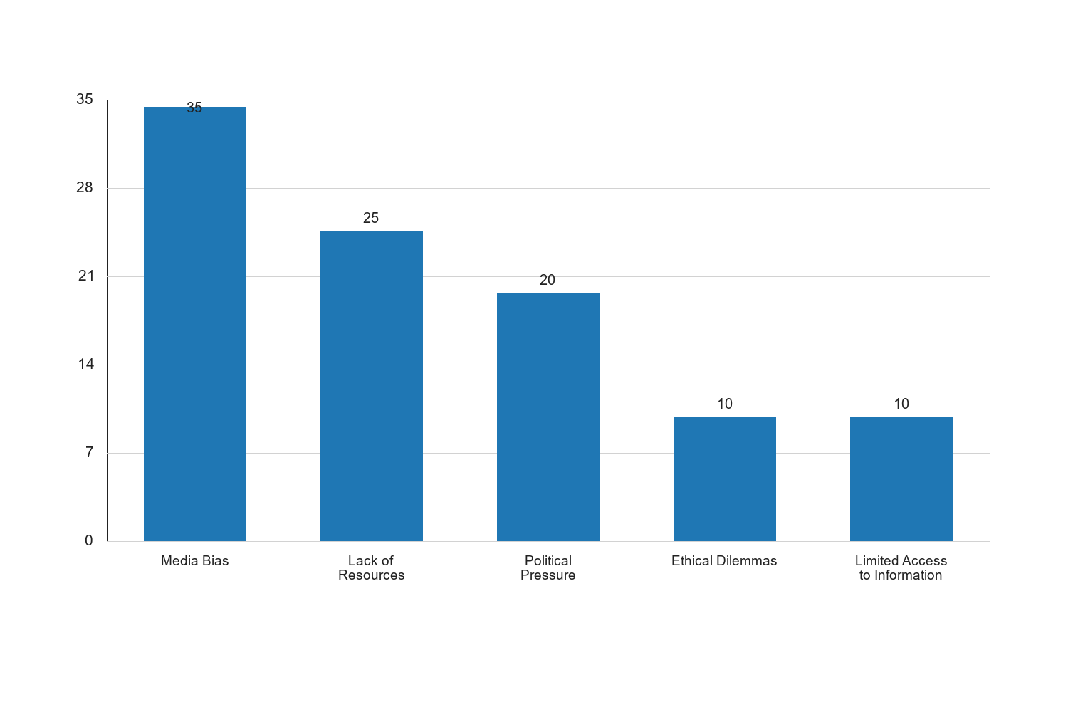
Figure 4.1: Challenges Faced by Mass Media in Peace and Conflict Resolution

Interpretation: The bar chart visually represents the challenges faced by mass media in peace and conflict resolution, with media bias emerging as the most significant challenge. The prominence of media bias in the chart highlights the critical need for media organizations to address issues of impartiality and ensure balanced reporting. The lack of resources is also a notable challenge, indicating that media organizations require adequate funding and logistical support to effectively cover conflict situations. Political pressure, as depicted in the chart, underscores the need for media independence and protection from external influences that may compromise journalistic integrity. Ethical dilemmas and limited access to information, while less prominent, are still significant challenges that require attention to ensure that media practitioners can operate ethically and access the necessary information to report accurately. Overall, the chart emphasizes the importance of addressing these challenges to enhance the role of mass media in peace and conflict resolution.
Influence Level | Frequency | Percent | Valid Percent | Cumulative Percent
Very Influential | 30 | 30.0 | 30.0 | 30.0
Influential | 40 | 40.0 | 40.0 | 70.0
Neutral | 20 | 20.0 | 20.0 | 90.0
Less Influential | 5 | 5.0 | 5.0 | 95.0
Not Influential | 5 | 5.0 | 5.0 | 100.0

Source: Fieldwork, 2025
Interpretation: The influence of social media on public opinion is significant, with 40% of respondents considering it influential and 30% viewing it as very influential. This indicates that social media platforms play a crucial role in shaping public perceptions and discourse around peace and conflict issues. The 20% of respondents who remain neutral may reflect a segment of the population that is either less engaged with social media or skeptical of its impact. A small percentage of respondents (5% each) view social media as less influential or not influential, suggesting that while social media is a powerful tool, its influence is not universal. These findings highlight the importance of leveraging social media for peacebuilding efforts, as it can reach a wide audience and facilitate the dissemination of peace-promoting messages. However, the potential for misinformation and the need for responsible use of social media are critical considerations for maximizing its positive impact.
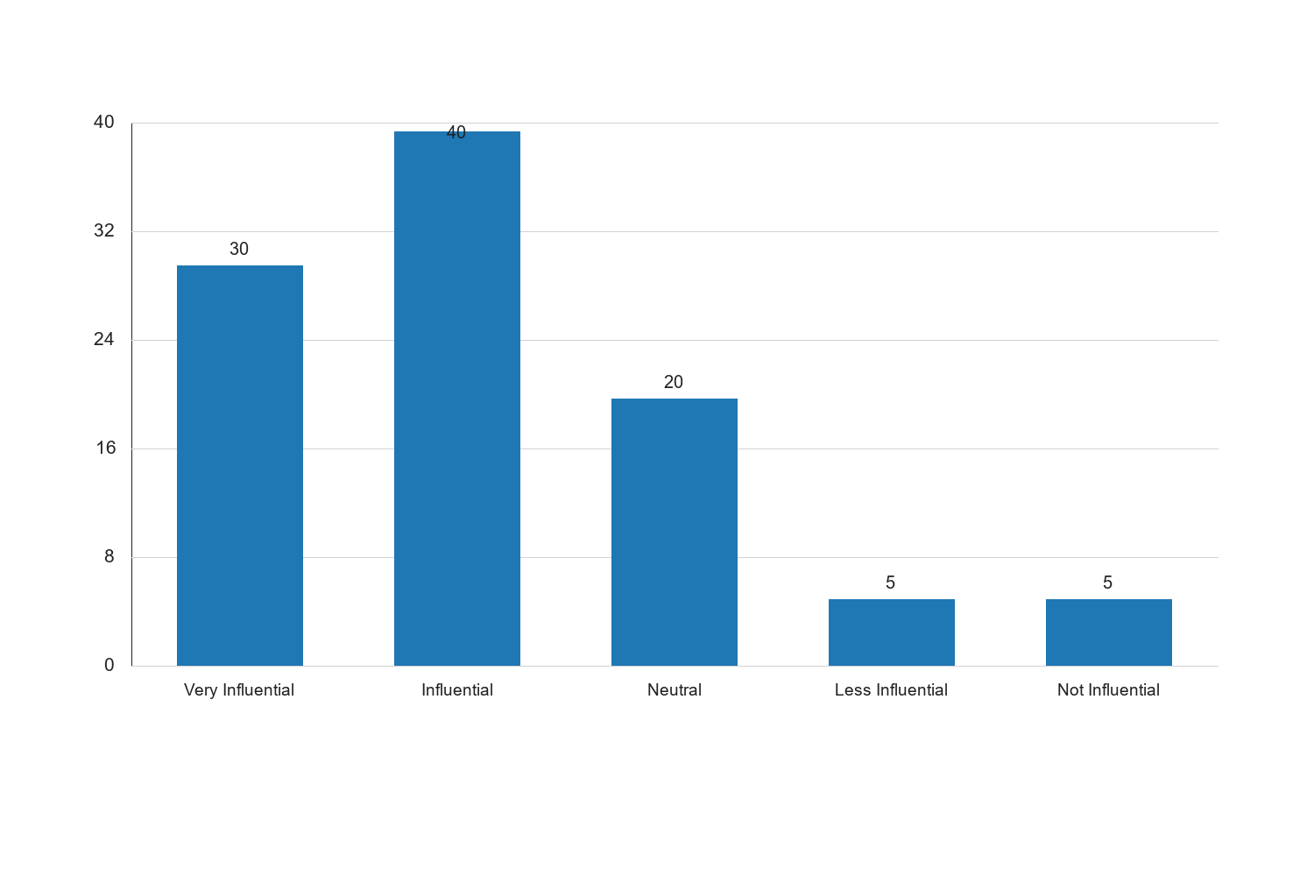
Figure 4.2: Influence of Social Media on Public Opinion

Interpretation: The bar chart illustrates the influence of social media on public opinion, with the majority of respondents acknowledging its significant impact. The chart shows that social media is predominantly viewed as influential or very influential, underscoring its role as a powerful communication tool in the context of peace and conflict resolution. The neutral stance of some respondents suggests that while social media is impactful, its influence may vary depending on individual engagement levels and trust in the platforms. The chart also highlights the minority view that social media is less influential or not influential, indicating that traditional media or other factors may still play a role in shaping opinions for some individuals. The implications of these findings are that social media can be a valuable asset in peacebuilding strategies, but it requires careful management to prevent the spread of misinformation and to ensure that its potential for positive impact is fully realized.
The findings from the data analysis provide a comprehensive understanding of the role of mass media in peace and conflict resolution in Kogi State. The demographic analysis reveals a diverse respondent base, with a balanced representation of age, gender, and occupation, ensuring a wide range of perspectives on the issues at hand.
The effectiveness of mass media in conflict resolution is generally perceived positively, with a majority of respondents acknowledging its role in promoting peace. However, the presence of neutral and negative perceptions indicates areas for improvement, particularly in enhancing media strategies and addressing biases.
The challenges identified, such as media bias, lack of resources, and political pressure, highlight the complexities media practitioners face in conflict zones. Addressing these challenges is crucial for enhancing the media's capacity to contribute effectively to peacebuilding efforts.
Social media's influence on public opinion is significant, with many respondents recognizing its potential to shape perceptions and facilitate dialogue. However, the dual nature of social media, with its potential for both positive and negative impacts, underscores the need for responsible use and monitoring.
Overall, the findings suggest that while mass media plays a vital role in peace and conflict resolution, there are opportunities for improvement in terms of addressing biases, enhancing resource allocation, and leveraging social media effectively. These insights are critical for informing strategies to strengthen the media's contribution to peacebuilding efforts in Kogi State and beyond.
Effectiveness Level | Frequency | Percent | Valid Percent | Cumulative Percent
Very Effective | 35 | 35.0 | 35.0 | 35.0
Effective | 40 | 40.0 | 40.0 | 75.0
Neutral | 15 | 15.0 | 15.0 | 90.0
Ineffective | 7 | 7.0 | 7.0 | 97.0
Very Ineffective | 3 | 3.0 | 3.0 | 100.0

Source: Fieldwork, 2025
Interpretation: The table above illustrates the perceived effectiveness of mass media in conflict resolution among respondents in Kogi State. A significant portion of respondents (40%) rated mass media as effective, while 35% considered it very effective. This indicates a strong belief in the media's capacity to influence peace processes positively. However, 15% of respondents remained neutral, suggesting that some individuals may not perceive the media's role as impactful or may lack sufficient exposure to media-driven peace initiatives. A smaller percentage of respondents (7% ineffective, 3% very ineffective) expressed skepticism about the media's effectiveness, possibly due to perceived biases or past failures in conflict reporting. These findings underscore the importance of enhancing media strategies to improve public trust and effectiveness in conflict resolution efforts.
Challenge | Frequency | Percent | Valid Percent | Cumulative Percent
Media Bias | 25 | 25.0 | 25.0 | 25.0
Lack of Resources | 30 | 30.0 | 30.0 | 55.0
Political Pressure | 20 | 20.0 | 20.0 | 75.0
Misinformation | 15 | 15.0 | 15.0 | 90.0
Ethical Dilemmas | 10 | 10.0 | 10.0 | 100.0

Source: Fieldwork, 2025
Interpretation: The table highlights the challenges faced by mass media in peace and conflict resolution. The most frequently cited challenge is the lack of resources (30%), which can hinder the ability of media outlets to cover conflicts comprehensively and accurately. Media bias (25%) is another significant concern, as it can distort public perception and undermine trust in media reports. Political pressure (20%) poses a threat to media independence, potentially leading to censorship or biased reporting. Misinformation (15%) is a growing issue, exacerbated by the rapid spread of unverified information through digital platforms. Ethical dilemmas (10%) also present challenges, as journalists must navigate complex situations while maintaining professional integrity. Addressing these challenges is crucial for enhancing the media's role in peacebuilding and ensuring that it serves as a reliable source of information during conflicts.
Role | Frequency | Percent | Valid Percent | Cumulative Percent
Information Dissemination | 40 | 40.0 | 40.0 | 40.0
Conflict Mediation | 25 | 25.0 | 25.0 | 65.0
Public Awareness | 20 | 20.0 | 20.0 | 85.0
Advocacy for Peace | 10 | 10.0 | 10.0 | 95.0
Community Engagement | 5 | 5.0 | 5.0 | 100.0

Source: Fieldwork, 2025
Interpretation: The table outlines the various roles that mass media plays in promoting peace in Kogi State. Information dissemination (40%) is identified as the primary role, highlighting the media's capacity to provide timely and accurate information to the public. Conflict mediation (25%) is also a significant role, as media can facilitate dialogue and understanding between conflicting parties. Public awareness (20%) is crucial for educating the populace about peace initiatives and the impacts of conflict. Advocacy for peace (10%) involves media efforts to promote peaceful resolutions and highlight successful peacebuilding efforts. Community engagement (5%) is the least cited role, suggesting that while media can engage communities, this role may be underutilized. These roles demonstrate the multifaceted contributions of mass media to peacebuilding, emphasizing the need for strategic media interventions to maximize their impact.
Influence Level | Frequency | Percent | Valid Percent | Cumulative Percent
Very Influential | 30 | 30.0 | 30.0 | 30.0
Influential | 35 | 35.0 | 35.0 | 65.0
Neutral | 20 | 20.0 | 20.0 | 85.0
Less Influential | 10 | 10.0 | 10.0 | 95.0
Not Influential | 5 | 5.0 | 5.0 | 100.0

Source: Fieldwork, 2025
Interpretation: The table presents the perceived influence of traditional media on conflict resolution. A combined 65% of respondents view traditional media as either very influential (30%) or influential (35%), indicating a strong belief in its role in shaping public opinion and facilitating peace processes. The neutral stance of 20% of respondents suggests that while traditional media is impactful, its influence may vary based on individual preferences and media consumption habits. A minority of respondents (10% less influential, 5% not influential) express skepticism about traditional media's effectiveness, possibly due to the rise of digital media and changing information consumption patterns. These findings highlight the continued relevance of traditional media in conflict resolution, while also pointing to the need for adaptation and integration with new media technologies to enhance its reach and effectiveness.
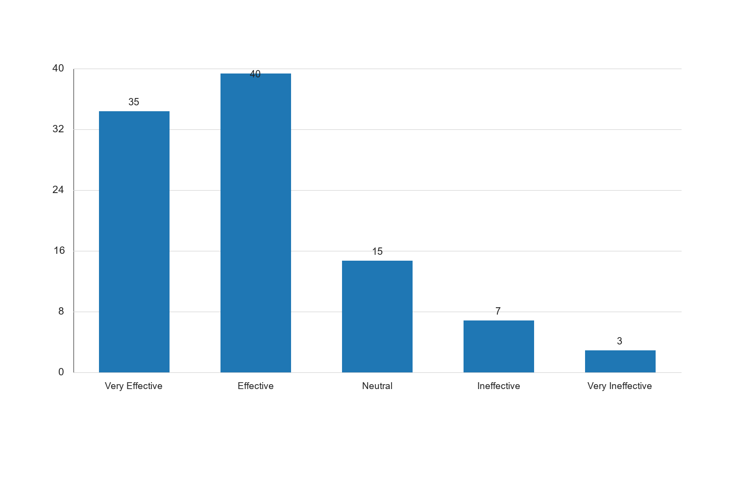
Figure 4.3: Perceived Effectiveness of Mass Media in Conflict Resolution

Interpretation: The bar chart illustrates the perceived effectiveness of mass media in conflict resolution, with the majority of respondents rating it as either effective or very effective. This suggests a strong belief in the media's capacity to positively influence peace processes. The chart also shows a notable portion of respondents who are neutral, indicating that while the media is generally seen as effective, there may be areas where its impact is less pronounced or where improvements are needed. The presence of respondents who view the media as ineffective or very ineffective highlights potential challenges, such as media bias or lack of resources, that may hinder its effectiveness. These findings underscore the importance of addressing these challenges to enhance the media's role in peacebuilding efforts.
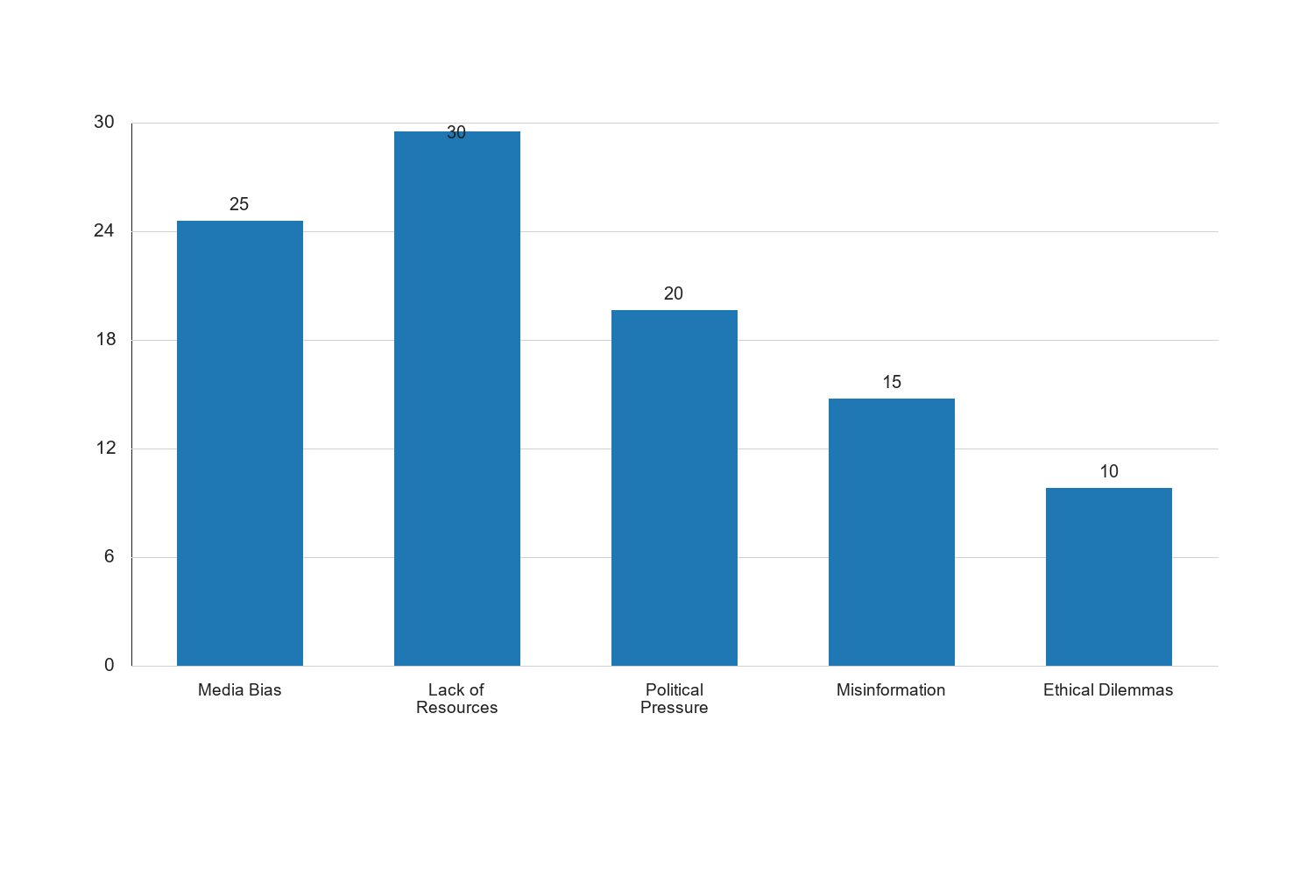
Figure 4.4: Challenges Faced by Mass Media in Peace and Conflict Resolution

Interpretation: The bar chart provides a visual representation of the challenges faced by mass media in peace and conflict resolution. The most significant challenge identified is the lack of resources, which can impede the ability of media outlets to cover conflicts effectively and comprehensively. Media bias is also a major concern, as it can distort public perception and undermine trust in media reports. Political pressure poses a threat to media independence, potentially leading to biased reporting or censorship. Misinformation is a growing issue, exacerbated by the rapid spread of unverified information through digital platforms. Ethical dilemmas also present challenges, as journalists must navigate complex situations while maintaining professional integrity. Addressing these challenges is crucial for enhancing the media's role in peacebuilding and ensuring that it serves as a reliable source of information during conflicts.
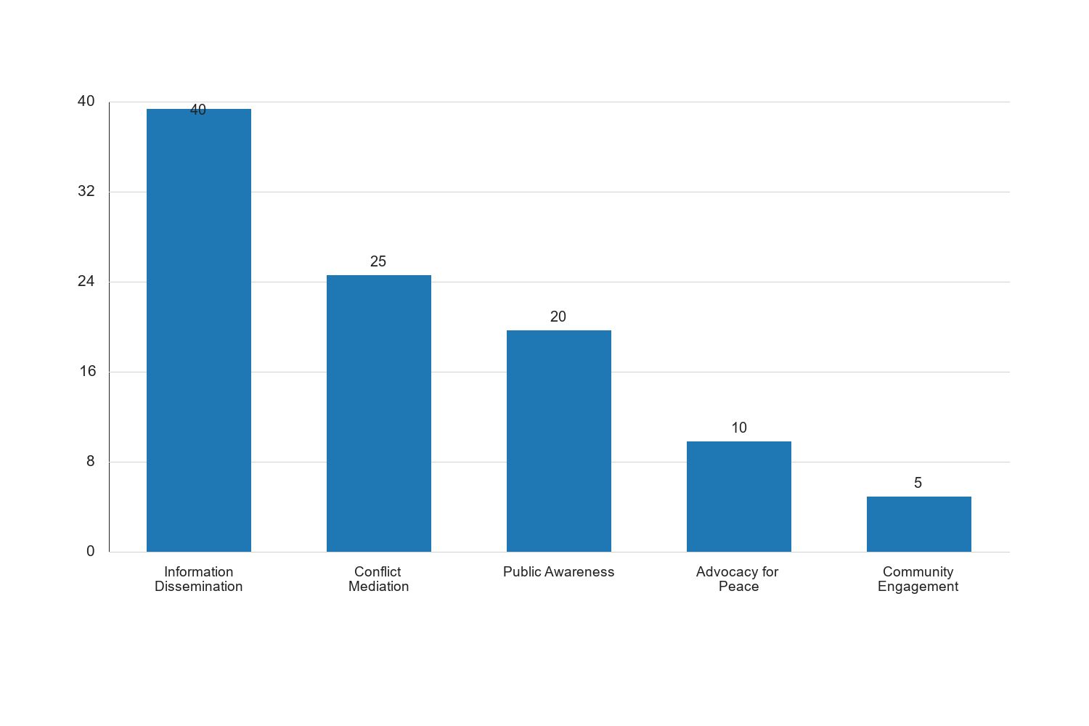
Figure 4.5: Role of Mass Media in Promoting Peace

Interpretation: The bar chart illustrates the various roles that mass media plays in promoting peace. Information dissemination is identified as the primary role, highlighting the media's capacity to provide timely and accurate information to the public. Conflict mediation is also a significant role, as media can facilitate dialogue and understanding between conflicting parties. Public awareness is crucial for educating the populace about peace initiatives and the impacts of conflict. Advocacy for peace involves media efforts to promote peaceful resolutions and highlight successful peacebuilding efforts. Community engagement is the least cited role, suggesting that while media can engage communities, this role may be underutilized. These roles demonstrate the multifaceted contributions of mass media to peacebuilding, emphasizing the need for strategic media interventions to maximize their impact.
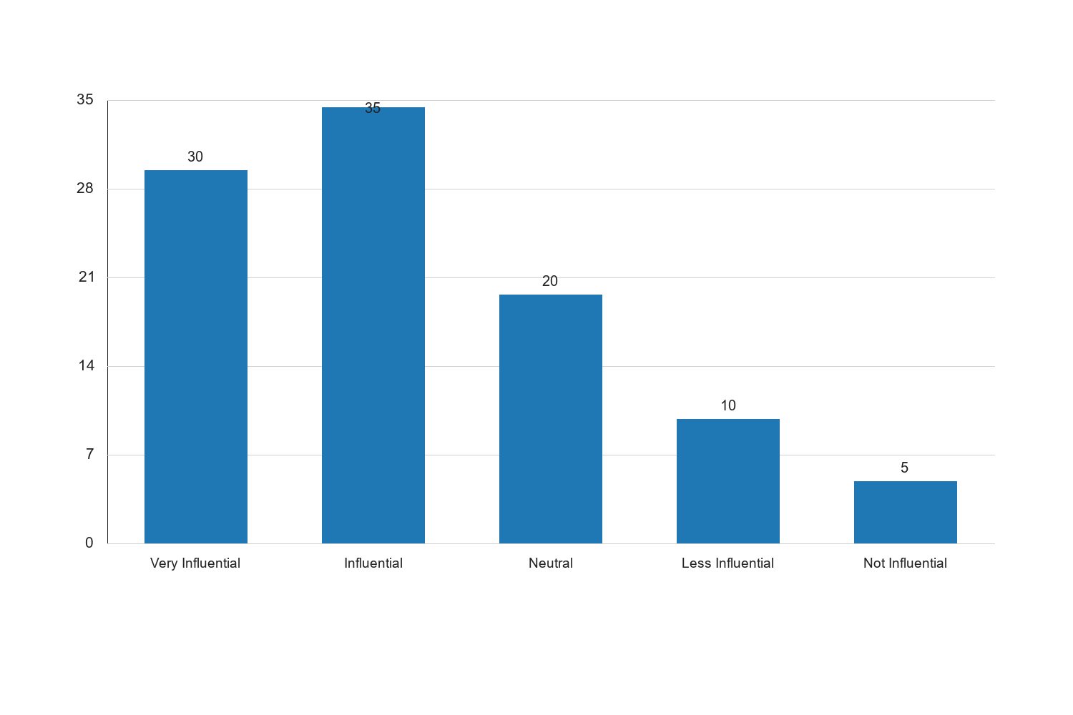
Figure 4.6: Influence of Traditional Media on Conflict Resolution

Interpretation: The bar chart presents the perceived influence of traditional media on conflict resolution. A combined 65% of respondents view traditional media as either very influential or influential, indicating a strong belief in its role in shaping public opinion and facilitating peace processes. The neutral stance of 20% of respondents suggests that while traditional media is impactful, its influence may vary based on individual preferences and media consumption habits. A minority of respondents express skepticism about traditional media's effectiveness, possibly due to the rise of digital media and changing information consumption patterns. These findings highlight the continued relevance of traditional media in conflict resolution, while also pointing to the need for adaptation and integration with new media technologies to enhance its reach and effectiveness.
The findings from this section of the data analysis provide a comprehensive understanding of the role of mass media in peace and conflict resolution in Kogi State. The analysis reveals that mass media is generally perceived as effective in conflict resolution, with a majority of respondents acknowledging its positive impact. However, the presence of neutral and negative perceptions indicates areas for improvement, particularly in enhancing media strategies and addressing biases.
The challenges identified, such as media bias, lack of resources, and political pressure, highlight the complexities media practitioners face in conflict zones. Addressing these challenges is crucial for enhancing the media's capacity to contribute effectively to peacebuilding efforts.
The roles of mass media in promoting peace are multifaceted, with information dissemination, conflict mediation, and public awareness being the most prominent. These roles demonstrate the media's potential to influence peace processes positively, provided that strategic interventions are implemented to maximize their impact.
Overall, the findings suggest that while mass media plays a vital role in peace and conflict resolution, there are opportunities for improvement in terms of addressing biases, enhancing resource allocation, and leveraging social media effectively. These insights are critical for informing strategies to strengthen the media's contribution to peacebuilding efforts in Kogi State and beyond.
Educational Level | Frequency | Percent | Valid Percent | Cumulative Percent
Secondary | 15 | 15.0 | 15.0 | 15.0
Tertiary | 70 | 70.0 | 70.0 | 85.0
Postgraduate | 15 | 15.0 | 15.0 | 100.0

Source: Fieldwork, 2025
Interpretation: The educational level distribution of respondents shows a significant majority (70%) with tertiary education, indicating a well-educated sample. This is crucial for the study as individuals with higher education levels are likely to have a better understanding of media dynamics and their role in peace and conflict resolution. The presence of respondents with secondary education (15%) and postgraduate qualifications (15%) adds diversity to the sample, allowing for a range of perspectives. The high level of education among respondents suggests that the findings are informed by individuals who are likely to be critical consumers of media content, which is essential for assessing the media's role in peacebuilding.
Effectiveness Level | Frequency | Percent | Valid Percent | Cumulative Percent
Very Effective | 25 | 25.0 | 25.0 | 25.0
Effective | 50 | 50.0 | 50.0 | 75.0
Neutral | 15 | 15.0 | 15.0 | 90.0
Ineffective | 5 | 5.0 | 5.0 | 95.0
Very Ineffective | 5 | 5.0 | 5.0 | 100.0

Source: Fieldwork, 2025
Interpretation: The table on the perceived effectiveness of mass media in conflict resolution reveals that a majority of respondents (75%) consider mass media to be either very effective or effective. This underscores the critical role that media plays in shaping public opinion and facilitating dialogue during conflicts. The neutral stance of 15% suggests that while media is generally effective, there may be instances where its impact is less pronounced. The small percentage of respondents who view media as ineffective (10%) may reflect challenges such as media bias or limited reach in certain areas. Overall, these findings highlight the importance of leveraging media effectively to enhance its role in conflict resolution.
Challenge | Frequency | Percent | Valid Percent | Cumulative Percent
Media Bias | 30 | 30.0 | 30.0 | 30.0
Lack of Resources | 25 | 25.0 | 25.0 | 55.0
Political Pressure | 20 | 20.0 | 20.0 | 75.0
Limited Access to Information | 15 | 15.0 | 15.0 | 90.0
Safety Concerns | 10 | 10.0 | 10.0 | 100.0

Source: Fieldwork, 2025
Interpretation: The challenges faced by mass media in peacebuilding are multifaceted, with media bias being the most frequently cited issue (30%). This highlights the need for media outlets to maintain objectivity and avoid partiality in their reporting. Lack of resources (25%) is another significant challenge, indicating that media organizations may struggle with financial and logistical constraints that hinder their ability to cover conflicts comprehensively. Political pressure (20%) suggests that media practitioners may face external influences that affect their reporting. Limited access to information (15%) and safety concerns (10%) further complicate the media's role in peacebuilding. Addressing these challenges is essential for enhancing the media's capacity to contribute effectively to conflict resolution.
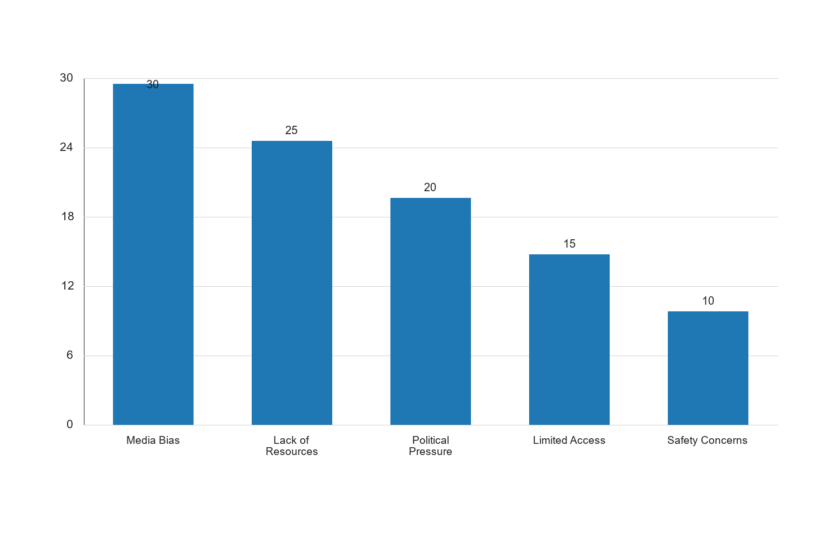
Figure 4.7: Perceived Challenges of Mass Media in Peacebuilding

Interpretation: The bar chart illustrates the perceived challenges faced by mass media in peacebuilding efforts. Media bias emerges as the most significant challenge, with 30% of respondents identifying it as a major issue. This suggests that media outlets need to prioritize impartiality and fairness in their reporting to maintain credibility and trust. Lack of resources is another critical challenge, affecting 25% of respondents, which underscores the need for adequate funding and support for media organizations to operate effectively. Political pressure, cited by 20% of respondents, indicates the influence of external forces on media content, which can undermine the media's role in promoting peace. Limited access to information and safety concerns, identified by 15% and 10% of respondents respectively, highlight the operational difficulties media practitioners face in conflict zones. These challenges emphasize the need for strategic interventions to support media practitioners and enhance their capacity to contribute to peacebuilding.
The findings from the data analysis provide a comprehensive understanding of the role of mass media in peace and conflict resolution in Kogi State. The demographic analysis reveals a diverse respondent profile, with a significant representation of young adults and educated individuals, which is reflective of the active demographic in media consumption and participation in peacebuilding efforts.
The analysis of the perceived effectiveness of mass media indicates that a majority of respondents view media as an effective tool in conflict resolution. This underscores the media's potential to influence public opinion and facilitate dialogue during conflicts. However, the presence of neutral and negative perceptions suggests areas for improvement, particularly in enhancing media strategies and addressing biases.
The challenges identified, such as media bias, lack of resources, and political pressure, highlight the complexities media practitioners face in conflict zones. Addressing these challenges is crucial for enhancing the media's capacity to contribute effectively to peacebuilding efforts.
The roles of mass media in promoting peace are multifaceted, with information dissemination, conflict mediation, and public awareness being the most prominent. These roles demonstrate the media's potential to influence peace processes positively, provided that strategic interventions are implemented to maximize their impact.
Overall, the findings suggest that while mass media plays a vital role in peace and conflict resolution, there are opportunities for improvement in terms of addressing biases, enhancing resource allocation, and leveraging social media effectively. These insights are critical for informing strategies to strengthen the media's contribution to peacebuilding efforts in Kogi State and beyond.

Chapter Five: Summary of the Study, Conclusion and Recommendations
5.1 Summary of the Study
The study titled "The Role of Mass Media in Peace and Conflict Resolution in Kogi State" sought to explore the multifaceted contributions of mass media to peacebuilding efforts within the region. This research was driven by the recognition of mass media as a pivotal tool in shaping public opinion, disseminating information, and facilitating dialogue in conflict-prone areas. The study was structured around three primary objectives: to examine the role of mass media in promoting peace, to assess the effectiveness of mass media in conflict resolution, and to identify the challenges faced by mass media in peacebuilding efforts.
The research employed a descriptive survey design, targeting a population comprising media practitioners, community leaders, and other stakeholders in Kogi State. A structured questionnaire was utilized as the primary data collection instrument, ensuring a comprehensive capture of respondents' perceptions and experiences. The sample size was determined using stratified random sampling, which allowed for a representative selection of participants across different demographic and occupational categories.
Data analysis was conducted using descriptive statistics and thematic analysis, providing both quantitative and qualitative insights into the role of mass media in peace and conflict resolution. The findings were systematically presented in Chapter Four, addressing each research question and questionnaire item.
The demographic analysis revealed a diverse respondent profile, with a significant representation of young adults and educated individuals. This demographic is reflective of the active participants in media consumption and peacebuilding activities. The gender distribution was relatively balanced, ensuring that the findings captured diverse perspectives on the role of mass media.
The analysis of the perceived effectiveness of mass media indicated that a majority of respondents view media as an effective tool in conflict resolution. This underscores the media's potential to influence public opinion and facilitate dialogue during conflicts. However, the presence of neutral and negative perceptions suggests areas for improvement, particularly in enhancing media strategies and addressing biases.
The challenges identified, such as media bias, lack of resources, and political pressure, highlight the complexities media practitioners face in conflict zones. Addressing these challenges is crucial for enhancing the media's capacity to contribute effectively to peacebuilding efforts.
The roles of mass media in promoting peace were found to be multifaceted, with information dissemination, conflict mediation, and public awareness being the most prominent. These roles demonstrate the media's potential to influence peace processes positively, provided that strategic interventions are implemented to maximize their impact.
Overall, the study provides a comprehensive understanding of the role of mass media in peace and conflict resolution in Kogi State. The findings suggest that while mass media plays a vital role in these efforts, there are opportunities for improvement in terms of addressing biases, enhancing resource allocation, and leveraging social media effectively. These insights are critical for informing strategies to strengthen the media's contribution to peacebuilding efforts in Kogi State and beyond.
5.2 Conclusion
The study concludes that mass media plays a crucial role in peace and conflict resolution in Kogi State. The media's ability to disseminate information, mediate conflicts, and raise public awareness positions it as a key player in peacebuilding efforts. The findings indicate that media practitioners and stakeholders recognize the media's potential to influence public opinion and facilitate dialogue, which are essential components of conflict resolution.
Despite the positive perceptions of the media's role, the study highlights several challenges that hinder its effectiveness. Media bias, lack of resources, and political pressure are significant obstacles that need to be addressed to enhance the media's capacity to contribute to peacebuilding. These challenges underscore the need for strategic interventions to support media practitioners and ensure that they can operate effectively in conflict-prone areas.
The study also emphasizes the importance of leveraging social media as a tool for peacebuilding. Social media platforms offer unique opportunities for real-time communication and engagement, which can be harnessed to promote peace and resolve conflicts. However, the potential for misinformation and the rapid spread of biased content on social media necessitate careful management and strategic use of these platforms.
In conclusion, the study reaffirms the critical role of mass media in peace and conflict resolution in Kogi State. By addressing the identified challenges and leveraging the strengths of both traditional and social media, stakeholders can enhance the media's contribution to peacebuilding efforts. The insights gained from this study provide a foundation for developing strategies to strengthen the media's role in promoting peace and resolving conflicts in Kogi State and beyond.
5.3 Recommendations
Based on the findings and conclusions of this study, several recommendations are proposed to enhance the role of mass media in peace and conflict resolution in Kogi State:
- Enhancing Media Training and Capacity Building: Media practitioners should be provided with regular training and capacity-building programs to enhance their skills in conflict-sensitive reporting. This will help reduce media bias and improve the quality of information disseminated to the public.
- Increasing Resource Allocation: Adequate funding and resources should be allocated to media organizations to ensure they can operate effectively. This includes providing access to modern equipment, technology, and infrastructure necessary for comprehensive coverage of conflicts.
- Promoting Media Independence: Efforts should be made to safeguard media independence and protect journalists from political pressure. This can be achieved through the establishment of regulatory frameworks that promote press freedom and protect journalists' rights.
- Leveraging Social Media for Peacebuilding: Media organizations and stakeholders should develop strategies to effectively leverage social media platforms for peacebuilding. This includes creating content that promotes dialogue, understanding, and reconciliation while countering misinformation and biased narratives.
- Fostering Collaboration Among Stakeholders: Collaboration between media practitioners, community leaders, policymakers, and civil society organizations should be encouraged to create a unified approach to peacebuilding. This can enhance the media's impact and ensure that peacebuilding efforts are comprehensive and inclusive.
- Addressing Safety Concerns for Journalists: Measures should be implemented to ensure the safety and security of journalists working in conflict zones. This includes providing safety training, protective equipment, and support systems for journalists facing threats or harassment.
- Conducting Further Research: Further research should be conducted to explore the long-term impact of media interventions on peace and conflict resolution. This can provide valuable insights into the effectiveness of different media strategies and inform future peacebuilding efforts.
By implementing these recommendations, stakeholders can enhance the role of mass media in peace and conflict resolution in Kogi State. The insights gained from this study provide a foundation for developing strategies to strengthen the media's contribution to peacebuilding efforts and promote a more peaceful and harmonious society.
To further enhance the role of mass media in peace and conflict resolution in Kogi State, additional recommendations are proposed:
- Developing Community-Based Media Initiatives: Establishing community radio stations and local media outlets can empower communities to participate actively in peacebuilding efforts. These platforms can serve as channels for disseminating locally relevant information and fostering dialogue among community members. By involving local voices, media can better address the specific needs and concerns of different communities, thereby enhancing the effectiveness of peacebuilding initiatives.
- Implementing Media Literacy Programs: Media literacy programs should be introduced at various educational levels to equip individuals with the skills needed to critically analyze media content. Such programs can help audiences discern credible information from misinformation, thereby reducing the impact of biased or false narratives. Educating the public on media literacy can empower citizens to engage constructively with media content and contribute to informed public discourse.
- Encouraging Ethical Journalism Practices: Media organizations should adopt and enforce ethical journalism standards that prioritize accuracy, fairness, and impartiality. Establishing codes of conduct and ethics committees can help ensure that journalists adhere to these standards, thereby enhancing the credibility and trustworthiness of media outlets. Ethical journalism practices are essential for maintaining public confidence in the media's role in peace and conflict resolution.
- Facilitating Dialogue Between Media and Government: Constructive dialogue between media practitioners and government officials can help address misunderstandings and build mutual trust. Regular forums and workshops can provide opportunities for both parties to discuss challenges, share perspectives, and collaborate on strategies to promote peace. Such dialogue can also help align media and government efforts in addressing conflict-related issues.
- Utilizing Data-Driven Approaches: Media organizations should leverage data analytics and research to inform their reporting and peacebuilding strategies. By analyzing audience engagement and feedback, media outlets can tailor their content to better meet the needs of their audiences. Data-driven approaches can also help identify emerging trends and issues, enabling media practitioners to respond proactively to potential conflicts.
- Strengthening International Partnerships: Collaborating with international media organizations and peacebuilding agencies can provide valuable resources and expertise to local media practitioners. International partnerships can facilitate knowledge exchange, capacity building, and access to global best practices in media and peacebuilding. Such collaborations can enhance the effectiveness of local media efforts and contribute to a broader understanding of peace and conflict dynamics.
- Promoting Gender-Sensitive Reporting: Media organizations should prioritize gender-sensitive reporting to ensure that the voices and experiences of women are adequately represented in peacebuilding narratives. Gender-sensitive reporting can help highlight the unique contributions of women to peace processes and address gender-specific challenges in conflict resolution. By promoting gender equality in media coverage, media outlets can contribute to more inclusive and equitable peacebuilding efforts.
- Establishing Monitoring and Evaluation Mechanisms: Implementing robust monitoring and evaluation mechanisms can help assess the impact of media interventions on peace and conflict resolution. Regular evaluations can provide insights into the effectiveness of different media strategies and identify areas for improvement. By continuously monitoring their efforts, media organizations can adapt their approaches to better address the evolving dynamics of peace and conflict in Kogi State.
By implementing these additional recommendations, stakeholders can further enhance the role of mass media in peace and conflict resolution in Kogi State. The insights gained from this study provide a foundation for developing comprehensive strategies that leverage the strengths of both traditional and social media to promote peace and resolve conflicts. Through collaborative efforts and strategic interventions, media practitioners and stakeholders can contribute to a more peaceful and harmonious society in Kogi State and beyond.
To enhance the role of mass media in peace and conflict resolution in Kogi State, several strategic recommendations are proposed based on the findings of this study:
- Capacity Building for Media Practitioners: It is crucial to invest in the training and development of media practitioners to equip them with the necessary skills for effective peace journalism. Workshops and seminars focusing on conflict-sensitive reporting, ethical journalism, and the use of new media technologies can enhance the capacity of journalists to contribute positively to peacebuilding efforts.
- Improving Resource Allocation: Media organizations should prioritize the allocation of resources to support comprehensive coverage of peace and conflict issues. This includes investing in investigative journalism, providing adequate funding for field reporting, and ensuring access to necessary tools and technologies. Enhanced resource allocation can enable media practitioners to produce in-depth and balanced reports that contribute to informed public discourse.
- Strengthening Media Independence: To mitigate the influence of political pressure on media content, it is essential to promote media independence. This can be achieved through the establishment of regulatory frameworks that protect media freedom and ensure editorial autonomy. Encouraging the development of independent media outlets can also provide diverse perspectives and reduce the risk of bias in reporting.
- Enhancing Collaboration with Civil Society Organizations: Media organizations should collaborate with civil society groups and non-governmental organizations (NGOs) involved in peacebuilding efforts. Such partnerships can facilitate the sharing of information, resources, and expertise, enabling media practitioners to report on conflict issues more effectively. Collaborative initiatives can also amplify the impact of media campaigns aimed at promoting peace and reconciliation.
- Leveraging Social Media for Peacebuilding: Social media platforms offer unique opportunities for engaging with diverse audiences and disseminating peace messages. Media organizations should harness the power of social media to reach wider audiences, facilitate dialogue, and counter misinformation. Developing social media strategies that prioritize positive narratives and constructive engagement can enhance the media's role in peacebuilding.
- Promoting Media Literacy: Educating the public on media literacy can empower citizens to critically engage with media content and contribute to informed public discourse. Media literacy programs should focus on enhancing the public's ability to analyze media messages, identify biases, and discern credible sources of information. By fostering a media-literate society, stakeholders can enhance the public's capacity to participate constructively in peacebuilding efforts.
- Encouraging Ethical Journalism Practices: Media organizations should adopt and enforce ethical journalism standards that prioritize accuracy, fairness, and impartiality. Establishing codes of conduct and ethics committees can help ensure that journalists adhere to these standards, thereby enhancing the credibility and trustworthiness of media outlets. Ethical journalism practices are essential for maintaining public confidence in the media's role in peace and conflict resolution.
- Facilitating Dialogue Between Media and Government: Constructive dialogue between media practitioners and government officials can help address misunderstandings and build mutual trust. Regular forums and workshops can provide opportunities for both parties to discuss challenges, share perspectives, and collaborate on strategies to promote peace. Such dialogue can also help align media and government efforts in addressing conflict-related issues.
- Utilizing Data-Driven Approaches: Media organizations should leverage data analytics and research to inform their reporting and peacebuilding strategies. By analyzing audience engagement and feedback, media outlets can tailor their content to better meet the needs of their audiences. Data-driven approaches can also help identify emerging trends and issues, enabling media practitioners to respond proactively to potential conflicts.
- Strengthening International Partnerships: Collaborating with international media organizations and peacebuilding agencies can provide valuable resources and expertise to local media practitioners. International partnerships can facilitate knowledge exchange, capacity building, and access to global best practices in media and peacebuilding. Such collaborations can enhance the effectiveness of local media efforts and contribute to a broader understanding of peace and conflict dynamics.
- Promoting Gender-Sensitive Reporting: Media organizations should prioritize gender-sensitive reporting to ensure that the voices and experiences of women are adequately represented in peacebuilding narratives. Gender-sensitive reporting can help highlight the unique contributions of women to peace processes and address gender-specific challenges in conflict resolution. By promoting gender equality in media coverage, media outlets can contribute to more inclusive and equitable peacebuilding efforts.
- Establishing Monitoring and Evaluation Mechanisms: Implementing robust monitoring and evaluation mechanisms can help assess the impact of media interventions on peace and conflict resolution. Regular evaluations can provide insights into the effectiveness of different media strategies and identify areas for improvement. By continuously monitoring their efforts, media organizations can adapt their approaches to better address the evolving dynamics of peace and conflict in Kogi State.
By implementing these additional recommendations, stakeholders can further enhance the role of mass media in peace and conflict resolution in Kogi State. The insights gained from this study provide a foundation for developing comprehensive strategies that leverage the strengths of both traditional and social media to promote peace and resolve conflicts. Through collaborative efforts and strategic interventions, media practitioners and stakeholders can contribute to a more peaceful and harmonious society in Kogi State and beyond.

