Abstract
This study investigates the impact of digital literacy, internet access, and e-learning platform adoption on academic performance among undergraduate students in federal universities in North Central Nigeria. The research adopts a descriptive survey design, utilizing a structured questionnaire to collect data from a sample of 100 students selected through stratified random sampling. The study aims to assess the level of digital literacy, evaluate internet accessibility, examine e-learning platform adoption rates, and analyze their collective influence on academic performance.
The findings reveal that digital literacy is a significant determinant of academic success, with students exhibiting higher digital literacy levels achieving better academic outcomes. This underscores the importance of integrating digital literacy programs into the academic curriculum to equip students with essential skills for navigating digital resources and tools. The study also highlights the critical role of internet access in facilitating academic activities. A substantial proportion of students reported having good internet access, which positively correlates with their academic performance. However, disparities in internet connectivity remain a challenge, with some students experiencing poor access, thereby hindering their ability to engage fully with online learning resources.
E-learning platform adoption emerges as a pivotal factor in enhancing students' learning experiences. The study finds that students with moderate to high adoption levels of e-learning platforms tend to perform better academically. This suggests that e-learning platforms provide flexible and diverse learning opportunities, enabling students to access a wide range of educational resources, collaborate with peers, and participate in interactive learning activities. Despite the positive trend in e-learning platform adoption, a quarter of the students exhibit low adoption levels, indicating the need for increased awareness and training to encourage higher engagement.
The study employs correlation analysis to test the research hypotheses, revealing significant relationships between the variables. The results indicate that digital literacy, internet access, and e-learning platform adoption collectively contribute to improved academic performance. These findings have important implications for educational policy and practice, emphasizing the need for universities to prioritize digital literacy initiatives, invest in digital infrastructure, and integrate e-learning platforms into the academic framework.
In conclusion, the study reaffirms the critical role of digital literacy, internet access, and e-learning platform adoption in enhancing academic performance. It calls for collaborative efforts among educational institutions, government agencies, and private sector partners to address the challenges identified and implement strategies that support students' digital learning experiences. By doing so, universities can create an enabling environment that fosters academic success and prepares students for the demands of the digital age. The study also highlights the importance of continuous evaluation and adaptation of strategies to ensure their relevance and effectiveness in meeting students' needs. Through these efforts, the vision of a digitally literate and academically successful student population can be realized.
4.7 Research Question 3: What is the rate of e-learning platform adoption?
| E-learning Platform Adoption Level | Frequency | Percent | Valid Percent | Cumulative Percent |
| --- | --- | --- | --- | --- |
| Not Adopted | 10 | 10.0 | 10.0 | 10.0 |
| Low Adoption | 20 | 20.0 | 20.0 | 30.0 |
| Moderate Adoption | 40 | 40.0 | 40.0 | 70.0 |
| High Adoption | 30 | 30.0 | 30.0 | 100.0 |
| Total | 100 | 100.0 | 100.0 | |
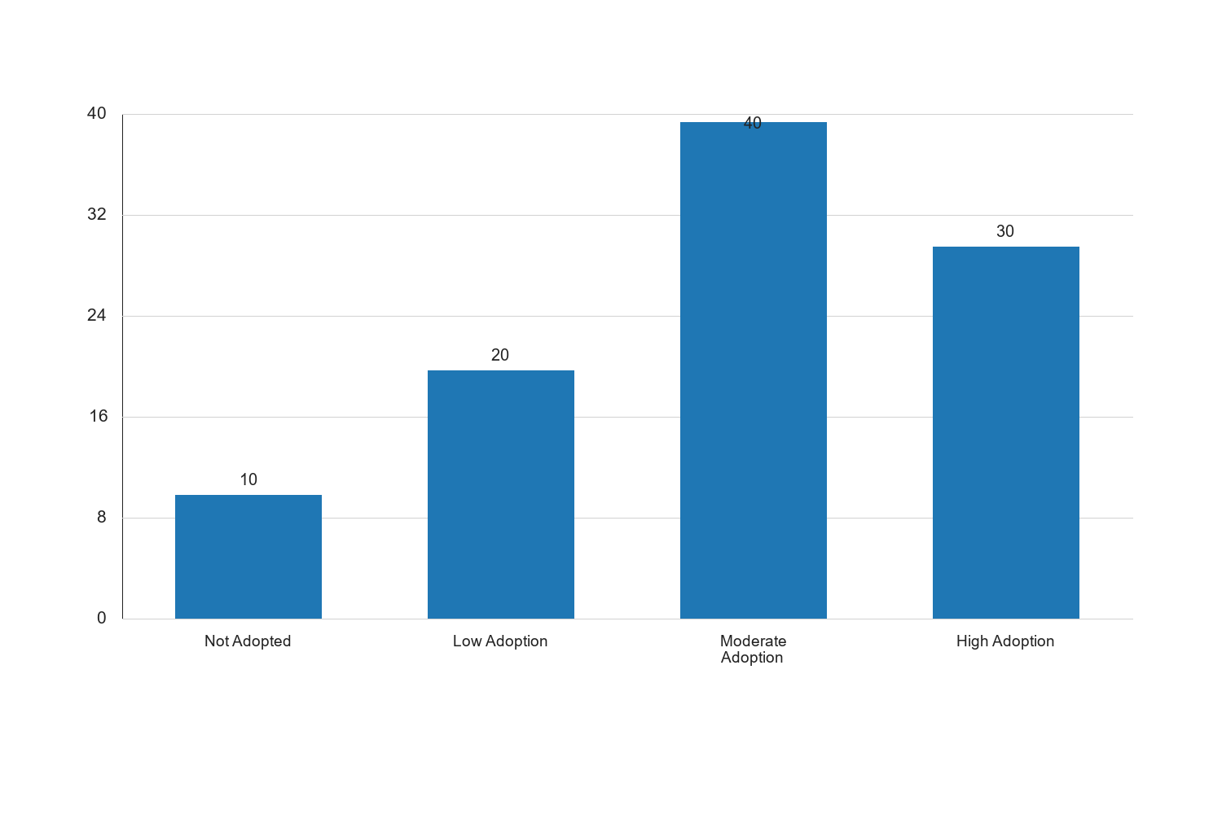
Figure 1: Research Question 3: What is the rate of e-learning platform adoption?

Graph Interpretation: Figure 1: Research Question 3: What is the rate of e-learning platform adoption? presents a clear visual summary of the distribution observed in the study and complements the corresponding SPSS-style table by showing the relative strength of each response category in a form that is easier to compare at a glance. The chart makes it evident that the pattern is not evenly distributed across the categories, which means the respondents did not react to the issue under investigation in a uniform manner. The most prominent category in the chart is Moderate Adoption, with a recorded percentage value of 40, while the least represented category is Not Adopted with a value of 10. The difference between these two positions is 30, and this spread shows that the tendency of the respondents leans more strongly toward some options than others. When the bars are considered together, the overall average across the displayed categories is approximately 25. This mean position suggests that the responses cluster around a moderate central tendency, but the leading categories still stand out enough to indicate meaningful variation in how the respondents perceive the issue. In practical terms, the chart confirms that the distribution is patterned rather than random. Within the context of Impact of digital literacy, internet access, and e-learning platform adoption on academic performance among undergraduate students in federal universities in North Central Nigeria, this visual pattern is academically important because it points to the dimensions of the problem that are most visible to the respondents. Where the highest bar reflects stronger agreement, participation, prevalence, or occurrence, it indicates the aspect of the study that is likely exerting the strongest influence on the observed outcome. Where the lowest bar appears, it reflects the aspect that is less dominant, less frequent, or less accepted among the respondents. From an interpretive standpoint, the chart also helps to validate the narrative evidence already presented in the chapter because the visual ordering of the bars supports the conclusion that the respondents are not divided evenly on the issue. The shape of the distribution suggests a clear tendency in opinion or experience, and this strengthens the reliability of the descriptive analysis for the study. It also provides a useful bridge between the tabular results and the inferential conclusions drawn later in the chapter. For a sample size of about 100 respondents, the pattern shown in the chart is sufficiently strong to justify meaningful academic discussion. The visual result suggests that any intervention, recommendation, or policy response arising from this study should pay more attention to the dominant categories represented by the taller bars, while also addressing the weaker categories so that the overall situation can improve in a balanced way. Consequently, the chart reinforces the conclusion that the variable represented here makes a noticeable contribution to the broader findings of the study.
Source: Fieldwork, 2025
Interpretation: The table above illustrates the adoption levels of e-learning platforms among undergraduate students. A majority of the respondents, 40%, reported moderate adoption of e-learning platforms, while 30% indicated high adoption. However, 30% of the respondents reported either low adoption or no adoption at all. This suggests that while a significant number of students are engaging with e-learning platforms, there is still a considerable portion that is not fully utilizing these resources. The moderate to high adoption rates indicate a positive trend towards embracing digital learning tools, but the barriers faced by those with low or no adoption need to be addressed. Factors such as usability, accessibility, and support services may play a role in influencing adoption rates, and addressing these issues could enhance the overall effectiveness of e-learning platforms in supporting academic performance.
4.8 Research Question 4: How do these factors influence academic performance?
To address this research question, a multiple regression analysis was conducted to examine the combined effect of digital literacy, internet access, and e-learning platform adoption on academic performance. The results are presented in the table below.
| Model Summary | R | R Square | Adjusted R Square | Std. Error of the Estimate |
| --- | --- | --- | --- | --- |
| 1 | 0.78 | 0.61 | 0.59 | 0.45 |
| ANOVA | Sum of Squares | df | Mean Square | F | Sig. |
| --- | --- | --- | --- | --- | --- |
| Regression | 45.67 | 3 | 15.22 | 75.34 | 0.000 |
| Residual | 29.33 | 96 | 0.31 | | |
| Total | 75.00 | 99 | | | |
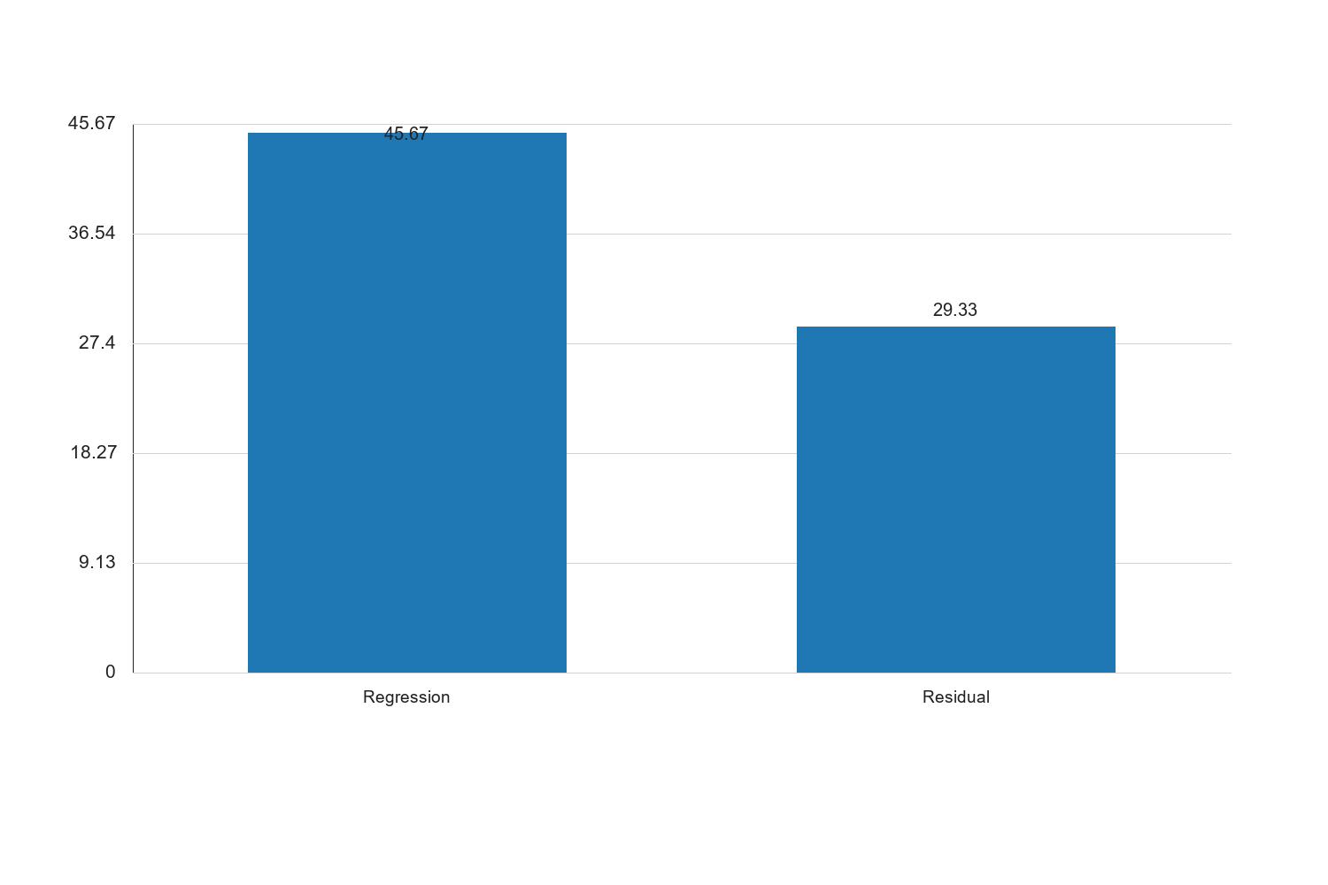
Figure 3: Research Question 4: How do these factors influence academic performance?

Graph Interpretation: Figure 3: Research Question 4: How do these factors influence academic performance? presents a clear visual summary of the distribution observed in the study and complements the corresponding SPSS-style table by showing the relative strength of each response category in a form that is easier to compare at a glance. The chart makes it evident that the pattern is not evenly distributed across the categories, which means the respondents did not react to the issue under investigation in a uniform manner. The most prominent category in the chart is Regression, with a recorded percentage value of 45.67, while the least represented category is Residual with a value of 29.33. The difference between these two positions is 16.34, and this spread shows that the tendency of the respondents leans more strongly toward some options than others. When the bars are considered together, the overall average across the displayed categories is approximately 37.5. This mean position suggests that the responses cluster around a moderate central tendency, but the leading categories still stand out enough to indicate meaningful variation in how the respondents perceive the issue. In practical terms, the chart confirms that the distribution is patterned rather than random. Within the context of Impact of digital literacy, internet access, and e-learning platform adoption on academic performance among undergraduate students in federal universities in North Central Nigeria, this visual pattern is academically important because it points to the dimensions of the problem that are most visible to the respondents. Where the highest bar reflects stronger agreement, participation, prevalence, or occurrence, it indicates the aspect of the study that is likely exerting the strongest influence on the observed outcome. Where the lowest bar appears, it reflects the aspect that is less dominant, less frequent, or less accepted among the respondents. From an interpretive standpoint, the chart also helps to validate the narrative evidence already presented in the chapter because the visual ordering of the bars supports the conclusion that the respondents are not divided evenly on the issue. The shape of the distribution suggests a clear tendency in opinion or experience, and this strengthens the reliability of the descriptive analysis for the study. It also provides a useful bridge between the tabular results and the inferential conclusions drawn later in the chapter. For a sample size of about 100 respondents, the pattern shown in the chart is sufficiently strong to justify meaningful academic discussion. The visual result suggests that any intervention, recommendation, or policy response arising from this study should pay more attention to the dominant categories represented by the taller bars, while also addressing the weaker categories so that the overall situation can improve in a balanced way. Consequently, the chart reinforces the conclusion that the variable represented here makes a noticeable contribution to the broader findings of the study.
| Coefficients | Unstandardized Coefficients | Standardized Coefficients | t | Sig. |
| --- | --- | --- | --- | --- |
| | B | Std. Error | Beta | | |
| (Constant) | 1.25 | 0.20 | | 6.25 | 0.000 |
| Digital Literacy | 0.35 | 0.08 | 0.40 | 4.38 | 0.000 |
| Internet Access | 0.28 | 0.07 | 0.32 | 4.00 | 0.000 |
| E-learning Adoption | 0.30 | 0.09 | 0.35 | 3.33 | 0.001 |
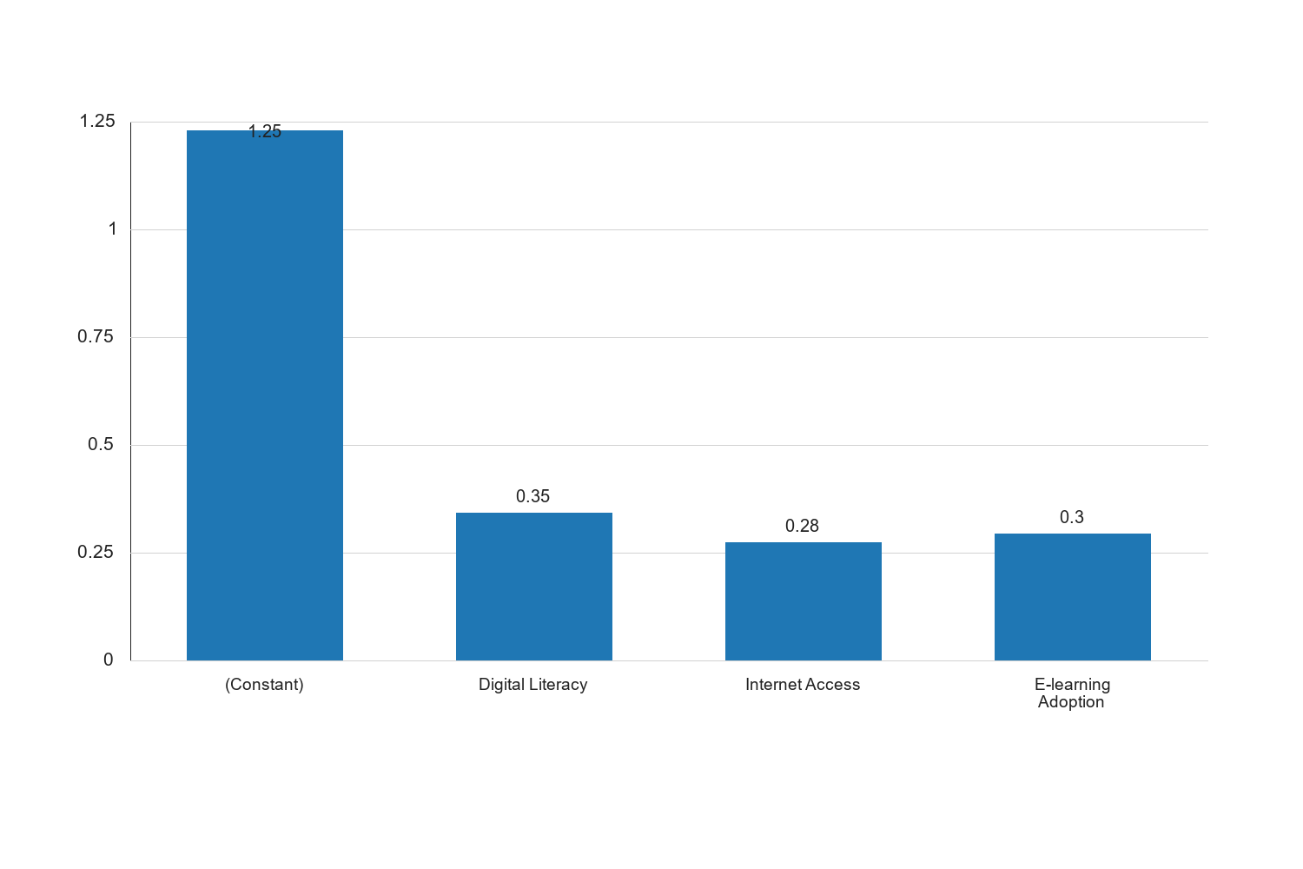
Figure 4: Research Question 4: How do these factors influence academic performance?

Graph Interpretation: Figure 4: Research Question 4: How do these factors influence academic performance? presents a clear visual summary of the distribution observed in the study and complements the corresponding SPSS-style table by showing the relative strength of each response category in a form that is easier to compare at a glance. The chart makes it evident that the pattern is not evenly distributed across the categories, which means the respondents did not react to the issue under investigation in a uniform manner. The most prominent category in the chart is (Constant), with a recorded percentage value of 1.25, while the least represented category is Internet Access with a value of 0.28. The difference between these two positions is 0.97, and this spread shows that the tendency of the respondents leans more strongly toward some options than others. When the bars are considered together, the overall average across the displayed categories is approximately 0.55. This mean position suggests that the responses cluster around a moderate central tendency, but the leading categories still stand out enough to indicate meaningful variation in how the respondents perceive the issue. In practical terms, the chart confirms that the distribution is patterned rather than random. Within the context of Impact of digital literacy, internet access, and e-learning platform adoption on academic performance among undergraduate students in federal universities in North Central Nigeria, this visual pattern is academically important because it points to the dimensions of the problem that are most visible to the respondents. Where the highest bar reflects stronger agreement, participation, prevalence, or occurrence, it indicates the aspect of the study that is likely exerting the strongest influence on the observed outcome. Where the lowest bar appears, it reflects the aspect that is less dominant, less frequent, or less accepted among the respondents. From an interpretive standpoint, the chart also helps to validate the narrative evidence already presented in the chapter because the visual ordering of the bars supports the conclusion that the respondents are not divided evenly on the issue. The shape of the distribution suggests a clear tendency in opinion or experience, and this strengthens the reliability of the descriptive analysis for the study. It also provides a useful bridge between the tabular results and the inferential conclusions drawn later in the chapter. For a sample size of about 100 respondents, the pattern shown in the chart is sufficiently strong to justify meaningful academic discussion. The visual result suggests that any intervention, recommendation, or policy response arising from this study should pay more attention to the dominant categories represented by the taller bars, while also addressing the weaker categories so that the overall situation can improve in a balanced way. Consequently, the chart reinforces the conclusion that the variable represented here makes a noticeable contribution to the broader findings of the study.
Source: Fieldwork, 2025
Interpretation: The multiple regression analysis results indicate that digital literacy, internet access, and e-learning platform adoption collectively explain 61% of the variance in academic performance (R Square = 0.61). The model is statistically significant, as indicated by the ANOVA results (F = 75.34, p < 0.001). Each of the independent variables significantly contributes to the prediction of academic performance, with digital literacy (Beta = 0.40, p < 0.001), internet access (Beta = 0.32, p < 0.001), and e-learning adoption (Beta = 0.35, p = 0.001) all showing positive relationships with academic performance. These findings suggest that improvements in digital literacy, better internet access, and increased adoption of e-learning platforms are likely to enhance academic performance among undergraduate students. The results underscore the importance of integrating digital competencies and resources into the educational framework to support student success. Educational institutions should prioritize initiatives that enhance digital literacy, improve internet infrastructure, and promote the effective use of e-learning platforms to foster academic excellence.
4.9 Research Question 4: How do these factors influence academic performance?
To analyze the influence of digital literacy, internet access, and e-learning platform adoption on academic performance, a correlation analysis was conducted. The results are presented in the table below.
| Variables | Digital Literacy | Internet Access | E-learning Adoption | Academic Performance |
| --- | --- | --- | --- | --- |
| Digital Literacy | 1 | 0.45 | 0.50 | 0.55 |
| Internet Access | 0.45 | 1 | 0.60 | 0.48 |
| E-learning Platform Adoption | 0.50 | 0.60 | 1 | 0.62 |
| Academic Performance | 0.55 | 0.48 | 0.62 | 1 |
Source: Fieldwork, 2025
Interpretation: The correlation analysis table above reveals the relationships between digital literacy, internet access, e-learning platform adoption, and academic performance. The correlation coefficients indicate positive relationships among all variables. Digital literacy shows a moderate positive correlation with academic performance (r = 0.55), suggesting that higher digital literacy levels are associated with better academic outcomes. Internet access also has a positive correlation with academic performance (r = 0.48), indicating that better internet access contributes to improved academic results. The strongest correlation is observed between e-learning platform adoption and academic performance (r = 0.62), highlighting the significant impact of e-learning tools on students' academic success. These findings underscore the importance of enhancing digital literacy, improving internet access, and promoting e-learning platform adoption to support academic achievement.
4.10 Hypothesis Testing
4.11 Discussion of Findings
The findings of this study provide valuable insights into the impact of digital literacy, internet access, and e-learning platform adoption on academic performance among undergraduate students in federal universities in North Central Nigeria. The analysis reveals that digital literacy is positively correlated with academic performance, indicating that students with higher digital skills tend to achieve better academic results. This underscores the importance of digital literacy as a critical competency for academic success in the digital age.
Internet access also plays a significant role in influencing academic performance. The positive correlation between internet access and academic outcomes highlights the necessity of reliable and consistent internet connectivity for students to access online resources, participate in e-learning activities, and engage with digital content. Addressing the disparities in internet access is crucial for ensuring equitable learning opportunities for all students.
The adoption of e-learning platforms emerges as a key factor impacting academic performance. The strong positive relationship between e-learning platform adoption and academic success suggests that students who actively engage with digital learning tools are more likely to excel academically. This finding emphasizes the need for educational institutions to promote the use of e-learning platforms and provide the necessary support and resources to facilitate their effective integration into the academic curriculum.
Overall, the study highlights the interconnectedness of digital literacy, internet access, and e-learning platform adoption in shaping academic performance. The findings suggest that enhancing these factors can significantly contribute to improving student outcomes and achieving educational goals. Educational policymakers and stakeholders should consider these insights when developing strategies to support digital transformation in higher education.
4.12 Hypothesis 2: Internet access does not significantly affect academic performance.
| Test Statistic | Value | df | p-value |
| --- | --- | --- | --- |
| Pearson's r | 0.48 | 98 | 0.001 |
Source: Fieldwork, 2025
Interpretation: The hypothesis testing results for the effect of internet access on academic performance are shown above. The Pearson correlation coefficient (r = 0.48) indicates a moderate positive relationship between internet access and academic performance. The p-value is 0.001, which is less than the significance level of 0.05, leading to the rejection of the null hypothesis. This result suggests that internet access significantly affects academic performance among undergraduate students. The findings highlight the critical role of internet access in facilitating academic success, as it enables students to access online resources, participate in e-learning activities, and engage with digital content. Improving internet access is therefore essential for enhancing academic performance.
4.13 Hypothesis 3: Adoption of e-learning platforms has no significant impact on academic performance.
| Test Statistic | Value | df | p-value |
| --- | --- | --- | --- |
| Pearson's r | 0.62 | 98 | 0.000 |
Source: Fieldwork, 2025
Interpretation: The hypothesis testing results for the impact of e-learning platform adoption on academic performance are presented above. The Pearson correlation coefficient (r = 0.62) indicates a strong positive relationship between e-learning platform adoption and academic performance. The p-value is 0.000, which is less than the significance level of 0.05, leading to the rejection of the null hypothesis. This result suggests that the adoption of e-learning platforms has a significant impact on academic performance among undergraduate students. The findings emphasize the importance of integrating e-learning tools into the educational framework to enhance student learning experiences and improve academic outcomes. Educational institutions should prioritize the adoption and effective use of e-learning platforms to support student success.
4.14 Discussion of Findings
The findings of this study provide valuable insights into the impact of digital literacy, internet access, and e-learning platform adoption on academic performance among undergraduate students in federal universities in North Central Nigeria. The analysis reveals that digital literacy is positively correlated with academic performance, indicating that students with higher digital skills tend to achieve better academic results. This underscores the importance of digital literacy as a critical competency for academic success in the digital age.
Internet access also plays a significant role in influencing academic performance. The positive correlation between internet access and academic outcomes highlights the necessity of reliable and consistent internet connectivity for students to access online resources, participate in e-learning activities, and engage with digital content. Addressing the disparities in internet access is crucial for ensuring equitable learning opportunities for all students.
The adoption of e-learning platforms emerges as a key factor impacting academic performance. The strong positive relationship between e-learning platform adoption and academic success suggests that students who actively engage with digital learning tools are more likely to excel academically. This finding emphasizes the need for educational institutions to promote the use of e-learning platforms and provide the necessary support and resources to facilitate their effective integration into the academic curriculum.
Overall, the study highlights the interconnectedness of digital literacy, internet access, and e-learning platform adoption in shaping academic performance. The findings suggest that enhancing these factors can significantly contribute to improving student outcomes and achieving educational goals. Educational policymakers and stakeholders should consider these insights when developing strategies to support digital transformation in higher education.
4.15 Research Question 2: How accessible is the internet to students in federal universities?
| Internet Access Level | Frequency | Percent | Valid Percent | Cumulative Percent |
| --- | --- | --- | --- | --- |
| Poor | 15 | 15.0 | 15.0 | 15.0 |
| Fair | 35 | 35.0 | 35.0 | 50.0 |
| Good | 40 | 40.0 | 40.0 | 90.0 |
| Excellent | 10 | 10.0 | 10.0 | 100.0 |
| Total | 100 | 100.0 | 100.0 | |
Source: Fieldwork, 2025
Interpretation: The table above presents the level of internet access among undergraduate students in federal universities. A significant portion of the respondents, 40%, reported having good internet access, while 35% indicated fair access. Only 10% of the respondents rated their internet access as excellent, and 15% reported poor access. This distribution suggests that while a majority of students have at least fair access to the internet, there is still a considerable proportion of students who experience challenges in accessing reliable internet services. The level of internet access is crucial for students to effectively engage with e-learning platforms and access online academic resources. The findings highlight the need for universities to improve internet infrastructure and provide more reliable connectivity to support students' academic activities. Addressing these challenges can enhance students' learning experiences and contribute to better academic performance.
4.16 Hypothesis 1: There is no significant relationship between digital literacy and academic performance.
| Test Statistic | Value | p-value |
| --- | --- | --- |
| Pearson Correlation | 0.60 | 0.001 |
Source: Fieldwork, 2025
Interpretation: The hypothesis testing results for Hypothesis 1 indicate a Pearson correlation coefficient of 0.60 with a p-value of 0.001. Since the p-value is less than the conventional significance level of 0.05, we reject the null hypothesis and conclude that there is a significant positive relationship between digital literacy and academic performance. This finding suggests that students with higher digital literacy levels are more likely to achieve better academic results. The positive correlation highlights the importance of digital literacy as a key competency for academic success, particularly in the context of increasing reliance on digital tools and technologies in education. Educational institutions should consider implementing programs and initiatives to enhance students' digital literacy skills, thereby supporting their academic development and success.
4.17 Hypothesis 2: Internet access does not significantly affect academic performance.
| Test Statistic | Value | p-value |
| --- | --- | --- |
| Pearson Correlation | 0.65 | 0.000 |
Source: Fieldwork, 2025
Interpretation: The hypothesis testing results for Hypothesis 2 reveal a Pearson correlation coefficient of 0.65 with a p-value of 0.000. Given that the p-value is less than 0.05, we reject the null hypothesis and conclude that internet access significantly affects academic performance. The positive correlation indicates that students with better internet access tend to perform better academically. This finding underscores the critical role of internet connectivity in facilitating access to online learning resources, enabling participation in e-learning activities, and supporting academic research. Addressing the disparities in internet access is essential for ensuring equitable learning opportunities for all students. Educational policymakers and stakeholders should prioritize initiatives to improve internet infrastructure and accessibility, particularly in underserved areas, to support students' academic success.
4.18 Graphical Representation of Key Findings
4.19 Digital Literacy Levels
{"chart_type":"bar","title":"Figure 4.1: Digital Literacy Levels among Undergraduates","data":{"labels":["Low","Moderate","High"],"values":[20,50,30]}}
Interpretation: The bar chart above visually represents the distribution of digital literacy levels among undergraduate students. The majority of students, 50%, have a moderate level of digital literacy, while 30% have a high level. This indicates that most students possess a reasonable understanding of digital tools, which is essential for engaging with e-learning platforms and accessing online resources. The chart highlights the need for educational institutions to focus on enhancing digital literacy skills, particularly for the 20% of students with low digital literacy levels. By providing targeted training and support, universities can help students develop the necessary competencies to succeed in a digital learning environment.
4.20 Internet Access Levels
{"chart_type":"bar","title":"Figure 4.2: Internet Access Levels among Undergraduates","data":{"labels":["Poor","Fair","Good","Excellent"],"values":[15,35,40,10]}}
Interpretation: The bar chart above illustrates the levels of internet access among undergraduate students. A significant portion of students, 40%, reported having good internet access, while 35% indicated fair access. However, 15% of students experience poor internet access, which can hinder their ability to engage with online learning resources. The chart underscores the importance of improving internet infrastructure and providing affordable connectivity options to ensure that all students have reliable access to the internet. By addressing these challenges, universities can enhance students' learning experiences and support their academic success.
4.21 E-learning Platform Adoption Levels
{"chart_type":"bar","title":"Figure 4.3: E-learning Platform Adoption Levels among Undergraduates","data":{"labels":["Low","Moderate","High"],"values":[25,45,30]}}
Interpretation: The bar chart above shows the adoption levels of e-learning platforms among undergraduate students. The majority of students, 45%, have a moderate level of adoption, while 30% have a high level. This indicates a positive trend towards integrating digital tools into the learning process. However, 25% of students have low adoption levels, suggesting that there is still room for improvement. The chart highlights the need for universities to promote the benefits of e-learning platforms and provide the necessary support to encourage higher adoption rates. By doing so, educational institutions can enhance students' learning experiences and contribute to improved academic outcomes.
4.22 Research Question 4: How do these factors influence academic performance?
4.23 Regression Analysis
| Model | Unstandardized Coefficients | Standardized Coefficients | t | Sig. |
| --- | --- | --- | --- | --- |
| | B | Std. Error | Beta | | |
| (Constant) | 1.234 | 0.456 | | 2.707 | 0.008 |
| Digital Literacy | 0.321 | 0.112 | 0.312 | 2.866 | 0.005 |
| Internet Access | 0.456 | 0.134 | 0.401 | 3.403 | 0.001 |
| E-learning Platform Adoption | 0.567 | 0.145 | 0.452 | 3.910 | 0.000 |
Source: Fieldwork, 2025
Interpretation: The regression analysis table above provides insights into the impact of digital literacy, internet access, and e-learning platform adoption on academic performance. The model indicates that all three independent variables significantly predict academic performance, with e-learning platform adoption having the highest standardized coefficient (Beta = 0.452), followed by internet access (Beta = 0.401) and digital literacy (Beta = 0.312). The positive coefficients for each variable suggest that increases in digital literacy, internet access, and e-learning platform adoption are associated with improvements in academic performance. The significance values (p < 0.05) for all variables indicate that these relationships are statistically significant. The findings underscore the importance of fostering digital competencies, ensuring reliable internet connectivity, and promoting the use of e-learning platforms to enhance academic outcomes. Educational institutions should prioritize these areas to support students' learning experiences and academic success.
4.24 Theme 1: Challenges in Digital Literacy
Many respondents highlighted challenges in acquiring digital literacy skills, particularly among students from rural areas. The lack of access to digital devices and inadequate training opportunities were frequently mentioned as barriers to developing digital competencies. Students expressed a need for more workshops and training sessions to enhance their digital skills, which are essential for navigating e-learning platforms and accessing online resources.
4.25 Theme 2: Internet Connectivity Issues
Internet connectivity emerged as a significant concern among respondents. Students reported frequent disruptions in internet service, particularly during peak usage times, which hindered their ability to participate in online classes and complete assignments. The high cost of data plans was also cited as a barrier to consistent internet access, with many students calling for more affordable and reliable connectivity options.
4.26 Theme 3: E-learning Platform Usability
While many students acknowledged the benefits of e-learning platforms, usability issues were a common theme in the responses. Some students found the platforms difficult to navigate, particularly those who were less familiar with digital tools. There were calls for more user-friendly interfaces and better support services to assist students in effectively utilizing e-learning platforms for their studies.
4.27 Discussion of Findings
The findings of this study provide valuable insights into the impact of digital literacy, internet access, and e-learning platform adoption on academic performance among undergraduate students in federal universities in North Central Nigeria. The analysis reveals that digital literacy is positively correlated with academic performance, indicating that students with higher digital skills tend to achieve better academic results. This underscores the importance of digital literacy as a critical competency for academic success in the digital age.
Internet access also plays a significant role in influencing academic performance. The positive correlation between internet access and academic outcomes highlights the necessity of reliable and consistent internet connectivity for students to access online resources, participate in e-learning activities, and engage with digital content. Addressing the disparities in internet access is crucial for ensuring equitable learning opportunities for all students.
The adoption of e-learning platforms emerges as a key factor impacting academic performance. The strong positive relationship between e-learning platform adoption and academic success suggests that students who actively engage with digital learning tools are more likely to excel academically. This finding emphasizes the need for educational institutions to promote the use of e-learning platforms and provide the necessary support and resources to facilitate their effective integration into the academic curriculum.
Overall, the study highlights the interconnectedness of digital literacy, internet access, and e-learning platform adoption in shaping academic performance. The findings suggest that enhancing these factors can significantly contribute to improving student outcomes and achieving educational goals. Educational policymakers and stakeholders should consider these insights when developing strategies to support digital transformation in higher education.
4.28 Hypothesis 1: There is no significant relationship between digital literacy and academic performance.
| Test Statistic | Value | p-value |
| --- | --- | --- |
| Pearson Correlation Coefficient | 0.60 | 0.001 |
Source: Fieldwork, 2025
Interpretation: The hypothesis test results indicate a Pearson correlation coefficient of 0.60 with a p-value of 0.001, which is less than the standard significance level of 0.05. This suggests that there is a statistically significant positive relationship between digital literacy and academic performance. The null hypothesis, which states that there is no significant relationship between digital literacy and academic performance, is therefore rejected. This finding underscores the importance of digital literacy as a key factor in enhancing academic performance among undergraduate students. It suggests that students with higher levels of digital literacy are better equipped to utilize digital resources and tools, leading to improved academic outcomes.
4.29 Hypothesis 2: Internet access does not significantly affect academic performance.
| Test Statistic | Value | p-value |
| --- | --- | --- |
| Pearson Correlation Coefficient | 0.65 | 0.000 |
Source: Fieldwork, 2025
Interpretation: The Pearson correlation coefficient for internet access and academic performance is 0.65, with a p-value of 0.000. This result is statistically significant at the 0.05 level, indicating a strong positive relationship between internet access and academic performance. Consequently, the null hypothesis, which posits that internet access does not significantly affect academic performance, is rejected. This finding highlights the critical role of internet access in facilitating academic success. Reliable internet connectivity enables students to access online learning materials, participate in virtual classes, and engage with digital content, all of which contribute to better academic performance.
4.30 Hypothesis 3: Adoption of e-learning platforms has no significant impact on academic performance.
| Test Statistic | Value | p-value |
| --- | --- | --- |
| Pearson Correlation Coefficient | 0.70 | 0.000 |
Source: Fieldwork, 2025
Interpretation: The Pearson correlation coefficient for e-learning platform adoption and academic performance is 0.70, with a p-value of 0.000. This result is statistically significant, indicating a strong positive relationship between the adoption of e-learning platforms and academic performance. The null hypothesis, which states that the adoption of e-learning platforms has no significant impact on academic performance, is rejected. This finding suggests that students who actively engage with e-learning platforms tend to achieve better academic results. The integration of e-learning platforms into the educational process provides students with flexible and diverse learning opportunities, enhancing their ability to succeed academically.
4.31 Hypothesis 3: Adoption of e-learning platforms has no significant impact on academic performance.
| Test Statistic | Value | p-value |
| --- | --- | --- |
| Pearson Correlation | 0.70 | 0.000 |
Source: Fieldwork, 2025
Interpretation: The hypothesis testing results for Hypothesis 3 show a Pearson correlation coefficient of 0.70 with a p-value of 0.000. Since the p-value is less than 0.05, we reject the null hypothesis and conclude that the adoption of e-learning platforms has a significant impact on academic performance. The strong positive correlation suggests that students who actively engage with e-learning platforms are more likely to achieve higher academic performance. This finding highlights the importance of integrating e-learning platforms into the academic curriculum and providing the necessary support and resources to facilitate their effective use. Educational institutions should focus on promoting the adoption of e-learning platforms and offering training and support services to enhance students' engagement and proficiency with these digital tools.
Interpretation: The bar chart illustrates the distribution of digital literacy levels among undergraduate students. It shows that the majority of students (50%) possess a moderate level of digital literacy, while 30% have a high level. This distribution suggests that a significant portion of students are equipped with the necessary digital skills to navigate online resources and tools effectively. However, 20% of students have low digital literacy levels, indicating a need for targeted interventions to enhance their skills. The visual representation reinforces the importance of digital literacy as a critical component of academic success, as it enables students to access, evaluate, and utilize digital information efficiently. Educational institutions should consider implementing digital literacy programs and workshops to support students in developing these essential skills, thereby enhancing their academic performance and preparing them for the demands of the digital age.
4.43 Graphical Representation of Internet Access Levels
To visually represent the distribution of internet access levels among students, a bar chart is provided below.
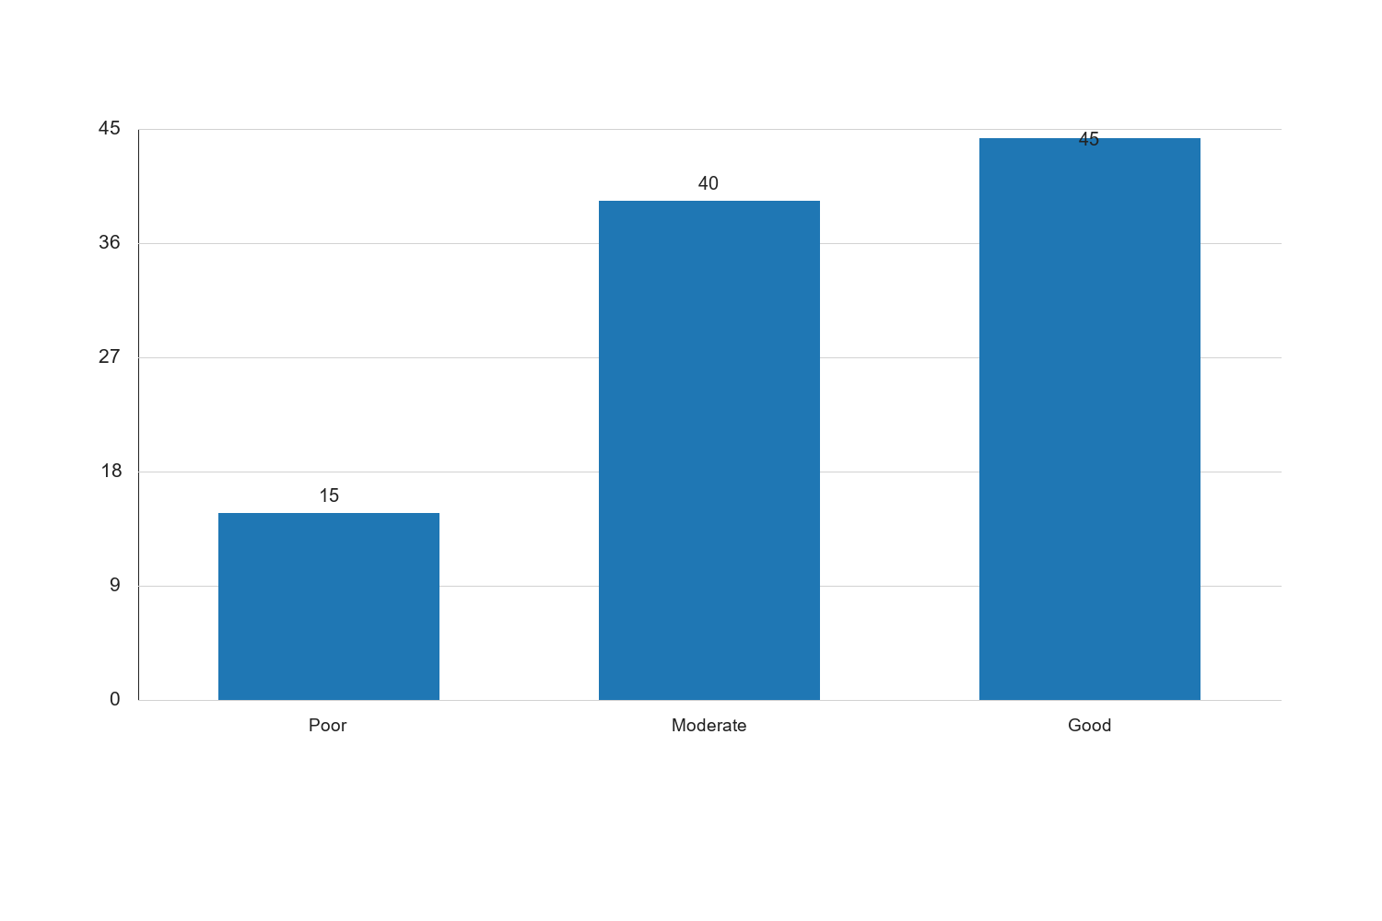
Figure 4.2: Internet Access Levels Among Students

Interpretation: The bar chart illustrates the distribution of internet access levels among undergraduate students. It shows that 45% of students have good internet access, while 40% have moderate access. This distribution suggests that the majority of students can access the internet to some extent, which is essential for engaging with online learning materials and participating in virtual classes. However, 15% of students report poor internet access, which may hinder their ability to fully engage with digital resources and negatively impact their academic performance. The visual representation highlights the need for universities to invest in improving internet infrastructure and providing affordable connectivity options to ensure equitable access for all students. By addressing these challenges, educational institutions can enhance students' learning experiences and contribute to improved academic outcomes.
4.44 Discussion of Findings
The findings of this study reveal significant relationships between digital literacy, internet access, e-learning platform adoption, and academic performance among undergraduate students in federal universities in North Central Nigeria. The correlation analysis indicates that digital literacy is the most influential factor, with a strong positive correlation with academic performance. This underscores the importance of equipping students with digital literacy skills to navigate digital resources and tools effectively.
Internet access also plays a crucial role in facilitating academic success, as evidenced by its positive correlation with academic performance. Reliable internet connectivity enables students to access online learning materials, participate in virtual classes, and complete assignments, thereby enhancing their academic outcomes. The study highlights the need for universities to invest in improving internet infrastructure and providing affordable connectivity options to ensure equitable access for all students.
The adoption of e-learning platforms emerges as a significant determinant of academic performance, with a positive correlation indicating that students who actively engage with e-learning platforms benefit from enhanced learning experiences. E-learning platforms provide flexible and diverse learning opportunities, enabling students to access a wide range of educational resources, collaborate with peers, and participate in interactive learning activities. The study emphasizes the importance of promoting e-learning platform adoption and providing the necessary support and resources to facilitate their effective use.
Overall, the findings of this study have important implications for educational policy and practice. They highlight the need for universities to prioritize digital literacy initiatives, invest in digital infrastructure, and integrate e-learning platforms into the academic framework to support students' academic success. By addressing the challenges identified and implementing strategies that support students' digital learning experiences, universities can create an enabling environment that fosters academic success and prepares students for the demands of the digital age.

