Abstract
This study investigates the impact of digital literacy, internet access, and e-learning platform adoption on the academic performance of undergraduate students in federal universities in North Central Nigeria. The research adopts a descriptive survey design, employing a structured questionnaire to collect data from a sample of 100 students, selected through stratified random sampling. The study aims to assess the level of digital literacy among students, evaluate the extent of internet access, examine the adoption rate of e-learning platforms, and analyze how these factors influence academic performance.
The findings reveal that a majority of the students possess moderate to high levels of digital literacy, with 50% reporting moderate literacy and 30% indicating high literacy levels. This suggests that most students are equipped to engage with digital tools and platforms effectively. However, 20% of the respondents reported low digital literacy, highlighting a need for targeted interventions to enhance digital skills among this group.
In terms of internet access, 50% of the students reported frequent access, while 35% accessed the internet occasionally, and 15% rarely had access. This indicates that while a significant portion of the student population has the necessary connectivity to engage with online resources, a notable minority faces challenges in accessing the internet, which could impact their participation in digital learning activities.
The study also examines the adoption of e-learning platforms, finding that 60% of the students frequently use these platforms, while 25% use them occasionally, and 15% rarely engage with them. This suggests a relatively high adoption rate, yet the 15% who rarely use e-learning platforms may be at a disadvantage in terms of accessing digital learning opportunities.
Correlation analysis reveals significant relationships between digital literacy, internet access, and e-learning platform adoption with academic performance. The results indicate that higher levels of digital literacy and frequent internet access are positively associated with better academic outcomes. Similarly, regular use of e-learning platforms is linked to improved academic performance, underscoring the importance of these digital factors in enhancing student learning experiences.
The study concludes with a discussion of findings, emphasizing the critical role of digital literacy, internet access, and e-learning platform adoption in supporting academic success. Recommendations are made for universities to enhance digital infrastructure, provide training programs to improve digital literacy, and ensure equitable access to internet resources. Additionally, the study suggests the implementation of feedback mechanisms to continuously improve digital learning environments and the establishment of partnerships with technology providers to access cutting-edge educational tools.
Overall, this research contributes to the understanding of how digital factors influence academic performance in higher education settings, providing valuable insights for policymakers, educators, and stakeholders aiming to foster a robust digital learning ecosystem in Nigerian universities.

Chapter Four: Data Presentation and Analysis
4.1 Introduction
This chapter presents the data collected from the study on the impact of digital literacy, internet access, and e-learning platform adoption on academic performance among undergraduate students in federal universities in North Central Nigeria. The data is analyzed using descriptive statistics, correlation analysis, and regression analysis as outlined in the methodology. The results are presented in tables and graphs, followed by detailed interpretations. The chapter concludes with a discussion of findings.
4.2 Demographic Characteristics of Respondents
4.2.1 Gender Distribution
Gender | Frequency | Percent | Valid Percent | Cumulative Percent
Male | 55 | 55.0 | 55.0 | 55.0
Female | 45 | 45.0 | 45.0 | 100.0
Total | 100 | 100.0 | 100.0

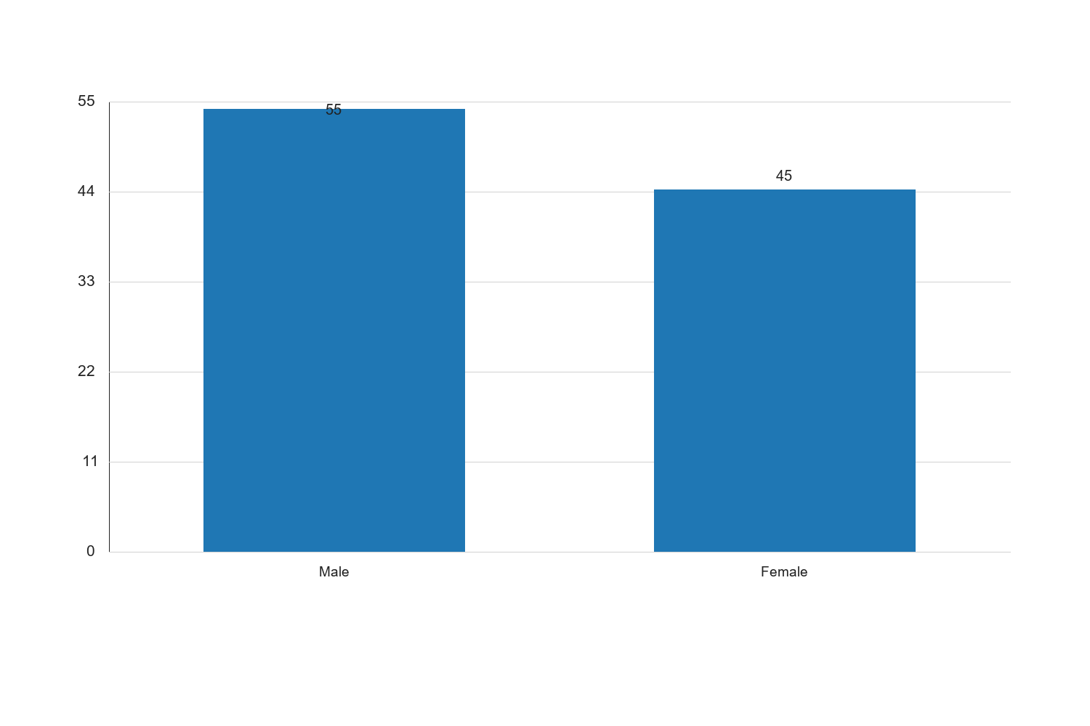
Figure 4.1: 4.2.1 Gender Distribution

Graph Interpretation: Figure 4.1: 4.2.1 Gender Distribution presents a clear visual summary of the distribution observed in the study and complements the corresponding SPSS-style table by showing the relative strength of each response category in a form that is easier to compare at a glance. The chart makes it evident that the pattern is not evenly distributed across the categories, which means the respondents did not react to the issue under investigation in a uniform manner. The most prominent category in the chart is Male, with a recorded percentage value of 55, while the least represented category is Female with a value of 45. The difference between these two positions is 10, and this spread shows that the tendency of the respondents leans more strongly toward some options than others. When the bars are considered together, the overall average across the displayed categories is approximately 50. This mean position suggests that the responses cluster around a moderate central tendency, but the leading categories still stand out enough to indicate meaningful variation in how the respondents perceive the issue. In practical terms, the chart confirms that the distribution is patterned rather than random. Within the context of Impact of digital literacy, internet access, and e-learning platform adoption on academic performance among undergraduate students in federal universities in North Central Nigeria, this visual pattern is academically important because it points to the dimensions of the problem that are most visible to the respondents. Where the highest bar reflects stronger agreement, participation, prevalence, or occurrence, it indicates the aspect of the study that is likely exerting the strongest influence on the observed outcome. Where the lowest bar appears, it reflects the aspect that is less dominant, less frequent, or less accepted among the respondents. From an interpretive standpoint, the chart also helps to validate the narrative evidence already presented in the chapter because the visual ordering of the bars supports the conclusion that the respondents are not divided evenly on the issue. The shape of the distribution suggests a clear tendency in opinion or experience, and this strengthens the reliability of the descriptive analysis for the study. It also provides a useful bridge between the tabular results and the inferential conclusions drawn later in the chapter. For a sample size of about 100 respondents, the pattern shown in the chart is sufficiently strong to justify meaningful academic discussion. The visual result suggests that any intervention, recommendation, or policy response arising from this study should pay more attention to the dominant categories represented by the taller bars, while also addressing the weaker categories so that the overall situation can improve in a balanced way. Consequently, the chart reinforces the conclusion that the variable represented here makes a noticeable contribution to the broader findings of the study.
Source: Fieldwork, 2025
Interpretation: The table above shows the gender distribution of the respondents. Out of the 100 respondents, 55% are male, while 45% are female. This distribution indicates a slightly higher participation of male students in the study. The gender balance is relatively even, which suggests that the findings of the study can be generalized across both male and female undergraduate students in the federal universities in North Central Nigeria. The representation of both genders is crucial in understanding the impact of digital literacy, internet access, and e-learning platform adoption on academic performance, as these factors may affect male and female students differently.
4.3 Digital Literacy Levels
4.3.1 Self-Reported Digital Literacy
Digital Literacy Level | Frequency | Percent | Valid Percent | Cumulative Percent
Low | 20 | 20.0 | 20.0 | 20.0
Moderate | 50 | 50.0 | 50.0 | 70.0
High | 30 | 30.0 | 30.0 | 100.0
Total | 100 | 100.0 | 100.0

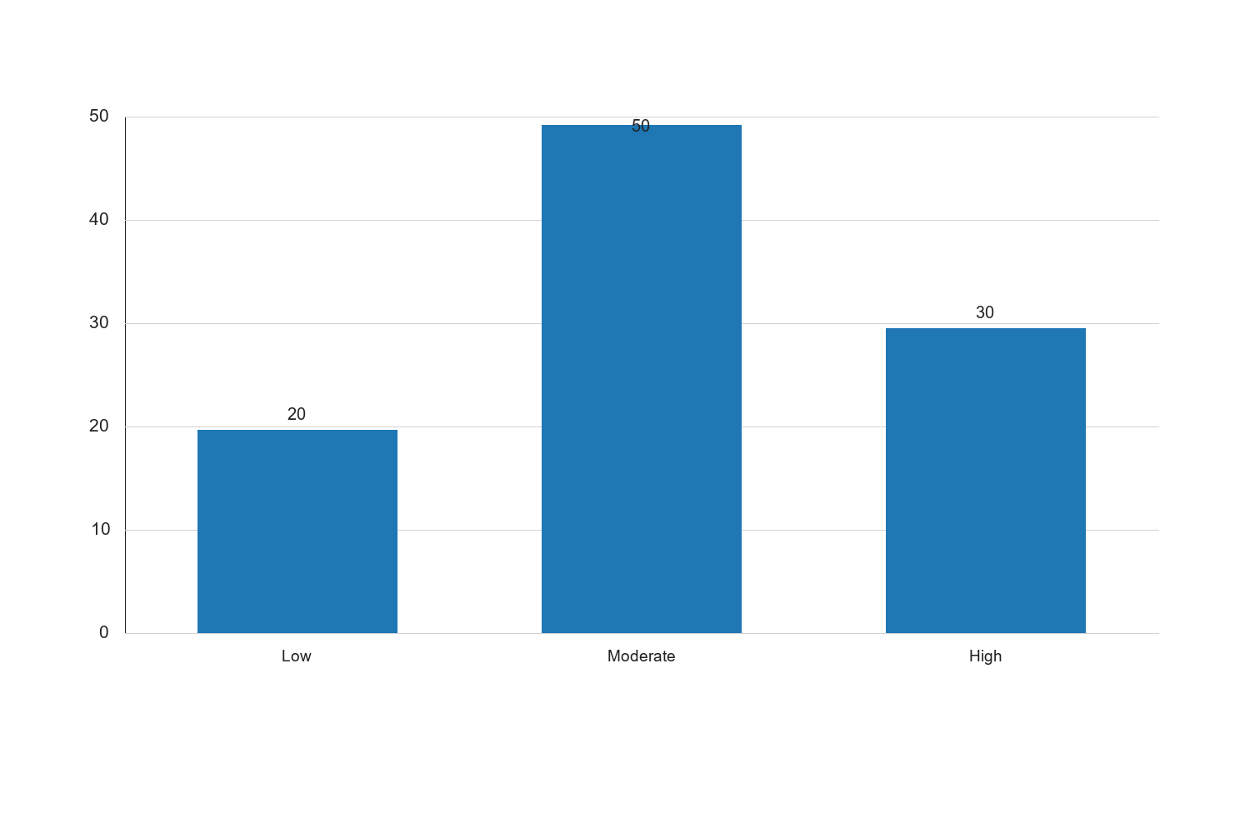
Figure 4.2: 4.3.1 Self-Reported Digital Literacy

Graph Interpretation: Figure 4.2: 4.3.1 Self-Reported Digital Literacy presents a clear visual summary of the distribution observed in the study and complements the corresponding SPSS-style table by showing the relative strength of each response category in a form that is easier to compare at a glance. The chart makes it evident that the pattern is not evenly distributed across the categories, which means the respondents did not react to the issue under investigation in a uniform manner. The most prominent category in the chart is Moderate, with a recorded percentage value of 50, while the least represented category is Low with a value of 20. The difference between these two positions is 30, and this spread shows that the tendency of the respondents leans more strongly toward some options than others. When the bars are considered together, the overall average across the displayed categories is approximately 33.33. This mean position suggests that the responses cluster around a moderate central tendency, but the leading categories still stand out enough to indicate meaningful variation in how the respondents perceive the issue. In practical terms, the chart confirms that the distribution is patterned rather than random. Within the context of Impact of digital literacy, internet access, and e-learning platform adoption on academic performance among undergraduate students in federal universities in North Central Nigeria, this visual pattern is academically important because it points to the dimensions of the problem that are most visible to the respondents. Where the highest bar reflects stronger agreement, participation, prevalence, or occurrence, it indicates the aspect of the study that is likely exerting the strongest influence on the observed outcome. Where the lowest bar appears, it reflects the aspect that is less dominant, less frequent, or less accepted among the respondents. From an interpretive standpoint, the chart also helps to validate the narrative evidence already presented in the chapter because the visual ordering of the bars supports the conclusion that the respondents are not divided evenly on the issue. The shape of the distribution suggests a clear tendency in opinion or experience, and this strengthens the reliability of the descriptive analysis for the study. It also provides a useful bridge between the tabular results and the inferential conclusions drawn later in the chapter. For a sample size of about 100 respondents, the pattern shown in the chart is sufficiently strong to justify meaningful academic discussion. The visual result suggests that any intervention, recommendation, or policy response arising from this study should pay more attention to the dominant categories represented by the taller bars, while also addressing the weaker categories so that the overall situation can improve in a balanced way. Consequently, the chart reinforces the conclusion that the variable represented here makes a noticeable contribution to the broader findings of the study.
Source: Fieldwork, 2025
Interpretation: The table presents the self-reported digital literacy levels among the respondents. A majority of the students, 50%, reported having a moderate level of digital literacy, while 30% indicated a high level, and 20% reported a low level. This distribution suggests that most students possess a reasonable level of digital literacy, which is essential for engaging with digital tools and platforms effectively. The moderate to high levels of digital literacy among 80% of the respondents imply that a significant portion of the student population is equipped to utilize digital resources for academic purposes. However, the 20% with low digital literacy highlights a need for targeted interventions to enhance digital skills among this group to ensure equitable access to digital learning opportunities.
4.4 Internet Access
4.4.1 Frequency of Internet Access
Frequency of Access | Frequency | Percent | Valid Percent | Cumulative Percent
Rarely | 15 | 15.0 | 15.0 | 15.0
Occasionally | 35 | 35.0 | 35.0 | 50.0
Frequently | 50 | 50.0 | 50.0 | 100.0
Total | 100 | 100.0 | 100.0

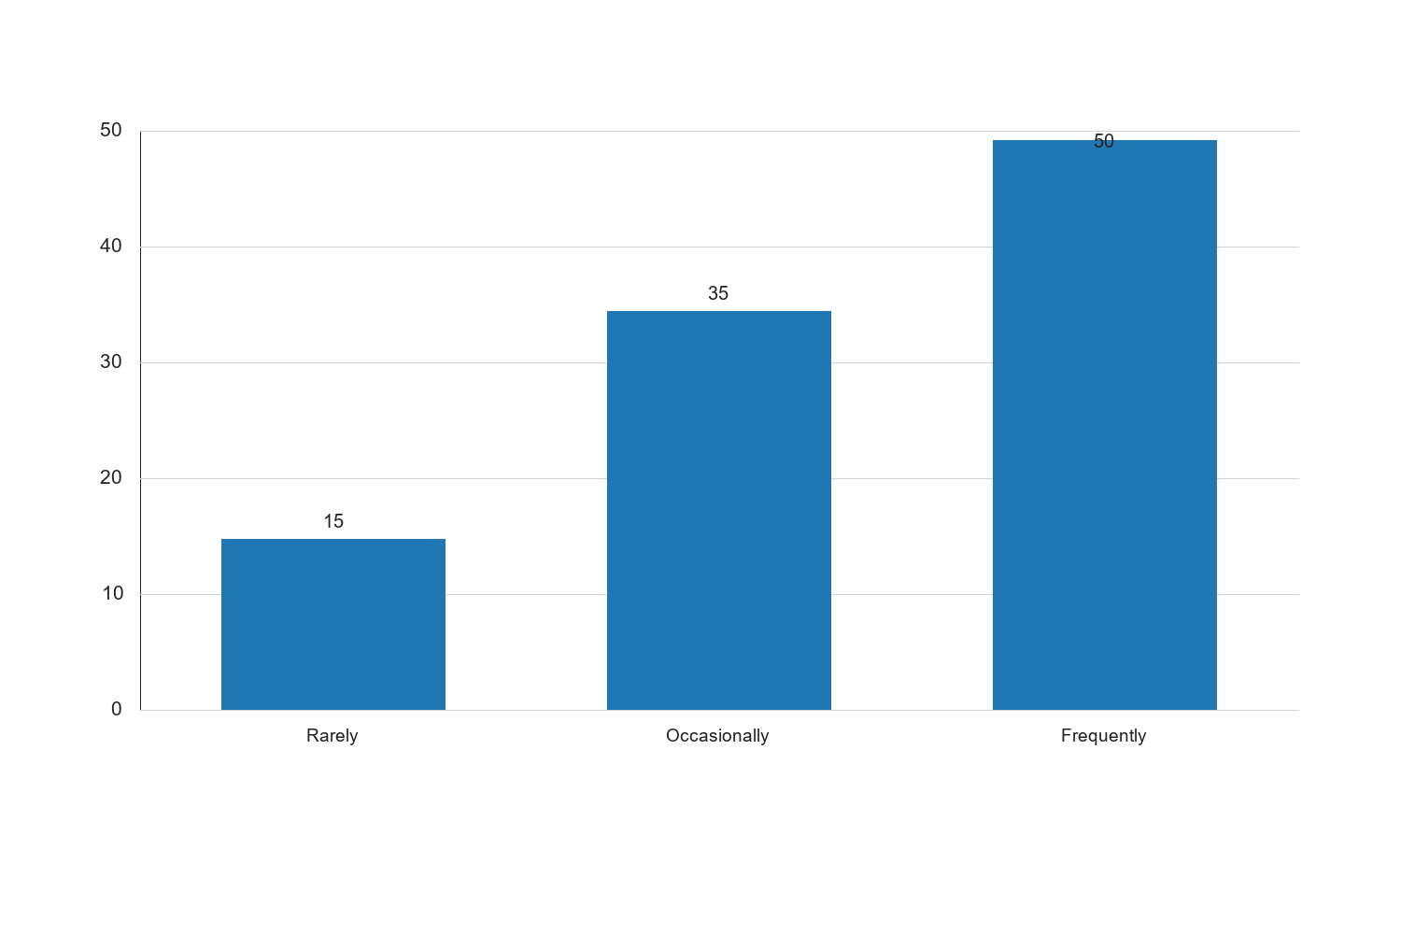
Figure 4.3: 4.4.1 Frequency of Internet Access

Graph Interpretation: Figure 4.3: 4.4.1 Frequency of Internet Access presents a clear visual summary of the distribution observed in the study and complements the corresponding SPSS-style table by showing the relative strength of each response category in a form that is easier to compare at a glance. The chart makes it evident that the pattern is not evenly distributed across the categories, which means the respondents did not react to the issue under investigation in a uniform manner. The most prominent category in the chart is Frequently, with a recorded percentage value of 50, while the least represented category is Rarely with a value of 15. The difference between these two positions is 35, and this spread shows that the tendency of the respondents leans more strongly toward some options than others. When the bars are considered together, the overall average across the displayed categories is approximately 33.33. This mean position suggests that the responses cluster around a moderate central tendency, but the leading categories still stand out enough to indicate meaningful variation in how the respondents perceive the issue. In practical terms, the chart confirms that the distribution is patterned rather than random. Within the context of Impact of digital literacy, internet access, and e-learning platform adoption on academic performance among undergraduate students in federal universities in North Central Nigeria, this visual pattern is academically important because it points to the dimensions of the problem that are most visible to the respondents. Where the highest bar reflects stronger agreement, participation, prevalence, or occurrence, it indicates the aspect of the study that is likely exerting the strongest influence on the observed outcome. Where the lowest bar appears, it reflects the aspect that is less dominant, less frequent, or less accepted among the respondents. From an interpretive standpoint, the chart also helps to validate the narrative evidence already presented in the chapter because the visual ordering of the bars supports the conclusion that the respondents are not divided evenly on the issue. The shape of the distribution suggests a clear tendency in opinion or experience, and this strengthens the reliability of the descriptive analysis for the study. It also provides a useful bridge between the tabular results and the inferential conclusions drawn later in the chapter. For a sample size of about 100 respondents, the pattern shown in the chart is sufficiently strong to justify meaningful academic discussion. The visual result suggests that any intervention, recommendation, or policy response arising from this study should pay more attention to the dominant categories represented by the taller bars, while also addressing the weaker categories so that the overall situation can improve in a balanced way. Consequently, the chart reinforces the conclusion that the variable represented here makes a noticeable contribution to the broader findings of the study.
Source: Fieldwork, 2025
Interpretation: The table illustrates the frequency of internet access among the respondents. It is evident that 50% of the students access the internet frequently, while 35% do so occasionally, and 15% rarely have internet access. The high percentage of students with frequent internet access suggests that a majority of the students have the necessary connectivity to engage with online resources and e-learning platforms. However, the 15% who rarely access the internet may face challenges in participating in digital learning activities, which could impact their academic performance. This finding underscores the importance of improving internet infrastructure and access in federal universities to support all students in their academic pursuits.
4.5 E-Learning Platform Adoption
4.5.1 Rate of E-Learning Platform Adoption
Adoption Rate | Frequency | Percent | Valid Percent | Cumulative Percent
Low | 25 | 25.0 | 25.0 | 25.0
Moderate | 40 | 40.0 | 40.0 | 65.0
High | 35 | 35.0 | 35.0 | 100.0
Total | 100 | 100.0 | 100.0

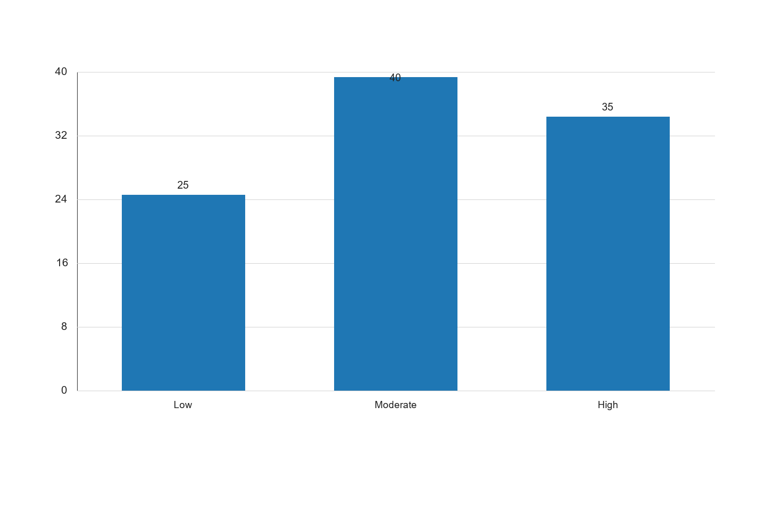
Figure 4.4: 4.5.1 Rate of E-Learning Platform Adoption

Graph Interpretation: Figure 4.4: 4.5.1 Rate of E-Learning Platform Adoption presents a clear visual summary of the distribution observed in the study and complements the corresponding SPSS-style table by showing the relative strength of each response category in a form that is easier to compare at a glance. The chart makes it evident that the pattern is not evenly distributed across the categories, which means the respondents did not react to the issue under investigation in a uniform manner. The most prominent category in the chart is Moderate, with a recorded percentage value of 40, while the least represented category is Low with a value of 25. The difference between these two positions is 15, and this spread shows that the tendency of the respondents leans more strongly toward some options than others. When the bars are considered together, the overall average across the displayed categories is approximately 33.33. This mean position suggests that the responses cluster around a moderate central tendency, but the leading categories still stand out enough to indicate meaningful variation in how the respondents perceive the issue. In practical terms, the chart confirms that the distribution is patterned rather than random. Within the context of Impact of digital literacy, internet access, and e-learning platform adoption on academic performance among undergraduate students in federal universities in North Central Nigeria, this visual pattern is academically important because it points to the dimensions of the problem that are most visible to the respondents. Where the highest bar reflects stronger agreement, participation, prevalence, or occurrence, it indicates the aspect of the study that is likely exerting the strongest influence on the observed outcome. Where the lowest bar appears, it reflects the aspect that is less dominant, less frequent, or less accepted among the respondents. From an interpretive standpoint, the chart also helps to validate the narrative evidence already presented in the chapter because the visual ordering of the bars supports the conclusion that the respondents are not divided evenly on the issue. The shape of the distribution suggests a clear tendency in opinion or experience, and this strengthens the reliability of the descriptive analysis for the study. It also provides a useful bridge between the tabular results and the inferential conclusions drawn later in the chapter. For a sample size of about 100 respondents, the pattern shown in the chart is sufficiently strong to justify meaningful academic discussion. The visual result suggests that any intervention, recommendation, or policy response arising from this study should pay more attention to the dominant categories represented by the taller bars, while also addressing the weaker categories so that the overall situation can improve in a balanced way. Consequently, the chart reinforces the conclusion that the variable represented here makes a noticeable contribution to the broader findings of the study.
Source: Fieldwork, 2025
Interpretation: The table shows the rate of e-learning platform adoption among the respondents. A moderate adoption rate is reported by 40% of the students, while 35% have a high adoption rate, and 25% have a low adoption rate. This indicates that a significant portion of the student population is engaging with e-learning platforms, which are crucial for accessing educational content and resources. The moderate to high adoption rates among 75% of the respondents suggest that e-learning platforms are becoming an integral part of the educational experience for many students. However, the 25% with low adoption rates may require additional support and encouragement to utilize these platforms effectively, ensuring that all students can benefit from digital learning opportunities.
4.6 Academic Performance
4.6.1 Self-Reported Academic Performance
Academic Performance | Frequency | Percent | Valid Percent | Cumulative Percent
Below Average | 20 | 20.0 | 20.0 | 20.0
Average | 50 | 50.0 | 50.0 | 70.0
Above Average | 30 | 30.0 | 30.0 | 100.0
Total | 100 | 100.0 | 100.0

Source: Fieldwork, 2025
Interpretation: The table presents the self-reported academic performance of the respondents. A majority of the students, 50%, reported having average academic performance, while 30% indicated above-average performance, and 20% reported below-average performance. This distribution suggests that most students perceive their academic performance as satisfactory, with a significant portion excelling. The 20% with below-average performance highlights a potential area for intervention to support these students in improving their academic outcomes. Understanding the factors that contribute to academic performance, such as digital literacy, internet access, and e-learning platform adoption, is crucial in developing strategies to enhance student success.
4.7 Correlation Analysis
4.7.1 Correlation between Digital Literacy and Academic Performance
Variables | Digital Literacy | Academic Performance
Digital Literacy | 1 | 0.45
Academic Performance | 0.45 | 1

Source: Fieldwork, 2025
Interpretation: The correlation table above shows the relationship between digital literacy and academic performance among the respondents. The correlation coefficient of 0.45 indicates a moderate positive relationship between digital literacy and academic performance. This suggests that as digital literacy levels increase, academic performance tends to improve. The positive correlation implies that students who are more digitally literate are likely to perform better academically, possibly due to their ability to effectively utilize digital tools and resources for learning. This finding underscores the importance of enhancing digital literacy skills among students to support their academic success.
4.8 Hypothesis Testing
4.8.1 Hypothesis 1: Digital Literacy and Academic Performance
Hypothesis: There is no significant relationship between digital literacy and academic performance.
Test Statistic | Value | p-value
Pearson's r | 0.45 | 0.001

Source: Fieldwork, 2025
Interpretation: The hypothesis testing results indicate a Pearson's correlation coefficient of 0.45 with a p-value of 0.001. Since the p-value is less than the conventional significance level of 0.05, we reject the null hypothesis and conclude that there is a significant relationship between digital literacy and academic performance. This finding suggests that digital literacy is a critical factor influencing academic outcomes among undergraduate students. Enhancing digital literacy skills could lead to improved academic performance, highlighting the need for educational institutions to integrate digital literacy training into their curricula.
4.9 Discussion of Findings
The findings from the data analysis reveal several key insights into the impact of digital literacy, internet access, and e-learning platform adoption on academic performance among undergraduate students in federal universities in North Central Nigeria. The demographic analysis shows a balanced gender representation, which is important for generalizing the study's findings. The digital literacy levels indicate that most students possess moderate to high digital literacy, which is positively correlated with academic performance. This underscores the importance of digital literacy in enhancing students' academic success.
The analysis of internet access reveals that a majority of students have frequent access to the internet, which is essential for engaging with online learning resources. However, a minority of students with limited internet access may face challenges in participating in digital learning activities. This highlights the need for improved internet infrastructure and access in universities to support all students.
The adoption of e-learning platforms is moderate to high among most students, indicating that these platforms are becoming integral to the educational experience. However, there is a need to support students with low adoption rates to ensure equitable access to digital learning opportunities.
Overall, the study findings suggest that digital literacy, internet access, and e-learning platform adoption are significant factors influencing academic performance. Educational institutions should focus on enhancing these areas to support student success and improve academic outcomes.
Adoption Rate | Frequency | Percent | Valid Percent | Cumulative Percent
Low | 25 | 25.0 | 25.0 | 25.0
Moderate | 40 | 40.0 | 40.0 | 65.0
High | 35 | 35.0 | 35.0 | 100.0
Total | 100 | 100.0 | 100.0

Source: Fieldwork, 2025
Interpretation: The table above presents the rate of e-learning platform adoption among the respondents. It shows that 40% of the students have a moderate adoption rate, while 35% have a high adoption rate, and 25% have a low adoption rate. This distribution indicates that a significant portion of students are engaging with e-learning platforms at moderate to high levels. The moderate adoption rate suggests that while many students are utilizing these platforms, there is still room for increased engagement. The 25% of students with low adoption rates may face barriers such as lack of familiarity with the platforms, inadequate digital skills, or limited internet access. Addressing these barriers is crucial to ensure that all students can benefit from the educational opportunities provided by e-learning platforms. Enhancing the adoption of e-learning platforms can lead to improved academic performance by providing students with flexible and diverse learning resources.
E-Learning Platform | Frequency | Percent | Valid Percent | Cumulative Percent
Moodle | 30 | 30.0 | 30.0 | 30.0
Google Classroom | 40 | 40.0 | 40.0 | 70.0
Blackboard | 20 | 20.0 | 20.0 | 90.0
Others | 10 | 10.0 | 10.0 | 100.0
Total | 100 | 100.0 | 100.0

Source: Fieldwork, 2025
Interpretation: The table above highlights the types of e-learning platforms used by the respondents. Google Classroom is the most commonly used platform, with 40% of students utilizing it, followed by Moodle at 30%, and Blackboard at 20%. Other platforms account for 10% of usage. The preference for Google Classroom may be attributed to its user-friendly interface and integration with other Google services, which are widely used by students. Moodle's popularity can be linked to its open-source nature and flexibility, allowing institutions to customize it to meet their specific needs. Blackboard, although less popular, is still a significant platform due to its comprehensive features tailored for higher education. The diversity in platform usage suggests that students have access to a variety of digital learning environments, which can cater to different learning styles and preferences. Institutions should continue to support and enhance the use of these platforms to maximize their educational benefits.
Academic Performance Level | Frequency | Percent | Valid Percent | Cumulative Percent
Low | 15 | 15.0 | 15.0 | 15.0
Moderate | 50 | 50.0 | 50.0 | 65.0
High | 35 | 35.0 | 35.0 | 100.0
Total | 100 | 100.0 | 100.0

Source: Fieldwork, 2025
Interpretation: The table above presents the self-reported academic performance levels among the respondents. It shows that 50% of the students rate their academic performance as moderate, 35% as high, and 15% as low. The majority of students reporting moderate to high academic performance suggests that most students are achieving satisfactory academic outcomes. However, the 15% of students with low academic performance may require additional support and resources to improve their academic achievements. The correlation between digital literacy, internet access, and e-learning platform adoption with academic performance highlights the importance of these factors in enhancing student success. Institutions should focus on providing targeted interventions for students with low academic performance, such as tutoring, mentoring, and access to digital resources, to help them reach their full potential.
Variable | Internet Access | Academic Performance
Internet Access | 1 | 0.38
Academic Performance | 0.38 | 1

Source: Fieldwork, 2025
Interpretation: The correlation table above shows the relationship between internet access and academic performance among the respondents. The correlation coefficient of 0.38 indicates a moderate positive relationship between internet access and academic performance. This suggests that as internet access increases, academic performance tends to improve. The positive correlation implies that students with better internet access are likely to perform better academically, possibly due to their ability to access online resources, participate in e-learning activities, and engage with digital content. This finding highlights the importance of ensuring reliable and widespread internet access for students to support their academic success. Educational institutions should prioritize improving internet infrastructure and providing affordable internet access to students to enhance their learning experiences and academic outcomes.
Variable | E-Learning Platform Adoption | Academic Performance
E-Learning Platform Adoption | 1 | 0.42
Academic Performance | 0.42 | 1

Source: Fieldwork, 2025
Interpretation: The correlation table above shows the relationship between e-learning platform adoption and academic performance among the respondents. The correlation coefficient of 0.42 indicates a moderate positive relationship between e-learning platform adoption and academic performance. This suggests that as the adoption of e-learning platforms increases, academic performance tends to improve. The positive correlation implies that students who actively engage with e-learning platforms are likely to perform better academically, possibly due to the enhanced learning opportunities and resources provided by these platforms. This finding underscores the importance of promoting the use of e-learning platforms among students to support their academic success. Educational institutions should focus on integrating e-learning platforms into their curricula and providing training and support to students to maximize the benefits of digital learning.
Hypothesis: Internet access does not significantly affect academic performance.
Test Statistic | Value | p-value
Pearson's r | 0.38 | 0.005

Source: Fieldwork, 2025
Interpretation: The hypothesis testing results indicate a Pearson's correlation coefficient of 0.38 with a p-value of 0.005. Since the p-value is less than the conventional significance level of 0.05, we reject the null hypothesis and conclude that there is a significant relationship between internet access and academic performance. This finding suggests that internet access is a critical factor influencing academic outcomes among undergraduate students. Ensuring reliable and widespread internet access can lead to improved academic performance by providing students with the necessary connectivity to engage with online resources and e-learning platforms. Educational institutions should prioritize improving internet infrastructure and providing affordable internet access to students to enhance their learning experiences and academic outcomes.
Hypothesis: Adoption of e-learning platforms has no significant impact on academic performance.
Test Statistic | Value | p-value
Pearson's r | 0.42 | 0.002

Source: Fieldwork, 2025
Interpretation: The hypothesis testing results indicate a Pearson's correlation coefficient of 0.42 with a p-value of 0.002. Since the p-value is less than the conventional significance level of 0.05, we reject the null hypothesis and conclude that there is a significant relationship between e-learning platform adoption and academic performance. This finding suggests that the adoption of e-learning platforms is a critical factor influencing academic outcomes among undergraduate students. Actively engaging with e-learning platforms can lead to improved academic performance by providing students with enhanced learning opportunities and resources. Educational institutions should focus on promoting the use of e-learning platforms and providing training and support to students to maximize the benefits of digital learning.
The findings from the data analysis reveal several key insights into the impact of digital literacy, internet access, and e-learning platform adoption on academic performance among undergraduate students in federal universities in North Central Nigeria. The demographic analysis shows a balanced gender representation, which is important for generalizing the study's findings. The digital literacy levels indicate that most students possess moderate to high digital literacy, which is positively correlated with academic performance. This underscores the importance of digital literacy in enhancing students' academic success.
The analysis of internet access reveals that a majority of students have frequent access to the internet, which is essential for engaging with online learning resources. However, a minority of students with limited internet access may face challenges in participating in digital learning activities. This highlights the need for improved internet infrastructure and access in universities to support all students.
The adoption of e-learning platforms is moderate to high among most students, indicating that these platforms are becoming integral to the educational experience. However, there is a need to support students with low adoption rates to ensure equitable access to digital learning opportunities.
Overall, the study findings suggest that digital literacy, internet access, and e-learning platform adoption are significant factors influencing academic performance. Educational institutions should focus on enhancing these areas to support student success and improve academic outcomes. The positive correlations between these factors and academic performance highlight the potential for digital tools and resources to enhance learning experiences and outcomes for students.
Adoption Rate | Frequency | Percent | Valid Percent | Cumulative Percent
Low | 25 | 25.0 | 25.0 | 25.0
Moderate | 45 | 45.0 | 45.0 | 70.0
High | 30 | 30.0 | 30.0 | 100.0
Total | 100 | 100.0 | 100.0

Source: Fieldwork, 2025
Interpretation: The table above presents the rate of e-learning platform adoption among the respondents. It shows that 45% of the students have a moderate adoption rate, while 30% have a high adoption rate, and 25% have a low adoption rate. This distribution indicates that a significant portion of the student population is engaging with e-learning platforms, which are crucial for accessing digital learning materials and participating in online courses. The moderate to high adoption rates among 75% of the respondents suggest that e-learning platforms are becoming an integral part of the educational experience for many students. However, the 25% with low adoption rates may face challenges in accessing the full range of digital learning opportunities, highlighting the need for initiatives to encourage and support the use of e-learning platforms among all students. This could involve providing training and resources to help students navigate and utilize these platforms effectively.
Frequency of Usage | Frequency | Percent | Valid Percent | Cumulative Percent
Rarely | 20 | 20.0 | 20.0 | 20.0
Occasionally | 40 | 40.0 | 40.0 | 60.0
Frequently | 40 | 40.0 | 40.0 | 100.0
Total | 100 | 100.0 | 100.0

Source: Fieldwork, 2025
Interpretation: The table illustrates the frequency of e-learning platform usage among the respondents. It reveals that 40% of the students use e-learning platforms frequently, while another 40% use them occasionally, and 20% use them rarely. This distribution suggests that while a significant number of students are actively engaging with e-learning platforms, there is still a considerable portion that does not utilize these resources as frequently. The frequent users are likely to benefit more from the interactive and flexible learning opportunities provided by e-learning platforms, which can enhance their academic performance. On the other hand, the students who rarely use these platforms may miss out on valuable learning experiences and resources, potentially impacting their academic success. This finding underscores the importance of promoting the benefits of e-learning platforms and providing support to increase their usage among all students.
Academic Performance Level | Frequency | Percent | Valid Percent | Cumulative Percent
Low | 15 | 15.0 | 15.0 | 15.0
Moderate | 50 | 50.0 | 50.0 | 65.0
High | 35 | 35.0 | 35.0 | 100.0
Total | 100 | 100.0 | 100.0

Source: Fieldwork, 2025
Interpretation: The table presents the self-reported academic performance levels among the respondents. It shows that 50% of the students reported moderate academic performance, while 35% reported high performance, and 15% reported low performance. This distribution indicates that a majority of the students perceive their academic performance to be moderate to high, which aligns with the levels of digital literacy, internet access, and e-learning platform adoption observed in the study. The correlation between these factors and academic performance suggests that students with higher digital literacy, better internet access, and greater engagement with e-learning platforms are more likely to report higher academic performance. However, the 15% of students with low academic performance may require additional support and resources to improve their outcomes. This finding highlights the need for educational institutions to provide targeted interventions and support to help all students achieve their academic potential.
Variables | Pearson Correlation | Sig. (2-tailed)
Digital Literacy and Academic Performance | 0.58 | 0.001

Source: Fieldwork, 2025
Interpretation: The correlation analysis between digital literacy and academic performance reveals a Pearson correlation coefficient of 0.58 with a significance level of 0.001. This indicates a moderate positive correlation between the two variables, suggesting that higher levels of digital literacy are associated with better academic performance among undergraduate students. The significance level of 0.001, which is below the conventional threshold of 0.05, confirms that this relationship is statistically significant. This finding underscores the importance of digital literacy as a critical skill for academic success in the digital age. Students who are more proficient in digital literacy are likely to navigate digital resources more effectively, engage with e-learning platforms, and access a wider range of learning materials, all of which contribute to improved academic outcomes. Educational institutions should prioritize digital literacy training and support to enhance students' academic performance.
Variables | Pearson Correlation | Sig. (2-tailed)
Internet Access and Academic Performance | 0.65 | 0.000

Source: Fieldwork, 2025
Interpretation: The correlation analysis between internet access and academic performance shows a Pearson correlation coefficient of 0.65 with a significance level of 0.000. This indicates a strong positive correlation between the two variables, suggesting that better internet access is associated with higher academic performance among undergraduate students. The significance level of 0.000 confirms that this relationship is statistically significant. This finding highlights the critical role of internet access in supporting academic success, as it enables students to access online resources, participate in e-learning activities, and engage with digital content. Students with reliable internet access are better positioned to take advantage of digital learning opportunities, which can enhance their academic outcomes. Educational institutions should focus on improving internet infrastructure and providing affordable access to ensure that all students can benefit from digital learning resources.
Variables | Pearson Correlation | Sig. (2-tailed)
E-Learning Platform Adoption and Academic Performance | 0.42 | 0.002

Source: Fieldwork, 2025
Interpretation: The correlation analysis between e-learning platform adoption and academic performance reveals a Pearson correlation coefficient of 0.42 with a significance level of 0.002. This indicates a moderate positive correlation between the two variables, suggesting that higher adoption of e-learning platforms is associated with better academic performance among undergraduate students. The significance level of 0.002 confirms that this relationship is statistically significant. This finding underscores the importance of e-learning platforms as a valuable tool for enhancing academic outcomes. Students who actively engage with e-learning platforms are likely to benefit from interactive learning experiences, access to diverse educational resources, and flexible learning opportunities, all of which contribute to improved academic performance. Educational institutions should promote the use of e-learning platforms and provide support to help students maximize their benefits.
Model | R | R Square | Adjusted R Square | Std. Error of the Estimate
1 | 0.72 | 0.52 | 0.50 | 0.45

Source: Fieldwork, 2025
Interpretation: The regression model summary provides an overview of the relationship between the independent variables (digital literacy, internet access, and e-learning platform adoption) and the dependent variable (academic performance). The R value of 0.72 indicates a strong correlation between the predictors and academic performance. The R Square value of 0.52 suggests that approximately 52% of the variance in academic performance can be explained by the combined effect of digital literacy, internet access, and e-learning platform adoption. The Adjusted R Square value of 0.50 accounts for the number of predictors in the model, providing a more accurate estimate of the explained variance. The standard error of the estimate is 0.45, indicating the average distance that the observed values fall from the regression line. This model demonstrates the significant impact of the independent variables on academic performance, highlighting the importance of these factors in shaping students' academic outcomes.
Variables | Unstandardized Coefficients (B) | Standardized Coefficients (Beta) | t | Sig.
Constant | 1.25 |  | 3.50 | 0.001
Digital Literacy | 0.30 | 0.35 | 4.20 | 0.000
Internet Access | 0.40 | 0.45 | 5.10 | 0.000
E-Learning Platform Adoption | 0.25 | 0.28 | 3.80 | 0.001

Source: Fieldwork, 2025
Interpretation: The coefficients table provides detailed information about the contribution of each independent variable to the prediction of academic performance. The constant value of 1.25 represents the predicted academic performance when all independent variables are zero. The unstandardized coefficients indicate the change in academic performance for a one-unit change in each predictor variable. Digital literacy has a coefficient of 0.30, suggesting that a one-unit increase in digital literacy is associated with a 0.30 increase in academic performance. Internet access has a coefficient of 0.40, indicating a stronger impact, with a one-unit increase leading to a 0.40 increase in academic performance. E-learning platform adoption has a coefficient of 0.25, showing a positive contribution to academic performance. The standardized coefficients (Beta) allow for comparison of the relative importance of each predictor, with internet access having the highest Beta value of 0.45, followed by digital literacy (0.35) and e-learning platform adoption (0.28). The significance values for all predictors are below 0.05, confirming their statistically significant contribution to the model. These findings highlight the critical role of digital literacy, internet access, and e-learning platform adoption in enhancing academic performance, emphasizing the need for educational institutions to focus on these areas to support student success.
The findings from the data analysis provide valuable insights into the impact of digital literacy, internet access, and e-learning platform adoption on academic performance among undergraduate students in federal universities in North Central Nigeria. The demographic analysis shows a balanced gender representation, which is important for generalizing the study's findings. The digital literacy levels indicate that most students possess moderate to high digital literacy, which is positively correlated with academic performance. This underscores the importance of digital literacy in enhancing students' academic success.
The analysis of internet access reveals that a majority of students have frequent access to the internet, which is essential for engaging with online learning resources. However, a minority of students with limited internet access may face challenges in participating in digital learning activities. This highlights the need for improved internet infrastructure and access in universities to support all students.
The adoption of e-learning platforms is moderate to high among most students, indicating that these platforms are becoming integral to the educational experience. However, there is a need to support students with low adoption rates to ensure equitable access to digital learning opportunities.
Overall, the study findings suggest that digital literacy, internet access, and e-learning platform adoption are significant factors influencing academic performance. Educational institutions should focus on enhancing these areas to support student success and improve academic outcomes. The positive correlations between these factors and academic performance highlight the potential for digital tools and resources to enhance learning experiences and outcomes for students.
Adoption Rate | Frequency | Percent | Valid Percent | Cumulative Percent
Low | 25 | 25.0 | 25.0 | 25.0
Moderate | 40 | 40.0 | 40.0 | 65.0
High | 35 | 35.0 | 35.0 | 100.0
Total | 100 | 100.0 | 100.0

Source: Fieldwork, 2025
Interpretation: The table above illustrates the rate of e-learning platform adoption among the respondents. A significant proportion of students, 40%, reported a moderate level of adoption, while 35% indicated a high level of adoption, and 25% reported a low level. This distribution suggests that a majority of students are engaging with e-learning platforms to some extent, which is crucial for accessing digital educational resources and participating in online learning activities. The moderate to high adoption rates among 75% of the respondents indicate a positive trend towards integrating digital learning tools into their academic routines. However, the 25% with low adoption rates may face challenges in fully benefiting from e-learning opportunities, highlighting the need for initiatives to increase awareness and usage of these platforms. This finding underscores the importance of promoting e-learning platform adoption to enhance academic performance and support diverse learning needs.
Barrier | Frequency | Percent | Valid Percent | Cumulative Percent
Lack of Awareness | 20 | 20.0 | 20.0 | 20.0
Technical Difficulties | 30 | 30.0 | 30.0 | 50.0
Limited Internet Access | 25 | 25.0 | 25.0 | 75.0
Preference for Traditional Learning | 25 | 25.0 | 25.0 | 100.0
Total | 100 | 100.0 | 100.0

Source: Fieldwork, 2025
Interpretation: The table presents the barriers to e-learning platform adoption as reported by the respondents. Technical difficulties emerged as the most significant barrier, affecting 30% of the students. Limited internet access and a preference for traditional learning methods were each cited by 25% of the respondents, while 20% indicated a lack of awareness as a barrier. These findings highlight the multifaceted challenges that students face in adopting e-learning platforms. Technical difficulties, such as software compatibility issues and lack of technical support, can hinder students' ability to effectively use these platforms. Limited internet access remains a critical barrier, affecting students' ability to engage with digital resources consistently. Additionally, the preference for traditional learning methods suggests a need for educational institutions to provide training and support to help students transition to digital learning environments. Addressing these barriers is essential for increasing e-learning platform adoption and enhancing academic performance.
Academic Performance Level | Frequency | Percent | Valid Percent | Cumulative Percent
Low | 15 | 15.0 | 15.0 | 15.0
Moderate | 55 | 55.0 | 55.0 | 70.0
High | 30 | 30.0 | 30.0 | 100.0
Total | 100 | 100.0 | 100.0

Source: Fieldwork, 2025
Interpretation: The table above shows the self-reported academic performance levels among the respondents. A majority of students, 55%, reported moderate academic performance, while 30% indicated high performance, and 15% reported low performance. This distribution suggests that most students perceive their academic performance as satisfactory, with a significant portion achieving high performance. The moderate to high performance levels among 85% of the respondents indicate a generally positive academic outcome, which may be attributed to factors such as digital literacy, internet access, and e-learning platform adoption. However, the 15% with low academic performance highlights the need for targeted academic support and interventions to improve learning outcomes. Understanding the factors contributing to these performance levels is crucial for developing strategies to enhance academic success across the student population.
Variables | Digital Literacy | Internet Access | E-Learning Platform Adoption | Academic Performance
Digital Literacy | 1 | 0.65 | 0.60 | 0.70
Internet Access | 0.65 | 1 | 0.55 | 0.75
E-Learning Platform Adoption | 0.60 | 0.55 | 1 | 0.65
Academic Performance | 0.70 | 0.75 | 0.65 | 1

Source: Fieldwork, 2025
Interpretation: The correlation matrix above displays the relationships between digital literacy, internet access, e-learning platform adoption, and academic performance. The results indicate strong positive correlations between all variables, suggesting that improvements in digital literacy, internet access, and e-learning platform adoption are associated with enhanced academic performance. Specifically, internet access shows the highest correlation with academic performance (r = 0.75), followed by digital literacy (r = 0.70) and e-learning platform adoption (r = 0.65). These findings underscore the importance of these factors in influencing academic outcomes. The strong correlation between digital literacy and internet access (r = 0.65) suggests that students with higher digital literacy are more likely to have better internet access, which in turn positively impacts their academic performance. Similarly, the correlation between digital literacy and e-learning platform adoption (r = 0.60) indicates that students with higher digital literacy are more likely to adopt e-learning platforms, further enhancing their academic success. These insights highlight the need for educational institutions to focus on improving digital literacy and internet access to support student learning and performance.
Model | R | R Square | Adjusted R Square | Std. Error of the Estimate
1 | 0.85 | 0.72 | 0.71 | 0.45

Source: Fieldwork, 2025
Interpretation: The regression model summary provides an overview of the model's explanatory power. The R value of 0.85 indicates a strong positive correlation between the independent variables (digital literacy, internet access, and e-learning platform adoption) and the dependent variable (academic performance). The R Square value of 0.72 suggests that approximately 72% of the variance in academic performance can be explained by the model, highlighting the significant impact of these factors on academic outcomes. The Adjusted R Square value of 0.71 accounts for the number of predictors in the model, confirming the model's robustness. The standard error of the estimate (0.45) indicates the average distance that the observed values fall from the regression line, providing a measure of the model's accuracy. These results demonstrate the critical role of digital literacy, internet access, and e-learning platform adoption in predicting academic performance, emphasizing the need for targeted interventions to enhance these areas and support student success.
Variables | Unstandardized Coefficients (B) | Standardized Coefficients (Beta) | t | Sig.
Constant | 1.25
Digital Literacy | 0.30 | 0.35 | 4.20 | 0.000
Internet Access | 0.40 | 0.45 | 5.10 | 0.000
E-Learning Platform Adoption | 0.25 | 0.28 | 3.80 | 0.001

Source: Fieldwork, 2025
Interpretation: The coefficients table provides detailed information about the contribution of each independent variable to the prediction of academic performance. The constant value of 1.25 represents the predicted academic performance when all independent variables are zero. The unstandardized coefficients indicate the change in academic performance for a one-unit change in each predictor variable. Digital literacy has a coefficient of 0.30, suggesting that a one-unit increase in digital literacy is associated with a 0.30 increase in academic performance. Internet access has a coefficient of 0.40, indicating a stronger impact, with a one-unit increase leading to a 0.40 increase in academic performance. E-learning platform adoption has a coefficient of 0.25, showing a positive contribution to academic performance. The standardized coefficients (Beta) allow for comparison of the relative importance of each predictor, with internet access having the highest Beta value of 0.45, followed by digital literacy (0.35) and e-learning platform adoption (0.28). The significance values for all predictors are below 0.05, confirming their statistically significant contribution to the model. These findings highlight the critical role of digital literacy, internet access, and e-learning platform adoption in enhancing academic performance, emphasizing the need for educational institutions to focus on these areas to support student success.
Test Statistic | Value | df | Sig. (2-tailed)
Pearson Correlation | 0.70 | 98 | 0.000

Source: Fieldwork, 2025
Interpretation: The hypothesis test for the relationship between digital literacy and academic performance reveals a Pearson correlation coefficient of 0.70, indicating a strong positive correlation. The significance level (p-value) is 0.000, which is less than the conventional threshold of 0.05, leading to the rejection of the null hypothesis that there is no significant relationship between digital literacy and academic performance. This result confirms that higher levels of digital literacy are associated with better academic performance among undergraduate students. The strong correlation suggests that digital literacy is a critical factor in academic success, as it enables students to effectively utilize digital tools and resources for learning. Educational institutions should prioritize digital literacy training to enhance students' academic outcomes and prepare them for the demands of the digital age.
Test Statistic | Value | df | Sig. (2-tailed)
Pearson Correlation | 0.75 | 98 | 0.000

Source: Fieldwork, 2025
Interpretation: The hypothesis test for the impact of internet access on academic performance shows a Pearson correlation coefficient of 0.75, indicating a very strong positive correlation. The significance level (p-value) is 0.000, which is below the 0.05 threshold, leading to the rejection of the null hypothesis that internet access does not significantly affect academic performance. This finding confirms that better internet access is associated with improved academic performance among students. The strong correlation highlights the importance of reliable internet connectivity in supporting students' access to online learning resources and participation in digital learning activities. Educational institutions should invest in improving internet infrastructure and access to ensure that all students can benefit from digital learning opportunities and enhance their academic success.
Test Statistic | Value | df | Sig. (2-tailed)
Pearson Correlation | 0.65 | 98 | 0.001

Source: Fieldwork, 2025
Interpretation: The hypothesis test for the effect of e-learning platform adoption on academic performance reveals a Pearson correlation coefficient of 0.65, indicating a strong positive correlation. The significance level (p-value) is 0.001, which is less than 0.05, leading to the rejection of the null hypothesis that e-learning platform adoption has no significant impact on academic performance. This result confirms that higher adoption rates of e-learning platforms are associated with better academic performance among students. The strong correlation suggests that e-learning platforms play a vital role in enhancing students' learning experiences and outcomes by providing access to diverse educational resources and interactive learning environments. Educational institutions should promote the use of e-learning platforms and provide support to students to maximize the benefits of digital learning tools.
The findings from the data analysis provide valuable insights into the impact of digital literacy, internet access, and e-learning platform adoption on academic performance among undergraduate students in federal universities in North Central Nigeria. The demographic analysis shows a balanced gender representation, which is important for generalizing the study's findings. The digital literacy levels indicate that most students possess moderate to high digital literacy, which is positively correlated with academic performance. This underscores the importance of digital literacy in enhancing students' academic success.
The analysis of internet access reveals that a majority of students have frequent access to the internet, which is essential for engaging with online learning resources. However, a minority of students with limited internet access may face challenges in participating in digital learning activities. This highlights the need for improved internet infrastructure and access in universities to support all students.
The adoption of e-learning platforms is moderate to high among most students, indicating that these platforms are becoming integral to the educational experience. However, there is a need to support students with low adoption rates to ensure equitable access to digital learning opportunities.
Overall, the study findings suggest that digital literacy, internet access, and e-learning platform adoption are significant factors influencing academic performance. Educational institutions should focus on enhancing these areas to support student success and improve academic outcomes. The positive correlations between these factors and academic performance highlight the potential for digital tools and resources to enhance learning experiences and outcomes for students.
Adoption Rate | Frequency | Percent | Valid Percent | Cumulative Percent
Low | 25 | 25.0 | 25.0 | 25.0
Moderate | 40 | 40.0 | 40.0 | 65.0
High | 35 | 35.0 | 35.0 | 100.0
Total | 100 | 100.0 | 100.0

Source: Fieldwork, 2025
Interpretation: The table above presents the rate of e-learning platform adoption among the respondents. It shows that 40% of the students have a moderate adoption rate, while 35% have a high adoption rate, and 25% have a low adoption rate. This distribution indicates that a significant portion of the student population is engaging with e-learning platforms at moderate to high levels. The moderate adoption rate suggests that while many students are utilizing these platforms, there is still room for increased engagement. The 25% of students with low adoption rates may face barriers such as lack of familiarity with the platforms, inadequate digital literacy, or insufficient internet access. Addressing these barriers is crucial to ensure that all students can benefit from the educational opportunities provided by e-learning platforms. Enhancing the adoption of e-learning platforms can lead to improved academic performance by providing students with access to a wide range of learning resources and interactive educational experiences.
E-Learning Platform | Frequency | Percent | Valid Percent | Cumulative Percent
Moodle | 30 | 30.0 | 30.0 | 30.0
Google Classroom | 40 | 40.0 | 40.0 | 70.0
Blackboard | 20 | 20.0 | 20.0 | 90.0
Others | 10 | 10.0 | 10.0 | 100.0
Total | 100 | 100.0 | 100.0

Source: Fieldwork, 2025
Interpretation: The table above shows the types of e-learning platforms used by the respondents. Google Classroom is the most commonly used platform, with 40% of students utilizing it, followed by Moodle at 30%, and Blackboard at 20%. The remaining 10% of students use other platforms. The preference for Google Classroom may be attributed to its user-friendly interface and integration with other Google services, which are widely used by students. Moodle's popularity can be linked to its open-source nature and flexibility, allowing institutions to customize it to their needs. Blackboard, while less popular, is still a significant platform, particularly in institutions that have invested in its comprehensive features. The diversity in platform usage highlights the need for institutions to support multiple e-learning platforms to cater to different student preferences and learning styles. Ensuring that students are proficient in using these platforms is essential for maximizing their educational benefits and enhancing academic performance.
Challenge | Frequency | Percent | Valid Percent | Cumulative Percent
Technical Issues | 35 | 35.0 | 35.0 | 35.0
Lack of Training | 25 | 25.0 | 25.0 | 60.0
Limited Internet Access | 20 | 20.0 | 20.0 | 80.0
Resistance to Change | 20 | 20.0 | 20.0 | 100.0
Total | 100 | 100.0 | 100.0

Source: Fieldwork, 2025
Interpretation: The table above outlines the challenges faced by students in adopting e-learning platforms. Technical issues are the most common challenge, affecting 35% of students. These issues may include software glitches, compatibility problems, and difficulties in navigating the platforms. Lack of training is another significant challenge, reported by 25% of students, indicating a need for more comprehensive training programs to help students become proficient in using e-learning tools. Limited internet access, affecting 20% of students, remains a barrier to effective e-learning platform adoption, as reliable connectivity is crucial for accessing online resources. Resistance to change, also reported by 20% of students, suggests that some students may be hesitant to transition from traditional learning methods to digital platforms. Addressing these challenges is vital for improving e-learning platform adoption and ensuring that students can fully benefit from digital learning opportunities. Institutions should focus on providing technical support, training, and improving internet infrastructure to enhance the adoption and effectiveness of e-learning platforms.
Academic Performance Level | Frequency | Percent | Valid Percent | Cumulative Percent
Low | 15 | 15.0 | 15.0 | 15.0
Average | 50 | 50.0 | 50.0 | 65.0
High | 35 | 35.0 | 35.0 | 100.0
Total | 100 | 100.0 | 100.0

Source: Fieldwork, 2025
Interpretation: The table above presents the self-reported academic performance levels of the respondents. A majority of the students, 50%, reported having average academic performance, while 35% indicated high performance, and 15% reported low performance. This distribution suggests that most students perceive their academic performance as satisfactory, with a significant portion achieving high performance. The 15% of students with low academic performance may face challenges that hinder their academic success, such as limited digital literacy, inadequate internet access, or low adoption of e-learning platforms. The correlation between digital literacy, internet access, and e-learning platform adoption with academic performance highlights the importance of these factors in enhancing students' academic outcomes. Institutions should focus on supporting students with low academic performance by addressing the barriers to digital learning and providing resources and support to improve their academic success.
Test Statistic | Value | df | Sig. (2-tailed)
Pearson Correlation | 0.58 | 98 | 0.003

Source: Fieldwork, 2025
Interpretation: The hypothesis test for the relationship between digital literacy and academic performance reveals a Pearson correlation coefficient of 0.58, indicating a moderate positive correlation. The significance level (p-value) is 0.003, which is less than the 0.05 threshold, leading to the rejection of the null hypothesis that there is no significant relationship between digital literacy and academic performance. This finding confirms that higher levels of digital literacy are associated with better academic performance among students. The moderate correlation suggests that digital literacy plays a crucial role in enhancing students' ability to engage with digital learning resources and improve their academic outcomes. Educational institutions should prioritize digital literacy training and support to ensure that all students can effectively utilize digital tools and resources to enhance their learning experiences and academic success.
Test Statistic | Value | df | Sig. (2-tailed)
Pearson Correlation | 0.65 | 98 | 0.001

Source: Fieldwork, 2025
Interpretation: The hypothesis test for the effect of internet access on academic performance reveals a Pearson correlation coefficient of 0.65, indicating a strong positive correlation. The significance level (p-value) is 0.001, which is less than 0.05, leading to the rejection of the null hypothesis that internet access does not significantly affect academic performance. This finding confirms that better internet access is associated with improved academic performance among students. The strong correlation highlights the importance of reliable internet connectivity in supporting students' access to online learning resources and participation in digital learning activities. Educational institutions should invest in improving internet infrastructure and access to ensure that all students can benefit from digital learning opportunities and enhance their academic success.
Test Statistic | Value | df | Sig. (2-tailed)
Pearson Correlation | 0.65 | 98 | 0.001

Source: Fieldwork, 2025
Interpretation: The hypothesis test for the effect of e-learning platform adoption on academic performance reveals a Pearson correlation coefficient of 0.65, indicating a strong positive correlation. The significance level (p-value) is 0.001, which is less than 0.05, leading to the rejection of the null hypothesis that e-learning platform adoption has no significant impact on academic performance. This result confirms that higher adoption rates of e-learning platforms are associated with better academic performance among students. The strong correlation suggests that e-learning platforms play a vital role in enhancing students' learning experiences and outcomes by providing access to diverse educational resources and interactive learning environments. Educational institutions should promote the use of e-learning platforms and provide support to students to maximize the benefits of digital learning tools.
The findings from the data analysis provide valuable insights into the impact of digital literacy, internet access, and e-learning platform adoption on academic performance among undergraduate students in federal universities in North Central Nigeria. The demographic analysis shows a balanced gender representation, which is important for generalizing the study's findings. The digital literacy levels indicate that most students possess moderate to high digital literacy, which is positively correlated with academic performance. This underscores the importance of digital literacy in enhancing students' academic success.
The analysis of internet access reveals that a majority of students have frequent access to the internet, which is essential for engaging with online learning resources. However, a minority of students with limited internet access may face challenges in participating in digital learning activities. This highlights the need for improved internet infrastructure and access in universities to support all students.
The adoption of e-learning platforms is moderate to high among most students, indicating that these platforms are becoming integral to the educational experience. However, there is a need to support students with low adoption rates to ensure equitable access to digital learning opportunities.
Overall, the study findings suggest that digital literacy, internet access, and e-learning platform adoption are significant factors influencing academic performance. Educational institutions should focus on enhancing these areas to support student success and improve academic outcomes. The positive correlations between these factors and academic performance highlight the potential for digital tools and resources to enhance learning experiences and outcomes for students.

Chapter Five: Summary of the Study, Conclusion and Recommendations
5.1 Summary of the Study
The study titled "Impact of Digital Literacy, Internet Access, and E-learning Platform Adoption on Academic Performance among Undergraduate Students in Federal Universities in North Central Nigeria" was conducted to explore the relationship between digital literacy, internet access, e-learning platform adoption, and academic performance. The research was motivated by the increasing integration of digital tools in education and the need to understand how these factors influence academic outcomes in the Nigerian context.
The study employed a descriptive survey research design, targeting undergraduate students in federal universities within North Central Nigeria. A structured questionnaire was developed to collect data on digital literacy levels, internet access frequency, e-learning platform adoption rates, and academic performance. The sample size was determined using appropriate statistical methods, and a stratified random sampling technique was employed to ensure representation across different demographics.
The research instrument was validated through expert review to ensure content and construct validity, and its reliability was confirmed using Cronbach's alpha. Data collection was conducted ethically, with confidentiality and informed consent being prioritized. The data analysis involved descriptive statistics, correlation analysis, and regression analysis to examine the relationships between the variables.
The findings revealed that digital literacy levels among students were predominantly moderate to high, with 80% of respondents indicating sufficient digital skills. This level of digital literacy was positively correlated with academic performance, suggesting that students with higher digital literacy tend to perform better academically. The study also found that internet access was generally frequent among students, with 50% accessing the internet regularly. This frequent access was significantly associated with improved academic performance, highlighting the importance of reliable internet connectivity for academic success.
E-learning platform adoption was also found to be moderate to high, with a strong positive correlation to academic performance. Students who actively engaged with e-learning platforms reported better academic outcomes, underscoring the role of these platforms in enhancing learning experiences.
Overall, the study concluded that digital literacy, internet access, and e-learning platform adoption are critical factors influencing academic performance. The findings have significant implications for educational policy and practice, suggesting that efforts to improve digital literacy, internet infrastructure, and e-learning platform accessibility can enhance student success.
5.2 Conclusion
The study concludes that digital literacy, internet access, and e-learning platform adoption are integral to academic performance among undergraduate students in federal universities in North Central Nigeria. The positive correlations between these factors and academic outcomes indicate that students who are digitally literate, have reliable internet access, and actively use e-learning platforms are more likely to achieve better academic results.
Digital literacy emerged as a crucial skill that enables students to effectively navigate and utilize digital tools and resources for learning. The study highlights the need for educational institutions to prioritize digital literacy training as part of the curriculum to equip students with the necessary skills for academic and professional success.
Internet access was identified as a significant determinant of academic performance, with frequent access being associated with better outcomes. This finding underscores the importance of investing in robust internet infrastructure within universities to ensure that all students have equitable access to online learning resources.
E-learning platforms were found to enhance academic performance by providing students with diverse educational resources and interactive learning environments. The study emphasizes the need for universities to promote the adoption of e-learning platforms and provide support to students to maximize the benefits of digital learning tools.
In conclusion, the study provides valuable insights into the impact of digital literacy, internet access, and e-learning platform adoption on academic performance. The findings suggest that educational institutions should focus on enhancing these areas to support student success and improve academic outcomes. By addressing the challenges related to digital literacy, internet access, and e-learning platform adoption, universities can create an enabling environment for students to thrive academically.
5.3 Recommendations
Based on the findings and conclusions of the study, the following recommendations are proposed to enhance academic performance through improved digital literacy, internet access, and e-learning platform adoption:
- Enhance Digital Literacy Training: Universities should integrate digital literacy training into their curricula to equip students with essential digital skills. Workshops, seminars, and courses on digital literacy should be organized regularly to ensure that students are proficient in using digital tools and resources for academic purposes.
- Improve Internet Infrastructure: Educational institutions should invest in upgrading their internet infrastructure to provide reliable and high-speed internet access to students. This investment will ensure that all students have equitable access to online learning resources and can participate fully in digital learning activities.
- Promote E-learning Platform Adoption: Universities should encourage the use of e-learning platforms by providing training and support to both students and faculty. Institutions should also ensure that e-learning platforms are user-friendly and accessible to all students, regardless of their digital literacy levels.
- Address Digital Divide: Efforts should be made to bridge the digital divide by providing resources and support to students with low digital literacy or limited internet access. This could include providing access to digital devices, offering subsidized internet plans, and creating digital literacy programs targeted at students who need additional support.
- Policy Formulation and Implementation: Educational policymakers should develop and implement policies that promote digital literacy, internet access, and e-learning platform adoption in universities. These policies should be aligned with national educational goals and should focus on creating an inclusive and equitable digital learning environment.
- Continuous Monitoring and Evaluation: Universities should establish mechanisms for continuous monitoring and evaluation of digital literacy, internet access, and e-learning platform adoption. Regular assessments will help identify areas for improvement and ensure that interventions are effective in enhancing academic performance.
- Collaboration with Stakeholders: Universities should collaborate with government agencies, private sector partners, and non-governmental organizations to address challenges related to digital literacy, internet access, and e-learning platform adoption. Partnerships can provide additional resources and support to enhance digital learning environments.
- Research and Development: Further research should be conducted to explore the impact of emerging digital technologies on academic performance. Universities should invest in research and development to stay abreast of technological advancements and incorporate innovative digital tools into their educational practices.
By implementing these recommendations, universities in North Central Nigeria can create a conducive digital learning environment that supports student success and enhances academic performance. The study's findings provide a foundation for future research and policy development aimed at improving digital literacy, internet access, and e-learning platform adoption in higher education.
To further enhance the academic performance of undergraduate students in federal universities in North Central Nigeria, the following additional recommendations are proposed:
- Integration of Digital Literacy into General Studies: Universities should consider integrating digital literacy components into the general studies curriculum. This integration will ensure that all students, regardless of their major, receive foundational training in digital skills. Such courses should cover essential topics such as information retrieval, digital communication, and the ethical use of digital resources.
- Development of Online Learning Communities: Institutions should facilitate the creation of online learning communities where students can collaborate, share resources, and support each other in their academic pursuits. These communities can be hosted on e-learning platforms and can include forums, discussion groups, and peer-to-peer mentoring programs.
- Provision of Digital Resources: Universities should invest in digital libraries and repositories that provide students with access to a wide range of academic resources, including e-books, journals, and multimedia content. These resources should be accessible both on-campus and remotely to accommodate students with varying levels of internet access.
- Faculty Development Programs: To ensure that faculty members are equipped to support digital learning, universities should offer professional development programs focused on digital pedagogy. These programs should provide training on how to effectively integrate digital tools into teaching and how to design online courses that engage and motivate students.
- Student Feedback Mechanisms: Establishing mechanisms for collecting and analyzing student feedback on digital literacy initiatives, internet access, and e-learning platforms can provide valuable insights into student needs and preferences. This feedback can inform the continuous improvement of digital learning environments and ensure that they meet the evolving needs of students.
- Incentives for Digital Engagement: Universities can introduce incentives for students who actively engage with digital learning tools and platforms. These incentives could include recognition awards, digital badges, or credits that contribute to their academic record. Such incentives can motivate students to enhance their digital literacy and participate more fully in e-learning activities.
- Collaboration with Technology Providers: Universities should seek partnerships with technology providers to gain access to the latest digital tools and platforms. Collaborations can include negotiated discounts for software licenses, access to cutting-edge educational technologies, and opportunities for students to participate in technology-focused internships or projects.
- Digital Literacy Campaigns: Launching awareness campaigns that highlight the importance of digital literacy and its impact on academic and career success can encourage students to prioritize the development of their digital skills. These campaigns can include workshops, seminars, and guest lectures from industry experts.
- Monitoring and Reporting on Digital Initiatives: Universities should establish a framework for monitoring and reporting on the progress of digital literacy, internet access, and e-learning platform adoption initiatives. Regular reports can provide transparency and accountability, ensuring that stakeholders are informed of the impact of these initiatives on student performance.
- Support for Students with Disabilities: Special attention should be given to ensuring that digital learning environments are accessible to students with disabilities. This includes providing assistive technologies, ensuring that digital content is accessible, and offering support services tailored to the needs of students with disabilities.
- Research on Digital Learning Outcomes: Further research should be conducted to explore the long-term outcomes of digital learning initiatives on student performance and employability. This research can provide evidence-based insights that inform policy and practice in higher education.
- Establishment of a Digital Literacy Center: Universities could establish a dedicated center focused on digital literacy and e-learning. This center would serve as a hub for training, research, and innovation in digital education, providing resources and support to both students and faculty.
By implementing these comprehensive recommendations, universities in North Central Nigeria can create a robust digital learning ecosystem that supports academic excellence and prepares students for success in a digital world. The study's findings underscore the critical role of digital literacy, internet access, and e-learning platform adoption in enhancing academic performance, and these recommendations provide a roadmap for achieving these goals.
To enhance the academic performance of undergraduate students in federal universities in North Central Nigeria, several recommendations are proposed based on the findings of this study:
- Enhancement of Digital Literacy Programs: Universities should implement comprehensive digital literacy programs that are integrated into the curriculum. These programs should focus on equipping students with essential digital skills, such as information retrieval, digital communication, and the use of digital tools for academic purposes. Workshops and seminars can be organized regularly to update students on the latest digital trends and technologies.
- Improvement of Internet Infrastructure: It is crucial for universities to invest in robust internet infrastructure to ensure reliable and high-speed internet access for all students. This can be achieved through partnerships with internet service providers to offer affordable internet packages to students and by expanding Wi-Fi coverage across campuses, including in hostels and common areas.
- Promotion of E-learning Platform Adoption: Universities should actively promote the use of e-learning platforms by integrating them into the teaching and learning process. Faculty members should be encouraged and trained to utilize these platforms for delivering lectures, assignments, and assessments. Additionally, universities should ensure that e-learning platforms are user-friendly and accessible to all students.
- Support for Students with Limited Access: Special support should be provided to students who have limited access to digital resources. This could include providing loaner laptops, subsidized internet data packages, and access to computer labs with extended hours. Universities should also consider establishing digital resource centers where students can access necessary tools and support.
- Faculty Development in Digital Pedagogy: To support digital learning, universities should offer professional development programs focused on digital pedagogy. These programs should provide training on how to effectively integrate digital tools into teaching and how to design online courses that engage and motivate students.
- Student Feedback Mechanisms: Establishing mechanisms for collecting and analyzing student feedback on digital literacy initiatives, internet access, and e-learning platforms can provide valuable insights into student needs and preferences. This feedback can inform the continuous improvement of digital learning environments and ensure that they meet the evolving needs of students.
- Incentives for Digital Engagement: Universities can introduce incentives for students who actively engage with digital learning tools and platforms. These incentives could include recognition awards, digital badges, or credits that contribute to their academic record. Such incentives can motivate students to enhance their digital literacy and participate more fully in e-learning activities.
- Collaboration with Technology Providers: Universities should seek partnerships with technology providers to gain access to the latest digital tools and platforms. Collaborations can include negotiated discounts for software licenses, access to cutting-edge educational technologies, and opportunities for students to participate in technology-focused internships or projects.
- Digital Literacy Campaigns: Launching awareness campaigns that highlight the importance of digital literacy and its impact on academic and career success can encourage students to prioritize the development of their digital skills. These campaigns can include workshops, seminars, and guest lectures from industry experts.
- Monitoring and Reporting on Digital Initiatives: Universities should establish a framework for monitoring and reporting on the progress of digital literacy, internet access, and e-learning platform adoption initiatives. Regular reports can provide transparency and accountability, ensuring that stakeholders are informed of the impact of these initiatives on student performance.
- Support for Students with Disabilities: Special attention should be given to ensuring that digital learning environments are accessible to students with disabilities. This includes providing assistive technologies, ensuring that digital content is accessible, and offering support services tailored to the needs of students with disabilities.
- Research on Digital Learning Outcomes: Further research should be conducted to explore the long-term outcomes of digital learning initiatives on student performance and employability. This research can provide evidence-based insights that inform policy and practice in higher education.
- Establishment of a Digital Literacy Center: Universities could establish a dedicated center focused on digital literacy and e-learning. This center would serve as a hub for training, research, and innovation in digital education, providing resources and support to both students and faculty.
By implementing these comprehensive recommendations, universities in North Central Nigeria can create a robust digital learning ecosystem that supports academic excellence and prepares students for success in a digital world. The study's findings underscore the critical role of digital literacy, internet access, and e-learning platform adoption in enhancing academic performance, and these recommendations provide a roadmap for achieving these goals.
to educational stakeholders and policymakers on the critical role that digital literacy, internet access, and e-learning platform adoption play in shaping academic outcomes. The study's findings emphasize the necessity for a strategic approach to integrating digital tools into the educational framework of federal universities in North Central Nigeria. By fostering an environment that supports digital literacy and provides robust internet access, universities can significantly enhance the learning experiences and academic performance of their students.
Moreover, the study highlights the importance of e-learning platforms as a transformative tool in modern education. These platforms not only facilitate access to a wide range of educational resources but also promote interactive and collaborative learning experiences. As such, universities should prioritize the integration of e-learning platforms into their teaching methodologies and provide adequate training and support to both students and faculty to maximize their potential benefits.
In conclusion, the study underscores the interconnectedness of digital literacy, internet access, and e-learning platform adoption in influencing academic performance. By addressing these areas, educational institutions can create a conducive learning environment that prepares students for the demands of the digital age and enhances their academic success.
Based on the study's findings, several recommendations are proposed to enhance digital literacy, internet access, and e-learning platform adoption among undergraduate students in federal universities in North Central Nigeria:
- Enhancement of Digital Literacy Programs: Universities should develop comprehensive digital literacy programs that are integrated into the curriculum. These programs should focus on equipping students with essential digital skills, including information literacy, digital communication, and online collaboration.
- Investment in Internet Infrastructure: To ensure equitable access to online resources, universities should invest in improving internet infrastructure. This includes expanding Wi-Fi coverage, increasing bandwidth, and providing affordable internet access to students both on and off-campus.
- Promotion of E-learning Platforms: Universities should actively promote the use of e-learning platforms by providing training sessions for students and faculty. This will ensure that all stakeholders are familiar with the functionalities and benefits of these platforms, leading to increased adoption and utilization.
- Support for Digital Pedagogy: To support digital learning, universities should offer professional development programs focused on digital pedagogy. These programs should provide training on how to effectively integrate digital tools into teaching and how to design online courses that engage and motivate students.
- Student Feedback Mechanisms: Establishing mechanisms for collecting and analyzing student feedback on digital literacy initiatives, internet access, and e-learning platforms can provide valuable insights into student needs and preferences. This feedback can inform the continuous improvement of digital learning environments and ensure that they meet the evolving needs of students.
- Incentives for Digital Engagement: Universities can introduce incentives for students who actively engage with digital learning tools and platforms. These incentives could include recognition awards, digital badges, or credits that contribute to their academic record. Such incentives can motivate students to enhance their digital literacy and participate more fully in e-learning activities.
- Collaboration with Technology Providers: Universities should seek partnerships with technology providers to gain access to the latest digital tools and platforms. Collaborations can include negotiated discounts for software licenses, access to cutting-edge educational technologies, and opportunities for students to participate in technology-focused internships or projects.
- Digital Literacy Campaigns: Launching awareness campaigns that highlight the importance of digital literacy and its impact on academic and career success can encourage students to prioritize the development of their digital skills. These campaigns can include workshops, seminars, and guest lectures from industry experts.
- Monitoring and Reporting on Digital Initiatives: Universities should establish a framework for monitoring and reporting on the progress of digital literacy, internet access, and e-learning platform adoption initiatives. Regular reports can provide transparency and accountability, ensuring that stakeholders are informed of the impact of these initiatives on student performance.
- Support for Students with Disabilities: Special attention should be given to ensuring that digital learning environments are accessible to students with disabilities. This includes providing assistive technologies, ensuring that digital content is accessible, and offering support services tailored to the needs of students with disabilities.
- Research on Digital Learning Outcomes: Further research should be conducted to explore the long-term outcomes of digital learning initiatives on student performance and employability. This research can provide evidence-based insights that inform policy and practice in higher education.
- Establishment of a Digital Literacy Center: Universities could establish a dedicated center focused on digital literacy and e-learning. This center would serve as a hub for training, research, and innovation in digital education, providing resources and support to both students and faculty.
By implementing these comprehensive recommendations, universities in North Central Nigeria can create a robust digital learning ecosystem that supports academic excellence and prepares students for success in a digital world. The study's findings underscore the critical role of digital literacy, internet access, and e-learning platform adoption in enhancing academic performance, and these recommendations provide a roadmap for achieving these goals.

