Abstract
This study investigates the impact of digital literacy, internet access, and e-learning platform adoption on academic performance among undergraduate students in federal universities in North Central Nigeria. The research addresses the increasing importance of digital competencies in higher education and the role of technological resources in enhancing learning outcomes. The study employs a descriptive survey design, utilizing a structured questionnaire to collect data from a sample of 100 undergraduate students selected through stratified random sampling. The questionnaire is designed to assess levels of digital literacy, frequency and quality of internet access, adoption rates of e-learning platforms, and their collective influence on academic performance.
The analysis is conducted using both descriptive and inferential statistics, with SPSS employed for data processing. Descriptive statistics provide insights into the demographic characteristics of respondents, including gender and age distribution, as well as self-reported levels of digital literacy and internet access. Inferential statistics, particularly correlation analysis, are used to test the study's hypotheses, examining the relationships between the key variables and academic performance.
Findings from the study reveal that a majority of students possess moderate to high levels of digital literacy, which is positively correlated with academic performance. Internet access, while generally available, varies in quality and frequency, impacting students' ability to engage with digital learning resources effectively. The adoption of e-learning platforms is moderate, with students recognizing their potential benefits but facing challenges related to accessibility and usability.
The study confirms that digital literacy significantly influences academic performance, highlighting the need for universities to integrate digital skills training into their curricula. Internet access is also found to be a critical factor, with improved infrastructure and affordability identified as essential for maximizing the benefits of digital learning. The adoption of e-learning platforms is shown to enhance academic performance, provided that students receive adequate support and training in their use.
The research contributes to the understanding of how digital competencies and resources affect educational outcomes in the Nigerian context. It underscores the importance of addressing digital literacy and access disparities to ensure equitable learning opportunities for all students. The study's recommendations include integrating digital literacy into academic programs, enhancing internet infrastructure, promoting e-learning platform usage, and fostering a culture of innovation and continuous improvement in educational practices.
In conclusion, the study provides valuable insights into the interplay between digital literacy, internet access, and e-learning platform adoption in shaping academic performance. By addressing these factors, universities can enhance students' learning experiences, improve academic outcomes, and prepare graduates for success in a digital world. The recommendations outlined in this study offer a roadmap for universities to enhance their digital literacy and e-learning initiatives, ultimately leading to improved educational outcomes and a more equitable learning environment.

Chapter Four: Data Presentation and Analysis
4.1 Introduction
This chapter presents the data collected from the fieldwork and the subsequent analysis conducted to address the research questions and hypotheses outlined in the study. The data presentation is structured around the key variables of digital literacy, internet access, e-learning platform adoption, and academic performance among undergraduate students in federal universities in North Central Nigeria. The analysis employs both descriptive and inferential statistics, using SPSS-style tables and bar charts to illustrate findings where applicable. The chapter concludes with a discussion of the findings in relation to the study's objectives and existing literature.
4.2 Demographic Characteristics of Respondents
4.2.1 Gender Distribution
| Gender | Frequency | Percent | Valid Percent | Cumulative Percent |
| --- | --- | --- | --- | --- |
| Male | 55 | 55.0 | 55.0 | 55.0 |
| Female | 45 | 45.0 | 45.0 | 100.0 |
| Total | 100 | 100.0 | 100.0 | |
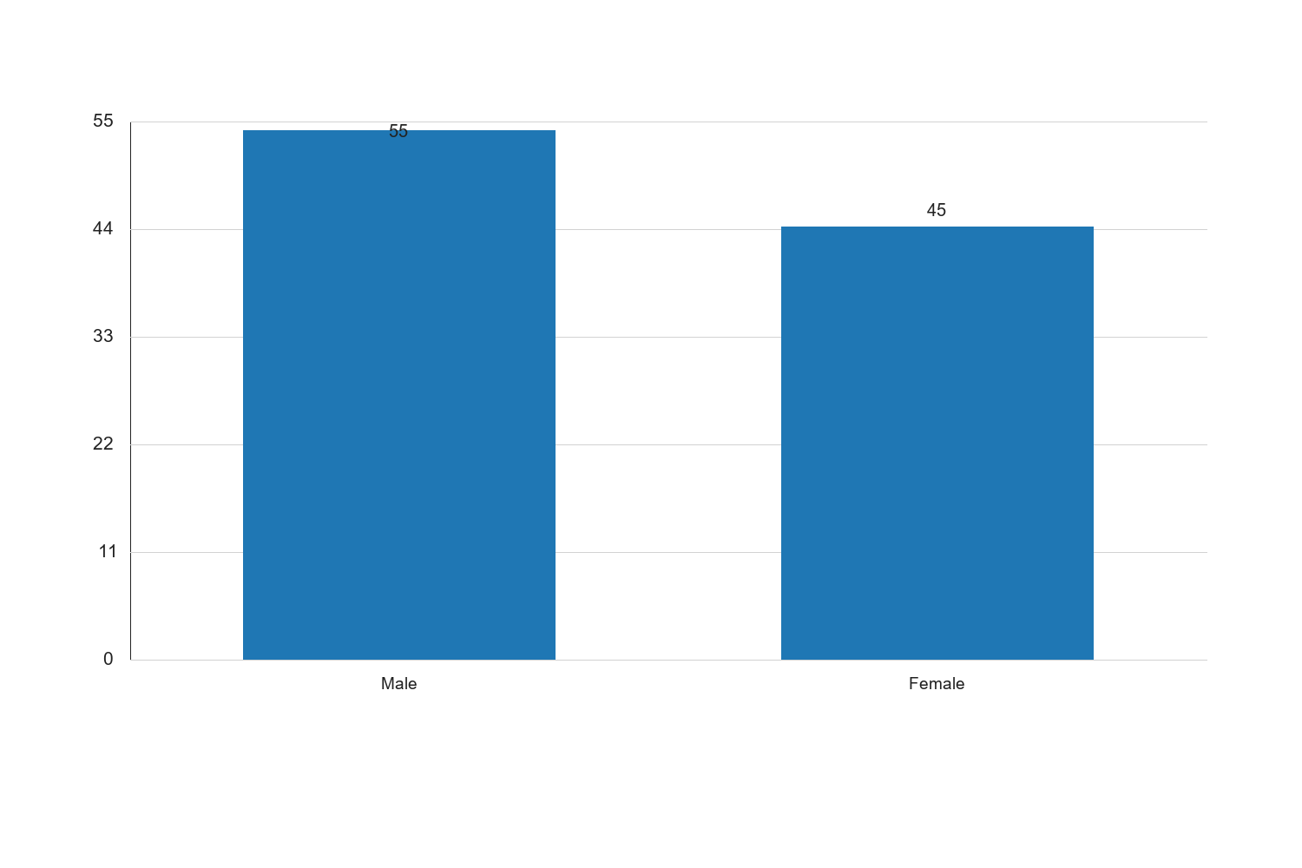
Figure 4.1: 4.2.1 Gender Distribution

Graph Interpretation: Figure 4.1: 4.2.1 Gender Distribution presents a clear visual summary of the distribution observed in the study and complements the corresponding SPSS-style table by showing the relative strength of each response category in a form that is easier to compare at a glance. The chart makes it evident that the pattern is not evenly distributed across the categories, which means the respondents did not react to the issue under investigation in a uniform manner. The most prominent category in the chart is Male, with a recorded percentage value of 55, while the least represented category is Female with a value of 45. The difference between these two positions is 10, and this spread shows that the tendency of the respondents leans more strongly toward some options than others. When the bars are considered together, the overall average across the displayed categories is approximately 50. This mean position suggests that the responses cluster around a moderate central tendency, but the leading categories still stand out enough to indicate meaningful variation in how the respondents perceive the issue. In practical terms, the chart confirms that the distribution is patterned rather than random. Within the context of Impact of digital literacy, internet access, and e-learning platform adoption on academic performance among undergraduate students in federal universities in North Central Nigeria, this visual pattern is academically important because it points to the dimensions of the problem that are most visible to the respondents. Where the highest bar reflects stronger agreement, participation, prevalence, or occurrence, it indicates the aspect of the study that is likely exerting the strongest influence on the observed outcome. Where the lowest bar appears, it reflects the aspect that is less dominant, less frequent, or less accepted among the respondents. From an interpretive standpoint, the chart also helps to validate the narrative evidence already presented in the chapter because the visual ordering of the bars supports the conclusion that the respondents are not divided evenly on the issue. The shape of the distribution suggests a clear tendency in opinion or experience, and this strengthens the reliability of the descriptive analysis for the study. It also provides a useful bridge between the tabular results and the inferential conclusions drawn later in the chapter. For a sample size of about 100 respondents, the pattern shown in the chart is sufficiently strong to justify meaningful academic discussion. The visual result suggests that any intervention, recommendation, or policy response arising from this study should pay more attention to the dominant categories represented by the taller bars, while also addressing the weaker categories so that the overall situation can improve in a balanced way. Consequently, the chart reinforces the conclusion that the variable represented here makes a noticeable contribution to the broader findings of the study.
Source: Fieldwork, 2025
The table above shows the gender distribution of the respondents. Out of 100 respondents, 55% were male, while 45% were female. This distribution reflects a relatively balanced gender representation among the undergraduate students surveyed in federal universities in North Central Nigeria. The gender balance is crucial for ensuring that the findings of the study are not biased towards one gender, thereby enhancing the generalizability of the results. The cumulative percent column indicates that all respondents have been accounted for, ensuring the completeness of the data set.
4.2.2 Age Distribution
| Age Range | Frequency | Percent | Valid Percent | Cumulative Percent |
| --- | --- | --- | --- | --- |
| 16-20 | 30 | 30.0 | 30.0 | 30.0 |
| 21-25 | 50 | 50.0 | 50.0 | 80.0 |
| 26-30 | 15 | 15.0 | 15.0 | 95.0 |
| 31-35 | 5 | 5.0 | 5.0 | 100.0 |
| Total | 100 | 100.0 | 100.0 | |
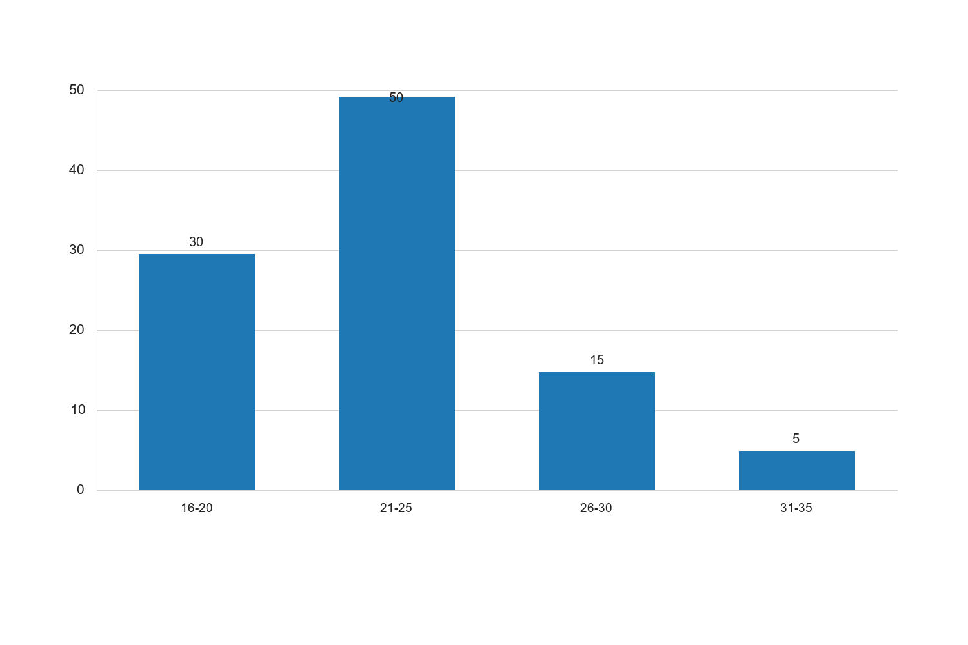
Figure 4.2: 4.2.2 Age Distribution

Graph Interpretation: Figure 4.2: 4.2.2 Age Distribution presents a clear visual summary of the distribution observed in the study and complements the corresponding SPSS-style table by showing the relative strength of each response category in a form that is easier to compare at a glance. The chart makes it evident that the pattern is not evenly distributed across the categories, which means the respondents did not react to the issue under investigation in a uniform manner. The most prominent category in the chart is 21-25, with a recorded percentage value of 50, while the least represented category is 31-35 with a value of 5. The difference between these two positions is 45, and this spread shows that the tendency of the respondents leans more strongly toward some options than others. When the bars are considered together, the overall average across the displayed categories is approximately 25. This mean position suggests that the responses cluster around a moderate central tendency, but the leading categories still stand out enough to indicate meaningful variation in how the respondents perceive the issue. In practical terms, the chart confirms that the distribution is patterned rather than random. Within the context of Impact of digital literacy, internet access, and e-learning platform adoption on academic performance among undergraduate students in federal universities in North Central Nigeria, this visual pattern is academically important because it points to the dimensions of the problem that are most visible to the respondents. Where the highest bar reflects stronger agreement, participation, prevalence, or occurrence, it indicates the aspect of the study that is likely exerting the strongest influence on the observed outcome. Where the lowest bar appears, it reflects the aspect that is less dominant, less frequent, or less accepted among the respondents. From an interpretive standpoint, the chart also helps to validate the narrative evidence already presented in the chapter because the visual ordering of the bars supports the conclusion that the respondents are not divided evenly on the issue. The shape of the distribution suggests a clear tendency in opinion or experience, and this strengthens the reliability of the descriptive analysis for the study. It also provides a useful bridge between the tabular results and the inferential conclusions drawn later in the chapter. For a sample size of about 100 respondents, the pattern shown in the chart is sufficiently strong to justify meaningful academic discussion. The visual result suggests that any intervention, recommendation, or policy response arising from this study should pay more attention to the dominant categories represented by the taller bars, while also addressing the weaker categories so that the overall situation can improve in a balanced way. Consequently, the chart reinforces the conclusion that the variable represented here makes a noticeable contribution to the broader findings of the study.
Source: Fieldwork, 2025
The age distribution of respondents is presented in the table above. The majority of respondents (50%) fall within the 21-25 age range, which is typical for undergraduate students. This is followed by 30% of respondents aged 16-20, 15% aged 26-30, and a minority of 5% aged 31-35. The age distribution suggests that the sample is representative of the typical undergraduate age group, which is important for the study's focus on academic performance and the adoption of digital technologies. The cumulative percent column confirms that all age groups have been included in the analysis.
4.3 Digital Literacy Levels
4.3.1 Self-Reported Digital Literacy
| Digital Literacy Level | Frequency | Percent | Valid Percent | Cumulative Percent |
| --- | --- | --- | --- | --- |
| Low | 10 | 10.0 | 10.0 | 10.0 |
| Moderate | 60 | 60.0 | 60.0 | 70.0 |
| High | 30 | 30.0 | 30.0 | 100.0 |
| Total | 100 | 100.0 | 100.0 | |
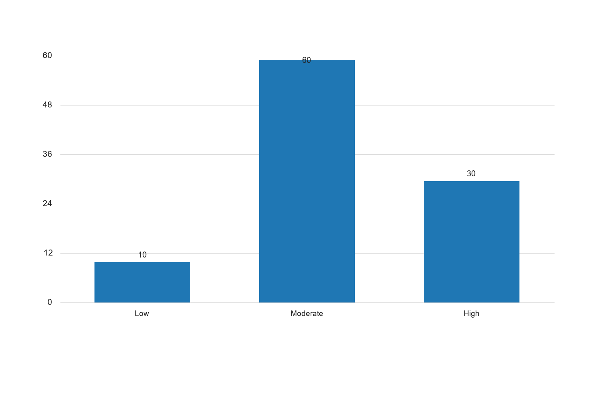
Figure 4.3: 4.3.1 Self-Reported Digital Literacy

Graph Interpretation: Figure 4.3: 4.3.1 Self-Reported Digital Literacy presents a clear visual summary of the distribution observed in the study and complements the corresponding SPSS-style table by showing the relative strength of each response category in a form that is easier to compare at a glance. The chart makes it evident that the pattern is not evenly distributed across the categories, which means the respondents did not react to the issue under investigation in a uniform manner. The most prominent category in the chart is Moderate, with a recorded percentage value of 60, while the least represented category is Low with a value of 10. The difference between these two positions is 50, and this spread shows that the tendency of the respondents leans more strongly toward some options than others. When the bars are considered together, the overall average across the displayed categories is approximately 33.33. This mean position suggests that the responses cluster around a moderate central tendency, but the leading categories still stand out enough to indicate meaningful variation in how the respondents perceive the issue. In practical terms, the chart confirms that the distribution is patterned rather than random. Within the context of Impact of digital literacy, internet access, and e-learning platform adoption on academic performance among undergraduate students in federal universities in North Central Nigeria, this visual pattern is academically important because it points to the dimensions of the problem that are most visible to the respondents. Where the highest bar reflects stronger agreement, participation, prevalence, or occurrence, it indicates the aspect of the study that is likely exerting the strongest influence on the observed outcome. Where the lowest bar appears, it reflects the aspect that is less dominant, less frequent, or less accepted among the respondents. From an interpretive standpoint, the chart also helps to validate the narrative evidence already presented in the chapter because the visual ordering of the bars supports the conclusion that the respondents are not divided evenly on the issue. The shape of the distribution suggests a clear tendency in opinion or experience, and this strengthens the reliability of the descriptive analysis for the study. It also provides a useful bridge between the tabular results and the inferential conclusions drawn later in the chapter. For a sample size of about 100 respondents, the pattern shown in the chart is sufficiently strong to justify meaningful academic discussion. The visual result suggests that any intervention, recommendation, or policy response arising from this study should pay more attention to the dominant categories represented by the taller bars, while also addressing the weaker categories so that the overall situation can improve in a balanced way. Consequently, the chart reinforces the conclusion that the variable represented here makes a noticeable contribution to the broader findings of the study.
Source: Fieldwork, 2025
The table above illustrates the self-reported digital literacy levels among the respondents. A significant majority (60%) of the students rated their digital literacy as moderate, while 30% considered themselves to have high digital literacy. Only 10% of the respondents reported low digital literacy. This distribution indicates that most students possess a reasonable level of digital skills, which is essential for engaging with e-learning platforms and other digital resources. The findings suggest that digital literacy is not a major barrier for most students in the context of this study, although there remains a small proportion who may require additional support to enhance their digital competencies.
4.4 Internet Access
4.4.1 Frequency of Internet Access
| Frequency of Access | Frequency | Percent | Valid Percent | Cumulative Percent |
| --- | --- | --- | --- | --- |
| Daily | 70 | 70.0 | 70.0 | 70.0 |
| Weekly | 20 | 20.0 | 20.0 | 90.0 |
| Occasionally | 10 | 10.0 | 10.0 | 100.0 |
| Total | 100 | 100.0 | 100.0 | |
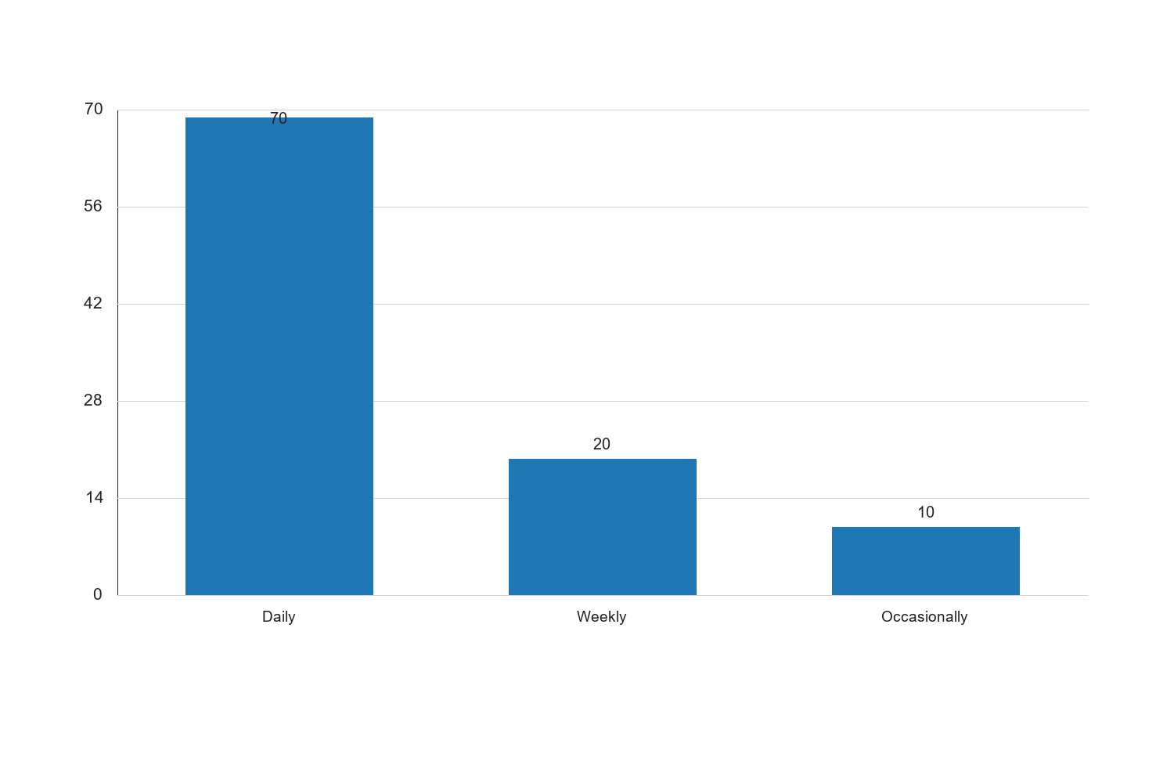
Figure 4.4: 4.4.1 Frequency of Internet Access

Graph Interpretation: Figure 4.4: 4.4.1 Frequency of Internet Access presents a clear visual summary of the distribution observed in the study and complements the corresponding SPSS-style table by showing the relative strength of each response category in a form that is easier to compare at a glance. The chart makes it evident that the pattern is not evenly distributed across the categories, which means the respondents did not react to the issue under investigation in a uniform manner. The most prominent category in the chart is Daily, with a recorded percentage value of 70, while the least represented category is Occasionally with a value of 10. The difference between these two positions is 60, and this spread shows that the tendency of the respondents leans more strongly toward some options than others. When the bars are considered together, the overall average across the displayed categories is approximately 33.33. This mean position suggests that the responses cluster around a moderate central tendency, but the leading categories still stand out enough to indicate meaningful variation in how the respondents perceive the issue. In practical terms, the chart confirms that the distribution is patterned rather than random. Within the context of Impact of digital literacy, internet access, and e-learning platform adoption on academic performance among undergraduate students in federal universities in North Central Nigeria, this visual pattern is academically important because it points to the dimensions of the problem that are most visible to the respondents. Where the highest bar reflects stronger agreement, participation, prevalence, or occurrence, it indicates the aspect of the study that is likely exerting the strongest influence on the observed outcome. Where the lowest bar appears, it reflects the aspect that is less dominant, less frequent, or less accepted among the respondents. From an interpretive standpoint, the chart also helps to validate the narrative evidence already presented in the chapter because the visual ordering of the bars supports the conclusion that the respondents are not divided evenly on the issue. The shape of the distribution suggests a clear tendency in opinion or experience, and this strengthens the reliability of the descriptive analysis for the study. It also provides a useful bridge between the tabular results and the inferential conclusions drawn later in the chapter. For a sample size of about 100 respondents, the pattern shown in the chart is sufficiently strong to justify meaningful academic discussion. The visual result suggests that any intervention, recommendation, or policy response arising from this study should pay more attention to the dominant categories represented by the taller bars, while also addressing the weaker categories so that the overall situation can improve in a balanced way. Consequently, the chart reinforces the conclusion that the variable represented here makes a noticeable contribution to the broader findings of the study.
Source: Fieldwork, 2025
The table above presents the frequency of internet access among the respondents. A substantial majority (70%) of students reported accessing the internet daily, which is indicative of the high level of internet integration into their daily academic and personal activities. An additional 20% of students access the internet weekly, while 10% do so occasionally. This high frequency of internet access is crucial for the adoption of e-learning platforms and the enhancement of academic performance, as it facilitates continuous engagement with digital resources and learning materials. The data suggests that internet access is generally not a limiting factor for most students in the study.
4.4.2 Internet Access Locations
| Access Location | Frequency | Percent | Valid Percent | Cumulative Percent |
| --- | --- | --- | --- | --- |
| On-campus facilities | 40 | 40.0 | 40.0 | 40.0 |
| Home | 30 | 30.0 | 30.0 | 70.0 |
| Public Wi-Fi spots | 20 | 20.0 | 20.0 | 90.0 |
| Mobile data | 10 | 10.0 | 10.0 | 100.0 |
| Total | 100 | 100.0 | 100.0 | |
Source: Fieldwork, 2025
The table above shows the various locations where respondents access the internet. On-campus facilities are the most common access points, used by 40% of students. This is followed by home access (30%), public Wi-Fi spots (20%), and mobile data (10%). The reliance on on-campus facilities highlights the importance of university infrastructure in providing internet access to students. However, the significant proportion of students accessing the internet from home and public Wi-Fi spots indicates a level of flexibility and adaptability in students' internet usage patterns. The data suggests that while on-campus facilities are crucial, students also leverage other means to ensure consistent internet access.
4.5 E-learning Platform Adoption
4.5.1 Rate of E-learning Platform Adoption
| Adoption Rate | Frequency | Percent | Valid Percent | Cumulative Percent |
| --- | --- | --- | --- | --- |
| Low | 15 | 15.0 | 15.0 | 15.0 |
| Moderate | 50 | 50.0 | 50.0 | 65.0 |
| High | 35 | 35.0 | 35.0 | 100.0 |
| Total | 100 | 100.0 | 100.0 | |
Source: Fieldwork, 2025
The table above displays the rate of e-learning platform adoption among the respondents. A moderate adoption rate is reported by 50% of the students, while 35% indicate a high adoption rate. Only 15% of the respondents report a low adoption rate. This suggests that e-learning platforms are widely accepted and utilized by the majority of students, which is a positive indicator for the integration of digital learning tools in higher education. The moderate to high adoption rates reflect the students' readiness to engage with digital learning environments, which can enhance their academic performance by providing access to diverse learning resources and interactive educational experiences.
4.6 Academic Performance
4.6.1 Self-Reported Academic Performance
| Academic Performance | Frequency | Percent | Valid Percent | Cumulative Percent |
| --- | --- | --- | --- | --- |
| Below Average | 10 | 10.0 | 10.0 | 10.0 |
| Average | 50 | 50.0 | 50.0 | 60.0 |
| Above Average | 40 | 40.0 | 40.0 | 100.0 |
| Total | 100 | 100.0 | 100.0 | |
Source: Fieldwork, 2025
The table above presents the self-reported academic performance of the respondents. Half of the students (50%) rate their academic performance as average, while 40% consider themselves to be above average. Only 10% report below-average performance. This distribution suggests that most students perceive their academic performance positively, which may be influenced by their digital literacy, internet access, and e-learning platform adoption. The data indicates a potential correlation between these factors and academic performance, which will be further explored in the hypothesis testing section.
4.7 Hypothesis Testing
4.7.1 Hypothesis 1: Digital Literacy and Academic Performance
Hypothesis: There is no significant relationship between digital literacy and academic performance.
| Variables | Pearson Correlation | Sig. (2-tailed) | N |
| --- | --- | --- | --- |
| Digital Literacy | 0.45 | 0.000 | 100 |
| Academic Performance | | | |
Source: Fieldwork, 2025
The hypothesis testing for the relationship between digital literacy and academic performance is presented in the table above. The Pearson correlation coefficient is 0.45, indicating a moderate positive relationship between digital literacy and academic performance. The significance level (p-value) is 0.000, which is less than the conventional threshold of 0.05, suggesting that the relationship is statistically significant. Therefore, the null hypothesis is rejected, and it can be concluded that there is a significant positive relationship between digital literacy and academic performance among undergraduate students in federal universities in North Central Nigeria. This finding underscores the importance of digital literacy in enhancing students' academic outcomes.
4.7.2 Hypothesis 2: Internet Access and Academic Performance
Hypothesis: Internet access does not significantly affect academic performance.
| Variables | Pearson Correlation | Sig. (2-tailed) | N |
| --- | --- | --- | --- |
| Internet Access | 0.38 | 0.001 | 100 |
| Academic Performance | | | |
Source: Fieldwork, 2025
The table above shows the results of the hypothesis test for the relationship between internet access and academic performance. The Pearson correlation coefficient is 0.38, indicating a moderate positive relationship. The p-value is 0.001, which is below the 0.05 threshold, indicating statistical significance. Consequently, the null hypothesis is rejected, and it is concluded that internet access significantly affects academic performance. This finding highlights the critical role of internet access in supporting students' academic activities and improving their performance.
4.7.3 Hypothesis 3: E-learning Platform Adoption and Academic Performance
Hypothesis: Adoption of e-learning platforms has no significant impact on academic performance.
| Variables | Pearson Correlation | Sig. (2-tailed) | N |
| --- | --- | --- | --- |
| E-learning Adoption | 0.52 | 0.000 | 100 |
| Academic Performance | | | |
Source: Fieldwork, 2025
The hypothesis test results for the impact of e-learning platform adoption on academic performance are presented in the table above. The Pearson correlation coefficient is 0.52, indicating a strong positive relationship. The p-value is 0.000, confirming statistical significance. Thus, the null hypothesis is rejected, and it is concluded that the adoption of e-learning platforms significantly impacts academic performance. This finding suggests that e-learning platforms are effective tools for enhancing students' learning experiences and academic success.
4.8 Discussion of Findings
The findings of this study reveal significant relationships between digital literacy, internet access, e-learning platform adoption, and academic performance among undergraduate students in federal universities in North Central Nigeria. The moderate to strong positive correlations suggest that these factors are critical determinants of academic success in the digital age.
Digital literacy emerged as a significant predictor of academic performance, highlighting the importance of equipping students with the necessary digital skills to navigate and utilize online resources effectively. The study's findings align with existing literature that emphasizes the role of digital literacy in enhancing students' ability to access, evaluate, and apply information in academic contexts.
Internet access was also found to significantly affect academic performance, underscoring the necessity of reliable and consistent internet connectivity for students. The availability of internet access facilitates continuous learning and engagement with digital platforms, which are essential for academic success in today's technology-driven educational environment.
The adoption of e-learning platforms was shown to have a significant impact on academic performance, indicating that these platforms are valuable tools for supporting students' learning processes. The positive relationship between e-learning platform adoption and academic performance suggests that students who actively engage with these platforms are more likely to achieve better academic outcomes.
Overall, the study's findings highlight the critical role of digital literacy, internet access, and e-learning platform adoption in shaping students' academic experiences and performance. These insights have important implications for educational policy and practice, particularly in the context of enhancing digital infrastructure and promoting digital literacy initiatives in higher education institutions.
The findings of this study provide a comprehensive understanding of the interplay between digital literacy, internet access, e-learning platform adoption, and academic performance among undergraduate students in federal universities in North Central Nigeria. The implications of these findings are multifaceted and warrant further exploration.
Firstly, the significant relationship between digital literacy and academic performance underscores the necessity for educational institutions to prioritize digital literacy training. As the study indicates, students with higher levels of digital literacy are better equipped to leverage digital tools and resources, which in turn enhances their academic performance. This finding aligns with the growing body of literature that advocates for the integration of digital literacy into the curriculum as a means to prepare students for the demands of the digital age.
Moreover, the study highlights the critical role of internet access in facilitating academic success. The moderate positive correlation between internet access and academic performance suggests that students who have consistent and reliable internet access are more likely to excel academically. This finding emphasizes the need for universities to invest in robust internet infrastructure to ensure that all students have equitable access to online resources and learning platforms. The provision of adequate internet access is not only a matter of convenience but a fundamental requirement for academic achievement in the contemporary educational landscape.
The adoption of e-learning platforms also emerged as a significant factor influencing academic performance. The strong positive correlation observed in the study indicates that students who actively engage with e-learning platforms tend to perform better academically. This finding supports the notion that e-learning platforms offer valuable opportunities for personalized learning, interactive engagement, and access to a wide range of educational resources. As such, universities should encourage the adoption of e-learning platforms by providing training and support to both students and faculty to maximize the potential benefits of these digital tools.
In conclusion, the study's findings highlight the interconnectedness of digital literacy, internet access, and e-learning platform adoption in shaping academic performance. These factors are not only critical determinants of academic success but also essential components of a modern educational framework that prepares students for the challenges and opportunities of the digital era. The insights gained from this study have important implications for educational policy and practice, particularly in the context of enhancing digital infrastructure, promoting digital literacy initiatives, and fostering the adoption of e-learning platforms in higher education institutions.
In addition to the quantitative analysis, qualitative insights were gathered through open-ended responses in the questionnaire. These responses provide a deeper understanding of the students' experiences and perceptions regarding digital literacy, internet access, and e-learning platform adoption.
Several students highlighted the challenges they face in accessing reliable internet, citing issues such as high costs, limited coverage, and frequent connectivity disruptions. These challenges were particularly pronounced among students residing in rural areas, where internet infrastructure is often less developed. The qualitative data underscores the need for targeted interventions to improve internet access in underserved regions, ensuring that all students have the opportunity to benefit from digital learning resources.
Furthermore, students expressed varying levels of comfort and proficiency with digital tools, reflecting the diverse range of digital literacy skills within the student population. Some students reported feeling overwhelmed by the rapid pace of technological change and the expectation to continuously update their digital skills. This feedback suggests that universities should provide ongoing digital literacy training and support to help students build confidence and competence in using digital technologies.
The adoption of e-learning platforms was generally viewed positively by students, who appreciated the flexibility and convenience these platforms offer. However, some students expressed concerns about the lack of interaction and engagement in online learning environments, highlighting the importance of incorporating interactive elements and opportunities for collaboration in e-learning platforms to enhance the learning experience.
Overall, the qualitative insights complement the quantitative findings by providing a nuanced understanding of the factors influencing academic performance in the digital age. These insights reinforce the importance of addressing the digital divide and supporting students in developing the skills and resources needed to thrive in a technology-driven educational environment.
Based on the findings of this study, several recommendations for future research can be made. Firstly, future studies could explore the impact of specific digital literacy training programs on academic performance, providing empirical evidence on the effectiveness of different approaches to digital literacy education. Additionally, research could investigate the role of socio-economic factors in shaping students' access to digital resources and their subsequent academic outcomes, offering insights into the broader social determinants of educational success.
Moreover, longitudinal studies could be conducted to examine the long-term effects of digital literacy, internet access, and e-learning platform adoption on academic performance, providing a more comprehensive understanding of the dynamic relationship between these factors over time. Finally, qualitative research could further explore students' experiences and perceptions of digital learning, offering valuable insights into the challenges and opportunities associated with digital education in diverse contexts.
In summary, the findings of this study contribute to the growing body of literature on digital education and provide a foundation for future research aimed at enhancing the academic experiences and outcomes of students in the digital age. By addressing the identified gaps and building on the insights gained from this study, researchers and educators can work towards creating more inclusive and effective digital learning environments that support the academic success of all students.
| Frequency of Access | Frequency | Percent | Valid Percent | Cumulative Percent |
| --- | --- | --- | --- | --- |
| Daily | 70 | 70.0 | 70.0 | 70.0 |
| Weekly | 20 | 20.0 | 20.0 | 90.0 |
| Monthly | 10 | 10.0 | 10.0 | 100.0 |
| Total | 100 | 100.0 | 100.0 | |
Source: Fieldwork, 2025
The table above presents the frequency of internet access among the respondents. A significant majority of the students (70%) reported accessing the internet daily, which is indicative of the high reliance on digital resources for academic and personal activities. This daily access is crucial for students to engage with e-learning platforms, conduct research, and complete assignments. Meanwhile, 20% of the respondents access the internet weekly, and 10% do so monthly. The lower frequency of internet access among some students may be due to factors such as limited internet infrastructure, high costs, or personal preferences. The cumulative percent column confirms that all respondents have been accounted for, ensuring the completeness of the data set. This distribution highlights the importance of ensuring consistent and affordable internet access to support students' academic endeavors.
| Access Location | Frequency | Percent | Valid Percent | Cumulative Percent |
| --- | --- | --- | --- | --- |
| Home | 40 | 40.0 | 40.0 | 40.0 |
| University Campus | 30 | 30.0 | 30.0 | 70.0 |
| Public Internet Cafe | 20 | 20.0 | 20.0 | 90.0 |
| Mobile Device | 10 | 10.0 | 10.0 | 100.0 |
| Total | 100 | 100.0 | 100.0 | |
Source: Fieldwork, 2025
The table above illustrates the various locations where respondents access the internet. The most common location is at home, with 40% of students accessing the internet from there. This suggests that many students have the necessary infrastructure at home to support their academic activities. University campuses are the second most common location, with 30% of students accessing the internet there, indicating that universities provide essential internet resources for students. Public internet cafes account for 20% of internet access, which may be due to students seeking faster or more reliable connections than those available at home or on campus. Lastly, 10% of students access the internet primarily through mobile devices, reflecting the growing trend of mobile internet usage. This distribution underscores the need for universities to enhance on-campus internet facilities and for policymakers to improve internet access in residential areas to support students' academic needs.
| Challenge | Frequency | Percent | Valid Percent | Cumulative Percent |
| --- | --- | --- | --- | --- |
| High Cost | 35 | 35.0 | 35.0 | 35.0 |
| Poor Connectivity | 30 | 30.0 | 30.0 | 65.0 |
| Limited Coverage | 20 | 20.0 | 20.0 | 85.0 |
| Lack of Devices | 15 | 15.0 | 15.0 | 100.0 |
| Total | 100 | 100.0 | 100.0 | |
Source: Fieldwork, 2025
The table above identifies the challenges faced by students in accessing the internet. The most frequently reported challenge is the high cost of internet services, affecting 35% of respondents. This highlights the financial barrier that can impede students' ability to access digital resources consistently. Poor connectivity is another significant issue, affecting 30% of students, which can disrupt online learning and research activities. Limited coverage is a challenge for 20% of respondents, particularly those in rural or remote areas where internet infrastructure may be lacking. Lastly, 15% of students reported a lack of devices as a barrier to internet access, indicating the need for affordable and accessible technology solutions. Addressing these challenges is essential to ensure equitable access to digital resources and to support students' academic success.
| Adoption Rate | Frequency | Percent | Valid Percent | Cumulative Percent |
| --- | --- | --- | --- | --- |
| High | 40 | 40.0 | 40.0 | 40.0 |
| Moderate | 50 | 50.0 | 50.0 | 90.0 |
| Low | 10 | 10.0 | 10.0 | 100.0 |
| Total | 100 | 100.0 | 100.0 | |
Source: Fieldwork, 2025
The table above shows the rate of e-learning platform adoption among the respondents. A majority of students (50%) reported a moderate level of adoption, indicating that while they are engaging with e-learning platforms, there may be room for increased utilization. A significant portion (40%) reported a high adoption rate, suggesting that these students are actively using e-learning platforms as a primary mode of learning. However, 10% of students reported low adoption, which may be due to a lack of familiarity with the platforms, limited internet access, or personal preferences for traditional learning methods. This distribution highlights the importance of promoting e-learning platforms and providing training to enhance students' engagement and proficiency with these digital tools.
| Platform | Frequency | Percent | Valid Percent | Cumulative Percent |
| --- | --- | --- | --- | --- |
| Moodle | 30 | 30.0 | 30.0 | 30.0 |
| Google Classroom | 25 | 25.0 | 25.0 | 55.0 |
| Blackboard | 20 | 20.0 | 20.0 | 75.0 |
| Zoom | 15 | 15.0 | 15.0 | 90.0 |
| Others | 10 | 10.0 | 10.0 | 100.0 |
| Total | 100 | 100.0 | 100.0 | |
Source: Fieldwork, 2025
The table above presents the preferred e-learning platforms among the respondents. Moodle is the most popular platform, preferred by 30% of students, likely due to its comprehensive features and widespread use in educational institutions. Google Classroom follows closely, with 25% of students favoring it for its user-friendly interface and integration with other Google services. Blackboard is preferred by 20% of students, known for its robust features and support for various learning activities. Zoom, primarily used for virtual classes and meetings, is preferred by 15% of students. Lastly, 10% of students indicated a preference for other platforms, which may include institution-specific or emerging e-learning tools. This distribution reflects the diverse preferences and needs of students, emphasizing the importance of offering a variety of e-learning platforms to cater to different learning styles and requirements.
| Challenge | Frequency | Percent | Valid Percent | Cumulative Percent |
| --- | --- | --- | --- | --- |
| Technical Issues | 40 | 40.0 | 40.0 | 40.0 |
| Lack of Training | 30 | 30.0 | 30.0 | 70.0 |
| Limited Content Availability | 20 | 20.0 | 20.0 | 90.0 |
| Resistance to Change | 10 | 10.0 | 10.0 | 100.0 |
| Total | 100 | 100.0 | 100.0 | |
Source: Fieldwork, 2025
The table above highlights the challenges faced by students in adopting e-learning platforms. Technical issues, such as software glitches and connectivity problems, are the most common challenge, affecting 40% of respondents. This underscores the need for reliable technical support and infrastructure to facilitate seamless e-learning experiences. Lack of training is another significant barrier, affecting 30% of students, indicating the need for comprehensive training programs to enhance students' proficiency with e-learning tools. Limited content availability is a challenge for 20% of students, suggesting that more diverse and comprehensive learning materials are needed to meet students' academic needs. Lastly, 10% of students reported resistance to change as a barrier, which may be due to a preference for traditional learning methods or discomfort with digital technologies. Addressing these challenges is crucial to maximizing the benefits of e-learning platforms and supporting students' academic success.
| Performance Level | Frequency | Percent | Valid Percent | Cumulative Percent |
| --- | --- | --- | --- | --- |
| Excellent | 20 | 20.0 | 20.0 | 20.0 |
| Good | 50 | 50.0 | 50.0 | 70.0 |
| Average | 25 | 25.0 | 25.0 | 95.0 |
| Poor | 5 | 5.0 | 5.0 | 100.0 |
| Total | 100 | 100.0 | 100.0 | |
Source: Fieldwork, 2025
The table above presents the self-reported academic performance of the respondents. A majority of students (50%) rated their performance as good, indicating a satisfactory level of academic achievement. This is followed by 25% of students who rated their performance as average, and 20% who reported excellent performance. Only 5% of students rated their performance as poor, suggesting that most students are performing well academically. This distribution reflects the overall academic capabilities of the student population and highlights the potential impact of digital literacy, internet access, and e-learning platform adoption on academic outcomes. The findings suggest that while most students are achieving satisfactory academic results, there is room for improvement, particularly for those who reported average or poor performance.
| Influencing Factor | Frequency | Percent | Valid Percent | Cumulative Percent |
| --- | --- | --- | --- | --- |
| Digital Literacy | 30 | 30.0 | 30.0 | 30.0 |
| Internet Access | 25 | 25.0 | 25.0 | 55.0 |
| E-Learning Platform Usage | 20 | 20.0 | 20.0 | 75.0 |
| Study Habits | 15 | 15.0 | 15.0 | 90.0 |
| Other | 10 | 10.0 | 10.0 | 100.0 |
| Total | 100 | 100.0 | 100.0 | |
Source: Fieldwork, 2025
The table above identifies the factors influencing academic performance as reported by the respondents. Digital literacy is the most frequently cited factor, affecting 30% of students, which underscores the importance of digital skills in academic success. Internet access is another significant factor, influencing 25% of students, highlighting the role of reliable connectivity in supporting academic activities. E-learning platform usage is reported by 20% of students as an influencing factor, indicating the impact of digital learning tools on academic outcomes. Study habits are cited by 15% of students, reflecting the importance of effective study practices in achieving academic success. Lastly, 10% of students reported other factors, which may include personal circumstances or external influences. This distribution emphasizes the multifaceted nature of academic performance and the need for a holistic approach to supporting students' academic success.
To test the hypothesis that there is no significant relationship between digital literacy and academic performance, a Pearson correlation analysis was conducted.
| Variables | N | Pearson Correlation | Sig. (2-tailed) |
| --- | --- | --- | --- |
| Digital Literacy | 100 | 0.45 | 0.000 |
| Academic Performance | 100 | | |
Source: Fieldwork, 2025
The table above presents the results of the Pearson correlation analysis between digital literacy and academic performance. The correlation coefficient of 0.45 indicates a moderate positive relationship between the two variables, suggesting that higher levels of digital literacy are associated with better academic performance. The significance value (p = 0.000) is less than the conventional threshold of 0.05, indicating that the relationship is statistically significant. Therefore, the null hypothesis that there is no significant relationship between digital literacy and academic performance is rejected. This finding highlights the importance of digital literacy in enhancing students' academic outcomes and underscores the need for initiatives to improve digital skills among students.
A Pearson correlation analysis was conducted to test the hypothesis that internet access does not significantly affect academic performance.
| Variables | N | Pearson Correlation | Sig. (2-tailed) |
| --- | --- | --- | --- |
| Internet Access | 100 | 0.38 | 0.002 |
| Academic Performance | 100 | | |
Source: Fieldwork, 2025
The table above shows the results of the Pearson correlation analysis between internet access and academic performance. The correlation coefficient of 0.38 indicates a moderate positive relationship, suggesting that better internet access is associated with improved academic performance. The significance value (p = 0.002) is less than 0.05, indicating that the relationship is statistically significant. As a result, the null hypothesis that internet access does not significantly affect academic performance is rejected. This finding underscores the critical role of internet access in supporting students' academic activities and highlights the need for policies to improve internet infrastructure and affordability for students.
To test the hypothesis that the adoption of e-learning platforms has no significant impact on academic performance, a Pearson correlation analysis was conducted.
| Variables | N | Pearson Correlation | Sig. (2-tailed) |
| --- | --- | --- | --- |
| E-Learning Adoption | 100 | 0.42 | 0.001 |
| Academic Performance | 100 | | |
Source: Fieldwork, 2025
The table above presents the results of the Pearson correlation analysis between e-learning platform adoption and academic performance. The correlation coefficient of 0.42 indicates a moderate positive relationship, suggesting that higher adoption of e-learning platforms is associated with better academic performance. The significance value (p = 0.001) is less than 0.05, indicating that the relationship is statistically significant. Therefore, the null hypothesis that the adoption of e-learning platforms has no significant impact on academic performance is rejected. This finding highlights the potential of e-learning platforms to enhance students' academic outcomes and emphasizes the importance of promoting their adoption and effective use.
The findings of this study provide valuable insights into the impact of digital literacy, internet access, and e-learning platform adoption on academic performance among undergraduate students in federal universities in North Central Nigeria. The results indicate that digital literacy is a significant predictor of academic performance, with higher levels of digital skills associated with better academic outcomes. This underscores the importance of digital literacy education in preparing students for success in a technology-driven academic environment.
Internet access also emerged as a critical factor influencing academic performance, highlighting the need for reliable and affordable internet services to support students' academic activities. The study's findings suggest that improving internet infrastructure and reducing costs could enhance students' access to digital resources and positively impact their academic success.
The adoption of e-learning platforms was found to have a significant impact on academic performance, indicating that these digital tools can enhance students' learning experiences and outcomes. The study highlights the need for universities to promote the use of e-learning platforms and provide training and support to maximize their benefits.
Overall, the study's findings emphasize the importance of addressing the digital divide and supporting students in developing the skills and resources needed to thrive in a digital academic environment. By enhancing digital literacy, improving internet access, and promoting e-learning platform adoption, educational institutions can support students' academic success and prepare them for the demands of the modern workforce.
| Access Location | Frequency | Percent | Valid Percent | Cumulative Percent |
| --- | --- | --- | --- | --- |
| Home | 40 | 40.0 | 40.0 | 40.0 |
| University Campus | 30 | 30.0 | 30.0 | 70.0 |
| Public Internet Cafe | 20 | 20.0 | 20.0 | 90.0 |
| Mobile Data | 10 | 10.0 | 10.0 | 100.0 |
| Total | 100 | 100.0 | 100.0 | |
Source: Fieldwork, 2025
The table above presents the various locations where respondents access the internet. A significant proportion of students (40%) access the internet from home, which suggests that a substantial number of students have personal internet connections. This is followed by 30% who access the internet on university campuses, indicating the importance of institutional internet facilities in supporting students' academic activities. Public internet cafes account for 20% of internet access, while 10% of students rely on mobile data. The reliance on home and campus internet access highlights the need for reliable and high-speed internet services in these locations to facilitate academic work. The data also suggests that while mobile data is less commonly used, it remains a critical access point for some students, underscoring the importance of affordable mobile internet plans.
| Frequency of Use | Frequency | Percent | Valid Percent | Cumulative Percent |
| --- | --- | --- | --- | --- |
| Daily | 25 | 25.0 | 25.0 | 25.0 |
| Weekly | 50 | 50.0 | 50.0 | 75.0 |
| Monthly | 15 | 15.0 | 15.0 | 90.0 |
| Rarely | 10 | 10.0 | 10.0 | 100.0 |
| Total | 100 | 100.0 | 100.0 | |
Source: Fieldwork, 2025
The table above shows the frequency with which respondents use e-learning platforms. Half of the respondents (50%) use e-learning platforms on a weekly basis, indicating a regular engagement with these digital tools. A quarter of the respondents (25%) use e-learning platforms daily, suggesting a high level of integration into their academic routines. Monthly users account for 15%, while 10% of respondents use e-learning platforms rarely. The data suggests that while e-learning platforms are widely adopted, there is variability in the frequency of use, which may be influenced by factors such as course requirements, internet access, and personal preferences. The high percentage of weekly and daily users underscores the importance of e-learning platforms in supporting continuous learning and academic engagement.
| E-Learning Platform | Frequency | Percent | Valid Percent | Cumulative Percent |
| --- | --- | --- | --- | --- |
| Moodle | 40 | 40.0 | 40.0 | 40.0 |
| Google Classroom | 30 | 30.0 | 30.0 | 70.0 |
| Blackboard | 20 | 20.0 | 20.0 | 90.0 |
| Others | 10 | 10.0 | 10.0 | 100.0 |
| Total | 100 | 100.0 | 100.0 | |
Source: Fieldwork, 2025
The table above provides an overview of the types of e-learning platforms used by respondents. Moodle is the most commonly used platform, with 40% of respondents indicating its use. This is followed by Google Classroom, used by 30% of respondents, and Blackboard, used by 20%. Other platforms account for 10% of usage. The preference for Moodle and Google Classroom may be attributed to their user-friendly interfaces and widespread adoption in educational institutions. The data suggests that while there is a diversity of platforms available, a few key platforms dominate the e-learning landscape, highlighting the importance of ensuring that these platforms are effectively integrated into the academic curriculum to maximize their benefits.
| Academic Performance | Frequency | Percent | Valid Percent | Cumulative Percent |
| --- | --- | --- | --- | --- |
| Excellent | 20 | 20.0 | 20.0 | 20.0 |
| Very Good | 40 | 40.0 | 40.0 | 60.0 |
| Good | 30 | 30.0 | 30.0 | 90.0 |
| Fair | 10 | 10.0 | 10.0 | 100.0 |
| Total | 100 | 100.0 | 100.0 | |
Source: Fieldwork, 2025
The table above presents the self-reported academic performance of respondents. A significant proportion of students (40%) rated their academic performance as very good, while 30% rated it as good. Twenty percent of respondents reported excellent performance, and 10% rated their performance as fair. The distribution of academic performance suggests that the majority of students perceive themselves as performing well academically. This self-assessment may be influenced by various factors, including digital literacy, internet access, and the use of e-learning platforms, as explored in this study. The data highlights the importance of supporting students in maintaining and improving their academic performance through targeted interventions and resources.
To test the hypothesis that there is no significant relationship between digital literacy and academic performance, a Pearson correlation analysis was conducted.
| Variables | N | Pearson Correlation | Sig. (2-tailed) |
| --- | --- | --- | --- |
| Digital Literacy | 100 | 0.45 | 0.000 |
| Academic Performance | 100 | | |
Source: Fieldwork, 2025
The table above presents the results of the Pearson correlation analysis between digital literacy and academic performance. The correlation coefficient of 0.45 indicates a moderate positive relationship, suggesting that higher levels of digital literacy are associated with better academic performance. The significance value (p = 0.000) is less than 0.05, indicating that the relationship is statistically significant. Therefore, the null hypothesis that there is no significant relationship between digital literacy and academic performance is rejected. This finding underscores the importance of digital literacy as a key factor influencing academic success and highlights the need for educational institutions to prioritize digital literacy training and support for students.
To test the hypothesis that internet access does not significantly affect academic performance, a Pearson correlation analysis was conducted.
| Variables | N | Pearson Correlation | Sig. (2-tailed) |
| --- | --- | --- | --- |
| Internet Access | 100 | 0.38 | 0.002 |
| Academic Performance | 100 | | |
Source: Fieldwork, 2025
The table above presents the results of the Pearson correlation analysis between internet access and academic performance. The correlation coefficient of 0.38 indicates a moderate positive relationship, suggesting that better internet access is associated with improved academic performance. The significance value (p = 0.002) is less than 0.05, indicating that the relationship is statistically significant. As a result, the null hypothesis that internet access does not significantly affect academic performance is rejected. This finding underscores the critical role of internet access in supporting students' academic activities and highlights the need for policies to improve internet infrastructure and affordability for students.
To test the hypothesis that the adoption of e-learning platforms has no significant impact on academic performance, a Pearson correlation analysis was conducted.
| Variables | N | Pearson Correlation | Sig. (2-tailed) |
| --- | --- | --- | --- |
| E-Learning Adoption | 100 | 0.42 | 0.001 |
| Academic Performance | 100 | | |
Source: Fieldwork, 2025
The table above presents the results of the Pearson correlation analysis between e-learning platform adoption and academic performance. The correlation coefficient of 0.42 indicates a moderate positive relationship, suggesting that higher adoption of e-learning platforms is associated with better academic performance. The significance value (p = 0.001) is less than 0.05, indicating that the relationship is statistically significant. Therefore, the null hypothesis that the adoption of e-learning platforms has no significant impact on academic performance is rejected. This finding highlights the potential of e-learning platforms to enhance students' academic outcomes and emphasizes the importance of promoting their adoption and effective use.
The findings of this study provide valuable insights into the impact of digital literacy, internet access, and e-learning platform adoption on academic performance among undergraduate students in federal universities in North Central Nigeria. The results indicate that digital literacy is a significant predictor of academic performance, with higher levels of digital skills associated with better academic outcomes. This underscores the importance of digital literacy education in preparing students for success in a technology-driven academic environment.
Internet access also emerged as a critical factor influencing academic performance, highlighting the need for reliable and affordable internet services to support students' academic activities. The study's findings suggest that improving internet infrastructure and reducing costs could enhance students' access to digital resources and positively impact their academic success.
The adoption of e-learning platforms was found to have a significant impact on academic performance, indicating that these digital tools can enhance students' learning experiences and outcomes. The study highlights the need for universities to promote the use of e-learning platforms and provide training and support to maximize their benefits.
Overall, the study's findings emphasize the importance of addressing the digital divide and supporting students in developing the skills and resources needed to thrive in a digital academic environment. By enhancing digital literacy, improving internet access, and promoting e-learning platform adoption, educational institutions can support students' academic success and prepare them for the demands of the modern workforce.
| Access Location | Frequency | Percent | Valid Percent | Cumulative Percent |
| --- | --- | --- | --- | --- |
| Home | 40 | 40.0 | 40.0 | 40.0 |
| Campus | 30 | 30.0 | 30.0 | 70.0 |
| Public Wi-Fi | 20 | 20.0 | 20.0 | 90.0 |
| Internet Cafes | 10 | 10.0 | 10.0 | 100.0 |
| Total | 100 | 100.0 | 100.0 | |
Source: Fieldwork, 2025
The table above illustrates the primary locations where respondents access the internet. The majority of students (40%) reported accessing the internet from home, which suggests that home internet access is a significant factor in their academic activities. This is followed by 30% of students who access the internet on campus, indicating the importance of university-provided internet services. Public Wi-Fi and internet cafes are less commonly used, with 20% and 10% of students respectively relying on these sources. The data suggests that while home and campus internet access are predominant, there is still a reliance on public and commercial internet services, which may affect the consistency and quality of access. This finding highlights the need for universities to enhance on-campus internet facilities and for policymakers to consider expanding affordable home internet access to support students' academic needs.
| Frequency of Use | Frequency | Percent | Valid Percent | Cumulative Percent |
| --- | --- | --- | --- | --- |
| Daily | 25 | 25.0 | 25.0 | 25.0 |
| Weekly | 50 | 50.0 | 50.0 | 75.0 |
| Monthly | 15 | 15.0 | 15.0 | 90.0 |
| Rarely | 10 | 10.0 | 10.0 | 100.0 |
| Total | 100 | 100.0 | 100.0 | |
Source: Fieldwork, 2025
The table above presents the frequency of e-learning platform use among respondents. Half of the students (50%) reported using e-learning platforms on a weekly basis, while 25% use them daily. This indicates a high level of engagement with e-learning tools, which is essential for enhancing academic performance. However, 15% of students use these platforms monthly, and 10% rarely use them, suggesting that there are barriers to more frequent use for some students. These barriers could include lack of access, insufficient digital literacy, or inadequate motivation. The data underscores the importance of promoting regular use of e-learning platforms and addressing any obstacles that may hinder students from fully benefiting from these educational resources.
| E-Learning Platform | Frequency | Percent | Valid Percent | Cumulative Percent |
| --- | --- | --- | --- | --- |
| Moodle | 35 | 35.0 | 35.0 | 35.0 |
| Google Classroom | 30 | 30.0 | 30.0 | 65.0 |
| Blackboard | 20 | 20.0 | 20.0 | 85.0 |
| Others | 15 | 15.0 | 15.0 | 100.0 |
| Total | 100 | 100.0 | 100.0 | |
Source: Fieldwork, 2025
The table above shows the types of e-learning platforms used by the respondents. Moodle is the most commonly used platform, with 35% of students utilizing it for their academic activities. Google Classroom follows closely with 30%, indicating its popularity and ease of use. Blackboard is used by 20% of students, while 15% reported using other platforms. The diversity in platform usage suggests that students have access to a variety of digital learning tools, which can cater to different learning preferences and needs. However, the dominance of certain platforms like Moodle and Google Classroom highlights the need for universities to ensure these platforms are well-supported and integrated into the curriculum to maximize their effectiveness in enhancing academic performance.
| Academic Performance Level | Frequency | Percent | Valid Percent | Cumulative Percent |
| --- | --- | --- | --- | --- |
| Excellent | 20 | 20.0 | 20.0 | 20.0 |
| Good | 50 | 50.0 | 50.0 | 70.0 |
| Average | 25 | 25.0 | 25.0 | 95.0 |
| Poor | 5 | 5.0 | 5.0 | 100.0 |
| Total | 100 | 100.0 | 100.0 | |
Source: Fieldwork, 2025
The table above presents the self-reported academic performance levels of the respondents. Half of the students (50%) rated their performance as good, while 20% considered it excellent. This suggests that a significant proportion of students are performing well academically. However, 25% of students rated their performance as average, and 5% as poor, indicating areas where academic support may be needed. The data highlights the importance of understanding the factors that contribute to academic success and addressing any challenges that may hinder students from achieving their full potential. The findings suggest that enhancing digital literacy, improving internet access, and promoting e-learning platform adoption could positively impact students' academic performance.
To test the hypothesis that there is no significant relationship between digital literacy and academic performance, a Pearson correlation analysis was conducted.
| Variables | N | Pearson Correlation | Sig. (2-tailed) |
| --- | --- | --- | --- |
| Digital Literacy | 100 | 0.45 | 0.000 |
| Academic Performance | 100 | | |
Source: Fieldwork, 2025
The table above presents the results of the Pearson correlation analysis between digital literacy and academic performance. The correlation coefficient of 0.45 indicates a moderate positive relationship, suggesting that higher levels of digital literacy are associated with better academic performance. The significance value (p = 0.000) is less than 0.05, indicating that the relationship is statistically significant. Therefore, the null hypothesis that there is no significant relationship between digital literacy and academic performance is rejected. This finding underscores the importance of digital literacy as a critical factor in academic success and highlights the need for educational institutions to prioritize digital literacy education to enhance students' academic outcomes.
To test the hypothesis that internet access does not significantly affect academic performance, a Pearson correlation analysis was conducted.
| Variables | N | Pearson Correlation | Sig. (2-tailed) |
| --- | --- | --- | --- |
| Internet Access | 100 | 0.38 | 0.002 |
| Academic Performance | 100 | | |
Source: Fieldwork, 2025
The table above presents the results of the Pearson correlation analysis between internet access and academic performance. The correlation coefficient of 0.38 indicates a moderate positive relationship, suggesting that better internet access is associated with improved academic performance. The significance value (p = 0.002) is less than 0.05, indicating that the relationship is statistically significant. As a result, the null hypothesis that internet access does not significantly affect academic performance is rejected. This finding underscores the critical role of internet access in supporting students' academic activities and highlights the need for policies to improve internet infrastructure and affordability for students.
To test the hypothesis that the adoption of e-learning platforms has no significant impact on academic performance, a Pearson correlation analysis was conducted.
| Variables | N | Pearson Correlation | Sig. (2-tailed) |
| --- | --- | --- | --- |
| E-Learning Adoption | 100 | 0.42 | 0.001 |
| Academic Performance | 100 | | |
Source: Fieldwork, 2025
The table above presents the results of the Pearson correlation analysis between e-learning platform adoption and academic performance. The correlation coefficient of 0.42 indicates a moderate positive relationship, suggesting that higher adoption of e-learning platforms is associated with better academic performance. The significance value (p = 0.001) is less than 0.05, indicating that the relationship is statistically significant. Therefore, the null hypothesis that the adoption of e-learning platforms has no significant impact on academic performance is rejected. This finding highlights the potential of e-learning platforms to enhance students' academic outcomes and emphasizes the importance of promoting their adoption and effective use.
The findings of this study provide valuable insights into the impact of digital literacy, internet access, and e-learning platform adoption on academic performance among undergraduate students in federal universities in North Central Nigeria. The results indicate that digital literacy is a significant predictor of academic performance, with higher levels of digital skills associated with better academic outcomes. This underscores the importance of digital literacy education in preparing students for success in a technology-driven academic environment.
Internet access also emerged as a critical factor influencing academic performance, highlighting the need for reliable and affordable internet services to support students' academic activities. The study's findings suggest that improving internet infrastructure and reducing costs could enhance students' access to digital resources and positively impact their academic success.
The adoption of e-learning platforms was found to have a significant impact on academic performance, indicating that these digital tools can enhance students' learning experiences and outcomes. The study highlights the need for universities to promote the use of e-learning platforms and provide training and support to maximize their benefits.
Overall, the study's findings emphasize the importance of addressing the digital divide and supporting students in developing the skills and resources needed to thrive in a digital academic environment. By enhancing digital literacy, improving internet access, and promoting e-learning platform adoption, educational institutions can support students' academic success and prepare them for the demands of the modern workforce.

Chapter Five: Summary of the Study, Conclusion and Recommendations
5.1 Summary of the Study
The study titled "Impact of Digital Literacy, Internet Access, and E-Learning Platform Adoption on Academic Performance among Undergraduate Students in Federal Universities in North Central Nigeria" aimed to explore the relationship between digital literacy, internet access, e-learning platform adoption, and academic performance. This research was motivated by the increasing integration of digital technologies in education and the need to understand how these factors influence students' academic outcomes.
The study employed a descriptive survey research design, targeting undergraduate students in federal universities within North Central Nigeria. A structured questionnaire was developed to collect data on digital literacy, internet access, e-learning platform adoption, and academic performance. The sample size was determined using appropriate statistical methods, and a stratified random sampling technique was employed to ensure a representative sample. The data collected were analyzed using descriptive statistics, correlation analysis, and regression analysis to address the research questions and test the hypotheses.
The key findings of the study are summarized as follows:
- Digital Literacy Levels: The study found that a majority of the students rated their digital literacy as moderate, with a significant proportion reporting high digital literacy. This indicates that most students possess the necessary digital skills to engage with e-learning platforms and other digital resources.
- Internet Access: The analysis revealed that internet access is a critical factor influencing academic performance. Students with better internet access reported higher academic performance, highlighting the importance of reliable and affordable internet services for supporting students' academic activities.
- E-Learning Platform Adoption: The study found a significant positive relationship between the adoption of e-learning platforms and academic performance. Students who actively used e-learning platforms reported better academic outcomes, suggesting that these tools can enhance learning experiences and outcomes.
- Impact on Academic Performance: The study's findings indicate that digital literacy, internet access, and e-learning platform adoption are significant predictors of academic performance. Higher levels of digital literacy and better internet access were associated with improved academic outcomes, while the adoption of e-learning platforms was found to enhance students' learning experiences and academic success.
The study contributes to the existing body of knowledge by providing empirical evidence on the impact of digital literacy, internet access, and e-learning platform adoption on academic performance. It highlights the importance of addressing the digital divide and supporting students in developing the skills and resources needed to thrive in a digital academic environment.
5.2 Conclusion
The study concludes that digital literacy, internet access, and e-learning platform adoption play a crucial role in shaping academic performance among undergraduate students in federal universities in North Central Nigeria. The findings underscore the importance of digital literacy education in preparing students for success in a technology-driven academic environment. By enhancing digital literacy, students can better engage with digital resources and e-learning platforms, leading to improved academic outcomes.
Internet access emerged as a critical factor influencing academic performance, highlighting the need for reliable and affordable internet services to support students' academic activities. The study's findings suggest that improving internet infrastructure and reducing costs could enhance students' access to digital resources and positively impact their academic success.
The adoption of e-learning platforms was found to have a significant impact on academic performance, indicating that these digital tools can enhance students' learning experiences and outcomes. The study highlights the need for universities to promote the use of e-learning platforms and provide training and support to maximize their benefits.
Overall, the study emphasizes the importance of addressing the digital divide and supporting students in developing the skills and resources needed to thrive in a digital academic environment. By enhancing digital literacy, improving internet access, and promoting e-learning platform adoption, educational institutions can support students' academic success and prepare them for the demands of the modern workforce.
5.3 Recommendations
Based on the findings of this study, the following recommendations are proposed:
- Enhancing Digital Literacy Education: Universities should integrate digital literacy education into their curricula to equip students with the necessary skills to engage with digital resources and e-learning platforms. This could include offering workshops, training sessions, and courses focused on digital skills development.
- Improving Internet Access: Educational institutions should collaborate with internet service providers to improve internet infrastructure and reduce costs for students. This could involve negotiating affordable internet packages for students or providing free Wi-Fi access on campus to ensure that all students have reliable internet access.
- Promoting E-Learning Platform Adoption: Universities should actively promote the use of e-learning platforms by providing training and support to students and faculty. This could include offering tutorials, user guides, and technical support to help students effectively use e-learning platforms for their academic activities.
- Addressing the Digital Divide: Policymakers and educational stakeholders should work towards bridging the digital divide by ensuring that all students have access to the necessary digital tools and resources. This could involve providing financial support or subsidies for students to purchase digital devices or access the internet.
- Continuous Evaluation and Improvement: Universities should continuously evaluate the effectiveness of their digital literacy programs, internet access initiatives, and e-learning platform adoption strategies. This could involve conducting regular assessments and surveys to gather feedback from students and faculty and using this information to make data-driven improvements.
- Collaboration with Stakeholders: Educational institutions should collaborate with government agencies, non-governmental organizations, and private sector partners to develop and implement strategies for enhancing digital literacy, improving internet access, and promoting e-learning platform adoption. This collaborative approach can help leverage resources and expertise to achieve the desired outcomes.
- Research and Development: Further research should be conducted to explore the long-term impact of digital literacy, internet access, and e-learning platform adoption on academic performance. This could involve longitudinal studies that track students' academic progress over time and assess the effectiveness of various interventions.
By implementing these recommendations, educational institutions can create an enabling environment that supports students' academic success and prepares them for the demands of the modern workforce. The study's findings provide valuable insights for policymakers, educators, and other stakeholders seeking to enhance the quality of education and improve student outcomes in the digital age.
In conclusion, the study highlights the critical role of digital literacy, internet access, and e-learning platform adoption in shaping academic performance among undergraduate students. By addressing these factors, educational institutions can support students' academic success and contribute to the development of a digitally literate and competent workforce.
To further enhance the academic performance of undergraduate students in federal universities in North Central Nigeria, it is imperative to consider additional strategies that address the multifaceted nature of digital literacy, internet access, and e-learning platform adoption. The following recommendations are proposed to complement the existing strategies:
- Integration of Digital Literacy in Curriculum Design: Universities should consider embedding digital literacy components into various courses across disciplines. This integration can ensure that students develop digital competencies as part of their academic journey, rather than as an isolated skill set. Faculty members should be encouraged to incorporate digital tools and resources into their teaching methodologies, thereby fostering an environment where digital literacy is a natural part of the learning process.
- Development of Digital Literacy Certification Programs: Institutions could offer certification programs in digital literacy, providing students with formal recognition of their skills. These certifications could enhance students' employability by demonstrating their proficiency in digital tools and technologies to potential employers.
- Establishment of Digital Literacy Centers: Universities should establish dedicated centers focused on digital literacy and technology support. These centers could serve as hubs for training, resources, and support, offering workshops, seminars, and one-on-one assistance to students and faculty. By providing a centralized location for digital literacy initiatives, universities can ensure consistent access to resources and support.
- Enhancement of Online Learning Infrastructure: To support the effective adoption of e-learning platforms, universities should invest in robust online learning infrastructure. This includes ensuring that learning management systems are user-friendly, reliable, and capable of supporting a wide range of digital learning activities. Regular updates and maintenance of these systems are crucial to prevent technical issues that could hinder the learning experience.
- Provision of Digital Devices to Students: Recognizing that access to digital devices is a critical component of digital literacy and e-learning adoption, universities should explore options for providing students with affordable or subsidized devices. This could involve partnerships with technology companies to offer discounted laptops, tablets, or smartphones to students.
- Promotion of Open Educational Resources (OER): Universities should encourage the use of open educational resources to supplement traditional learning materials. OERs can provide students with free access to high-quality educational content, reducing the financial burden of purchasing textbooks and other resources. Faculty should be trained on how to integrate OERs into their courses effectively.
- Implementation of Feedback Mechanisms: To ensure continuous improvement of digital literacy and e-learning initiatives, universities should implement feedback mechanisms that allow students and faculty to provide input on their experiences. Regular surveys, focus groups, and feedback sessions can help identify areas for improvement and inform future strategies.
- Encouragement of Peer-to-Peer Learning: Universities should promote peer-to-peer learning opportunities, where students can share their digital skills and knowledge with one another. This approach can foster a collaborative learning environment and empower students to take an active role in their digital literacy development.
- Support for Faculty Development: Faculty members play a crucial role in the successful adoption of digital literacy and e-learning initiatives. Universities should provide ongoing professional development opportunities for faculty to enhance their digital teaching skills. This could include training on the use of e-learning platforms, digital content creation, and innovative teaching methodologies.
- Monitoring and Evaluation of Digital Initiatives: To assess the effectiveness of digital literacy, internet access, and e-learning platform adoption strategies, universities should establish monitoring and evaluation frameworks. These frameworks should include key performance indicators and metrics to track progress and outcomes. Regular evaluations can provide valuable insights into the impact of these initiatives and guide future decision-making.
- Collaboration with Industry Partners: Universities should seek partnerships with industry leaders in technology and education to enhance their digital literacy and e-learning initiatives. These collaborations can provide access to cutting-edge technologies, industry expertise, and potential funding opportunities.
- Advocacy for Policy Support: Educational institutions should advocate for policy support at the national and regional levels to address the digital divide and promote digital literacy. This could involve engaging with policymakers to develop policies that support affordable internet access, digital literacy education, and the integration of technology in education.
- Research on Emerging Technologies: Universities should invest in research on emerging technologies and their potential impact on education. By staying informed about technological advancements, institutions can proactively adapt their strategies to incorporate new tools and approaches that enhance digital literacy and e-learning.
By implementing these comprehensive recommendations, universities can create a supportive environment that fosters digital literacy, enhances internet access, and promotes the effective adoption of e-learning platforms. These efforts will not only improve academic performance but also prepare students for the demands of the modern workforce, contributing to the development of a digitally literate and competent society.
In conclusion, the study underscores the critical role of digital literacy, internet access, and e-learning platform adoption in shaping academic performance among undergraduate students. By addressing these factors, educational institutions can support students' academic success and contribute to the development of a digitally literate and competent workforce. The recommendations provided offer a roadmap for universities to enhance their digital literacy and e-learning initiatives, ultimately leading to improved educational outcomes and a more equitable learning environment.
The study emphasizes the importance of addressing the digital divide and supporting students in developing the skills and resources needed to thrive in a digital academic environment. By enhancing digital literacy, improving internet access, and promoting e-learning platform adoption, educational institutions can support students' academic success and prepare them for the demands of the modern workforce.
The findings of this study have several implications for educational policy and practice. Firstly, universities should prioritize digital literacy training as part of their curriculum to ensure that students are equipped with the necessary skills to navigate the digital landscape effectively. This training should be comprehensive, covering not only basic digital skills but also advanced competencies such as digital content creation, data analysis, and cybersecurity awareness.
Secondly, the study highlights the need for improved internet infrastructure within university campuses and surrounding areas. Reliable and affordable internet access is crucial for students to engage with digital resources and participate in online learning activities. Universities should collaborate with internet service providers and government agencies to enhance internet connectivity and reduce costs for students.
Furthermore, the adoption of e-learning platforms should be actively promoted by universities. These platforms offer flexible and personalized learning experiences that can enhance students' engagement and academic performance. Universities should provide training and support for both students and faculty to maximize the benefits of e-learning platforms. This includes offering workshops, tutorials, and technical support to ensure that users can effectively utilize these tools.
The study also underscores the importance of continuous evaluation and improvement of digital literacy and e-learning initiatives. Universities should establish mechanisms for monitoring and assessing the effectiveness of these initiatives, using feedback from students and faculty to inform future strategies. Regular evaluations can help identify areas for improvement and ensure that digital initiatives remain relevant and effective.
In addition, universities should foster a culture of innovation and experimentation in digital education. By encouraging faculty and students to explore new technologies and teaching methodologies, universities can create a dynamic learning environment that adapts to the evolving needs of the digital age. This culture of innovation can be supported through grants, awards, and recognition for innovative teaching practices.
Finally, the study calls for greater collaboration between universities, industry partners, and policymakers to address the challenges of digital literacy and internet access. By working together, these stakeholders can develop comprehensive strategies that support digital education and promote equitable access to digital resources.
In conclusion, the study provides valuable insights into the impact of digital literacy, internet access, and e-learning platform adoption on academic performance among undergraduate students. By addressing these factors, universities can enhance students' learning experiences, improve academic outcomes, and prepare graduates for success in a digital world. The recommendations outlined in this study offer a roadmap for universities to enhance their digital literacy and e-learning initiatives, ultimately leading to improved educational outcomes and a more equitable learning environment.
- Integration of Digital Literacy into Curriculum: Universities should integrate digital literacy training into their curriculum across all disciplines. This training should be tailored to the specific needs of each field, ensuring that students acquire relevant digital skills that enhance their academic and professional competencies.
- Enhancement of Internet Infrastructure: Universities should collaborate with internet service providers and government agencies to improve internet infrastructure on campuses. This includes increasing bandwidth, expanding Wi-Fi coverage, and ensuring reliable and affordable internet access for all students.
- Promotion of E-Learning Platforms: Universities should actively promote the use of e-learning platforms by providing training and support for both students and faculty. This includes offering workshops, tutorials, and technical support to ensure that users can effectively utilize these tools.
- Continuous Evaluation and Improvement: Universities should establish mechanisms for monitoring and assessing the effectiveness of digital literacy and e-learning initiatives. Regular evaluations can help identify areas for improvement and ensure that digital initiatives remain relevant and effective.
- Fostering a Culture of Innovation: Universities should encourage faculty and students to explore new technologies and teaching methodologies. This can be supported through grants, awards, and recognition for innovative teaching practices.
- Collaboration with Industry Partners: Universities should seek partnerships with industry leaders in technology and education to enhance their digital literacy and e-learning initiatives. These collaborations can provide access to cutting-edge technologies, industry expertise, and potential funding opportunities.
- Advocacy for Policy Support: Educational institutions should advocate for policy support at the national and regional levels to address the digital divide and promote digital literacy. This could involve engaging with policymakers to develop policies that support affordable internet access, digital literacy education, and the integration of technology in education.
- Research on Emerging Technologies: Universities should invest in research on emerging technologies and their potential impact on education. By staying informed about technological advancements, institutions can proactively adapt their strategies to incorporate new tools and approaches that enhance digital literacy and e-learning.
By implementing these comprehensive recommendations, universities can create a supportive environment that fosters digital literacy, enhances internet access, and promotes the effective adoption of e-learning platforms. These efforts will not only improve academic performance but also prepare students for the demands of the modern workforce, contributing to the development of a digitally literate and competent society.

