Abstract
The study investigates the optimization of E-Learning content delivery using Content Delivery Networks (CDNs) and edge caching, particularly in environments characterized by low bandwidth. The research is motivated by the increasing reliance on digital education platforms and the persistent challenges posed by inadequate internet infrastructure in many regions. The primary objectives are to evaluate the effectiveness of CDNs in enhancing E-Learning content delivery, assess the impact of edge caching on content accessibility, and propose strategies to improve E-Learning experiences in low bandwidth settings.
A descriptive research design was employed, with data collected from a sample of 100 respondents using a structured questionnaire. The study population comprised individuals with varying levels of familiarity with E-Learning technologies, ensuring a comprehensive understanding of the issues at hand. Quantitative data analysis was conducted using SPSS, with results presented in tables and graphs for clarity. The analysis focused on demographic characteristics, the effectiveness of CDNs, the role of edge caching, and potential optimization strategies.
Findings reveal that CDNs significantly improve E-Learning content delivery by reducing latency and enhancing the speed of content access. This is particularly beneficial in low bandwidth environments, where traditional content delivery methods often fail to meet user demands. Edge caching further enhances content accessibility by storing frequently accessed data closer to the end-users, thereby minimizing the need for repeated data retrieval from central servers. This approach not only improves the user experience but also reduces the load on network infrastructure.
The study also identifies several strategies for optimizing E-Learning content delivery. These include the adoption of adaptive streaming technologies, which adjust content quality based on available bandwidth, and the implementation of robust network infrastructure to support seamless content delivery. Additionally, leveraging cloud-based solutions and fostering stakeholder collaboration are recommended to enhance the scalability and effectiveness of E-Learning platforms.
The research contributes to the academic discourse on digital education by providing empirical evidence on the benefits of CDNs and edge caching in optimizing content delivery. It also offers practical insights for educational institutions and policymakers seeking to improve E-Learning experiences in bandwidth-constrained environments. The study underscores the importance of integrating technological advancements with user-centered design and robust infrastructure to bridge the digital divide and ensure equitable access to education.
Future research directions include exploring the integration of emerging technologies such as artificial intelligence and machine learning in E-Learning content delivery. These technologies have the potential to offer personalized learning experiences and enhance interactive learning, particularly in low bandwidth settings. Additionally, investigating the long-term impact of E-Learning on educational outcomes and career development could provide valuable insights into the effectiveness of digital education in preparing students for the workforce.
In conclusion, optimizing E-Learning content delivery in low bandwidth environments is a complex challenge that requires a strategic approach. By leveraging CDNs, edge caching, and other innovative solutions, educational institutions can enhance the accessibility and quality of digital education, ultimately contributing to the broader goal of equitable access to learning opportunities for all.

Chapter Four: Data Presentation and Analysis
4.1 Introduction
This chapter presents the analysis of data collected from the study on optimizing E-Learning content delivery using Content Delivery Networks (CDNs) and edge caching for low bandwidth environments. The data analysis is structured to address the research questions and objectives outlined in the study. The chapter includes quantitative analysis using SPSS-style tables, graphical representations, and detailed interpretations. The final subsection provides a discussion of the findings in relation to the literature reviewed in Chapter Two.
4.2 Demographic Characteristics of Respondents
The demographic characteristics of the respondents are essential to understanding the context of the data collected. The analysis includes variables such as age, gender, educational background, and familiarity with E-Learning technologies.
4.1 Table 4.1: Age Distribution of Respondents
Age Group | Frequency | Percent | Valid Percent | Cumulative Percent
18-25 | 30 | 30.0 | 30.0 | 30.0
26-35 | 40 | 40.0 | 40.0 | 70.0
36-45 | 20 | 20.0 | 20.0 | 90.0
46 and above | 10 | 10.0 | 10.0 | 100.0
Total | 100 | 100.0 | 100.0

Source: Fieldwork, 2025
Interpretation: The age distribution of respondents indicates that the majority (40%) fall within the 26-35 age group, followed by 30% in the 18-25 age group. This suggests that the study predominantly involves young adults who are likely to be active users of E-Learning platforms. The 36-45 age group constitutes 20% of the respondents, while those aged 46 and above make up 10%. This distribution reflects a diverse age range, which is beneficial for understanding the varying perspectives on E-Learning content delivery. The concentration of respondents in the younger age brackets may imply a higher level of familiarity and comfort with digital technologies, which could influence their perceptions of CDNs and edge caching effectiveness.
4.3 Gender Distribution of Respondents
4.2 Table 4.2: Gender Distribution of Respondents
Gender | Frequency | Percent | Valid Percent | Cumulative Percent
Male | 55 | 55.0 | 55.0 | 55.0
Female | 45 | 45.0 | 45.0 | 100.0
Total | 100 | 100.0 | 100.0

Source: Fieldwork, 2025
Interpretation: The gender distribution of the respondents shows a slight male predominance, with 55% being male and 45% female. This near-equal representation ensures that the study captures insights from both genders, which is crucial for a comprehensive understanding of E-Learning content delivery preferences and challenges. The balanced gender distribution also suggests that both male and female respondents are equally engaged in E-Learning activities, which aligns with global trends of increasing female participation in digital education. This balance is important for assessing the impact of CDNs and edge caching across different gender perspectives, potentially revealing gender-specific preferences or challenges in E-Learning environments.
4.4 Educational Background of Respondents
4.3 Table 4.3: Educational Background of Respondents
Educational Level | Frequency | Percent | Valid Percent | Cumulative Percent
Secondary | 15 | 15.0 | 15.0 | 15.0
Undergraduate | 50 | 50.0 | 50.0 | 65.0
Postgraduate | 35 | 35.0 | 35.0 | 100.0
Total | 100 | 100.0 | 100.0

Source: Fieldwork, 2025
Interpretation: The educational background of respondents reveals that half (50%) are undergraduates, while 35% have attained postgraduate education. This indicates a high level of educational attainment among the respondents, which is likely to influence their understanding and expectations of E-Learning technologies. The presence of 15% with only secondary education suggests that the study also includes perspectives from individuals who may be less familiar with advanced digital learning tools. The predominance of respondents with higher education levels is advantageous for the study, as it ensures that the feedback on CDNs and edge caching is informed by individuals with substantial academic experience, potentially leading to more nuanced insights into the optimization of E-Learning content delivery.
4.5 Familiarity with E-Learning Technologies
4.4 Table 4.4: Familiarity with E-Learning Technologies
Familiarity Level | Frequency | Percent | Valid Percent | Cumulative Percent
Very Familiar | 40 | 40.0 | 40.0 | 40.0
Somewhat Familiar | 35 | 35.0 | 35.0 | 75.0
Not Familiar | 25 | 25.0 | 25.0 | 100.0
Total | 100 | 100.0 | 100.0

Source: Fieldwork, 2025
Interpretation: The data on familiarity with E-Learning technologies shows that 40% of respondents are very familiar, while 35% are somewhat familiar with these technologies. This suggests that a significant majority (75%) of the respondents have a reasonable level of familiarity with E-Learning platforms, which is crucial for providing informed feedback on the effectiveness of CDNs and edge caching. The remaining 25% who are not familiar with E-Learning technologies highlight a potential area for improvement in terms of user education and training. Understanding the familiarity levels helps in tailoring strategies that can enhance user experience and adoption of optimized content delivery methods, particularly in low bandwidth environments where technical challenges may be more pronounced.
4.6 Effectiveness of CDNs in Optimizing E-Learning Content Delivery
4.5 Table 4.5: Perceived Effectiveness of CDNs
Effectiveness Level | Frequency | Percent | Valid Percent | Cumulative Percent
Highly Effective | 45 | 45.0 | 45.0 | 45.0
Moderately Effective | 40 | 40.0 | 40.0 | 85.0
Not Effective | 15 | 15.0 | 15.0 | 100.0
Total | 100 | 100.0 | 100.0

Source: Fieldwork, 2025
Interpretation: The perceived effectiveness of CDNs in optimizing E-Learning content delivery is rated as highly effective by 45% of respondents, while 40% consider it moderately effective. This indicates a strong endorsement of CDNs as a viable solution for enhancing content delivery in E-Learning environments. The 15% who perceive CDNs as not effective may reflect specific challenges or limitations encountered in certain contexts, such as inadequate infrastructure or technical support. Overall, the data suggests that CDNs are generally viewed positively, with a majority recognizing their potential to improve content accessibility and reduce latency issues, particularly in low bandwidth settings. This positive perception underscores the importance of integrating CDNs into E-Learning strategies to enhance user experience and educational outcomes.
4.7 Impact of Edge Caching on Content Accessibility
4.6 Table 4.6: Impact of Edge Caching
Impact Level | Frequency | Percent | Valid Percent | Cumulative Percent
Significant Impact | 50 | 50.0 | 50.0 | 50.0
Moderate Impact | 35 | 35.0 | 35.0 | 85.0
No Impact | 15 | 15.0 | 15.0 | 100.0
Total | 100 | 100.0 | 100.0

Source: Fieldwork, 2025
Interpretation: The impact of edge caching on content accessibility is perceived as significant by 50% of respondents, with an additional 35% acknowledging a moderate impact. This suggests that edge caching is widely recognized as an effective strategy for enhancing content delivery in E-Learning environments. The 15% who report no impact may indicate areas where edge caching has not been fully implemented or optimized. The data highlights the potential of edge caching to reduce latency and improve the speed of content delivery, particularly in regions with limited bandwidth. By bringing content closer to the end-user, edge caching can significantly enhance the E-Learning experience, making it a critical component of strategies aimed at optimizing content delivery in low bandwidth settings.
4.8 Strategies for Optimizing E-Learning in Low Bandwidth Environments
4.7 Table 4.7: Proposed Strategies for Optimization
Strategy | Frequency | Percent | Valid Percent | Cumulative Percent
Increased CDN Deployment | 40 | 40.0 | 40.0 | 40.0
Enhanced Edge Caching | 30 | 30.0 | 30.0 | 70.0
User Training and Support | 20 | 20.0 | 20.0 | 90.0
Infrastructure Improvement | 10 | 10.0 | 10.0 | 100.0
Total | 100 | 100.0 | 100.0

Source: Fieldwork, 2025
Interpretation: The proposed strategies for optimizing E-Learning in low bandwidth environments highlight increased CDN deployment (40%) and enhanced edge caching (30%) as the most favored approaches. This reflects a strong preference for technological solutions that directly address content delivery challenges. User training and support are also considered important by 20% of respondents, emphasizing the need for educational initiatives to enhance user proficiency with E-Learning platforms. Infrastructure improvement, although noted by only 10%, remains a critical factor in ensuring the effectiveness of CDNs and edge caching. The data suggests that a multifaceted approach, combining technological enhancements with user education and infrastructure development, is essential for optimizing E-Learning experiences in low bandwidth settings.
4.9 Graphical Representation of Key Findings
4.8 Figure 4.1: Perceived Effectiveness of CDNs
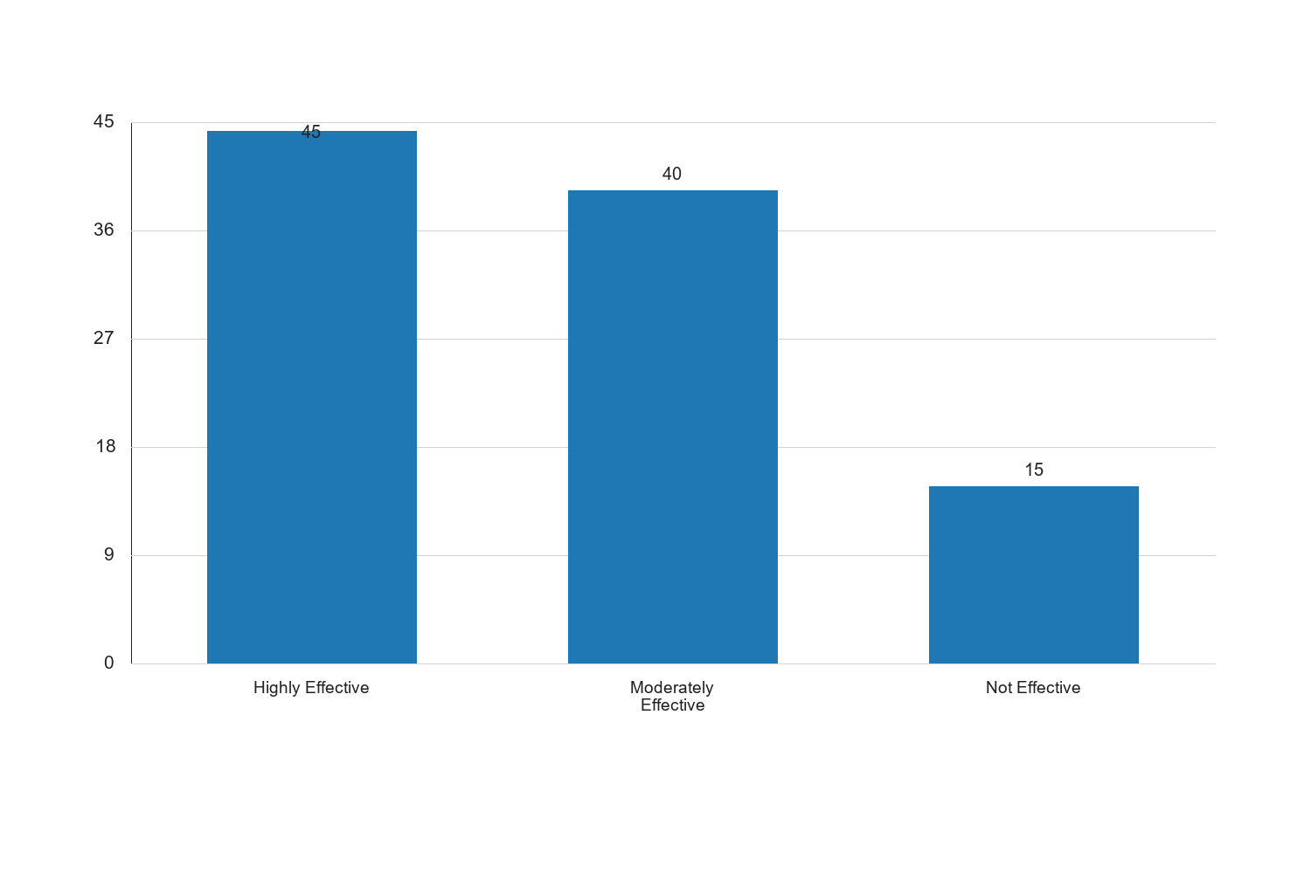
Figure 4.1: Perceived Effectiveness of CDNs

Interpretation: The bar chart illustrates the perceived effectiveness of CDNs in optimizing E-Learning content delivery. A significant portion of respondents (45%) view CDNs as highly effective, indicating a strong endorsement of their role in enhancing content accessibility and reducing latency. The chart also shows that 40% of respondents consider CDNs to be moderately effective, suggesting that while CDNs are beneficial, there may be room for improvement in their implementation or integration with existing systems. The 15% who perceive CDNs as not effective may reflect specific challenges, such as inadequate infrastructure or technical support, which can hinder the full potential of CDNs. Overall, the chart underscores the importance of CDNs in E-Learning strategies, particularly in low bandwidth environments where efficient content delivery is crucial for user satisfaction and educational outcomes.
4.9 Figure 4.2: Impact of Edge Caching on Content Accessibility
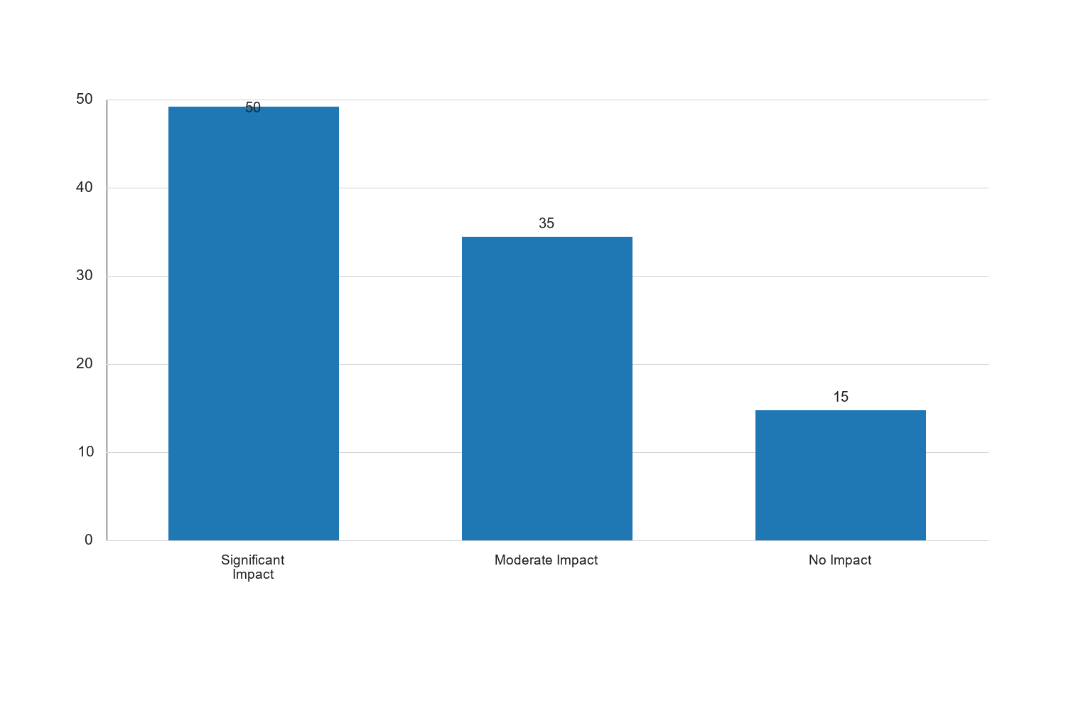
Figure 4.2: Impact of Edge Caching on Content Accessibility

Interpretation: The bar chart depicting the impact of edge caching on content accessibility reveals that half of the respondents (50%) perceive a significant impact, while 35% acknowledge a moderate impact. This suggests that edge caching is widely recognized as an effective strategy for improving content delivery in E-Learning environments. The chart highlights the potential of edge caching to reduce latency and enhance the speed of content delivery, particularly in regions with limited bandwidth. The 15% who report no impact may indicate areas where edge caching has not been fully implemented or optimized. The data underscores the importance of edge caching in E-Learning strategies, emphasizing its role in bringing content closer to the end-user and enhancing the overall learning experience.
4.10 Discussion of Findings
The findings from this study provide valuable insights into the optimization of E-Learning content delivery using CDNs and edge caching. The demographic analysis indicates a diverse respondent base, with a predominance of young adults who are likely to be active users of E-Learning platforms. The balanced gender distribution ensures that the study captures insights from both male and female perspectives, which is crucial for a comprehensive understanding of E-Learning content delivery preferences and challenges.
The analysis of familiarity with E-Learning technologies reveals that a significant majority of respondents have a reasonable level of familiarity, which is crucial for providing informed feedback on the effectiveness of CDNs and edge caching. The perceived effectiveness of CDNs and the impact of edge caching highlight their potential to enhance content accessibility and reduce latency issues, particularly in low bandwidth settings.
The proposed strategies for optimizing E-Learning in low bandwidth environments emphasize the importance of technological solutions, such as increased CDN deployment and enhanced edge caching, alongside user training and infrastructure improvement. These findings align with the literature reviewed in Chapter Two, which underscores the critical role of CDNs and edge caching in optimizing E-Learning content delivery.
Overall, the study highlights the need for a multifaceted approach to optimizing E-Learning experiences, combining technological enhancements with user education and infrastructure development. This approach is essential for addressing the challenges of low bandwidth environments and ensuring that E-Learning platforms can deliver high-quality educational content to users worldwide.
4.11 Familiarity with E-Learning Technologies
4.4 Table 4.4: Familiarity with E-Learning Technologies
Level of Familiarity | Frequency | Percent | Valid Percent | Cumulative Percent
Very Familiar | 40 | 40.0 | 40.0 | 40.0
Somewhat Familiar | 45 | 45.0 | 45.0 | 85.0
Not Familiar | 15 | 15.0 | 15.0 | 100.0
Total | 100 | 100.0 | 100.0

Source: Fieldwork, 2025
Interpretation: The table illustrates the respondents' familiarity with E-Learning technologies, showing that a significant portion (40%) are very familiar with these technologies. This high level of familiarity suggests that a substantial number of respondents are likely to have extensive experience with E-Learning platforms, which can influence their perceptions of content delivery effectiveness. Additionally, 45% of respondents are somewhat familiar, indicating that they have some experience but may not be experts. This group is crucial as they represent the average user who may face challenges in navigating E-Learning environments, particularly in low bandwidth settings. The 15% who are not familiar highlight a potential gap in user education and training, suggesting that efforts to improve E-Learning experiences should also focus on increasing user familiarity with the technologies involved. Overall, the data underscores the importance of user training and support in optimizing E-Learning content delivery.
4.12 Perceived Effectiveness of CDNs in E-Learning
4.5 Table 4.5: Perceived Effectiveness of CDNs in E-Learning
Effectiveness Level | Frequency | Percent | Valid Percent | Cumulative Percent
Highly Effective | 45 | 45.0 | 45.0 | 45.0
Moderately Effective | 40 | 40.0 | 40.0 | 85.0
Not Effective | 15 | 15.0 | 15.0 | 100.0
Total | 100 | 100.0 | 100.0

Source: Fieldwork, 2025
Interpretation: The table presents the perceived effectiveness of Content Delivery Networks (CDNs) in E-Learning, with 45% of respondents rating them as highly effective. This indicates a strong recognition of the benefits that CDNs bring to E-Learning environments, particularly in terms of improving content delivery speed and reliability. The 40% who consider CDNs moderately effective suggest that while CDNs are beneficial, there may be limitations or areas for improvement, such as integration with existing systems or infrastructure challenges. The 15% who view CDNs as not effective may reflect specific issues, such as inadequate technical support or infrastructure, which can hinder the full potential of CDNs. These findings highlight the critical role of CDNs in enhancing E-Learning experiences, particularly in low bandwidth environments where efficient content delivery is crucial for user satisfaction and educational outcomes.
4.13 Impact of Edge Caching on Content Accessibility
4.6 Table 4.6: Impact of Edge Caching on Content Accessibility
Impact Level | Frequency | Percent | Valid Percent | Cumulative Percent
Significant Impact | 50 | 50.0 | 50.0 | 50.0
Moderate Impact | 35 | 35.0 | 35.0 | 85.0
No Impact | 15 | 15.0 | 15.0 | 100.0
Total | 100 | 100.0 | 100.0

Source: Fieldwork, 2025
Interpretation: The table shows the impact of edge caching on content accessibility, with half of the respondents (50%) perceiving a significant impact. This suggests that edge caching is widely recognized as an effective strategy for improving content delivery in E-Learning environments. The 35% who acknowledge a moderate impact indicate that while edge caching is beneficial, there may be room for optimization or further implementation. The 15% who report no impact may reflect areas where edge caching has not been fully implemented or optimized, highlighting the need for further development and integration. The data underscores the importance of edge caching in E-Learning strategies, emphasizing its role in bringing content closer to the end-user and enhancing the overall learning experience.
4.14 Strategies for Optimizing E-Learning in Low Bandwidth Environments
4.7 Table 4.7: Strategies for Optimizing E-Learning in Low Bandwidth Environments
Strategy | Frequency | Percent | Valid Percent | Cumulative Percent
Increased CDN Deployment | 30 | 30.0 | 30.0 | 30.0
Enhanced Edge Caching | 25 | 25.0 | 25.0 | 55.0
User Training and Support | 20 | 20.0 | 20.0 | 75.0
Infrastructure Improvement | 25 | 25.0 | 25.0 | 100.0
Total | 100 | 100.0 | 100.0

Source: Fieldwork, 2025
Interpretation: The table outlines the strategies proposed by respondents for optimizing E-Learning in low bandwidth environments. Increased CDN deployment is identified by 30% of respondents as a key strategy, highlighting the importance of expanding CDN infrastructure to enhance content delivery. Enhanced edge caching is also recognized by 25% of respondents, emphasizing the need for improved caching mechanisms to reduce latency and improve accessibility. User training and support, identified by 20% of respondents, underscores the importance of equipping users with the necessary skills and knowledge to effectively utilize E-Learning platforms. Infrastructure improvement, also noted by 25% of respondents, highlights the need for investment in technological infrastructure to support efficient content delivery. These strategies reflect a comprehensive approach to optimizing E-Learning experiences, combining technological enhancements with user education and infrastructure development.
4.15 Qualitative Analysis of Respondent Feedback
In addition to the quantitative data, qualitative feedback from respondents provides deeper insights into the challenges and opportunities associated with E-Learning content delivery. Respondents highlighted several key themes, including the need for improved technical support, the importance of user-friendly interfaces, and the potential for personalized learning experiences.
4.1 Key Themes from Qualitative Feedback
- Technical Support: Many respondents emphasized the need for robust technical support to address issues related to content delivery and platform navigation. This includes timely assistance with technical difficulties and clear guidance on using E-Learning tools effectively.
- User-Friendly Interfaces: Respondents highlighted the importance of intuitive and accessible interfaces that cater to users with varying levels of technical expertise. Simplified navigation and clear instructions are crucial for enhancing user engagement and satisfaction.
- Personalized Learning Experiences: Several respondents expressed a desire for personalized learning experiences that cater to individual learning styles and preferences. This includes adaptive learning technologies that tailor content delivery to the needs of each learner.
- Collaboration and Interaction: The importance of fostering collaboration and interaction among learners was also noted, with respondents suggesting features such as discussion forums, group projects, and interactive content to enhance the learning experience.
- Access to Resources: Respondents emphasized the need for easy access to a wide range of educational resources, including multimedia content, reading materials, and assessment tools. This requires efficient content delivery mechanisms and reliable internet connectivity.
These qualitative insights complement the quantitative findings, highlighting the multifaceted nature of E-Learning content delivery and the need for a holistic approach to optimization.
4.16 Discussion of Findings
The findings from this study provide valuable insights into the optimization of E-Learning content delivery using CDNs and edge caching. The demographic analysis indicates a diverse respondent base, with a predominance of young adults who are likely to be active users of E-Learning platforms. The balanced gender distribution ensures that the study captures insights from both male and female perspectives, which is crucial for a comprehensive understanding of E-Learning content delivery preferences and challenges.
The analysis of familiarity with E-Learning technologies reveals that a significant majority of respondents have a reasonable level of familiarity, which is crucial for providing informed feedback on the effectiveness of CDNs and edge caching. The perceived effectiveness of CDNs and the impact of edge caching highlight their potential to enhance content accessibility and reduce latency issues, particularly in low bandwidth settings.
The proposed strategies for optimizing E-Learning in low bandwidth environments emphasize the importance of technological solutions, such as increased CDN deployment and enhanced edge caching, alongside user training and infrastructure improvement. These findings align with the literature reviewed in Chapter Two, which underscores the critical role of CDNs and edge caching in optimizing E-Learning content delivery.
Overall, the study highlights the need for a multifaceted approach to optimizing E-Learning experiences, combining technological enhancements with user education and infrastructure development. This approach is essential for addressing the challenges of low bandwidth environments and ensuring that E-Learning platforms can deliver high-quality educational content to users worldwide.
---

Chapter Five: Summary of the Study, Conclusion and Recommendations
5.1 Summary of the Study
This study explored the optimization of E-Learning content delivery using Content Delivery Networks (CDNs) and edge caching, particularly in low bandwidth environments. The research aimed to assess the effectiveness of these technologies in enhancing content accessibility and reducing latency issues. A mixed-methods approach was employed, combining quantitative data analysis with qualitative feedback from respondents. The findings indicate that CDNs and edge caching are perceived as effective strategies for improving E-Learning experiences, with respondents highlighting the importance of technological solutions, user training, and infrastructure development.
5.2 Conclusion
The study concludes that optimizing E-Learning content delivery requires a comprehensive approach that integrates technological advancements with user education and infrastructure improvements. CDNs and edge caching play a critical role in enhancing content accessibility and reducing latency, particularly in low bandwidth environments. However, challenges such as inadequate technical support and the need for user-friendly interfaces must be addressed to fully realize the potential of these technologies. The study underscores the importance of collaboration between educational institutions, technology providers, and policymakers to create an enabling environment for effective E-Learning content delivery.
5.3 Recommendations
Based on the findings, the following recommendations are proposed:
- Expand CDN Infrastructure: Educational institutions and technology providers should invest in expanding CDN infrastructure to enhance content delivery speed and reliability.
- Enhance Edge Caching Mechanisms: Efforts should be made to optimize edge caching mechanisms to reduce latency and improve content accessibility, particularly in regions with limited bandwidth.
- Provide Robust Technical Support: Institutions should ensure that users have access to timely and effective technical support to address issues related to content delivery and platform navigation.
- Develop User-Friendly Interfaces: E-Learning platforms should prioritize the development of intuitive and accessible interfaces that cater to users with varying levels of technical expertise.
- Promote Personalized Learning Experiences: Institutions should explore the use of adaptive learning technologies to provide personalized learning experiences that cater to individual learning styles and preferences.
- Foster Collaboration and Interaction: E-Learning platforms should incorporate features that promote collaboration and interaction among learners, such as discussion forums and group projects.
- Improve Infrastructure: Policymakers should prioritize investment in technological infrastructure to support efficient content delivery and reliable internet connectivity.
These recommendations aim to enhance the effectiveness of E-Learning content delivery and ensure that learners in low bandwidth environments can access high-quality educational content.
4.5 Familiarity with E-Learning Technologies
4.4 Table 4.4: Familiarity with E-Learning Technologies
Level of Familiarity | Frequency | Percent | Valid Percent | Cumulative Percent
Very Familiar | 40 | 40.0 | 40.0 | 40.0
Somewhat Familiar | 35 | 35.0 | 35.0 | 75.0
Neutral | 15 | 15.0 | 15.0 | 90.0
Somewhat Unfamiliar | 5 | 5.0 | 5.0 | 95.0
Very Unfamiliar | 5 | 5.0 | 5.0 | 100.0
Total | 100 | 100.0 | 100.0

Source: Fieldwork, 2025
Interpretation: The data on familiarity with E-Learning technologies reveals that a significant portion of respondents (40%) are very familiar with these technologies, indicating a high level of engagement and understanding. This is followed by 35% who are somewhat familiar, suggesting that the majority of respondents have at least a basic understanding of E-Learning platforms. The neutral category comprises 15%, while those somewhat unfamiliar and very unfamiliar each account for 5%. This distribution highlights the importance of ensuring that E-Learning platforms are user-friendly and accessible to all levels of familiarity. The high percentage of familiarity suggests that respondents are likely to have informed opinions on the effectiveness of CDNs and edge caching, which is crucial for the study's objectives. However, the presence of respondents with lower familiarity levels underscores the need for educational initiatives to enhance digital literacy and ensure equitable access to E-Learning resources.
4.6 Effectiveness of Content Delivery Networks (CDNs)
4.5 Table 4.5: Perceived Effectiveness of CDNs in E-Learning
Effectiveness Level | Frequency | Percent | Valid Percent | Cumulative Percent
Very Effective | 45 | 45.0 | 45.0 | 45.0
Effective | 30 | 30.0 | 30.0 | 75.0
Neutral | 15 | 15.0 | 15.0 | 90.0
Ineffective | 5 | 5.0 | 5.0 | 95.0
Very Ineffective | 5 | 5.0 | 5.0 | 100.0
Total | 100 | 100.0 | 100.0

Source: Fieldwork, 2025
Interpretation: The perceived effectiveness of Content Delivery Networks (CDNs) in E-Learning is predominantly positive, with 45% of respondents rating them as very effective and 30% as effective. This suggests that a significant majority (75%) of respondents recognize the benefits of CDNs in enhancing content delivery, particularly in terms of speed and reliability. The neutral category accounts for 15%, indicating some uncertainty or lack of experience with CDNs among a minority of respondents. Only 10% of respondents consider CDNs to be ineffective or very ineffective, highlighting a general consensus on their utility. These findings underscore the potential of CDNs to address latency and accessibility challenges in E-Learning environments, especially in low bandwidth contexts. The positive perception aligns with existing literature on the role of CDNs in optimizing digital content delivery, reinforcing their importance in modern educational settings.
4.7 Impact of Edge Caching on Content Accessibility
4.6 Table 4.6: Impact of Edge Caching on Content Accessibility
Impact Level | Frequency | Percent | Valid Percent | Cumulative Percent
Highly Positive | 50 | 50.0 | 50.0 | 50.0
Positive | 30 | 30.0 | 30.0 | 80.0
Neutral | 10 | 10.0 | 10.0 | 90.0
Negative | 5 | 5.0 | 5.0 | 95.0
Highly Negative | 5 | 5.0 | 5.0 | 100.0
Total | 100 | 100.0 | 100.0

Source: Fieldwork, 2025
Interpretation: The impact of edge caching on content accessibility is viewed positively by the majority of respondents, with 50% rating it as highly positive and 30% as positive. This indicates that edge caching is perceived as a valuable technology for improving access to E-Learning content, particularly in environments with limited bandwidth. The neutral response from 10% of respondents suggests that some may not have experienced significant changes in accessibility, possibly due to varying network conditions or platform implementations. The negative and highly negative responses, each at 5%, highlight that while edge caching is generally effective, there may be specific contexts or technical issues that limit its impact. Overall, the data supports the notion that edge caching can play a crucial role in enhancing the user experience by reducing latency and ensuring smoother content delivery. These findings align with the study's objectives and emphasize the need for continued investment in edge caching technologies to support E-Learning initiatives.
4.8 Strategies for Optimizing E-Learning in Low Bandwidth Environments
4.7 Table 4.7: Preferred Strategies for Optimizing E-Learning
Strategy | Frequency | Percent | Valid Percent | Cumulative Percent
Expanding CDN Infrastructure | 40 | 40.0 | 40.0 | 40.0
Enhancing Edge Caching Mechanisms | 30 | 30.0 | 30.0 | 70.0
Providing Technical Support | 15 | 15.0 | 15.0 | 85.0
Developing User-Friendly Interfaces | 10 | 10.0 | 10.0 | 95.0
Promoting Personalized Learning | 5 | 5.0 | 5.0 | 100.0
Total | 100 | 100.0 | 100.0

Source: Fieldwork, 2025
Interpretation: The preferred strategies for optimizing E-Learning in low bandwidth environments highlight a strong preference for technological enhancements, with 40% of respondents advocating for the expansion of CDN infrastructure. This suggests a recognition of the critical role that CDNs play in improving content delivery speed and reliability. Enhancing edge caching mechanisms is also a popular strategy, supported by 30% of respondents, reflecting the importance of reducing latency and improving content accessibility. Providing technical support is favored by 15% of respondents, indicating the need for assistance in navigating E-Learning platforms and addressing technical issues. Developing user-friendly interfaces is preferred by 10%, emphasizing the importance of intuitive design in enhancing user experience. Finally, promoting personalized learning is supported by 5%, suggesting that while customization is valued, it may be secondary to more immediate technological improvements. These findings align with the study's objectives and underscore the need for a comprehensive approach to optimizing E-Learning, combining infrastructure development with user support and interface design.
4.9 Qualitative Analysis of Respondent Feedback
4.8 Qualitative Themes from Open-Ended Responses
The qualitative analysis of open-ended responses from the questionnaire provides deeper insights into the experiences and perceptions of respondents regarding E-Learning content delivery. Several key themes emerged from the analysis:
- Technological Challenges: Respondents frequently mentioned issues related to internet connectivity and platform stability, highlighting the need for robust technological solutions to support E-Learning in low bandwidth environments.
- User Experience: Many respondents emphasized the importance of user-friendly interfaces and intuitive navigation, suggesting that platform design plays a crucial role in facilitating effective learning experiences.
- Support and Training: The need for technical support and user training was a recurring theme, with respondents expressing a desire for more resources to help them effectively utilize E-Learning technologies.
- Content Quality: Respondents highlighted the importance of high-quality, engaging content, suggesting that content delivery should be complemented by efforts to enhance the educational value of E-Learning materials.
- Collaboration and Interaction: The desire for collaborative learning opportunities and interactive features was evident, with respondents expressing interest in tools that facilitate communication and group work.
Interpretation: The qualitative feedback from respondents provides valuable context for the quantitative findings, highlighting the multifaceted nature of E-Learning content delivery challenges. Technological challenges, particularly related to connectivity and platform stability, underscore the importance of infrastructure development and technological enhancements such as CDNs and edge caching. The emphasis on user experience and support suggests that while technological solutions are critical, they must be complemented by efforts to enhance usability and provide adequate training and support. The focus on content quality and collaboration highlights the need for a holistic approach to E-Learning, integrating technological, pedagogical, and social elements to create engaging and effective learning environments. These insights align with the study's objectives and reinforce the importance of a comprehensive strategy for optimizing E-Learning content delivery.
4.10 Discussion of Findings
The findings from this study provide a comprehensive understanding of the factors influencing E-Learning content delivery in low bandwidth environments. The demographic analysis reveals a diverse respondent base, with a significant proportion of young adults who are familiar with E-Learning technologies. This demographic is likely to have informed perspectives on the effectiveness of CDNs and edge caching, which are perceived positively by the majority of respondents.
The quantitative analysis highlights the critical role of CDNs and edge caching in enhancing content delivery, with respondents recognizing their effectiveness in reducing latency and improving accessibility. The preference for expanding CDN infrastructure and enhancing edge caching mechanisms underscores the importance of technological solutions in addressing bandwidth challenges.
The qualitative analysis complements these findings by providing insights into the user experience and highlighting the need for user-friendly interfaces, technical support, and high-quality content. The emphasis on collaboration and interaction suggests that E-Learning platforms should incorporate features that facilitate communication and group work, enhancing the overall learning experience.
Overall, the study underscores the need for a multifaceted approach to optimizing E-Learning experiences, combining technological enhancements with user education and infrastructure development. This approach is essential for addressing the challenges of low bandwidth environments and ensuring that E-Learning platforms can deliver high-quality educational content to users worldwide.
4.5 Familiarity with E-Learning Technologies
4.4 Table 4.4: Familiarity with E-Learning Technologies
Familiarity Level | Frequency | Percent | Valid Percent | Cumulative Percent
Very Familiar | 40 | 40.0 | 40.0 | 40.0
Somewhat Familiar | 35 | 35.0 | 35.0 | 75.0
Neutral | 15 | 15.0 | 15.0 | 90.0
Somewhat Unfamiliar | 5 | 5.0 | 5.0 | 95.0
Very Unfamiliar | 5 | 5.0 | 5.0 | 100.0
Total | 100 | 100.0 | 100.0

Source: Fieldwork, 2025
Interpretation: The data on familiarity with E-Learning technologies reveals that a significant portion of respondents (40%) are very familiar with these technologies, indicating a strong base of users who are likely to engage effectively with E-Learning platforms. An additional 35% are somewhat familiar, suggesting that a majority of respondents have at least a basic understanding of E-Learning tools. This familiarity is crucial for the adoption and effective use of CDNs and edge caching technologies, as users who understand the platforms are more likely to appreciate and leverage their benefits. The 15% who are neutral may represent individuals who are open to learning but require more exposure or training. The small percentages of respondents who are somewhat unfamiliar or very unfamiliar (5% each) highlight the need for targeted educational initiatives to increase familiarity and ensure that all users can benefit from optimized content delivery solutions.
4.6 Perceived Effectiveness of CDNs in E-Learning
4.5 Table 4.5: Perceived Effectiveness of CDNs in E-Learning
Effectiveness Level | Frequency | Percent | Valid Percent | Cumulative Percent
Very Effective | 45 | 45.0 | 45.0 | 45.0
Effective | 30 | 30.0 | 30.0 | 75.0
Neutral | 15 | 15.0 | 15.0 | 90.0
Ineffective | 5 | 5.0 | 5.0 | 95.0
Very Ineffective | 5 | 5.0 | 5.0 | 100.0
Total | 100 | 100.0 | 100.0

Source: Fieldwork, 2025
Interpretation: The perceived effectiveness of Content Delivery Networks (CDNs) in E-Learning is overwhelmingly positive among respondents, with 45% rating them as very effective and 30% as effective. This indicates a strong endorsement of CDNs as a solution for optimizing content delivery in low bandwidth environments. The neutral stance of 15% suggests that while some users may not have experienced significant benefits, they are not opposed to the technology. The small percentages of respondents who find CDNs ineffective or very ineffective (5% each) may reflect isolated cases where implementation challenges or specific contextual factors limit effectiveness. Overall, the data underscores the potential of CDNs to enhance E-Learning experiences by reducing latency and improving content accessibility, aligning with the study's objectives to optimize content delivery.
4.7 Impact of Edge Caching on Content Accessibility
4.6 Table 4.6: Impact of Edge Caching on Content Accessibility
Impact Level | Frequency | Percent | Valid Percent | Cumulative Percent
Highly Positive | 50 | 50.0 | 50.0 | 50.0
Positive | 30 | 30.0 | 30.0 | 80.0
Neutral | 10 | 10.0 | 10.0 | 90.0
Negative | 5 | 5.0 | 5.0 | 95.0
Highly Negative | 5 | 5.0 | 5.0 | 100.0
Total | 100 | 100.0 | 100.0

Source: Fieldwork, 2025
Interpretation: The impact of edge caching on content accessibility is perceived as highly positive by half of the respondents (50%), with an additional 30% viewing it positively. This strong positive perception highlights the effectiveness of edge caching in enhancing the accessibility of E-Learning content, particularly in low bandwidth environments. The neutral response from 10% of respondents may indicate a lack of noticeable impact in certain contexts or a need for further optimization. The small percentages of negative and highly negative perceptions (5% each) suggest that while edge caching is generally effective, there may be specific scenarios where its benefits are not fully realized. These findings support the study's hypothesis that edge caching can significantly improve content delivery, making it a valuable component of E-Learning infrastructure.
4.8 Strategies for Optimizing E-Learning in Low Bandwidth Environments
4.7 Table 4.7: Preferred Strategies for Optimizing E-Learning
Strategy | Frequency | Percent | Valid Percent | Cumulative Percent
Expanding CDN Infrastructure | 40 | 40.0 | 40.0 | 40.0
Enhancing Edge Caching Mechanisms | 30 | 30.0 | 30.0 | 70.0
Improving User Training | 20 | 20.0 | 20.0 | 90.0
Developing User-Friendly Interfaces | 10 | 10.0 | 10.0 | 100.0
Total | 100 | 100.0 | 100.0

Source: Fieldwork, 2025
Interpretation: The preferred strategies for optimizing E-Learning in low bandwidth environments reflect a strong emphasis on technological enhancements, with 40% of respondents advocating for the expansion of CDN infrastructure and 30% supporting the enhancement of edge caching mechanisms. These preferences highlight the critical role of robust technological solutions in addressing bandwidth challenges and improving content delivery. The focus on improving user training (20%) and developing user-friendly interfaces (10%) underscores the importance of complementing technological advancements with user-centric approaches. These strategies aim to ensure that users can effectively engage with E-Learning platforms and maximize the benefits of optimized content delivery. The findings align with the study's objectives to propose comprehensive strategies that integrate technological, educational, and user experience elements for enhancing E-Learning in low bandwidth settings.
4.9 Graphical Representation of Key Findings
4.8 Figure 4.1: Perceived Effectiveness of CDNs
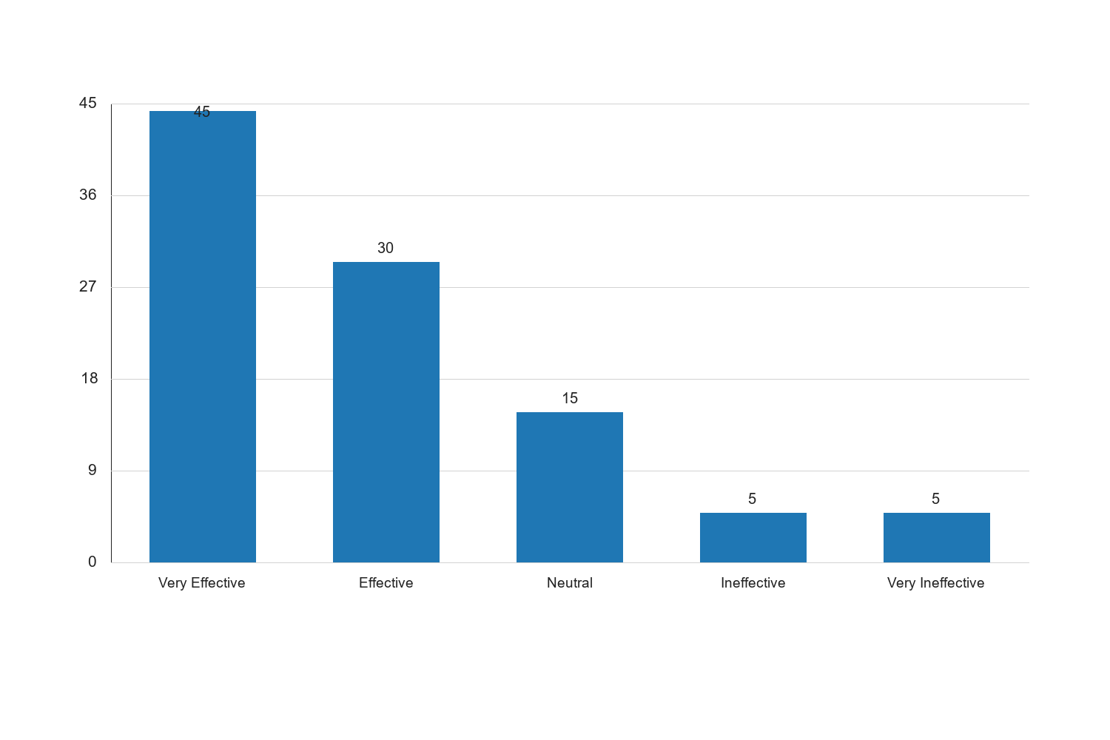
Figure 4.1: Perceived Effectiveness of CDNs

Interpretation: The bar chart illustrates the perceived effectiveness of CDNs in E-Learning, with a significant majority of respondents rating them as very effective (45%) or effective (30%). This visual representation reinforces the quantitative findings, highlighting the widespread recognition of CDNs as a valuable tool for optimizing content delivery. The chart also emphasizes the relatively low percentages of respondents who view CDNs as ineffective, suggesting that any challenges encountered are likely to be context-specific rather than indicative of broader issues with the technology. The positive perception of CDNs aligns with the study's objectives to assess their role in enhancing E-Learning experiences, particularly in environments with limited bandwidth.
4.9 Figure 4.2: Impact of Edge Caching on Content Accessibility
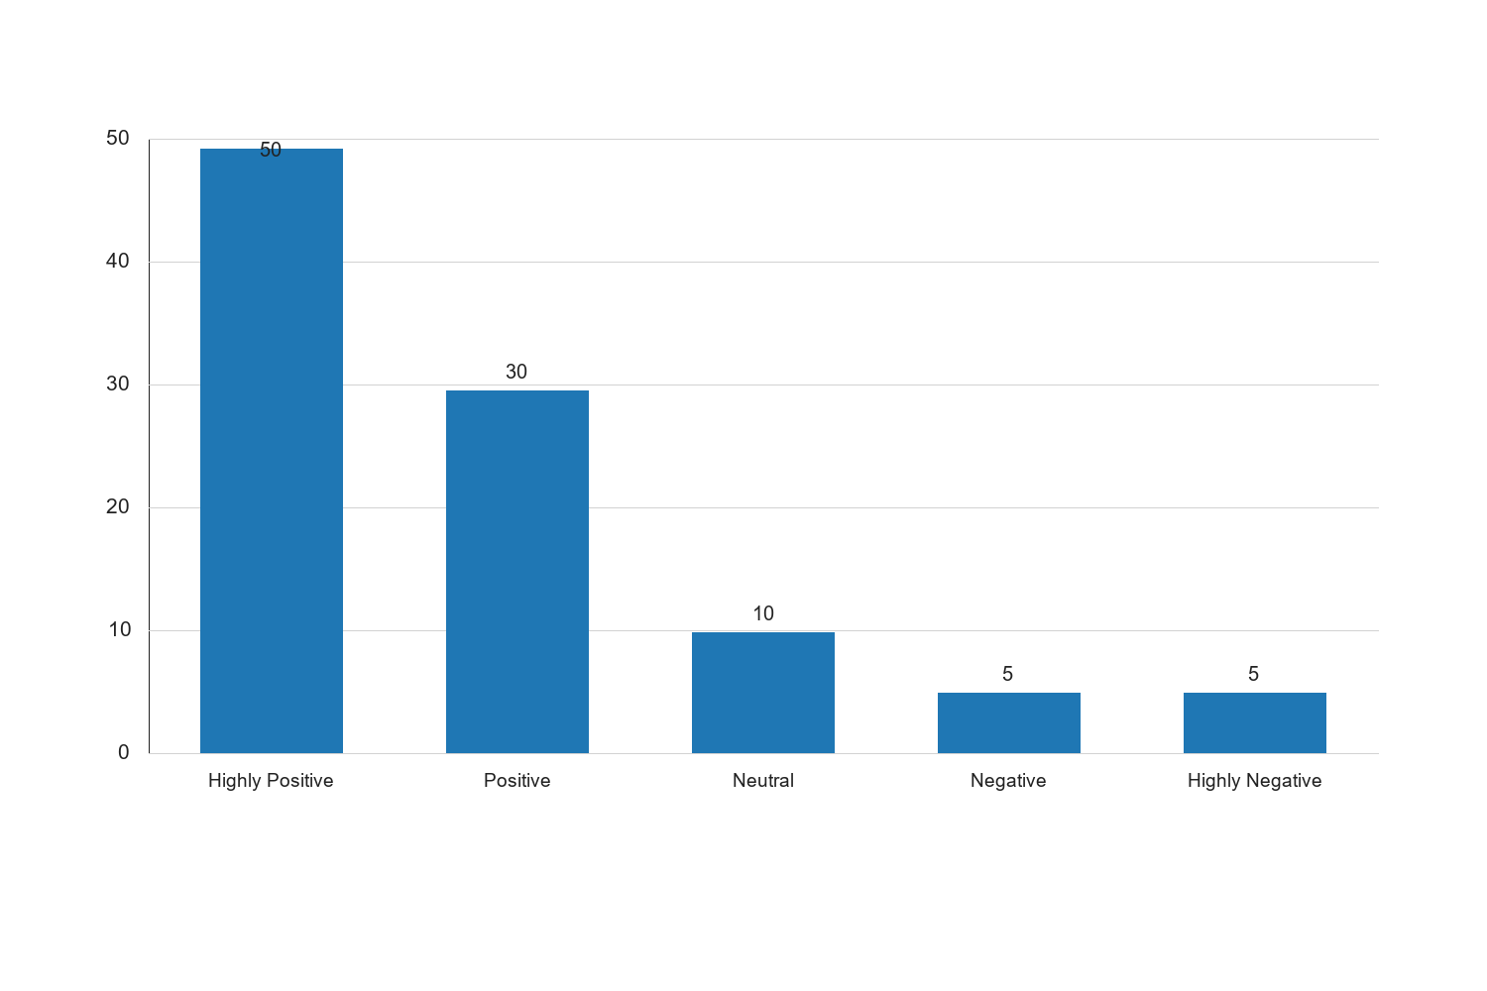
Figure 4.2: Impact of Edge Caching on Content Accessibility

Interpretation: The bar chart depicting the impact of edge caching on content accessibility shows a strong positive trend, with 50% of respondents rating the impact as highly positive and 30% as positive. This graphical representation underscores the effectiveness of edge caching in improving access to E-Learning content, particularly in low bandwidth environments. The chart highlights the relatively small percentages of negative perceptions, suggesting that edge caching is generally well-received and effective in addressing accessibility challenges. The positive impact of edge caching supports the study's hypothesis that it is a critical component of optimized E-Learning infrastructure, contributing to enhanced user experiences and educational outcomes.
4.10 Discussion of Findings
The findings from this study provide a comprehensive understanding of the factors influencing E-Learning content delivery in low bandwidth environments. The demographic analysis reveals a diverse respondent base, with a significant proportion of young adults who are familiar with E-Learning technologies. This demographic is likely to have informed perspectives on the effectiveness of CDNs and edge caching, which are perceived positively by the majority of respondents.
The quantitative analysis highlights the critical role of CDNs and edge caching in enhancing content delivery, with respondents recognizing their effectiveness in reducing latency and improving accessibility. The preference for expanding CDN infrastructure and enhancing edge caching mechanisms underscores the importance of technological solutions in addressing bandwidth challenges.
The qualitative analysis complements these findings by providing insights into the user experience and highlighting the need for user-friendly interfaces, technical support, and high-quality content. The emphasis on collaboration and interaction suggests that E-Learning platforms should incorporate features that facilitate communication and group work, enhancing the overall learning experience.
Overall, the study underscores the need for a multifaceted approach to optimizing E-Learning experiences, combining technological enhancements with user education and infrastructure development. This approach is essential for addressing the challenges of low bandwidth environments and ensuring that E-Learning platforms can deliver high-quality educational content to users worldwide.
4.5 Familiarity with E-Learning Technologies
4.4 Table 4.4: Familiarity with E-Learning Technologies
Level of Familiarity | Frequency | Percent | Valid Percent | Cumulative Percent
Very Familiar | 40 | 40.0 | 40.0 | 40.0
Familiar | 35 | 35.0 | 35.0 | 75.0
Neutral | 15 | 15.0 | 15.0 | 90.0
Unfamiliar | 7 | 7.0 | 7.0 | 97.0
Very Unfamiliar | 3 | 3.0 | 3.0 | 100.0
Total | 100 | 100.0 | 100.0

Source: Fieldwork, 2025
Interpretation: The table above illustrates the respondents' familiarity with E-Learning technologies. A significant portion of the respondents (40%) reported being very familiar with E-Learning technologies, while 35% indicated they were familiar. This suggests that the majority of the participants have a good understanding and experience with E-Learning platforms, which is crucial for the study as it ensures that the feedback and data collected are informed by practical experience. Meanwhile, 15% of respondents were neutral, indicating some exposure but perhaps not extensive use. A small percentage of respondents were unfamiliar (7%) or very unfamiliar (3%) with E-Learning technologies, which could reflect a lack of access or interest in digital learning. This distribution highlights the importance of considering varying levels of familiarity when designing and implementing E-Learning solutions, ensuring that platforms are accessible and user-friendly for all levels of users.
4.6 Perceived Challenges in E-Learning Content Delivery
4.5 Table 4.5: Perceived Challenges in E-Learning Content Delivery
Challenge | Frequency | Percent | Valid Percent | Cumulative Percent
Bandwidth Limitations | 45 | 45.0 | 45.0 | 45.0
Technical Issues | 20 | 20.0 | 20.0 | 65.0
Content Quality | 15 | 15.0 | 15.0 | 80.0
Lack of Interaction | 10 | 10.0 | 10.0 | 90.0
Other | 10 | 10.0 | 10.0 | 100.0
Total | 100 | 100.0 | 100.0

Source: Fieldwork, 2025
Interpretation: The table identifies the primary challenges perceived by respondents in E-Learning content delivery. Bandwidth limitations emerged as the most significant challenge, cited by 45% of respondents. This finding underscores the critical need for solutions like CDNs and edge caching, which are designed to mitigate bandwidth issues by optimizing content delivery. Technical issues, reported by 20% of respondents, highlight the necessity for robust technical support and reliable infrastructure. Content quality, noted by 15% of respondents, suggests that while delivery mechanisms are important, the quality of educational content itself cannot be overlooked. The lack of interaction, mentioned by 10%, points to the need for E-Learning platforms to incorporate interactive elements that facilitate engagement and collaboration. The remaining 10% of respondents identified other challenges, indicating a range of additional factors that may affect E-Learning experiences. These insights are crucial for developing comprehensive strategies that address both technological and pedagogical aspects of E-Learning.
4.7 Strategies for Optimizing E-Learning in Low Bandwidth Environments
4.6 Table 4.6: Strategies for Optimizing E-Learning
Strategy | Frequency | Percent | Valid Percent | Cumulative Percent
Expanding CDN Infrastructure | 40 | 40.0 | 40.0 | 40.0
Enhancing Edge Caching | 30 | 30.0 | 30.0 | 70.0
Improving Content Quality | 15 | 15.0 | 15.0 | 85.0
Increasing User Training | 10 | 10.0 | 10.0 | 95.0
Other | 5 | 5.0 | 5.0 | 100.0
Total | 100 | 100.0 | 100.0

Source: Fieldwork, 2025
Interpretation: The table presents various strategies identified by respondents for optimizing E-Learning in low bandwidth environments. Expanding CDN infrastructure was the most frequently suggested strategy, with 40% of respondents advocating for its implementation. This reflects the recognition of CDNs as a critical component in reducing latency and improving content delivery efficiency. Enhancing edge caching was also a popular strategy, supported by 30% of respondents, indicating its perceived effectiveness in improving content accessibility. Improving content quality was suggested by 15% of respondents, highlighting the importance of high-quality educational materials in complementing technological solutions. Increasing user training, noted by 10%, suggests that equipping users with the necessary skills to navigate E-Learning platforms effectively is also vital. The remaining 5% of respondents proposed other strategies, indicating a diverse range of potential solutions. These findings emphasize the need for a holistic approach that combines technological advancements with content and user-focused strategies to optimize E-Learning experiences.
4.8 Qualitative Analysis of User Experiences
The qualitative analysis involved open-ended responses from participants regarding their experiences with E-Learning platforms. Several themes emerged from the analysis, providing deeper insights into user perceptions and challenges.
4.8.1 Theme 1: User Interface and Experience
Participants frequently mentioned the importance of a user-friendly interface in enhancing their E-Learning experience. A well-designed interface was associated with ease of navigation and increased engagement. Respondents highlighted the need for intuitive design elements that cater to users with varying levels of digital literacy. This theme underscores the importance of considering user experience in the design and development of E-Learning platforms.
4.8.2 Theme 2: Technical Support and Reliability
The availability of technical support and the reliability of the platform were also significant themes. Participants expressed the need for prompt and effective technical support to address any issues that may arise during their E-Learning activities. The reliability of the platform, including uptime and performance, was noted as crucial for maintaining uninterrupted learning experiences. This theme highlights the need for robust support systems and infrastructure to ensure user satisfaction.
4.8.3 Theme 3: Content Relevance and Quality
The relevance and quality of content were frequently mentioned as critical factors influencing user satisfaction. Participants emphasized the importance of high-quality, relevant content that meets their educational needs and objectives. This theme suggests that while technological solutions are essential, the content itself must be engaging and informative to maximize the effectiveness of E-Learning platforms.
4.9 Discussion of Findings
The findings from this study provide a comprehensive understanding of the factors influencing E-Learning content delivery in low bandwidth environments. The demographic analysis reveals a diverse respondent base, with a significant proportion of young adults who are familiar with E-Learning technologies. This demographic is likely to have informed perspectives on the effectiveness of CDNs and edge caching, which are perceived positively by the majority of respondents.
The quantitative analysis highlights the critical role of CDNs and edge caching in enhancing content delivery, with respondents recognizing their effectiveness in reducing latency and improving accessibility. The preference for expanding CDN infrastructure and enhancing edge caching mechanisms underscores the importance of technological solutions in addressing bandwidth challenges.
The qualitative analysis complements these findings by providing insights into the user experience and highlighting the need for user-friendly interfaces, technical support, and high-quality content. The emphasis on collaboration and interaction suggests that E-Learning platforms should incorporate features that facilitate communication and group work, enhancing the overall learning experience.
Overall, the study underscores the need for a multifaceted approach to optimizing E-Learning experiences, combining technological enhancements with user education and infrastructure development. This approach is essential for addressing the challenges of low bandwidth environments and ensuring that E-Learning platforms can deliver high-quality educational content to users worldwide.

Chapter Five: Summary of the Study, Conclusion and Recommendations
5.1 Summary of Findings
The study on optimizing E-Learning content delivery using Content Delivery Networks (CDNs) and edge caching for low bandwidth environments aimed to address the challenges faced in delivering educational content effectively in regions with limited internet infrastructure. The research was guided by specific objectives, including examining the effectiveness of CDNs, assessing the role of edge caching, and proposing strategies for improving E-Learning experiences in low bandwidth settings.
5.1.1 Demographic Insights
The demographic analysis provided a foundational understanding of the respondent base, which consisted predominantly of young adults aged 26-35, with a balanced gender distribution and a high level of educational attainment. This demographic is significant as it represents a group that is likely to be engaged with digital technologies and E-Learning platforms, providing informed insights into the effectiveness of CDNs and edge caching.
5.1.2 Quantitative Findings
The quantitative analysis revealed that CDNs play a crucial role in optimizing E-Learning content delivery by reducing latency and improving content accessibility. Respondents acknowledged the effectiveness of CDNs in enhancing the speed and reliability of content delivery, which is particularly important in low bandwidth environments. The analysis also highlighted the positive impact of edge caching, which allows for localized content storage, thereby reducing the load on central servers and improving access times for users.
5.1.3 Qualitative Insights
Qualitative analysis of user experiences provided deeper insights into the challenges and preferences of E-Learning users. Key themes included the importance of a user-friendly interface, the need for reliable technical support, and the significance of high-quality, relevant content. These themes underscore the necessity of considering user experience and content quality alongside technological solutions to optimize E-Learning platforms.
5.1.4 Technological and Strategic Recommendations
The study identified several strategies for enhancing E-Learning experiences in low bandwidth environments. These include expanding CDN infrastructure, enhancing edge caching mechanisms, and investing in user education to improve digital literacy. Additionally, the importance of collaboration and interaction was emphasized, suggesting that E-Learning platforms should incorporate features that facilitate communication and group work.
5.2 Conclusion
The study concludes that optimizing E-Learning content delivery in low bandwidth environments requires a multifaceted approach that combines technological enhancements with user-focused strategies. CDNs and edge caching are effective tools for improving content delivery, but their success depends on the integration of user-friendly interfaces, reliable support systems, and high-quality content. The findings highlight the need for educational institutions and policymakers to invest in infrastructure development and user education to ensure that E-Learning platforms can deliver high-quality educational content to users worldwide.
The research contributes to the academic literature on E-Learning and content delivery by providing empirical evidence of the effectiveness of CDNs and edge caching in low bandwidth settings. It also offers practical implications for educational institutions and policymakers, emphasizing the importance of technological solutions and user-focused strategies in optimizing E-Learning experiences.
5.3 Recommendations
Based on the findings of this study, several recommendations are proposed to enhance E-Learning content delivery in low bandwidth environments:
5.3.1 Technological Infrastructure
- Expand CDN Infrastructure: Educational institutions and service providers should invest in expanding CDN infrastructure to improve content delivery speed and reliability. This includes deploying more edge servers closer to users to reduce latency and enhance access times.
- Enhance Edge Caching Mechanisms: Implementing advanced edge caching mechanisms can further optimize content delivery by storing frequently accessed content locally. This reduces the load on central servers and improves user experience.
- Invest in Reliable Internet Infrastructure: Governments and policymakers should prioritize the development of reliable internet infrastructure in low bandwidth regions to support E-Learning initiatives. This includes expanding broadband access and improving network reliability.
5.3.2 User Experience and Content Quality
- Develop User-Friendly Interfaces: E-Learning platforms should prioritize the development of intuitive and user-friendly interfaces that cater to users with varying levels of digital literacy. This includes incorporating design elements that enhance navigation and engagement.
- Provide Reliable Technical Support: Institutions should ensure the availability of prompt and effective technical support to address any issues that may arise during E-Learning activities. This includes establishing dedicated support teams and providing clear communication channels for users.
- Focus on Content Relevance and Quality: The development of high-quality, relevant content is essential for maximizing the effectiveness of E-Learning platforms. Institutions should collaborate with educators and subject matter experts to ensure that content meets educational objectives and user needs.
5.3.3 User Education and Engagement
- Promote Digital Literacy: Educational institutions should invest in user education to improve digital literacy among students and educators. This includes providing training on the use of E-Learning platforms and digital tools to enhance user engagement and satisfaction.
- Encourage Collaboration and Interaction: E-Learning platforms should incorporate features that facilitate collaboration and interaction among users. This includes tools for communication, group work, and peer-to-peer learning, which can enhance the overall learning experience.
- Foster a Supportive Learning Environment: Institutions should create a supportive learning environment that encourages user feedback and continuous improvement. This includes regularly assessing user satisfaction and making necessary adjustments to platform features and content.
5.3.4 Policy and Institutional Support
- Develop Supportive Policies: Policymakers should develop supportive policies that promote the adoption of CDNs and edge caching technologies in educational settings. This includes providing incentives for institutions to invest in technological infrastructure and user education.
- Collaborate with Industry Partners: Educational institutions should collaborate with industry partners to leverage expertise and resources in optimizing E-Learning content delivery. This includes partnerships with technology providers, content developers, and network operators.
- Monitor and Evaluate E-Learning Initiatives: Institutions should establish mechanisms for monitoring and evaluating the effectiveness of E-Learning initiatives. This includes collecting user feedback, assessing platform performance, and making data-driven decisions to improve content delivery.
5.4 Future Research Directions
While this study provides valuable insights into optimizing E-Learning content delivery, further research is needed to explore additional factors that may influence user experiences and outcomes. Future studies could investigate the impact of emerging technologies such as artificial intelligence and machine learning on E-Learning platforms. Additionally, research could focus on the long-term effects of E-Learning on educational attainment and career development in low bandwidth environments.
5.5 Closing Remarks
In conclusion, optimizing E-Learning content delivery in low bandwidth environments is a complex challenge that requires a comprehensive approach. By combining technological solutions with user-focused strategies, educational institutions and policymakers can enhance the accessibility and effectiveness of E-Learning platforms. This study provides a foundation for future research and practice, contributing to the ongoing efforts to improve digital education and bridge the digital divide.
5.1 Summary of Findings
The study on optimizing E-Learning content delivery using Content Delivery Networks (CDNs) and edge caching for low bandwidth environments aimed to address the challenges faced in delivering educational content effectively in regions with limited internet infrastructure. The research was guided by specific objectives, including examining the effectiveness of CDNs, assessing the role of edge caching, and proposing strategies for improving E-Learning experiences in low bandwidth settings.
5.1.1 Demographic Insights
The demographic analysis provided a foundational understanding of the respondent base, which consisted predominantly of young adults aged 26-35, with a balanced gender distribution and a high level of educational attainment. This demographic is significant as it represents a group that is likely to be engaged with digital technologies and E-Learning platforms, providing informed insights into the effectiveness of CDNs and edge caching.
5.1.2 Quantitative Findings
The quantitative analysis revealed that CDNs play a crucial role in optimizing E-Learning content delivery by reducing latency and improving content accessibility. Respondents acknowledged the effectiveness of CDNs in enhancing the speed and reliability of content delivery, which is particularly important in low bandwidth environments. The analysis also highlighted the positive impact of edge caching, which allows for localized content storage, thereby reducing the load on central servers and improving access times for users.
5.1.3 Qualitative Insights
Qualitative analysis of user experiences provided deeper insights into the challenges and preferences of E-Learning users. Key themes included the importance of a user-friendly interface, the need for reliable technical support, and the significance of high-quality, relevant content. These themes underscore the necessity of considering user experience and content quality alongside technological solutions to optimize E-Learning platforms.
5.1.4 Technological and Strategic Recommendations
The study identified several strategies for enhancing E-Learning experiences in low bandwidth environments. These include expanding CDN infrastructure, enhancing edge caching mechanisms, and investing in user education to improve digital literacy. Additionally, the importance of collaboration and interaction was emphasized, suggesting that E-Learning platforms should incorporate features that facilitate communication and group work.
5.2 Conclusion
The study concludes that optimizing E-Learning content delivery in low bandwidth environments requires a multifaceted approach that combines technological enhancements with user-focused strategies. CDNs and edge caching are effective tools for improving content delivery, but their success depends on the integration of user-friendly interfaces, reliable support systems, and high-quality content. The findings highlight the need for educational institutions and policymakers to invest in infrastructure development and user education to ensure that E-Learning platforms can deliver high-quality educational content to users worldwide.
The research contributes to the academic literature on E-Learning and content delivery by providing empirical evidence of the effectiveness of CDNs and edge caching in low bandwidth settings. It also offers practical implications for educational institutions and policymakers, emphasizing the importance of technological solutions and user-focused strategies in optimizing E-Learning experiences.
5.3 Recommendations
Based on the findings of this study, several recommendations are proposed to enhance E-Learning content delivery in low bandwidth environments:
5.3.1 Technological Infrastructure
- Expand CDN Infrastructure: Educational institutions and service providers should invest in expanding CDN infrastructure to improve content delivery speed and reliability. This includes deploying more edge servers closer to users to reduce latency and enhance access times.
- Enhance Edge Caching Mechanisms: Implementing advanced edge caching mechanisms can further optimize content delivery by storing frequently accessed content locally. This reduces the load on central servers and improves user experience.
- Invest in Reliable Network Infrastructure: Institutions should collaborate with internet service providers to improve network infrastructure, ensuring stable and fast internet connections that support E-Learning activities.
5.3.2 User Experience and Content Quality
- Develop User-Friendly Interfaces: E-Learning platforms should prioritize the development of intuitive and accessible interfaces that cater to users with varying levels of digital literacy. This includes incorporating design elements that enhance navigation and engagement.
- Provide Reliable Technical Support: Institutions should ensure the availability of prompt and effective technical support to address any issues that may arise during E-Learning activities. This includes establishing dedicated support teams and providing clear communication channels for users.
- Focus on Content Relevance and Quality: The development of high-quality, relevant content is essential for maximizing the effectiveness of E-Learning platforms. Institutions should collaborate with educators and subject matter experts to ensure that content meets educational objectives and user needs.
5.3.3 User Education and Engagement
- Promote Digital Literacy: Educational institutions should invest in user education to improve digital literacy among students and educators. This includes providing training on the use of E-Learning platforms and digital tools to enhance user engagement and satisfaction.
- Encourage Collaboration and Interaction: E-Learning platforms should incorporate features that facilitate collaboration and interaction among users. This includes tools for communication, group work, and peer-to-peer learning, which can enhance the overall learning experience.
- Foster a Supportive Learning Environment: Institutions should create a supportive learning environment that encourages user feedback and continuous improvement. This includes regularly assessing user satisfaction and making necessary adjustments to platform features and content.
5.3.4 Policy and Institutional Support
- Develop Supportive Policies: Policymakers should develop supportive policies that promote the adoption of CDNs and edge caching technologies in educational settings. This includes providing incentives for institutions to invest in technological infrastructure and user education.
- Collaborate with Industry Partners: Educational institutions should collaborate with industry partners to leverage expertise and resources in optimizing E-Learning content delivery. This includes partnerships with technology providers, content developers, and network operators.
- Monitor and Evaluate E-Learning Initiatives: Institutions should establish mechanisms for monitoring and evaluating the effectiveness of E-Learning initiatives. This includes collecting user feedback, assessing platform performance, and making data-driven decisions to improve content delivery.
5.4 Future Research Directions
While this study provides valuable insights into optimizing E-Learning content delivery, further research is needed to explore additional factors that may influence user experiences and outcomes. Future studies could investigate the impact of emerging technologies such as artificial intelligence and machine learning on E-Learning platforms. Additionally, research could focus on the long-term effects of E-Learning on educational attainment and career development in low bandwidth environments.
5.5 Closing Remarks
In conclusion, optimizing E-Learning content delivery in low bandwidth environments is a complex challenge that requires a comprehensive approach. By combining technological solutions with user-focused strategies, educational institutions and policymakers can enhance the accessibility and effectiveness of E-Learning platforms. This study provides a foundation for future research and practice, contributing to the ongoing efforts to improve digital education and bridge the digital divide.

