MIT 8103 Advanced Database Systems – Portfolio Documentation
  - Case study: NairaFlow Digital Bank
Ilesanmi Sulaimon · i.sulaimon9160@miva.edu.ng · [Matric number]
[Submission date]
GitHub repository: https://github.com/iamroyalmayor/mit8103-advanced-database-portfolio (private; assessor added as collaborator)

1. Selected organisation
NairaFlow Digital Bank is a simulated Nigerian mobile-first bank. Customers open savings or current accounts after BVN-based KYC (tiers 1–3) and move money through the mobile app, USSD, web, POS, ATM and branch channels. Users: customers, tellers, customer-support staff, auditors and compliance, operations and regulatory reporting. Major data: customers, accounts, transactions, a double-entry ledger, beneficiaries, staff and an audit trail. Key operations: deposit, withdraw, transfer funds atomically, reverse failed or disputed transactions, statements, reconciliation, money-mule detection, and failed-transaction and dormancy reports. A bank was chosen because it makes every advanced topic concrete: a lost update here is lost money.

2. Portfolio 1 – Database design and modelling
A 9-table schema (state, account_type, customer, account, txn, ledger_entry, beneficiary, staff, audit_log), normalised from a flat statement layout through 1NF/2NF/3NF to BCNF. The core idea is a double-entry ledger: every transaction has debit and credit legs that must balance, which a DEFERRABLE INITIALLY DEFERRED constraint trigger checks at COMMIT. Keys combine surrogate identity PKs with natural candidate keys (BVN, NUBAN, e-mail, phone, transaction UUID used as an idempotency key), a composite PK for the M:N beneficiary relationship, and a recursive FK for reversals. CHECK constraints enforce the phone format, minimum age, the no-overdraft rule (except internal GL accounts) and the reversal link. transfer_funds() and reverse_transaction() hold the business logic. Evidence: ER diagram, DDL, and 13 validation tests, each rejected by the expected constraint; Σ of all balances = 0.00.
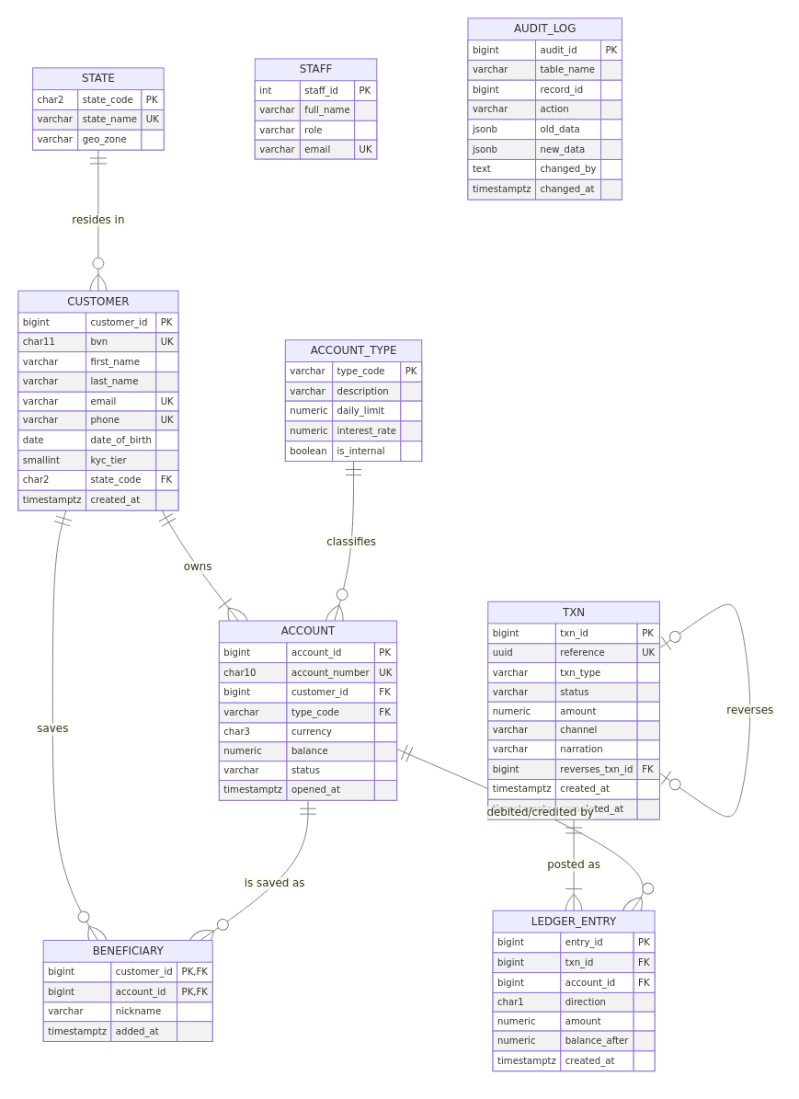
NairaFlow ER diagram (full size in portfolio-1-database-design/diagrams)

3. Portfolio 2 – Query processing and optimisation
The schema was loaded with 60 k customers, 100 k accounts, 1.1 M transactions and about 2.1 M ledger rows. Seven workload queries were run with EXPLAIN (ANALYZE, BUFFERS) before and after indexing:
Query | Before (ms) | After (ms) | Index used
Q1 account statement | 333.6 | 0.23 | composite (account_id, created_at DESC)
Q2 e-mail lookup | 74.7 | 0.04 | expression lower(email)
Q3 failed-txn dashboard | 181.7 | 13.7 | partial WHERE status='FAILED'
Q4 top senders (7 days) | 529.2 | 173.3 | covering INCLUDE (...) (index-only)
Q5 mule detection | 503.3 | 196.5 | covering + uq_leg
Q6 reconciliation | 11,101.5 | 0.62 | composite (LATERAL LIMIT 1)
Q7 dormant accounts | 575.3 | 436.4 | anti-join; needs a design change, not an index
Each index was chosen from the plan: a composite B-tree (equality column, then range/sort column) removed a Seq Scan and a Sort for statements; an expression index made lower(email) searchable; a partial index covers only FAILED rows; a covering index with INCLUDE gave index-only scans. The largest gain (Q6) turned a correlated LATERAL lookup from 50 full scans into 50 index probes. Index cost (space and write amplification) is discussed in the README. Monthly range partitioning pruned 14 of 15 partitions (672 ms → 101 ms) and enabled DETACH PARTITION archiving.

4. Portfolio 3 – Transactions and concurrency
Single-session demos show COMMIT, ROLLBACK, automatic rollback of a failed transaction, SAVEPOINT partial rollback, and idempotent retries. Two-session scenarios, synchronised and time-stamped, reproduce: a lost update at READ COMMITTED (₦30,000 vanished); its fixes, SELECT … FOR UPDATE (B blocked until A committed) and REPEATABLE READ (serialization failure, so retry); write skew that REPEATABLE READ allows (the combined-balance rule was violated) but SERIALIZABLE (SSI) prevents; and a deadlock with its fix, global lock ordering. A pgbench stress test (16 clients, 50 hot accounts) showed naive read-modify-write creating money (Σ ≠ 0), while transfer_funds() processed 21,864 transfers (≈ 1,450 tps) with 0 failures, Σ = 0.00 and every balance matching the ledger.

5. Portfolio 4 – NoSQL and advanced data models
MongoDB: customers embed bounded KYC documents, devices and beneficiaries; accounts are referenced (hot, frequently updated); transactions embed their ledger legs, so a posting is a single atomic document write; a bucket pattern stores one statement document per account-month. $jsonSchema validation, Decimal128 money, multikey and partial indexes cut account-history scans from 157,974 to 13 documents (≈ 400 ms → 5 ms). A multi-document transaction (withTransaction, snapshot / majority) committed one transfer and rolled back three failure cases. Redis handles sessions (TTL), OTP rate limiting, idempotency keys (SET NX), a balance cache, sorted-set leaderboards and HyperLogLog fraud counters. A Neo4j Cypher design covers multi-hop mule rings. Conclusion: polyglot persistence, with PostgreSQL as the system of record.

6. Portfolio 5 – Distributed and cloud databases
With Docker Compose: a PostgreSQL primary plus a streaming hot standby (replication slot). The replica rejects writes, replication lag was measured under a 200 k-row burst, synchronous commit blocked writes when the standby was down (CAP: consistency chosen over availability), and failover promoted the replica, which kept every committed transfer. A 3-node MongoDB replica set elected a new primary in about 11.5–12 s after the primary was killed; w:majority writes continued and the old primary rejoined as a secondary. A w:5 write returned an error yet was still applied: a write-concern error means “unknown outcome”, not “rolled back”. A shard-key simulation showed HASH(customer_id) spreading data evenly with single-shard statements, while RANGE(created_at) would create a write hot spot. A cloud design (Multi-AZ PostgreSQL, MongoDB Atlas, Redis, CDC, NDPA 2023 data residency, RPO 0 / RTO < 60 s) is in cloud-architecture.md.

7. Individual technical reflection
Draft for you to rewrite in your own words. The assessor marks this as evidence of your understanding (3 marks).
Design choices. I chose a double-entry ledger over simply updating balances, because it makes correctness checkable: Σ balances must be zero and every transaction must balance. That check later exposed real bugs. I kept a stored balance for O(1) authorisation and accepted that controlled redundancy, reconciling it against the ledger.
Challenges. (1) The pgbench test failed at first because the stored functions resolved table names through the caller’s search_path. Pinning SET search_path on every function fixed it and also closes a known security hole. (2) After the stress test, a few accounts’ last ledger row did not match the balance. The cause was now(), which returns the transaction start time, so a transfer that waited for a row lock was stamped earlier than the transfer it queued behind. Using clock_timestamp() after the locks are acquired fixed the ordering. (3) Making two-session experiments reproducible required synchronising on pg_stat_activity instead of fixed sleeps.
Lessons learned. Isolation levels are not abstract: READ COMMITTED silently lost money, and only SERIALIZABLE caught write skew. Indexes must be justified from execution plans and paid for in write cost. Distribution is a set of trade-offs (synchronous replication gives RPO 0 but can block writes). Document databases excel at read-shaped aggregates but push integrity rules into code.

References
- Cahill, M. J., Röhm, U. and Fekete, A. D. (2008) ‘Serializable isolation for snapshot databases’, Proc. ACM SIGMOD, pp. 729–738.
- Connolly, T. and Begg, C. (2015) Database Systems: A Practical Approach to Design, Implementation, and Management. 6th edn. Pearson.
- Elmasri, R. and Navathe, S. B. (2016) Fundamentals of Database Systems. 7th edn. Pearson.
- Kleppmann, M. (2017) Designing Data-Intensive Applications. O’Reilly Media.
- Abadi, D. (2012) ‘Consistency tradeoffs in modern distributed database system design: CAP is only part of the story’, IEEE Computer, 45(2), pp. 37–42.
- PostgreSQL Global Development Group (2025) PostgreSQL 16 Documentation: chapters 11 (Indexes), 13 (Concurrency Control), 14 (Performance Tips), 5.11 (Table Partitioning), 27 (High Availability and Replication). https://www.postgresql.org/docs/16/
- MongoDB Inc. (2025) MongoDB 7.0 Manual: Data Modeling, Schema Validation, Transactions, Replication. https://www.mongodb.com/docs/v7.0/
- Redis Ltd. (2025) Redis Documentation: data types, EXPIRE, HyperLogLog. https://redis.io/docs/
- Federal Republic of Nigeria (2023) Nigeria Data Protection Act, 2023.
- Central Bank of Nigeria (2023) Guidelines on Operations of Bank Accounts and AML/CFT regulations.

