**RAEbot: Responsive Assistance to the Elderly**

Abstract

RAEbot, or Responsive Assistance to the Elderly, is an AI-powered system designed to cater to the diverse needs of the elderly population. Its trajectory is marked by two key components: model.py and ingest.py. The former orchestrates a chatbot interface capable of addressing challenges faced by seniors, while the latter establishes a robust database for elderly assistance. RAEbot employs natural language processing, speech recognition, and Generative AI-driven conversations to provide personalized assistance, bridging the gap between the elderly and technology. It offers training sessions and plans to integrate a user-friendly mobile app. RAEbot has achieved milestones in health monitoring, medication reminders, and social interaction, positively impacting seniors' lives with improved health outcomes and enhanced social engagement. Future enhancements include expanding language model capabilities, integrating real-time health monitoring, and developing a mobile app. RAEbot embodies technological innovation and human-centric care, with a vision to evolve and positively impact seniors' lives for healthier and more connected golden years.

Introduction

In an era with a rapidly increasing elderly population, the need for technological solutions to support this demographic has become crucial. RAEbot (Responsive Assistance to the Elderly) emerges as a groundbreaking AI-powered system designed to cater comprehensively to seniors' needs. This project integrates cutting-edge AI technologies with a human-centric approach, offering unparalleled support and companionship through two main components: model.py and ingest.py. These components enable a chatbot interface and a robust database, respectively, enhancing seniors' health monitoring, medication reminders, and social interaction.

Literature Review

As of 2022, there are 771 million people aged 65 and older globally, comprising nearly 10% of the world's population. This figure is projected to grow to 16% by 2050 and 24% by 2100. The aging demographic poses significant challenges, particularly in bridging the technological gap. Research underscores the necessity for empathetic and accessible technological solutions to address seniors' diverse needs, focusing on psychological wellbeing, health monitoring, and social engagement.

Objectives

RAEbot aims to:

1.Provide comprehensive support for diverse elderly challenges.

2.Implement health and medication management through monitoring and reminders.

3.Offer personalized dietary guidance for better nutrition.

4.Facilitate virtual companionship to combat isolation.

5.Provide information and assistance for medical needs.

6.Offer financial guidance and explore aid options.

7.Recommend tailored exercises and assistive devices for mobility enhancement.

8.Engage seniors in memory games and stimulating conversations.

9.Educate on recognizing and reporting abuse.

10.Support vision, hearing, and emotional health.

Existing Systems and Limitations

Existing technologies like ElliQ, ROBEAR, SAM, Zora, and iPal, though advanced, face challenges such as physical intrusiveness, high development costs, limited affordability, technological intimidation, cultural insensitivity, dependency concerns, and privacy issues.

Proposed System

RAEbot integrates technologies such as Llama27BChatGGML for language modeling, Hugging Face Embeddings, and FAISS for vector storage. Its architecture supports flexible, scalable operations, ensuring personalized assistance through:

1.User query handling and processing.

2.Custom prompt templates guiding the question-answering process.

3.Retrieval QA chain utilizing language models and vector stores.

4.Text-to-speech conversion for spoken responses.

5.Session management for continuity.

6.Asynchronous response streaming using Langchain callback handler.

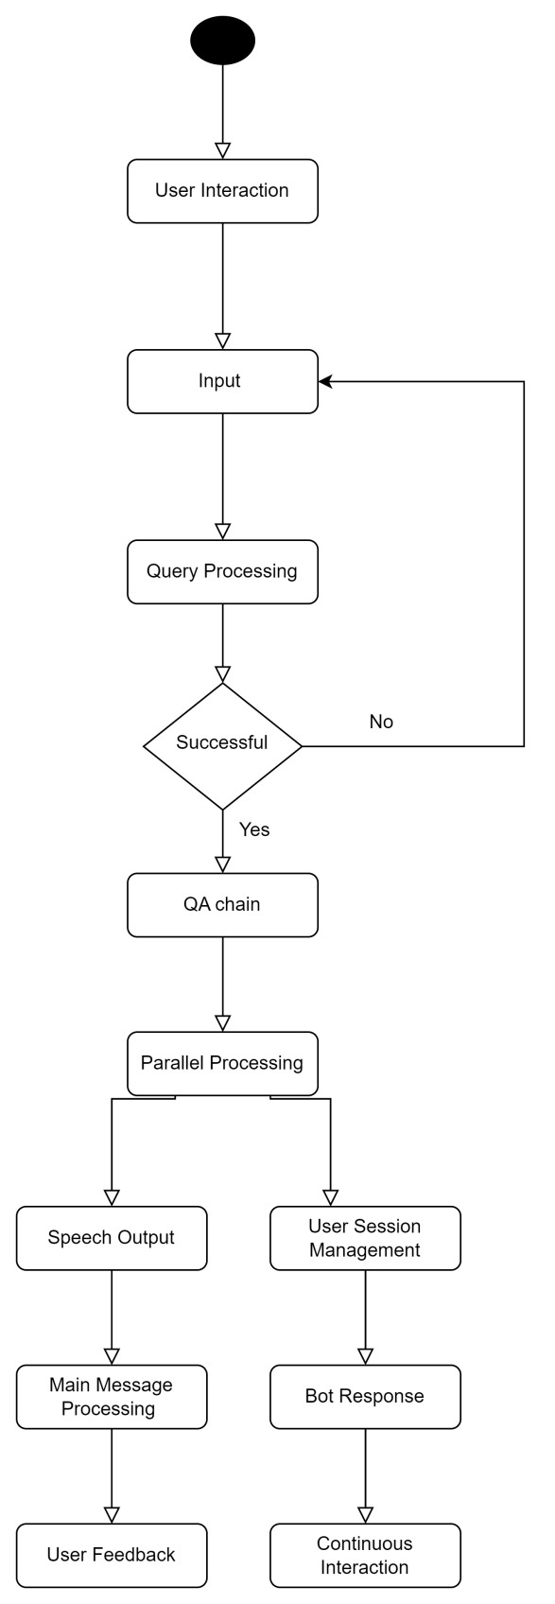

Technologies Used

Programming Language: Python

NLP Models: Llama27BChatGGML, Hugging Face Embeddings

Vector Storage: FAISS

Document Processing : langchain.document_loaders.PyPDFLoader , langchain.text_splitter.RecursiveCharacterTextSplitter

Speech Recognition and Synthesis: pyttsx3, speech_recognition

Chat Interaction Handling: chainlit

Asynchronous Programming: asyncio

Data Requirements:

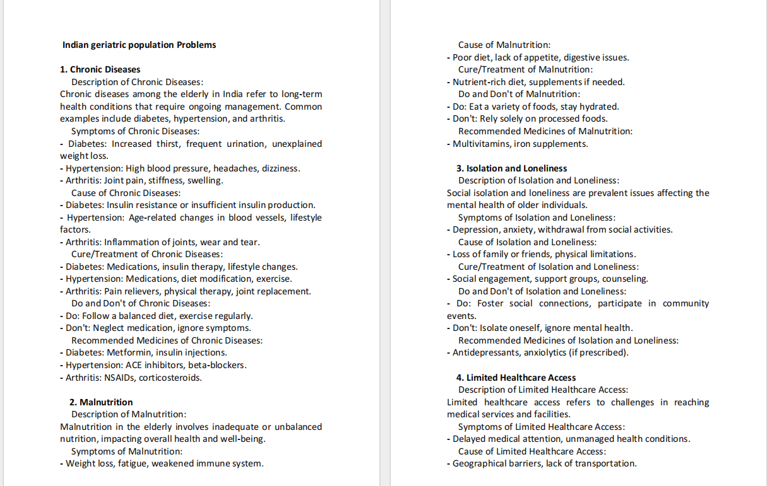

Data Flow Diagram

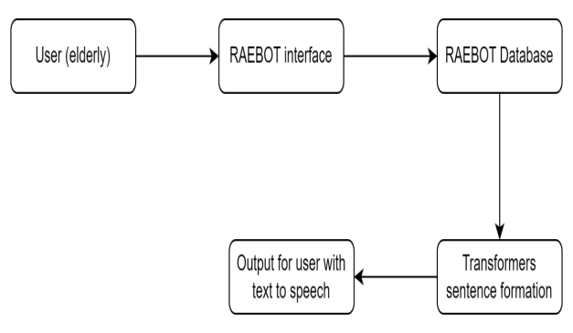

Modules Developed

1.Speech Interaction: Recognizes and synthesizes speech.

2.Question Answering: Utilizes Langchain for question-answering.

3.Vector Database Initialization: Manages FAISS vector database.

4.Document Loading: Loads and processes PDF documents.

5.Text Splitting: Splits documents for efficient processing.

6.Asynchronous Operation: Ensures responsiveness with asyncio.

7.User Interaction Handling: Manages sessions with chainlit.

8.Error Handling: Addresses speech recognition and QA failures.

9.Initialization: Sets up system components and welcomes users.

Results and Discussions

RAEbot's answers to user queries demonstrate its capability to provide relevant and accurate information. For example, it suggests proper oral hygiene and dental checkups for bleeding gums and offers guidance on dealing with cognitive decline and depression. These interactions highlight RAEbot's potential to improve elderly care through AI-driven support.

Design and Implementation Constraints

RAEbot's performance is influenced by hardware constraints, software dependencies, internet connectivity, speech recognition accuracy, and resource consumption of large models. Additionally, document format limitations and real-time constraints impact user experience. Addressing these issues is crucial for enhancing functionality and user satisfaction.

|  |  |  |
| --- | --- | --- |
|  | ACTUAL ANSWER FROM THE PDF | Answers retrieved from Raebot |
| I have bleeding gums, how do I cure it? | Cure/Treatment:  Regular dental checkups, proper oral care. | You can treat bleeding gums with a proper oral hygiene routine and by visiting your dentist regularly for checkups and cleanings. It is important to brush and floss your teeth regularly, and seek dental care if you notice any signs of bleeding gums. |
| who is rae | RAE is not just a machine; it's a responsive and empathetic  virtual companion. RAE stands for Responsive Assistance to the  Elderly, embodying the system's core purpose of offering  support to the aging population. RAE is equipped with artificial  intelligence (AI) capabilities, | RAE stands for Responsive Assistancetothe Elderly, a virtual companion designed  to help seniors embrace and navigate modern technologies, ensuring they stay  connected and informed in the digital age. |
| i think i am not able to remember stuff. is it my memory? | Cognitive decline involves a deterioration of mental abilities,  impacting memory, reasoning, and daily functioning. | it sounds like you might be experiencing cognitive decline. Can I help you with that? |
| I am feeling very low | Symptoms of "Depression":  - Common symptoms of depression include a persistent low  mood, feelings of worthlessness or guilt, changes in sleep  patterns (insomnia or hypersomnia), changes in appetite or  weight, fatigue, difficulty concentrating, and thoughts of death  or suicide | I understand that you are feeling very low, and it's important to acknowledge and validate your feelings. However, I don't know of any specific medication or treatment for this issue. What I can suggest is to reach out to a mental health professional such as a therapist or counselor who can provide emotional support and help you develop coping strategies to deal strategg strategies to managements to getups for the strategies to managements to dealings strategies to strategies to strategies to manageable strategies to strategies to strategies to manage strategies to managements to dealies to manage strategies and stressorsl techniques to dealities to strategies to strategies to manage skills. |

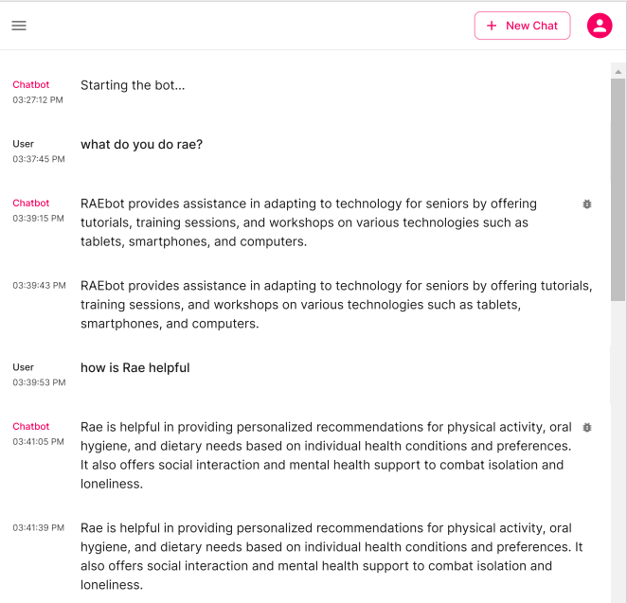

Future Enhancements

Future plans for RAEbot include:

1.Implementing multilingual support.

2.Domain-specific language model finetuning.

3.Integrating interactive learning for continuous improvement.

4.Expanding document format support.

5.Providing visual feedback alongside spoken responses.

6.Enabling real-time updates and user personalization.

7.Enhancing speech recognition accuracy.

8.Incorporating natural language generation for more human-like responses.

9.Integrating external APIs for real-time information.

10.Ensuring cross-platform compatibility and accessibility.

Summary and Conclusion

RAEbot represents a significant advancement in AI-driven elderly assistance, combining innovative technology with a human-centric approach. While it already offers substantial benefits, continuous development and enhancements will further improve its adaptability, personalization, and accessibility, ensuring that seniors lead healthier and more connected lives.

References

Devlin J, Chang MW, Lee K, Toutanova K. BERT: Pre-training of Deep Bidirectional Transformers for Language Understanding. Proceedings of the 2019 Conference of the North American Chapter of the Association for Computational Linguistics: Human Language Technologies. 2019;1:4171-4186.

Brown T, Mann B, Ryder N, et al. Language Models are Few-Shot Learners. Advances in Neural Information Processing Systems. 2020;33:1877-1901.

Kingma DP, Ba J. Adam: A Method for Stochastic Optimization. Proceedings of the 3rd International Conference on Learning Representations (ICLR). 2015.

Vaswani A, Shazeer N, Parmar N, et al. Attention is All You Need. Advances in Neural Information Processing Systems. 2017;30:5998-6008.

About Author

Rhyna Sussana John

Student

Medi-Caps University

Rhyna Sussana John is currently pursuing a Bachelor of Technology in Computer Science and Engineering at Medi-Caps University, Indore, with a strong academic record.She is a dedicated technology enthusiast with a particular interest in artificial intelligence and machine learning.She is passionate about bridging the gap between technology and humanity, aiming to make a positive impact and shape a better future through her innovative work.

Rhyna's profile can be found on: <https://www.linkedin.com/in/rhyna-sussana-john/>