Identity and Access Management

Identity management (IdM), also known as identity and access management (IAM or IdAM), is a framework of policies and technologies for ensuring that the proper people in an enterprise have the appropriate access to technology resources. IdM systems fall under the overarching umbrellas of IT security and Data Management. Identity and access management systems not only identify, authenticate and authorize individuals who will be utilizing IT resources, but also the hardware and applications employees need to access.

Identity management (ID management) is the organizational process for identifying, authenticating and authorizing individuals or groups of people to have access to applications, systems or networks by associating user rights and restrictions with established identities. Identity management (IdM) is the task of controlling information about users on computers. Such information includes information that authenticates the identity of a user, and information that describes information and actions they are authorized to access and/or perform.

User access
User access enables users to assume a specific digital identity across applications, which enables access controls to be assigned and evaluated against this identity. The use of a single identity for a given user across multiple systems eases tasks for administrators and users. It simplifies access monitoring and verification and allows the organizations to minimize excessive privileges granted to one user. User access can be tracked from initiation to termination of user access.
When organizations deploy an identity management process or system, their motivation is normally not primarily to manage a set of identities, but rather to grant appropriate access rights to those entities via their identities. In other words, access management is normally the motivation for identity management and the two sets of processes are consequently closely related.

Services
Organizations continue to add services for both internal users and by customers. Many such services require identity management to properly provide these services. Increasingly, identity management has been partitioned from application functions so that a single identity can serve many or even all of an organization's activities.
For internal use identity management is evolving to control access to all digital assets, including devices, network equipment, servers, portals, content, applications and/or products.
Services often require access to extensive information about a user, including address books, preferences, entitlements and contact information. Since much of this information is subject to privacy and/or confidentiality requirements, controlling access to it is vital.

Identity federation
Identity federation comprises one or more systems that share user access and allow users to log in based on authenticating against one of the systems participating in the federation. This trust between several systems is often known as "Circle of Trust". In this setup, one system acts as the Identity Provider (IdP) and other system(s) acts as Service Provider (SP). When a user needs to access some service controlled by SP, he/she first authenticates against the IdP. Upon successful authentication, the IdP sends a secure "assertion" to the Service Provider. "SAML assertions, specified using a mark up language intended for describing security assertions, can be used by a verifier to make a statement to a relying party about the identity of a claimant. SAML assertions may optionally be digitally signed."

SAML

Security Assertion Markup Language (SAML) standard defines an XML-based framework for describing and exchanging security information between on-line business partners. This security information is expressed in the form of portable SAML assertions that applications working across security domain boundaries can trust. The OASIS SAML standard defines precise syntax and rules for requesting, creating, communicating, and using these SAML assertions.

SAML needed for exchanging security information :- There are several drivers behind the adoption of the SAML standard, including >>
- Single Sign-On: Single sign-on (SSO) is a property of access control of multiple related, yet independent, software systems. With this property, a user logs in with a single ID and password to gain access to any of several related systems. It is often accomplished by using the Lightweight Directory Access Protocol (LDAP) and stored LDAP databases on (directory) servers. A simple version of single sign-on can be achieved over IP networks using cookies but only if the sites share a common DNS parent domain.

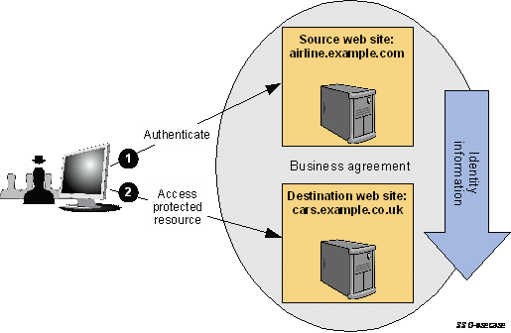

In this use case, a user has a login session (that is, a security context) on a web site (airline.example.com) and is accessing resources on that site. At some point, either explicitly or transparently, he is directed over to a partner's web site (cars.example.co.uk). In this case, we assume that a federated identity for the user has been previously established between airline.example.com and cars.example.co.uk based on a business agreement between them. The identity provider site (airline.example.com) asserts to the service provider site (cars.example.co.uk) that the user is known (by referring to the user by their federated identity), has authenticated to it, and has certain identity attributes. Since cars.example.co.uk trusts airline.example.com, it trusts that the user is valid and properly authenticated and thus creates a local session for the user.

- Federated identity:
This use case, shown in bellow, how, during web SSO, the sites can dynamically establish the federated name identifiers used in the account linking process. One identity provider, airline.example.com, and two service providers exist in this example: cars.example.co.uk for car rentals and hotels.example.ca for hotel bookings. The example assumes a user is registered on all three provider sites (i.e. they have pre-existing local login accounts), but the local accounts all have different account identifiers. At airline.example.com, user John is registered as johndoe, on cars.example.co.uk his account is jdoe, and on hotels.example.ca it is johnd. The sites have established an agreement to use persistent SAML privacy-preserving pseudonyms for the user's federated name identifiers. John has not previously federated his identities between these sites.

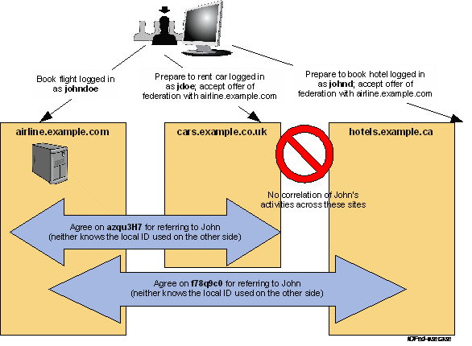

- Web services and other industry standards: SAML allows for its security assertion format to be used outside of a “native” SAML-based protocol context. This modularity has proved useful to other industry efforts addressing authorization services (IETF, OASIS), identity frameworks, web services (OASIS, Liberty Alliance), etc. The OASIS WS-Security Technical Committee has defined a profile for how to use SAML's rich assertion constructs within a WS-Security security token that can be used, for example, to secure web service SOAP message exchanges. In particular, the advantage offered by the use of a SAML assertion is that it provides a standards-based approach to the exchange of information, including attributes, that are not easily conveyed using other WS-Security token formats.

LDAP

LDAP stands for Lightweight Directory Access Protocol. As the name suggests, it is a lightweight client-server protocol for accessing directory services, specifically X.500-based directory services. LDAP runs over TCP/IP or other connection oriented transfer services. LDAP is defined in "RFC2251" The Lightweight Directory Access Protocol (v3).
A directory is similar to a database, but tends to contain more descriptive, attribute-based information. The information in a directory is generally read much more often than it is written. Directories are tuned to give quick-response to high-volume lookup or search operations. They may have the ability to replicate information widely in order to increase availability and reliability, while reducing response time. When directory information is replicated, temporary inconsistencies between the replicas may be OK, as long as they get in sync eventually.

OpenID Connect (OIDC)

OpenID Connect is a simple identity layer on top of the OAuth 2.0 protocol, which allows computing clients to verify the identity of an end-user based on the authentication performed by an authorization server, as well as to obtain basic profile information about the end-user in an interoperable and REST-like manner. In technical terms, OpenID Connect specifies a RESTful HTTP API, using JSON as a data format.

The communication flow in both processes is similar :
- The user requests a resource or site login from the application.
- The site sees that the user is not authenticated. It formulates a request for the identity provider, encodes it, and sends it to the user as part of a redirect URL.
- The user's browser requests the redirect URL for the identity provider, including the application's request
- If necessary, the identity provider authenticates the user (perhaps by asking them for their username and password)
- Once the identity provider is satisfied that the user is sufficiently authenticated, it processes the application's request, formulates a response, and sends that back to the user along with a redirect URL back to the application.
- The user's browser requests the redirect URL that goes back to the application, including the identity provider's response
- The application decodes the identity provider's response, and carries on accordingly.
- (OAuth only) The response includes an access token which the application can use to gain direct access to the identity provider's services on the user's behalf.

