**Name: SAJO SAM**

**Roll No: 32**

**Batch: BATCH B**

**Date: 25-03-2022**

**ADVANCED DBMS LAB**

**Experiment No.: 1**

**Aim**

To study various DDL commands – CREATE, INSERT

**QUESTION**

Create the following Tables and Insert values.

**Table 1: DEPOSIT**

ACTNO VARCHAR (5) PRIMARY KEY, FIRST LETTER MUST START WITH ‘D’

CNAME VARCHAR (20) FOREIGN KEY REFERENCES CUSTOMER

BNAME VARCHAR (20) FOREGIGN KEY REFERENCES BRANCH

AMOUNT NUMBER (8,2) NOT NULL, CANNOT BE 0

ADATE DATE

**Table 2: BRANCH**

BNAME VARCHAR2(20) PRIMARY KEY

CITY VARCHAR2(30) NOT NULL , any one of NAGPUR, DELHI, BANGALORE, BOMBAY

**Table 3: CUSTOMER**

CNAME VARCHAR (15) PRIMARY KEY

CITY VARCHAR (20) NOT NULL

**Table 4: BORROW**

LOANNO VARCHAR (28) PRIMARY KEY / FIRST LETTER MUST START WITH ‘L’

CNAME VARCHAR (15) FOREIGN KEY REFERENCES CUSTOMER

BNAME VARCHAR2(20) FOREIGN KEY REFERENCES BRANCH

AMOUNT NUMBER(8,2) NOT NULL, CANNOT BE 0

**PROCEDURE**

1. **Customer table (Create and Insert)**



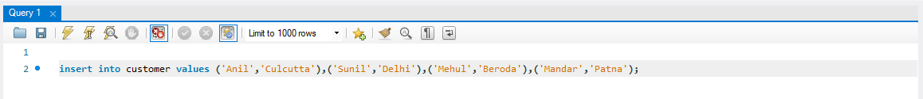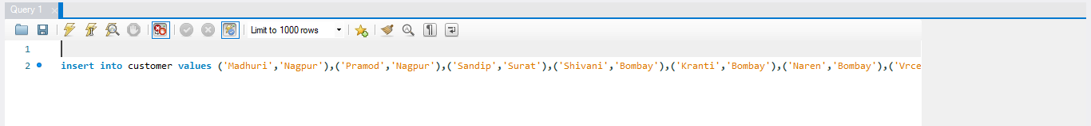

1. **Branch (Create and Insert)**

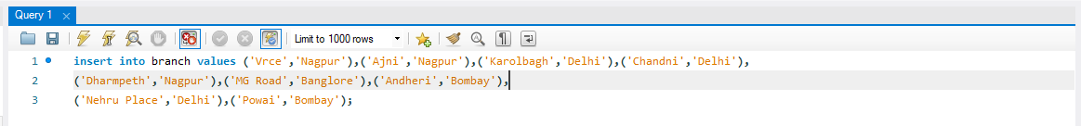

1. **Borrow (Create and Insert)**

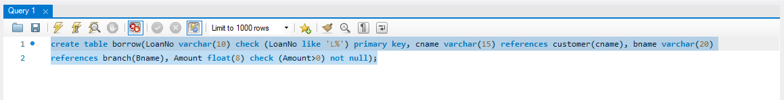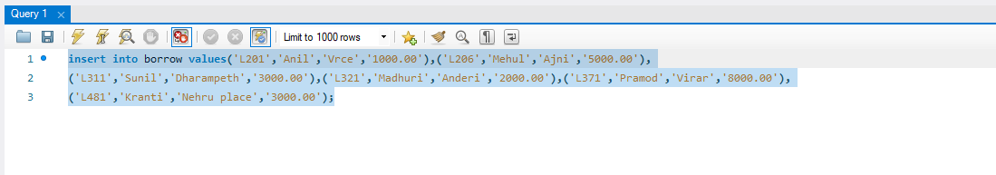

1. **Deposit (Create and Insert)**

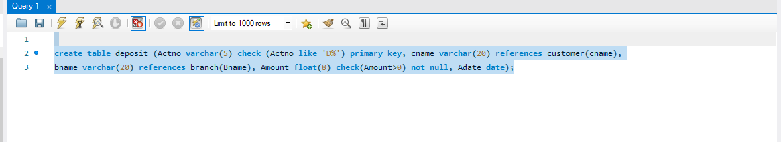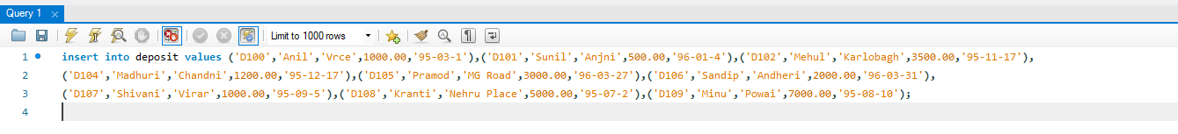

**Output Screenshot**

1. **Customer Table**

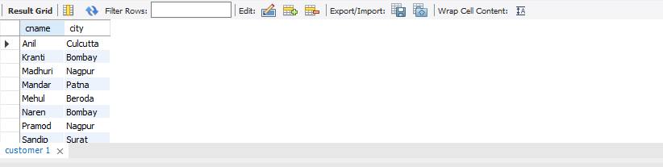

1. **Branch Table**

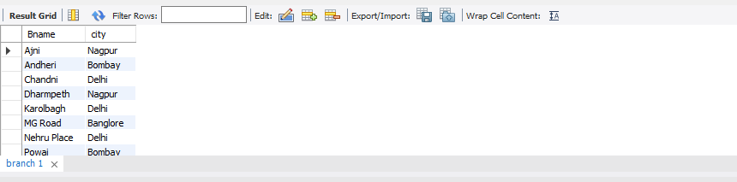

1. **BORROW TABLE**

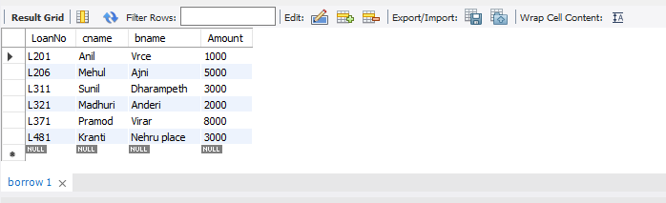

1. **DEPOSIT TABLE**

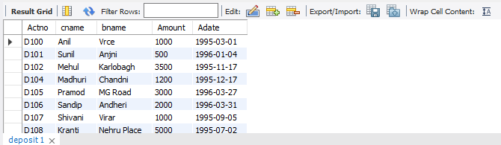

**Name: SAJO SAM**

**Roll No: 32**

**Batch: BATCH B**

**Date: 08-04-2022**

**ADVANCED DBMS LAB**

**Experiment No.: 2**

**Aim**

To familiarize with selecting data from single table

**Questions**

1. List all data from table deposite.

2. List all data from borrow.

3. List all data from customer.

4. List all data from branch.

5. Give account no and amount of deposite.

6. Give customer name and account no of depositors.

7. Give name of customers.

8. Give name of branches.

9. Give name of borrows.

10. Give names of customer living in city Nagpur.

11. Give names of depositors having amount greater than 4000.

12. Give account date of Anil.

13. Give name of all branches located in Bombay.

14. Give name of borrower having loan number l205.

15. Give names of depositors having account at VRCE.

16. Give names of all branched located in city Delhi.

17. Give name of the customers who opened account date ‘1-12-96’.

18. Give account no and deposit amount of customers having account opened between

dates  ‘1-12-96’ and ‘1-5-96’.

19. Give name of the city where branch KAROLBAGH is located.

20. Give details of customer ANIL.

**Procedure & Output**

1. **use banking; select * from deposit;**

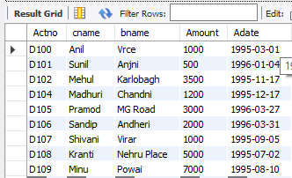

1. **select * from borrow;**

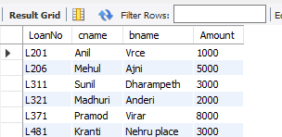

1. **select * from customer;**

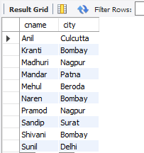

1. **select * from branch;**

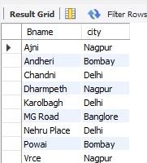

1. **select Actno, Amount from deposit;**

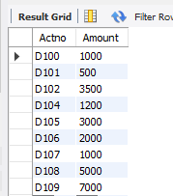

1. **select cname, Actno from deposit;**

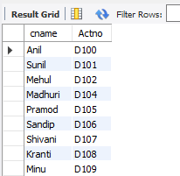

1. **select cname from customer;**

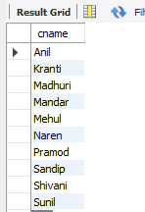

1. **select Bname from branch;**

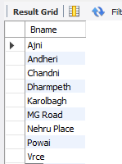

1. **select cname from borrow;**

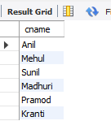

1. **select cname from customer where city='Nagpur';**

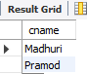

1. **select cname from deposit where Amount>4000;**

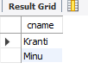

1. **select cname,Adate from deposit where cname='Anil';**

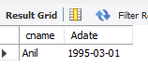

1. **select Bname from branch where city='Bombay';**

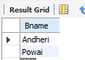

1. **select cname from borrow where LoanNo='L205';**



1. **select cname from deposit where bname='Vrce';**

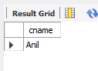

1. **select bname from branch where city='Delhi';**

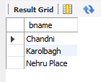

1. **select cname from deposit where Adate='1996-12-01';**

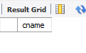

1. **select cname, Actno, Amount from deposit where Adate between '1996-12-01' and '1996-05-01';**

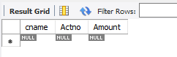

1. **select city from branch where bname='Karolbagh';**

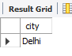

1. **select * from customer join borrow on customer.cname=borrow.cname join deposit on deposit.cname=borrow.cname where customer.cname='Anil';**



**Name: SAJO SAM**

**Roll No: 32**

**Batch: BATCH B**

**Date: 08-04-2022**

**ADVANCED DBMS LAB**

**Experiment No.: 3**

**Aim**

To familiarize DDL Commands- ALTER,DROP,TRUNCATE,RENAME

**Questions**

1. Create a table emp with attributes empno number(4)as primary key, ename char(10),hiredate,  salary, commission

insert 5 rows of data

|  |  |  |  |  |
| --- | --- | --- | --- | --- |
| 101 | Ramesh | 17-Jan  1980 | 5000 |  |
| 102 | Ajay | 05-Jul  1985 | 5000 | 500 |
| 103 | Ravi | 12-Aug  1981 | 1500 |  |
| 104 | Nikesh | 03-Mar  1983 | 3000 | 700 |
| 105 | Ravi | 05-jul  1985 | 3000 |  |

2. Modifying the structure of tables

a. .Add new columns: sal number(7,2)

b. Dropping a column from a table: sal

c. Modifying existing column :ename varchar2(15)

d. Renaming the tables: emp to emp1

e. truncating the tables:emp1

f. Destroying tables:emp

3. Create a table stud with sname varchar2(20) primary key , rollno number(10) not null,dob  date not null

4.Create a table student as regno number (6), mark number (3) check constraint (mark >=0 and  mark  <=100));

5.Create a table cust with(custid number(6) constraint unique, name char(10)

**Procedure & Output**

1. **create database employee;**

**use employee;**

**create table emp (empno integer primary key, ename varchar(20), hiredate date, salary integer, commission integer);**

**insert into emp values(101, 'Ramesh','1980-01-17', 5000,null),(102,'AJAY','1985-07-05',5000,500),(103,'RAVI','1981-08-12',1500,null),(104,'Nikesh','1983-03-03',3000,700), (105,'Ravi','1985-07-05',3000,null);**

**select * from emp;**

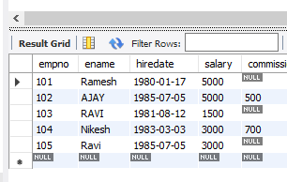

2. **ALTER TABLE emp ADD sal int;**

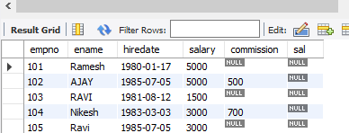

1. **ALTER TABLE emp DROP COLUMN sal;**

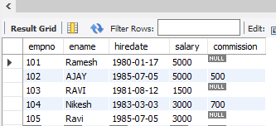

1. **ALTER TABLE emp MODIFY ename VARCHAR(15);**



1. **RENAME table emp to emp1;**



1. **TRUNCATE TABLE emp1; select * from emp1;**

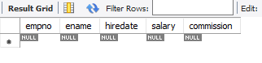

1. **DROP TABLE emp1;**



1. **CREATE TABLE stud(sname varchar(20) PRIMARY KEY, rollno int NOT NULL, dob date NOT NULL); select * from stud;**

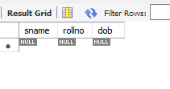

1. **Create table student (regno int, mark int(3) check (mark >=0 and mark <=100));**

**SELECT * from STUDENT;**

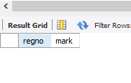

1. **CREATE TABLE cust(custid int(6) UNIQUE, name char(10));**

**select * from cust;**

