SAMYUKTA BALAJI

https://www.linkedin.com/in/samyuktabalaji/

PROJECT - 2

**1.Which state has the highest number of hotels? Depict this via a bar graph that compares all states.**

From the above bar plot, we can infer that Kerala is the state with the highest number of hotels. It has 672000 hotels.

**2.Which states have three types of climatic conditions? (convert the map, an unstructured data, to an Excel file in a structured format and mention the number of climates along with the state)**



**States with three types of climatic conditions:**

|  |  |
| --- | --- |
| No of Climates | 3 |
|  |  |
| **Row Labels** |  |
| **Gujarat** |  |
| Tropical semi-arid, Subtropical semi-arid, Savannah |  |
| **Haryana** |  |
| Subtropical semi-arid, Tropical semi-arid, Subtropical Humid |  |
| **Himachal Pradesh** |  |
| Subtropical Humid, Mountain, Tropical semi-arid |  |
| **Karnataka** |  |
| Tropical monsoon, Tropical semi-arid, Savannah |  |
| **Madhya Pradesh** |  |
| Savannah, Subtropical Humid, Tropical semi-arid |  |
| **Tamil Nadu** |  |
| Tropical monsoon, Tropical semi-arid, Savannah |  |
| **West Bengal** |  |
| Savannah, Subtropical Humid, Mountain |  |

**3. Among the northeastern states which are best to set up a hotel? Use Clustered Column Chart and give recommendations for hotel industry investors.**

|  |  |  |
| --- | --- | --- |
| **Row Labels** | **Sum of No of Climates** | **Sum of No of Hotels** |
| Arunachal Pradesh | 2 | 5000 |
| Assam | 2 | 25000 |
| Manipur | 1 | 3000 |
| Meghalaya | 1 | 2000 |
| Mizoram | 1 | 1000 |
| Nagaland | 1 | 1000 |
| Sikkim | 1 | 12000 |
| Tripura | 1 | 1000 |
| **Grand Total** | **10** | **50000** |

**Arunachal Pradesh**: With 5000 hotels and a climate that includes subtropical humid and mountainous regions, Arunachal Pradesh could be a good option for hotel investors. The diverse climate can attract tourists seeking different experiences.

**Assam**: Assam has the highest number of hotels (25000) and a diverse climate, making it a potentially lucrative option for the hotel industry.

**Sikkim**: Sikkim, with 12000 hotels and a mountainous climate, could also be a good choice, especially for those interested in mountain tourism.

**Manipur, Meghalaya, Mizoram, Nagaland**: These states have a moderate number of hotels and a subtropical humid climate. While they may not have as many hotels as Assam, they could still be attractive for investors looking for less competitive markets.

**Tripura**: With 1000 hotels and a tropical monsoon climate, Tripura may have potential for investors interested in exploring diverse climates.

In conclusion, Assam, Arunachal Pradesh, and Sikkim seem to be promising options for hotel industry investors due to the combination of a significant number of hotels and diverse climates. The final decision should also consider other factors like infrastructure, local attractions, and potential market demand.

**4. Customise the pivot charts to add/change the fields in the fields list with other fields and by using chart styles to customise the charts. (choose the data and parameters according to your choice)**

The above plots are different views of the dataset. **Pie chart** has been used to visualize the proportion of the number of hotels each state has. The **combination chart** can be used to visualize for each state, the number of climates and the number of hotels at the same time. This helps in analyzing which state can be more suitable as a tourist spot.

**5. Which is the best state for setting up a hotel? Why?**

Choosing Maharashtra for setting up a hotel can be a viable option, considering its diverse climatic conditions and a substantial number of existing hotels.

* **Diverse Climatic Conditions**:

Maharashtra experiences a range of climates, including Tropical Monsoon, Savannah, Subtropical Humid, and Tropical Semi-Arid. This diversity caters to different preferences and allows for year-round tourism, attracting a broad spectrum of visitors.

* **Number of Hotels**:

Maharashtra has a significant number of hotels (102000), indicating a well-established hospitality industry. This existing infrastructure suggests a demand for accommodation services and a competitive market that may present opportunities for new entrants.

* **Tourist Attractions**:

Maharashtra is home to various tourist attractions such as Mumbai, Pune, Ajanta and Ellora Caves, Goa, and hill stations like Mahabaleshwar. These destinations cater to both leisure and business travelers, contributing to a consistent flow of visitors.

* **Economic Hub**:

As one of India's leading economic and industrial states, Maharashtra attracts business travelers. Cities like Mumbai are financial and commercial centers, potentially leading to a steady demand for business-oriented hotels.

* **Cultural and Entertainment Hub**:
* Maharashtra, particularly Mumbai, is a cultural and entertainment hub. Events, festivals, and the Bollywood industry contribute to the state's appeal, attracting tourists and creating opportunities for hospitality businesses.
* **Connectivity**:

Maharashtra has well-developed transportation infrastructure, including airports, railways, and road networks. This connectivity enhances accessibility for tourists and business travelers, making it convenient for them to visit various parts of the state.

* **Diverse Culinary Scene**:

The diverse culinary scene in Maharashtra, featuring local Maharashtrian cuisine and international options, can be an added attraction for food enthusiasts, contributing to the overall tourism experience.

* **Potential for Expansion**:

With a substantial number of hotels already in place, it indicates a competitive market. However, Maharashtra's continued economic growth and diverse tourism offerings suggest potential opportunities for expansion and business growth.

While Maharashtra appears promising, it's crucial to conduct a thorough market analysis, assess local regulations, and consider specific business goals before making any investment decisions. Additionally, individual preferences and the target market segment should guide the decision-making process for setting up a hotel.

**6. What is the average number of days the rainy season lasts in Indian states?**

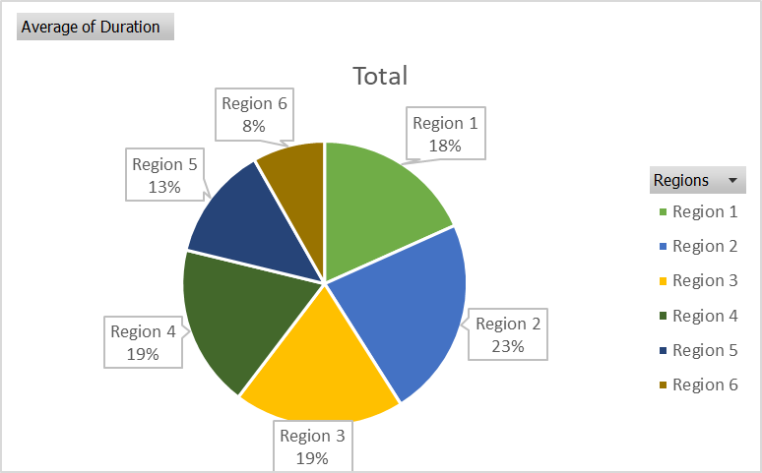

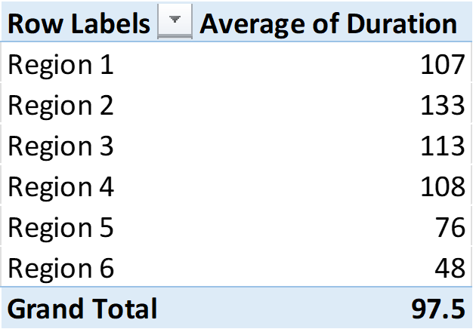

The rainy season lasts for around 97.5 days in the Indian states throughout the year.