UPI TRANSACTIONS DATA CASE STUDY

SAMYUKTA BALAJI

[Samyukta Balaji - Amrita Vishwa Vidyapeetham - LinkedIn India](https://in.linkedin.com/in/samyukta-balaji-8950a1259)

|  |
| --- |
| Which types of UPI transactions are the most common and what is the reason behind the same? |

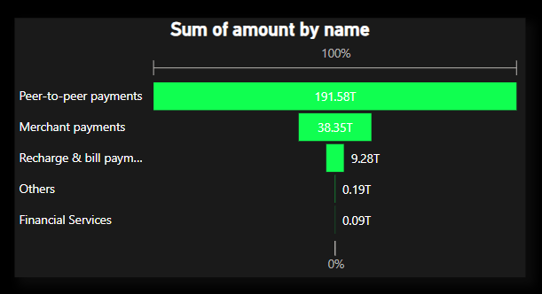

**Peer-to-Peer Payments:**

Peer-to-peer payments are the most common type of UPI transaction. Several factors contribute to their prevalence:

1. **Everyday Transactions**: Peer-to-peer payments are often used for everyday transactions between individuals, such as splitting bills, repaying loans, or sending gifts. The frequency of these transactions drives their prevalence.
2. **Convenience**: UPI offers a convenient and user-friendly platform for peer-to-peer payments. With just a few taps on a smartphone, users can transfer money instantly to friends, family, or acquaintances without needing to visit a bank or handle cash.
3. **Wide Adoption**: Peer-to-peer payments were one of the primary use cases driving the adoption of UPI. As a result, many individuals are familiar with and regularly use UPI for person-to-person transactions.
4. **Promotional Incentives**: Payment platforms and banks often offer incentives such as cashback rewards or discounts to encourage users to make peer-to-peer payments using UPI. These promotional offers further boost the usage of peer-to-peer transactions.
5. **Social Dynamics**: There may be social factors at play, as individuals prefer the ease and immediacy of sending money directly to friends and family using UPI, particularly for informal or spontaneous transactions.

**Other MODES OF PAYMENT:**

1. **Merchant Payments**: These transactions involve purchases made at retail outlets, online stores, restaurants, and various businesses. They are prevalent due to routine expenses, convenience, wide acceptance, promotional incentives, and the growth of the digital economy.
2. **Recharge and Bill Payments**: These transactions include prepaid mobile recharge, postpaid bill payments, utility bill payments, and more. They are common due to the necessity of paying bills and recharging services regularly, coupled with the convenience and speed of UPI payments.
3. **Other Payments**: This category encompasses a diverse range of transactions beyond peer-to-peer, merchant, and bill payments. It may include charitable donations, online subscriptions, government fees, professional services, and more. The prevalence of these transactions depends on specific use cases, customization, and niche markets.
4. **Financial Services**: Transactions related to financial services such as investments, insurance premiums, loan repayments, and wealth management fall into this category. While relatively fewer in number, they cater to specialized financial needs and contribute to the overall ecosystem of UPI transactions.

Overall, the prevalence of each category of UPI transactions is driven by a combination of factors including convenience, necessity, promotional incentives, social dynamics, and the overall growth of digital payments.

|  |
| --- |
| According to the data, which state has the maximum UPI transaction amount? |

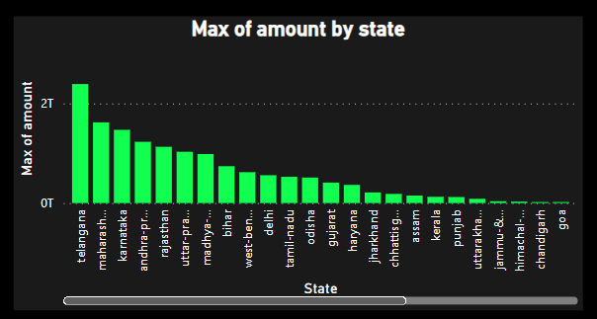

Telangana has the maximum UPI transaction amount of Rs.23,90,00,00,00,000.

1. **Significant Economic Activity**: Telangana's high UPI transaction amount indicates a significant level of economic activity within the state. This could be attributed to factors such as a thriving business ecosystem, a large consumer base, and increasing adoption of digital payment methods.
2. **Urbanization and Digitalization**: Cities like Hyderabad, the capital of Telangana, are hubs of economic activity and innovation. The state's urbanization and digitalization efforts have likely contributed to the widespread adoption of digital payment technologies like UPI.
3. **Government Initiatives**: Telangana government's initiatives to promote digital payments, such as awareness campaigns, incentives for digital transactions, and infrastructure development, may have played a role in driving up the UPI transaction amount.
4. **Business Environment**: Telangana's business-friendly policies and supportive ecosystem for startups and enterprises could have led to a higher volume of commercial transactions conducted through UPI.
5. **Consumer Behavior**: The population's inclination towards digital transactions, convenience, and security provided by UPI might have led to increased usage and contributed to the high transaction amount.
6. **Technological Infrastructure**: Telangana's robust technological infrastructure, including high-speed internet connectivity and widespread smartphone usage, facilitates seamless digital transactions and could have bolstered the UPI transaction amount.
7. **Partnerships and Collaborations**: Collaborations between government bodies, financial institutions, and technology companies to promote digital payments and improve the UPI ecosystem could have further boosted transaction volumes in Telangana.
8. **Future Growth Potential**: The high UPI transaction amount in Telangana indicates a strong foundation for further growth in digital payments. Continued investments in technology, infrastructure, and policy support could drive even higher transaction volumes in the future.

Overall, Telangana's status as the state with the maximum UPI transaction amount reflects its dynamic economy, digital readiness, supportive policies, and the preference for digital payment solutions among its residents and businesses.

|  |
| --- |
| Provide an overview of the growth of UPI transactions in India over the past few years. |

The growth of UPI (Unified Payments Interface) transactions in India over the past few years has been nothing short of remarkable. Here's an overview of the key developments and trends:

**1. Introduction and Early Adoption (2016-2017):**

* + UPI was launched by the National Payments Corporation of India (NPCI) in August 2016.
  + Initially, UPI transactions were relatively low, as the system was new and required widespread adoption among consumers and businesses.
  + Early adopters were primarily tech-savvy individuals and startups who recognized the potential of UPI for easy and instant payments.

**2. Exponential Growth (2017-2019):**

* + UPI transactions started gaining traction rapidly, driven by factors such as increasing smartphone penetration, demonetization, and the government's push for digital payments.
  + Introduction of UPI-enabled apps by banks and third-party payment service providers further accelerated adoption.
  + The simplicity, convenience, and interoperability of UPI attracted a wide range of users, including urban and rural populations, merchants, and small businesses.
  + Transaction volumes and values surged significantly during this period, establishing UPI as a dominant player in the Indian payments landscape.

**3. Expansion of Use Cases and Ecosystem (2019-2021):**

* + UPI expanded beyond person-to-person (P2P) transactions to include merchant payments, bill payments, online shopping, and more.
  + Integration of UPI with various government services, e-commerce platforms, and utility bill providers made it the preferred choice for a wide range of transactions.
  + Collaborations between banks, fintech companies, and government agencies led to innovations such as UPI-based recurring payments, overdraft facilities, and cashbacks, further driving adoption.
  + The number of UPI transactions and the transaction value continued to soar, with millions of transactions processed daily, reflecting the growing confidence of users in the platform's reliability and security.

**4. Maturation and Consolidation (2021-Present):**

* + UPI has become the backbone of India's digital payments ecosystem, with billions of transactions processed each month.
  + Regulatory interventions and improvements in infrastructure, such as increasing transaction limits, enhancing security features, and introducing new functionalities, have contributed to the maturation of the UPI system.
  + The ecosystem has witnessed consolidation, with dominant players emerging in both the banking and fintech sectors, offering innovative UPI-based products and services.
  + UPI's success has also attracted international attention, leading to collaborations with foreign payment systems and adoption of UPI-like systems in other countries.

Overall, the growth trajectory of UPI transactions in India has been remarkable, fueled by technological advancements, regulatory support, changing consumer behavior, and industry collaborations. As UPI continues to evolve, it is expected to play an increasingly central role in shaping India's digital economy.

|  |
| --- |
| What are some potential challenges or obstacles that could affect the future growth of UPI transactions in India? |

While the growth trajectory of UPI transactions in India has been impressive, several potential challenges and obstacles could impact its future growth. Here are some key considerations:

1. **Security Concerns**: As UPI transactions become more prevalent, the risk of fraud, phishing attacks, and unauthorized access to bank accounts also increases. Maintaining robust security measures and raising awareness among users about safe transaction practices will be essential to mitigate these risks.
2. **Infrastructure Constraints**: Despite significant progress, India still faces challenges related to internet connectivity, especially in rural areas. Inadequate infrastructure could hinder the adoption of UPI in remote regions, limiting its reach and usability.
3. **Interoperability Issues**: While UPI is designed to be interoperable across different banks and payment service providers, interoperability challenges may arise due to technical glitches, system outages, or disputes between stakeholders. Ensuring seamless interoperability will be crucial to maintain the convenience and accessibility of UPI transactions.
4. **Regulatory Changes**: Regulatory changes and interventions, while aimed at enhancing consumer protection and promoting competition, could also introduce uncertainty and compliance challenges for UPI service providers. Adapting to evolving regulatory requirements while maintaining innovation and service quality will be a balancing act for industry players.
5. **Privacy Concerns**: With the increasing digitization of financial transactions, protecting user privacy and personal data becomes paramount. Striking the right balance between data privacy and transaction transparency will be critical to building and maintaining user trust in UPI.
6. **Fraud and Cybersecurity**: As UPI transactions grow in volume and value, they become attractive targets for cybercriminals. Cybersecurity threats such as malware, phishing attacks, and data breaches pose significant risks to UPI users and service providers. Continued investment in cybersecurity measures and awareness programs is essential to mitigate these threats.
7. **Dependency on Smartphone Technology**: UPI transactions heavily rely on smartphone technology and internet connectivity. Any disruptions or limitations in access to smartphones or internet services could hinder the adoption and usage of UPI, particularly among segments of the population with limited access to these technologies.
8. **Market Competition**: The emergence of new payment technologies and players could intensify competition in the digital payments space, potentially fragmenting the market and complicating the user experience. UPI service providers will need to continuously innovate and differentiate their offerings to stay competitive.

Addressing these challenges will require collaboration among government agencies, regulatory bodies, financial institutions, technology providers, and other stakeholders to ensure the continued growth and success of UPI transactions in India.