Tribhuvan University

Orchid International College

Bijaychowk, Gaushala

A Project Report On

“Quiz Management System”

Submitted To:

Department of CSIT

Submitted By:

Name/Roll/Section:

Sabin Gautam/17/B

Sabita Guragain/18/B

Sangeet Godar/19/B

Sanskriti Shrestha/20/B

March,2018

Acknowledgement

The success and final outcome of this project required a lot of guidance and assistance from many people and we are extremely privileged to have got this all along the completion of our project. All that we have done is only due to such supervision and assistance and we would not forget to thank them.

We respect and thank **Mr. Dhiraj Kumar Jha**, for providing us an opportunity to do the project work and giving us all support and guidance which made us complete the project duly. We are extremely thankful to him for providing such a nice support and guidance, although he had busy schedule managing his corporate affairs.

We would not forget to remember **Mr. Bidur Dahal**, the principal of Orchid International College for his encouragement and more over for his timely support and guidance till the completion of our project.

The completion of our project wouldn’t be possible without the help and support of our colleagues and all the Teaching staffs of Orchid International College. We would like to offer sincere thanks to all those who have helped us directly or indirectly.

Table of Contents

Contents Page no.

1. Introduction……………………………………………………….1
2. Functional Decomposition………………………………………..2
3. Attached Code………………………………………………….....5
4. Appendix……………………………………………………….....23

Introduction

This project in **Quiz Management System** is a console application developed without graphics using C programming language. This is a simple quiz game compiled in Code Blocks with the GCC compiler. In this game, the questions are about basic general knowledge. Per right answer of the questions, users have been rewarded fixed points.

In this program, admin can perform various functions such as add questions, update answers, search question, delete question, etc and players can play the quiz game. File handling has been extensively used in this project for almost all functions. The source code is organized well, and it has many comment lines to understand the program better.

These are some of the functions used in this program:

1. void admin( )
2. void add( )
3. void display( )
4. void search( )
5. void update( )
6. void deleterec( )

Functional Decomposition

On the startup of this game, we can see the main menu displaying in the console with the welcome message.

1. Main( )

From the main( ), the compiler begins to execute the program. It consists mainly three functions in this program. First one is for the admin, second one is for the players, and the last one is to exit from the game. Functions are called according to the choice of the admin or the player. For the choices, if else function is used. Scanf( ) function has been used to enter the choice in integer format. The integer value entered is tested with various case values to open required function as per the need.

2. Admin( )

This function is called when users enters ‘1’ in the main menu. This function is for the admin to control and manage the game. It allows the admin to add, display, search, update, and delete the questions as well as its options for the proper management of this application. For this purpose, switch function is used.

a. Add( )

This function is called when user enters ‘1’ under the admin option. It allows the admin to add new questions. Data file “questions.dat” has been opened in append mode using file pointer fp for this purpose. Admin is then allowed to enter the question, and its various four options along with correct answer option which are stored in a structure. Then, the structure is written to the data file using fwrite( ). Finally, the data file is closed using fclose( ).

b. Display( )

This function is called when user enter ‘2’ under the admin option. This function displays all the questions stored in the file. For this “questions.dat” has been opened in read mode. And all the contents of the file are copied to structure and displayed through structure.

c. Search( )

This function is called when user enters ‘3’ under the admin option. This function allows the admin to search the questions from the quiz file. Question number is asked to the admin which is then compared with the question number present in the file. When the two question number are matched, the data corresponding to the question number are displayed.

d. Delete( )

This function is called when user enters ‘5’ under the admin option. The admin can delete any question from the file with the help of this function. For this the quiz data file “questions.dat” is opened in read mode and a temporary file “TempFile.dat” is opened in write mode. Then, the admin is asked to enter the question number which is to be deleted and similar to search( ) function, the data is searched. In the searching process all the data not matching with entered question number is copied to temporary file “TempFile.dat” and the one that matches is not copied to the temporary file which indeed is deleting the data. Then finally the data from “TempFile.dat” is copied to the original file “questions.dat” by opening the original file in write mode. Opening the file in write mode erases all the previous contents and hence all the content from “TempFile.dat” are copied to it.

e. Update( )

This function is called when users enters ‘4’ under the admin option. It allows the admin to modify the question, answers or both according to need. Similar to delete( ) function two files are opened for this purpose and instead of not writing the matching question number’s data, they are modified and written to the temporary file and finally the content of temporary file is overwritten to original file.

3. Start( )

This function is called when users enters ‘2’ in the main menu. This function is for the player to start the game. It allows the player to play the game. The questions are asked serially and player has to choose between a, b, c or d options. If incorrect option is choosen then the correct option is displayed along with further other next question. At the end, the score obtained by player is displayed.

4. Exit( )

This function is called when users enters ‘3’ in the main menu. When this function is called, the console application is terminated and the admin or the player can exit from the game.

Attached Code

/** A program about the quiz management system**/

#include<stdio.h>

#include<stdlib.h>

#include<conio.h>

#include<ctype.h>

#include<string.h>

///declaration of structure

struct Quizplay{

char questions[1000];

int qno;

char a[150];

char b[150];

char c[150];

char d[150];

char answer;

}ques;

//function declaration

//FUNCTION DECLARATION

void admin();

void add();

void display();

void search();

void update();

void deleterec();

int comp(int qn);

int count();

int empty();

void play(int N);

///main implementation

int main(){

//structure variable

int choice,c;

char playername[50];

///main home

mainhome:

system("cls");

printf("\t\t\tC PROGRAM QUIZ GAME\n");

printf("\n\t\t________________________________________");

printf("\n\t\t\t WELCOME ");

printf("\n\t\t\t to ");

printf("\n\t\t\t THE GAME ");

printf("\n\t\t________________________________________");

printf("\n\t\t________________________________________");

printf("\n\t\t TEST YOUR GK!!!!!!!!!!! ") ;

printf("\n\t\t________________________________________");

printf("\n\t\t________________________________________");

printf("\n\t\t > Press 1 for Admin control");

printf("\n\t\t > Press 2 to start game ");

printf("\n\t\t > Press 3 to quit");

printf("\n\t\t________________________________________\n\n");

scanf("%d",&choice);

if (choice==1)

{

admin();

goto mainhome;

}

else if (choice==3){

exit(1);

}

else if(choice==2)

{

system("cls");

printf("\n\n\n\n\n\n\n\n\n\n\t\t\tResister your name:");

gets(playername);

system("cls");

printf("\n ------------------ Welcome %s to C Program Quiz Game --------------------------",playername);

printf("\n\n Here are some tips you might wanna know before playing:");

printf("\n\n\n Press Y to start the game!\n");

printf("\n Press any other key to return to the main menu!");

if (tolower(getch())=='y')

{

c=count();

play(c);

goto mainhome;

}

else

{

goto mainhome;

system("cls");

}

}

getch();

return 0;

}//main ends

//function definition

//admin menu

void admin(){

system("cls");

int choice;

printf("Enter a choice \n1)Add \t\t2)display \n3)search \n4)update \t5)delete \n6)Goto main menu");

scanf("%d",&choice);

switch(choice){

case 1:

add();

break;

case 2:

display();

break;

case 3:

search();

break;

case 4:

update();

break;

case 5:

deleterec();

case 6:

break;

default:

printf("\nInvalid choice");

}

}

// FUNCTION TO INSERT RECORDS TO THE FILE

void add()

{

system("cls");

FILE *fp;

fp = fopen("questions.dat", "a");

printf("Enter the Question no : ");

scanf("%d", &ques.qno);

printf("Enter the Question : ");

fflush(stdin);

gets(ques.questions);

printf("Enter the option 'a' : ");

fflush(stdin);

gets(ques.a);

printf("Enter the option 'b': ");

fflush(stdin);

gets(ques.b);

printf("Enter the option 'c': ");

fflush(stdin);

gets(ques.c);

printf("Enter the option 'd': ");

fflush(stdin);

gets(ques.d);

printf("Enter the answer: ");

fflush(stdin);

scanf("%c",&ques.answer);

fwrite(&ques, sizeof(ques), 1, fp);

fclose(fp);

}

// FUNCTION TO DISPLAY RECORDS

void display()

{

system("cls");

FILE *fp1;

fp1 = fopen("questions.dat", "r");

while (fread(&ques, sizeof(ques), 1, fp1))

printf(" \nQ.%d %s \na)%s \tb)%s \nc)%s \td)%s \nAnswer: %c", ques.qno, ques.questions, ques.a, ques.b, ques.c, ques.d ,ques.answer);

fclose(fp1);

getch();

}

//function definition to search a question according to the number

void search()

{

system("cls");

FILE *fp2;

int r, s, avl;

printf("\nEnter the Question no. you want to search :");

scanf("%d", &r);

avl = comp(r);

if (avl == 0)

printf("Question no.%d is not available in the file\n",r);

else

{

fp2 = fopen("questions.dat", "r");

while (fread(&ques, sizeof(ques), 1, fp2))

{

s = ques.qno;

if (s == r){

printf("\n %s", ques.questions);

printf("\n a.%s", ques.a);

printf("\n b.%s", ques.b);

printf("\n c.%s", ques.c);

printf("\n d.%s", ques.d);

printf("\n the correct answer is %c",ques.answer);

}//if ends

}//while ends

fclose(fp2);

}//if-else ends

getch();

}

// FUNCTION TO DELETE A RECORD

void deleterec()

{

system("cls");

FILE *fpo;

FILE *fpt;

int r, s;

printf("Enter the Question no you want to delete :");

scanf("%d", &r);

if (comp(r) == 0)

printf("Question no %d is not available in the file\n", r);

else

{

fpo = fopen("questions.dat", "r");

fpt = fopen("TempFile.dat", "w");

while (fread(&ques, sizeof(ques), 1, fpo))

{

s = ques.qno;

if (s != r)

fwrite(&ques, sizeof(ques), 1, fpt);

}//while ends

fclose(fpo);

fclose(fpt);

fpo = fopen("questions.dat", "w");

fpt = fopen("TempFile.dat", "r");

while (fread(&ques, sizeof(ques), 1, fpt))

fwrite(&ques, sizeof(ques), 1, fpo);

printf("\nQUESTION DELETED\n");

fclose(fpo);

fclose(fpt);

}//if-else ends

getch();

}

// FUNCTION TO UPDATE THE RECORD

void update()

{

system("cls");

int avl;

FILE *fpt;

FILE *fpo;

int s, r, ch;

printf("Enter Question no to update:");

scanf("%d", &r);

avl = comp(r);

if (avl == 0)

{

printf("Question no %d is not Available in the file", r);

}

else

{

fpo = fopen("questions.dat", "r");

fpt = fopen("TempFile.dat", "w");

while (fread(&ques, sizeof(ques), 1, fpo))

{

s = ques.qno;

if (s != r)

fwrite(&ques, sizeof(ques), 1, fpt);

else

{

printf("\n\t1. Update Question of Question no %d", r);

printf("\n\t2. Update option 'a' of Question no %d", r);

printf("\n\t3. Update option 'b' of Question no %d", r);

printf("\n\t4. Update option 'c' of Question no %d", r);

printf("\n\t5. Update option 'd' of Question no %d", r);

printf("\n\t6. Update answer of Question no %d", r);

printf("\n\t7. Update all Question, option and answer of question %d", r);

printf("\nEnter your choice:");

scanf("%d", &ch);

//MENU

switch (ch)

{

case 1:

printf("Enter Question:");

fflush(stdin);

gets(ques.questions);

break;

case 2:

printf("Enter option 'a': ");

fflush(stdin);

gets(ques.a);

break;

case 3:

printf("Enter option 'b': ");

fflush(stdin);

gets(ques.b);

break;

case 4:

printf("Enter option 'c': ");

fflush(stdin);

gets(ques.c);

break;

case 5:

printf("Enter option 'd': ");

fflush(stdin);

gets(ques.d);

break;

case 6:

printf("Enter answer: ");

fflush(stdin);

scanf("%c",&ques.answer);

break;

case 7:

printf("Enter Question:");

fflush(stdin);

gets(ques.questions);

printf("Enter option 'a': ");

fflush(stdin);

gets(ques.a);

printf("Enter option 'b': ");

fflush(stdin);

gets(ques.b);

printf("Enter option 'c': ");

fflush(stdin);

gets(ques.c);

printf("Enter option 'd': ");

fflush(stdin);

gets(ques.d);

printf("Enter answer: ");

fflush(stdin);

scanf("%c",ques.answer);

break;

default:

printf("Invalid Selection");

break;

}

fwrite(&ques, sizeof(ques), 1, fpt);

}//inner if-else ends

}//while loop ends

fclose(fpo);

fclose(fpt);

fpo = fopen("questions.dat", "w");

fpt = fopen("TempFile.dat", "r");

while (fread(&ques, sizeof(ques), 1, fpt))

{

fwrite(&ques, sizeof(ques), 1, fpo);

}//while loop ends

fclose(fpo);

fclose(fpt);

printf("QUESTION UPDATED");

}//if-else ends

getch();

}

// FUNCTION TO CHECK GIVEN QUESTION NUMBER IS AVAILABLE //

int comp(int qn)

{

FILE *fp;

int c = 0;

fp = fopen("questions.dat", "r");

while (!feof(fp))

{

fread(&ques, sizeof(ques), 1, fp);

if (qn == ques.qno){

fclose(fp);

return 1;

}//if ends

}//while loop ends

fclose(fp);

getch();

return 0;

}

//FUNCTION TO CHECK THE FILE IS EMPTY OR NOT

int empty()

{

int c = 0;

FILE *fp;

fp = fopen("questions.dat", "r");

while (fread(&ques, sizeof(ques), 1, fp))

c = 1;

fclose(fp);

return c;

}

//FUNCTION TO COUNT QUESTION

int count(){

int c = 0;

FILE *fp;

fp = fopen("questions.dat", "r");

while(fread(&ques,sizeof(ques),1,fp))

c++;

return c;

}

//FUNCTION TO PLAY GAME

void play(int N){

system("cls");

FILE *fp;

fp = fopen("questions.dat", "r");

int score=0,i;

char ans;

struct Quizplay q[N];

for(i=0;i<N;i++)

{

fread(&q[i],sizeof(q[i]),1,fp);

printf("\nQ.%d %s \na)%s \tb)%s \nc)%s \td)%s \n", q[i].qno, q[i].questions, q[i].a, q[i].b, q[i].c, q[i].d);

fflush(stdin);

scanf("%c",&ans);

if(tolower(ans)==tolower(q[i].answer))

{

score++;

}else

{

printf("\nThe correct answer is %c",q[i].answer);

}

}

printf("\nYour score is %d",score);

getch();

}//function ends

Appendix

Here, we can see screenshots of the console screen of Quiz Management System.

The below picture shows the main menu.

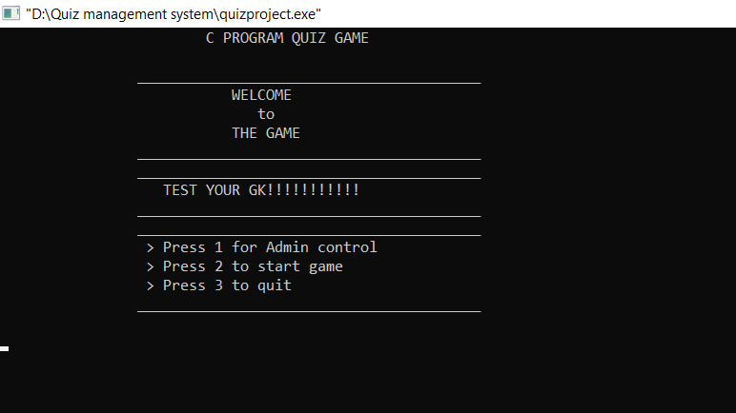

The below picture shows the admin controls.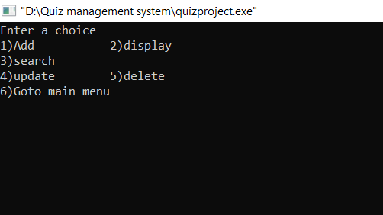

\The below pictures shows about adding of the question along with options and answer. 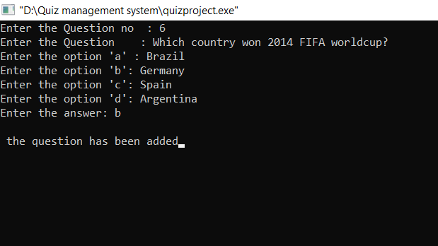The below picture shows the display of all the questions along with options and answers. 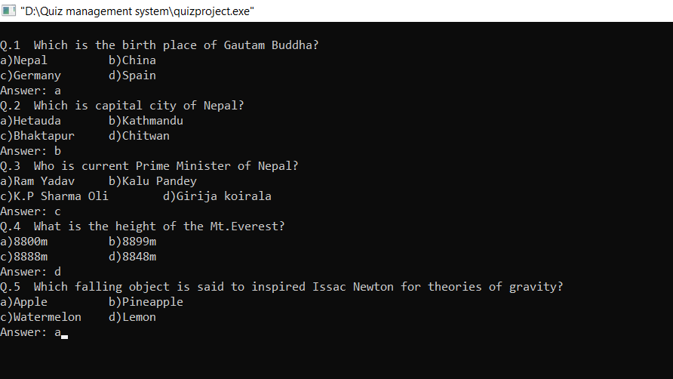

The below pictures shows searching result according to the question number. 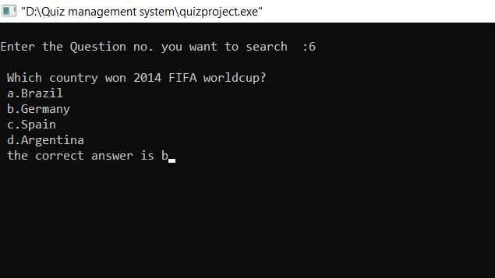

The below pictures shows erasure of the question according to the question number. 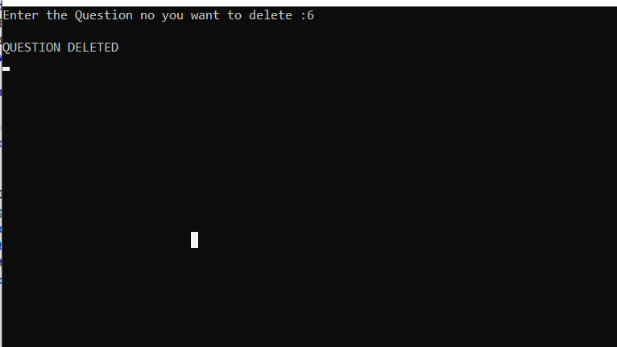

The below pictures shows the update which have been made by the admin. 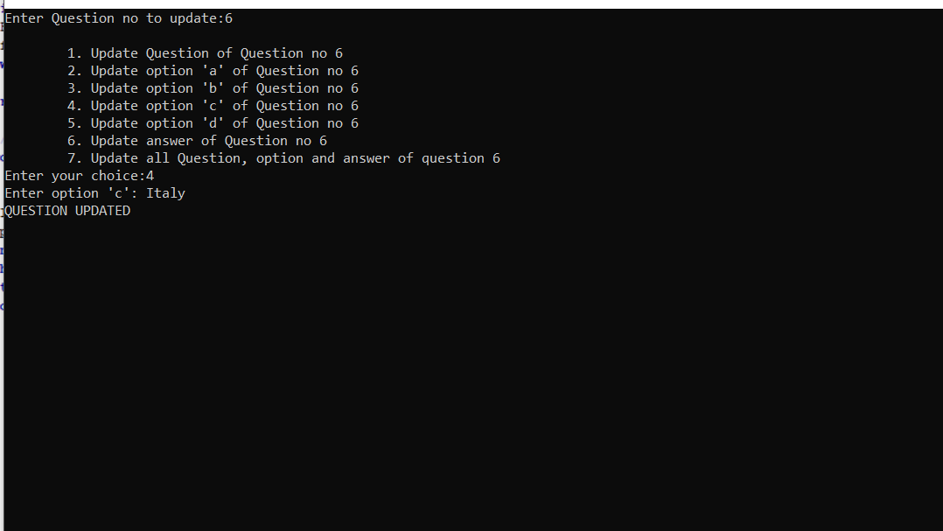

The below pictures shows about the confirmation to play the game for player. 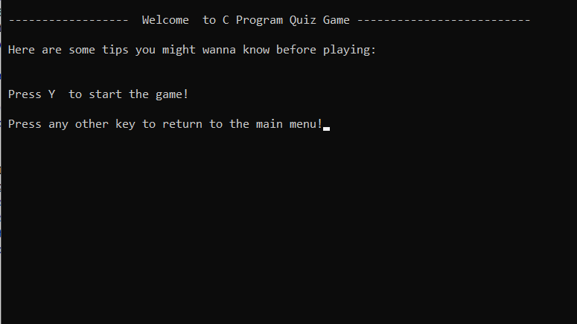

The below pictures shows the score obtained by player along with all the questions he/she faced. 