1. **Machine name**



1. **Kernel name, version and release**

* Kernel name



* Kernel Version

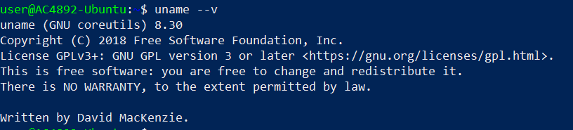

* Kernel Release



1. **Version of *uname* command**



1. **System memory amount (GiB)**

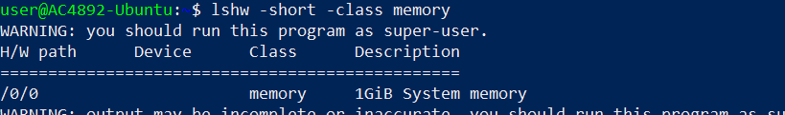

1. **Processor**

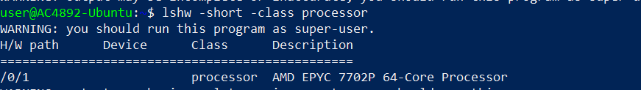

1. **Display adapter**

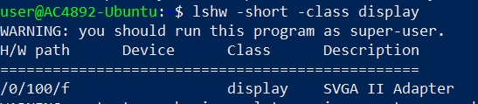

1. **Distribution release and description**

* Release



* Description



1. **Codename of the distribution**

