1. **Run command ps aux | less and find descriptions for column titles used in output.**





1. **What is the default delay for top commands screen updates? Change this update time to 0.5 seconds.**

**Defauls time is 3.0 seconds**



Press d

Then change the time

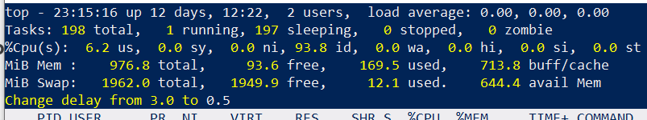

1. **Open another SSH connection to your Ubuntu (for example using Putty) and shutdown this connection using kill command (Tip: use PID of opened SSH connection).**

To find the PID of a opened connection



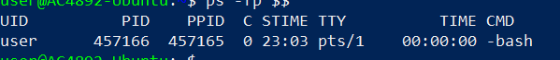

Now open another connection



Previous connection got closed



1. **Open another SSH connection again to your Ubuntu. Print the tree view of processes when SSH connection has been established. Now shutdown the second SSH connection and print the tree view again. How is SSH connection displayed in tree view on both cases (connection established and connection closed)?**



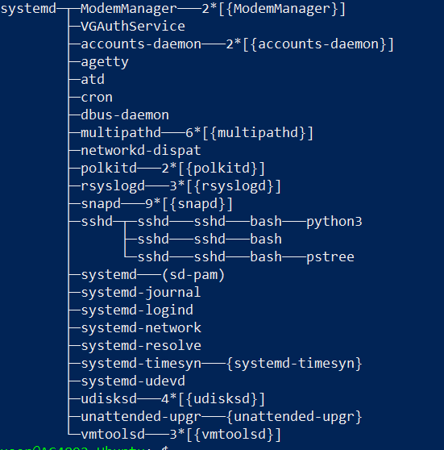



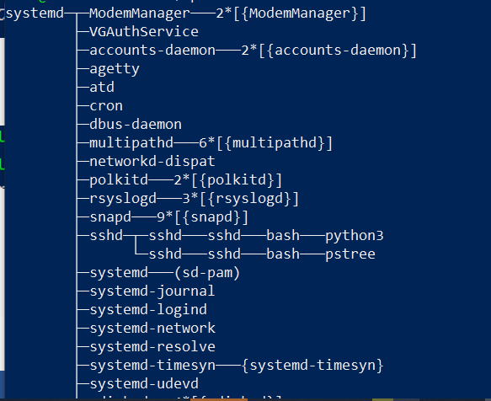

As soon as the connection was close ssh displayed without a branch

1. **Why is SSH displayed in tree view even when there is no SSH client connection open from Putty? Important: In VLE environment you will always have SSH client connection open!**

Even though there is no ssh connection opened from putty ssh displayed in the tree view

1. **How can you shutdown SSH connection through top program?**



Press K to kill the process

