1. **Change your user to another (for example from regular user to root) and input a wrong password. How and from what log file in /var/log path you can retrieve the information from this failed login attempt?**

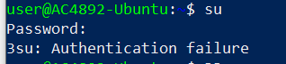





1. **How do you retrieve the logged information from journald from last 24 hours so that newest entries are displayed first (at the top)?**



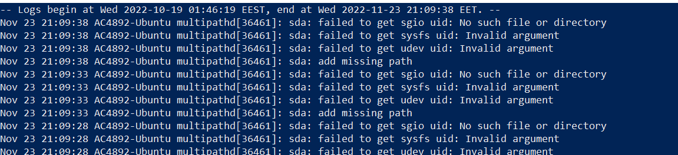

1. **How much do stored journal files take up disk space?**



1. **Open journald for real-time logging. Now open SSH connection to your Ubuntu (refer to Putty guide in**[**here**](http://hantt.pages.labranet.jamk.fi/ttc1040-material/materials/05_editors_and_utilities/)**). Try to login by typing first the invalid and then the correct password. How are these entries logged?**

**When inserting wrong password**



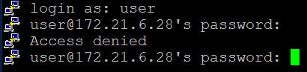

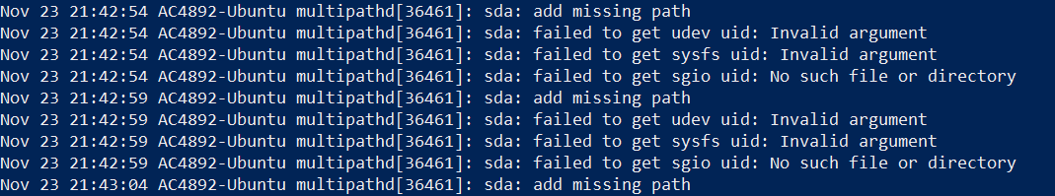

When giving the correct password



1. **Open authentication log file (auth.log) and check the content. How can you print only lines from this log file to the CLI containing new sessions from your user (tip: use grep)?**



1. **In previous exercise (EX-11) you installed Apache2 web server (if you haven’t, install it with sudo apt install apache2). What log files does this service have (see /var/log directory)?**

