**Exercise 2**

1. **List all available shells on your Linux distribution.**

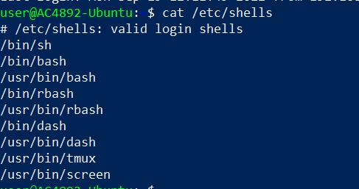

1. **Find general guidelines using man command for user password (Hint: passwd).**



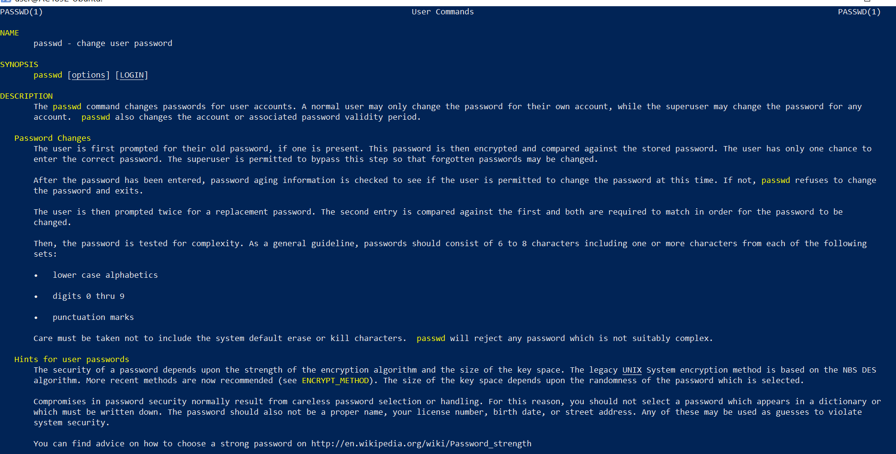

1. **How can you change your user from regular to root user and back to regular?**

* Change to root user

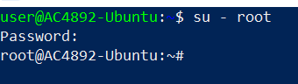

* Change back to regular user

Once we exit from the super user regular user shell will be available

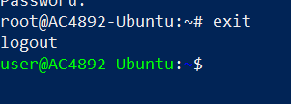

1. **Find out what is the description of the following Linux commands:**
   * *echo*



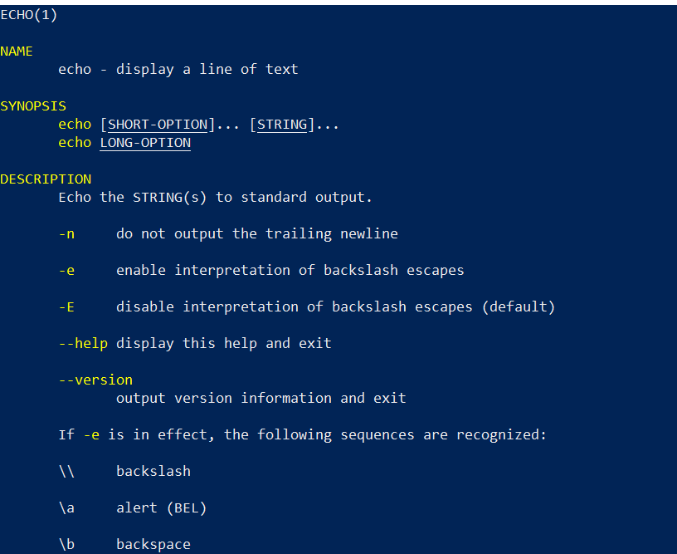

* + *free*



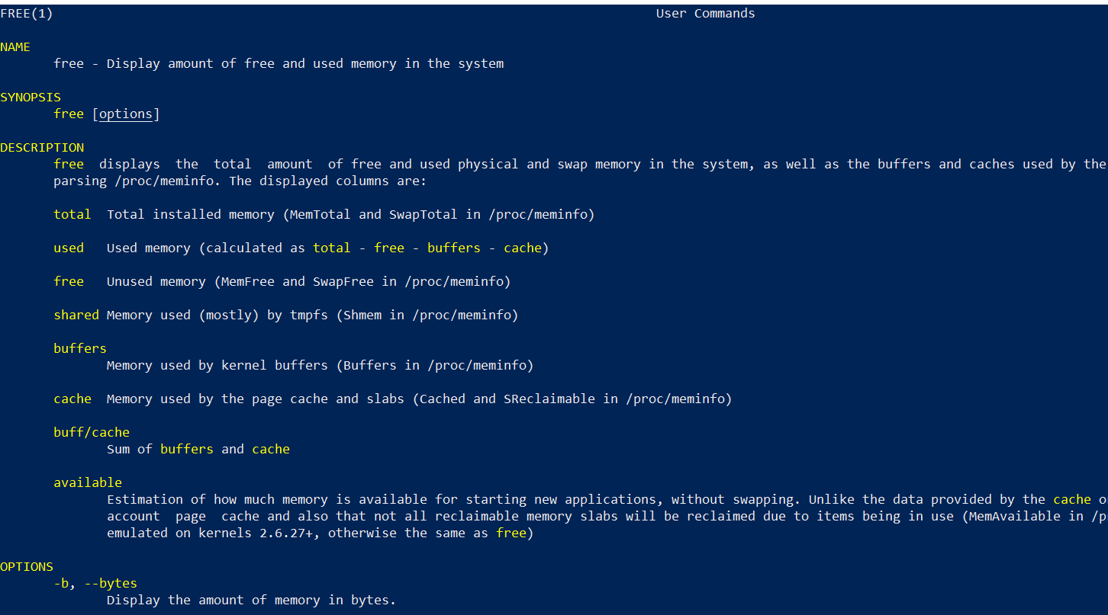

* + *history*



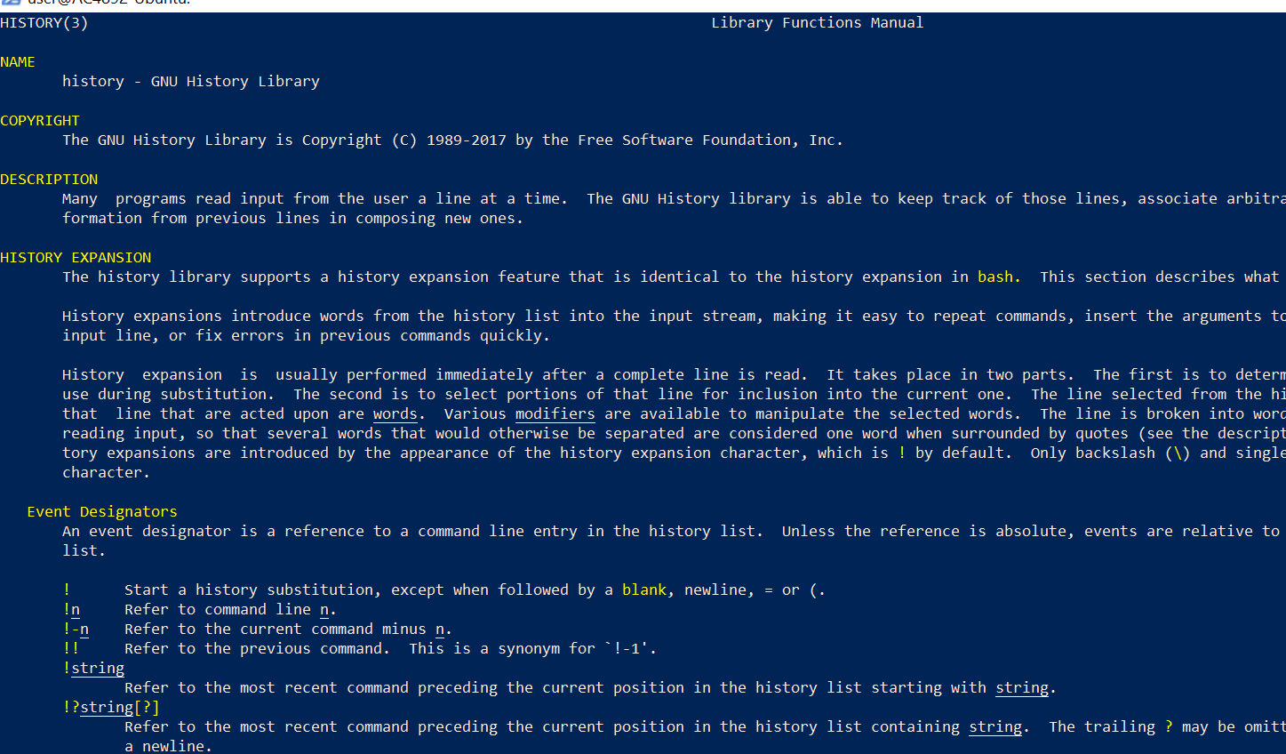

* + *w*



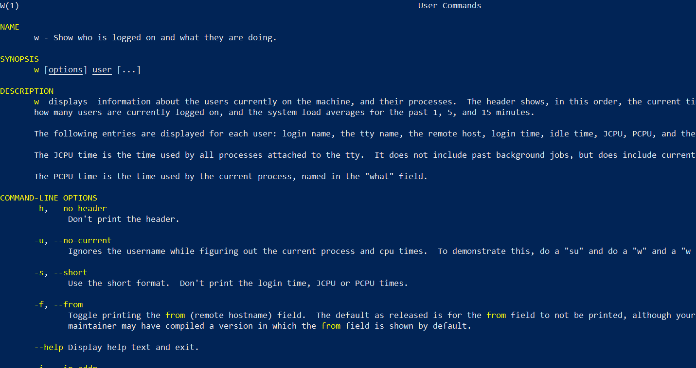

1. **Give an example of all of the above commands and command outputs.**

* echo

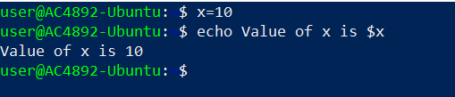

* free

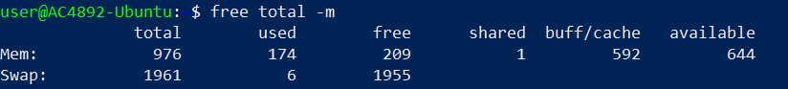

* history

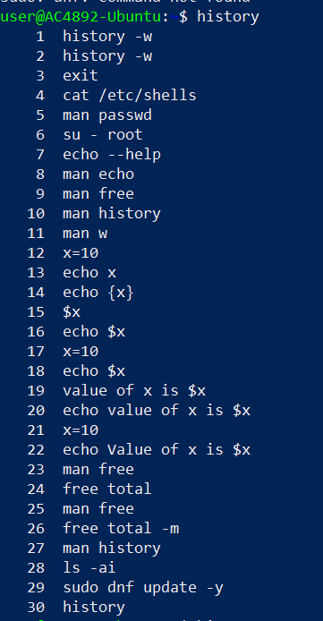

* w

