1. **List only directories and one level from Linux root directory.**



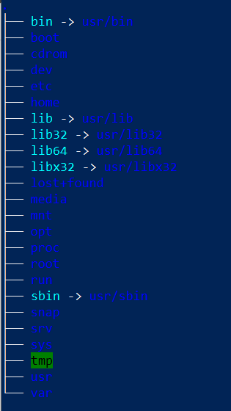

1. **List /var/log directory content with two levels and full path prefix for each file.**



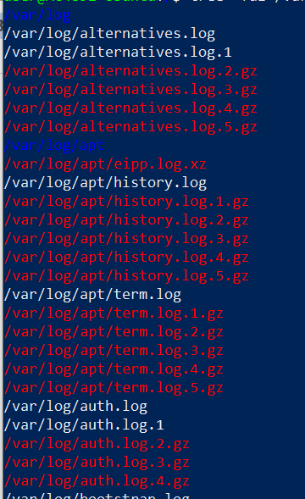

1. **List /bin directory content with owner information, size in human readable format and name starting with 'xs'.**

