1. **Create the tar archive from dir2 directory created in previous exercise (Linux exercise 4 - Basic commands) and compress it using gzip.**

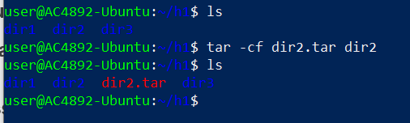

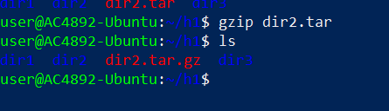

1. **Open one of the files you have created earlier with text editor of your choice. Add text to the file and save it with different name.**



After add the text press ctrl+o and then change the text file name and press ‘y’ to confirm the message File will be save with the new name

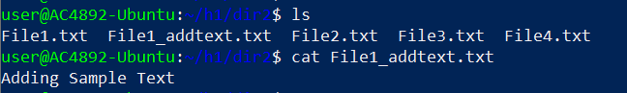

1. **Open some file using less command. Find out how search feature works in less command.**



Then use ‘/pattern’ that we need to search here I searched for ‘am’

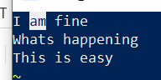

1. **Download and extract the Apache web server package:**[**Apache web server**](http://student.labranet.jamk.fi/~hantt/apache/httpd-2.4.41.tar.gz)**.**





1. **Use Vim editor in this task. Open CHANGES file from extracted Apache web server directory and add this line to the beginning of the file:**
   * **====== This file has been edited in *current_date* ======**
   * **Save the file and print first 18 lines of the file to the command line.**

**Fist open the file**



Then press I to Insert the line

Insert the line and press escape and the use ‘:x’ to save and exit

When you view again following will be added

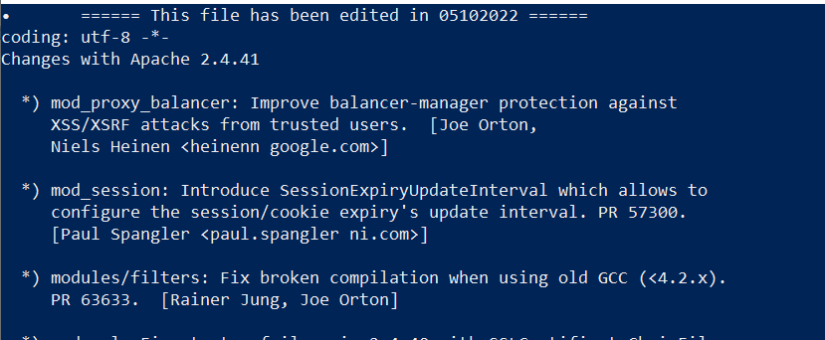

To print the first 18 lines

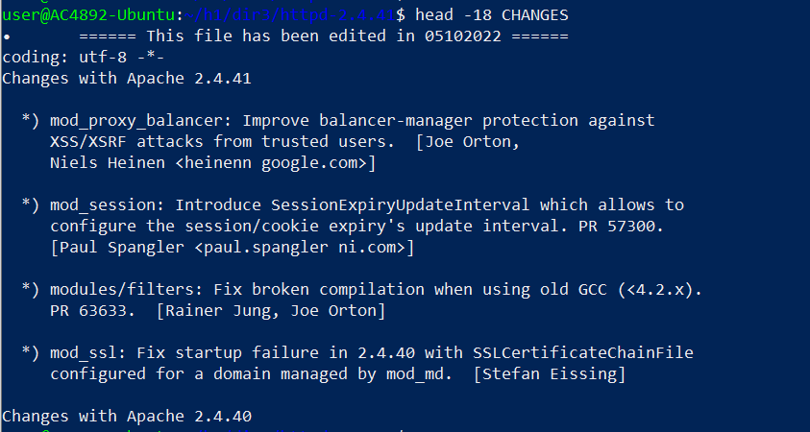

1. **Open Kernel log file (/var/log/kern.log) using tail command so that new log lines are listed in real-time.**



1. **Examine curl program parameter through help feature. Download Funet network's wiki page**[**https://fi.wikipedia.org/wiki/Funet**](https://fi.wikipedia.org/wiki/Funet)**and save the content of the page to the file (Write to file) called funetpage.html. Add screenshot presenting part of this file's content.**

Used sudo command because of the permission issue



To view the file



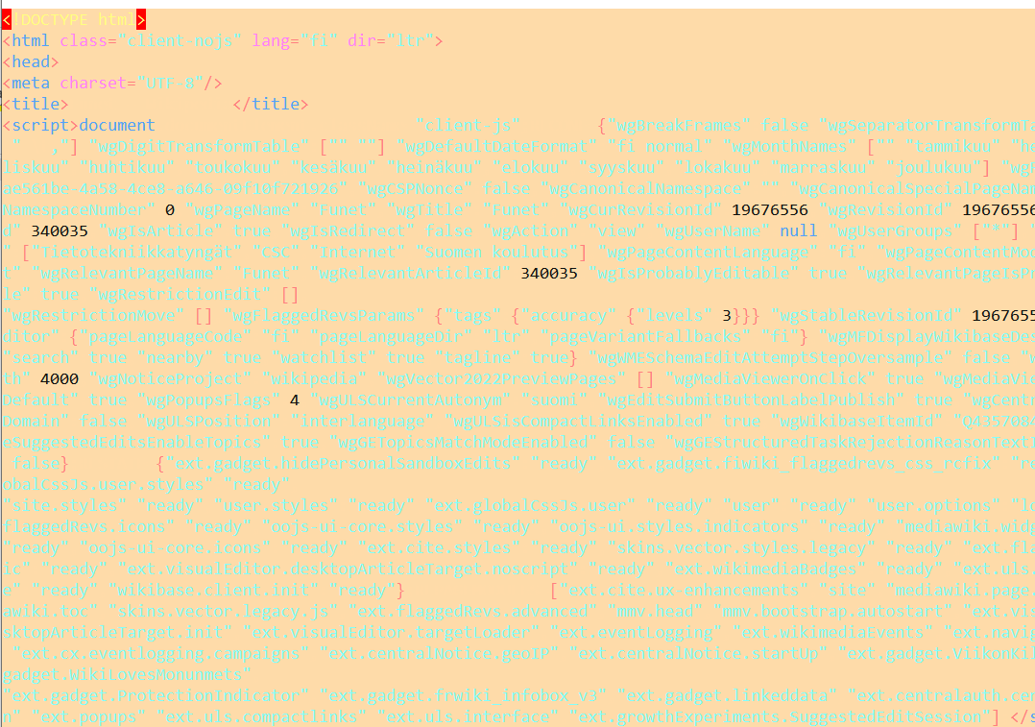

1. **In this task curl command will be used to connect to remote servers:**  
   a) **README file is located in the server http://ftp.funet.fi. How do you open this file using curl command so that you can view it page by page (hint: utilize other commands with curl)?**  
   b) **How do you list the content of remote server's folder ftp://ftp.gnu.org/? What files are included in listing?**
   * 1. 

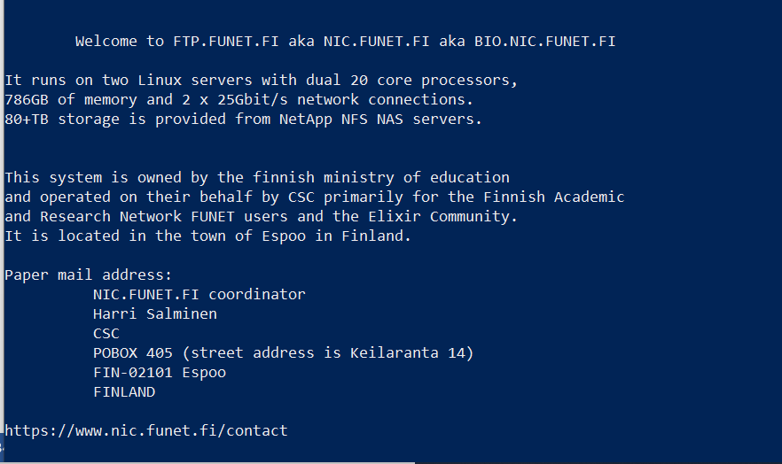

b) 

