1. **Create a new file *first.txt* and a new directory *second* to your user's home directory. What are the permissions for newly created file and directory?**





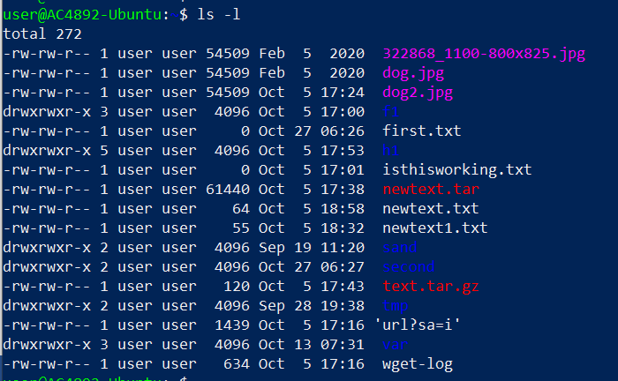

1. **Change file (first.txt) permissions using numerical format in the following way: owner → all permissions, group → read and write permissions and other → no permissions. Return original permissions for the file using symbolic format.**

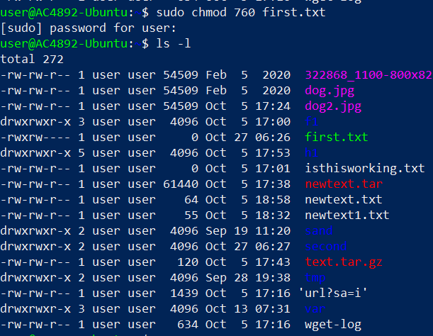

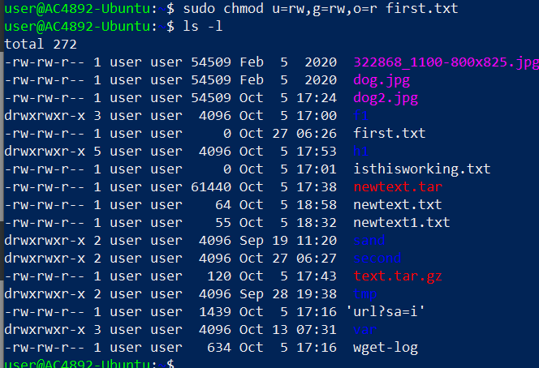

1. **Change root or other user for the owner for the directory (second).**

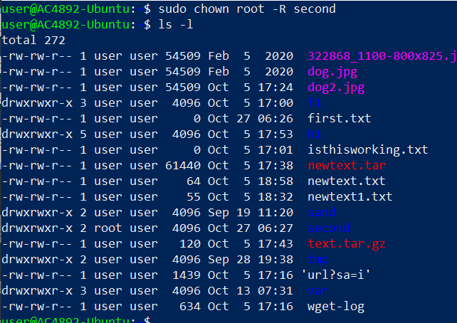

1. **Change directory permissions in a way that only owner has permissions for the directory.**

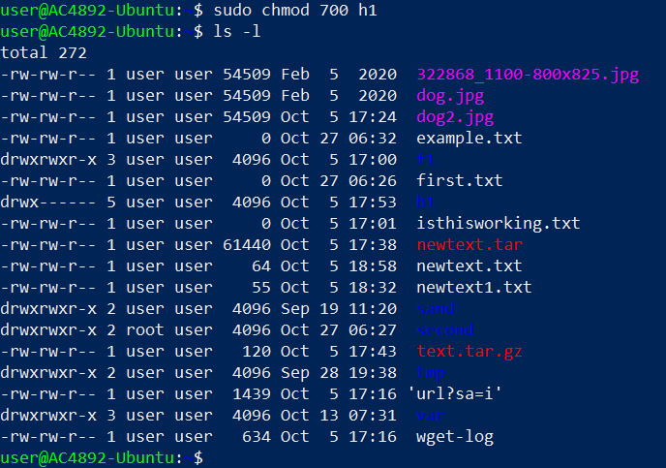

1. **Create a new file and set root or other user as a file owner.**

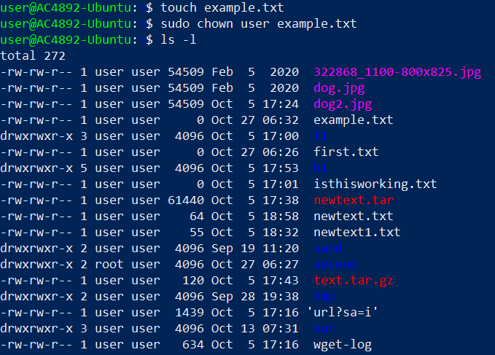

1. **Create two files: hard_link.txt and soft_link.txt. Create hard and soft link for these files according to file names. Check the results with ls -l command. What does the output of the command tell about the links and how do links differ? Remove the files you created and recheck the results with ls -l command. What differences do you notice?**

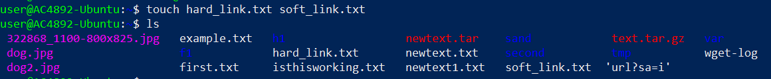

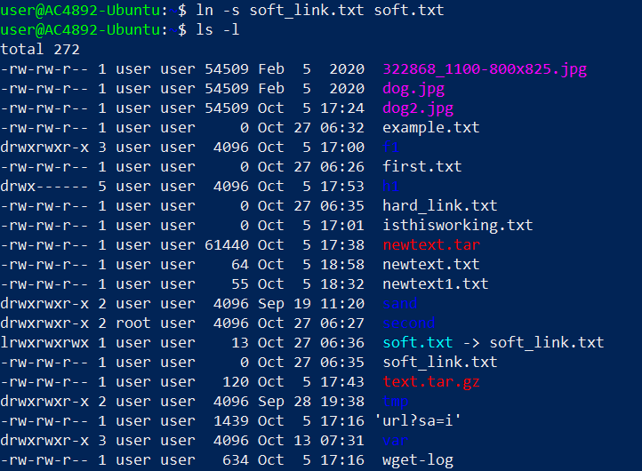

Softlink does not increases the number of links but hardlink increases the no of links

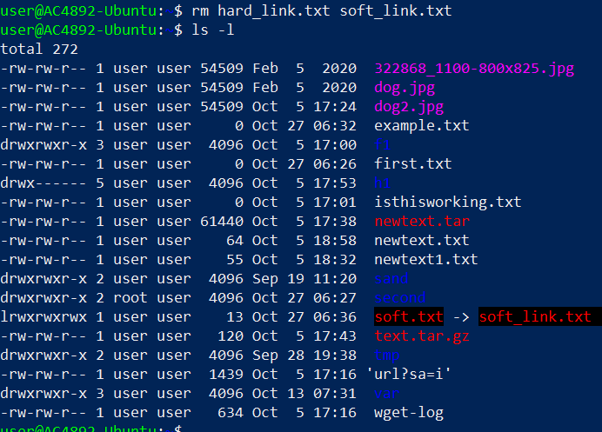

When we remove the files hardlink decreases and the softlink turned to red

1. **Use find command to list /etc directory contents including only files with .conf extension and starting with letter l (small l, not capital I). Do not include files from subdirectories!**



1. **Below is a presentation of a directory structure where temperature data from sensors s1, s2 and s3 has been saved for log files under sensor specific directories. Create this directory structure with files. Important: Check the location of this directory structure within the Linux filesystem!**

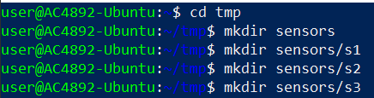

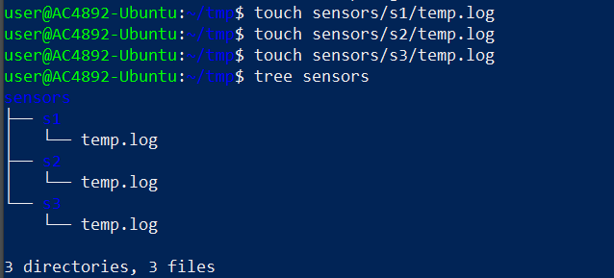

1. **Users user (regular user) and root have been marked for the directory presentation below. Create the following permissions: user can only access the first sensor's temp.log file and root has access to the whole directory structure. User should have adequate permissions for reading and editing the temp.log file.**

