1. **At first, update package repositories. Then check the available commands for apt using command help. What commands are used to perform the following tasks with apt:**
   * **Upgrading installed packages in the system**



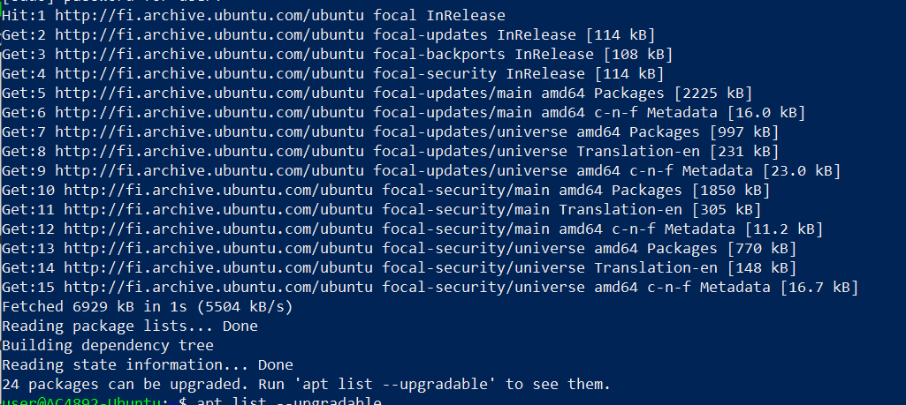

* + **Removing unused packages from the system**



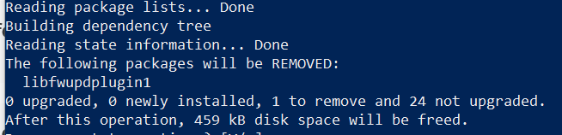

1. **Check the information for the package called figlet and answer the following questions:**
   * **What is the size of the package?**





* + **What is the newest version available for the package?**



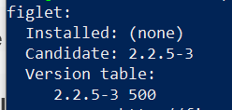

* + **Check the package description → What does the program do?**



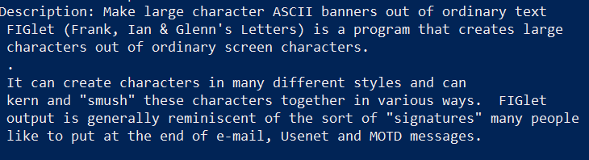

1. **Install the figlet package and verify it works.**



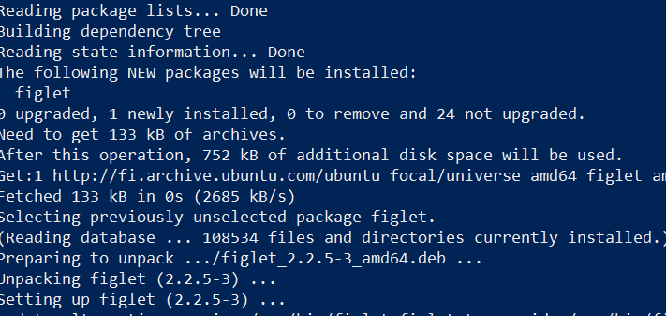

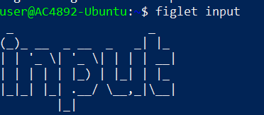

1. **Remove figlet from the system with all configuration files. Check that program cannot be run after the removal.**



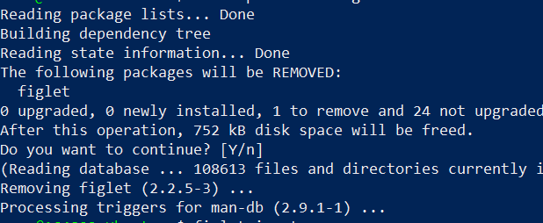



1. **In this task you must install Python3 by compiling it from the source code. Download the package from the url**[**http://student.labranet.jamk.fi/~hantt/os/Python-3.7.4.tgz**](http://student.labranet.jamk.fi/~hantt/os/Python-3.7.4.tgz)**.**
   * **Before the compilation process, install the following packages with apt:**
     + **libffi-dev**



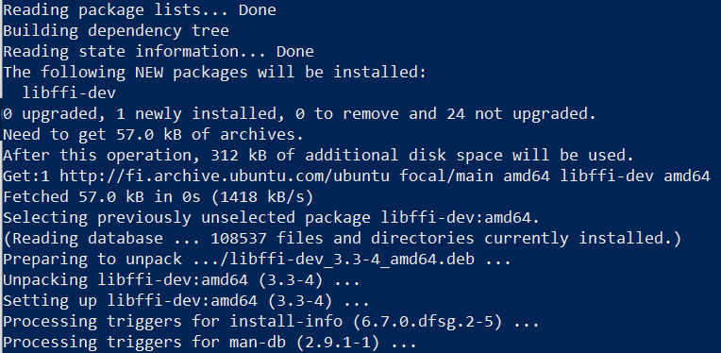

* + - **zlib1g-dev**



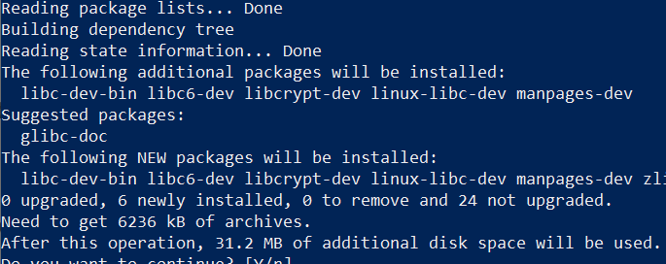

* + **If you cannot start your newly installed Python3 fix the symbolic link to point for the *python3.7* executable.**



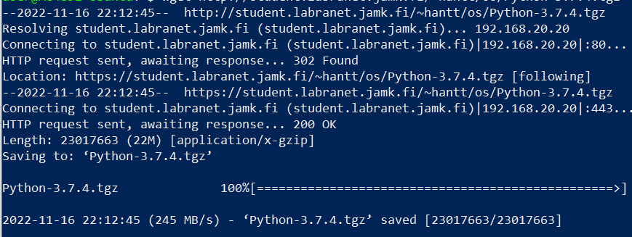

**Then extract it**





* + **Verify the operation of Python3 by starting the shell with command python3. You should now see the version 3.7.4 at the start of your Python shell.**

