



**Linux Basics exam**

Write all answers here in this document. Use screenshots to support your answers. Screenshot must include the commands you used. For example, a simple **ls** from a directory is not adequate. If screenshot won’t cover your answer or is missing some essential parts, you may add written answer as well in addition to screenshot.

Return the exam document before the given deadline into the Moodle return box in **PDF format**.

Maximum amount of points from the exam is 60 points. Question specific maximum points are marked after each question.

1. Create the directory structure presented below. [2p]

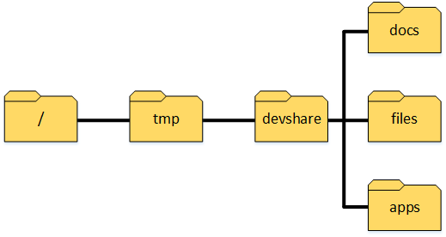

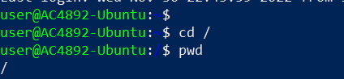







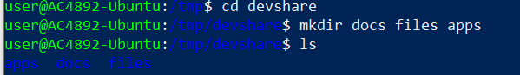

1. Create user group called *developers*. [2p]







1. Create user *arto* with home directory and set bash as user’s default shell. In addition, set user password. [3p]



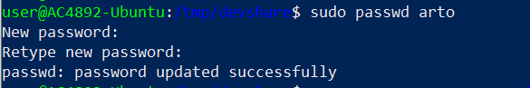

1. Change directory *devshare* owner group to be developers so that owner permissions inherit to subdirectories. [3p]



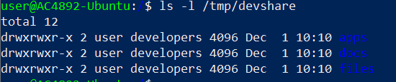

1. Give write permissions for group developers to *devshare* directory and its subdirectories. [2p]

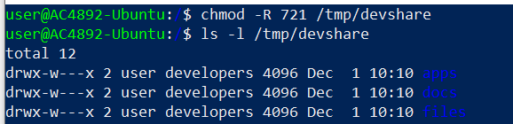

1. Change permissions for directory */tmp/devshare/apps* so that only directory owner has permissions for the directory. [2p]

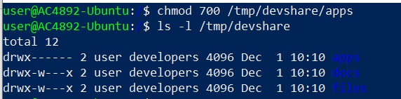

1. Set *developers* as *arto’s* primary group and add *arto* to group *sudo*. [3p]



1. Switch to user arto so that the whole environment will be changed (**do the following exercises as user arto!**) [3p]

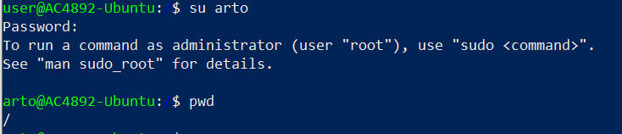

**Su –l arto**

1. Create a new directory called *exam* to *arto’s* home directory using absolute path. Create the following two files inside *exam* directory using relative path: *file1.txt* and *file2.txt*. Write the following line to *file1.txt*: **This is quite easy**. [4p]

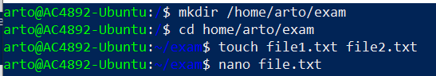

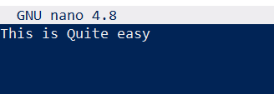

1. Copy the *exam* directory to previously created directory */tmp/devshare/docs*. [2p]

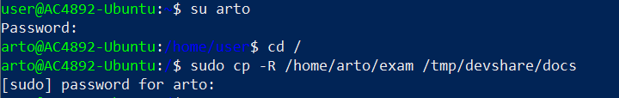



1. Download the following package using wget tool and move it to directory */tmp/devshare/files* with a new name *data.tar.gz*: <http://student.labranet.jamk.fi/~hantt/exam/examdata.tar.gz>. [3p]



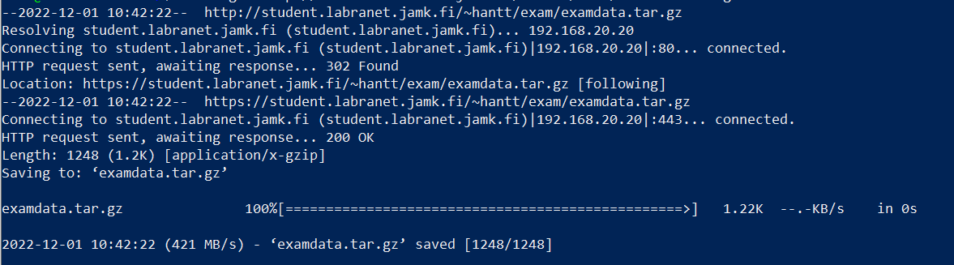

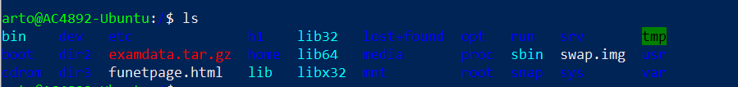



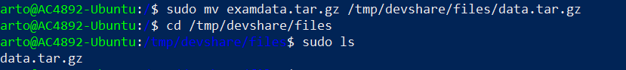

1. Extract the package data.tar.gz with one command. Print the content of file *data1.txt* to command line. [2p]

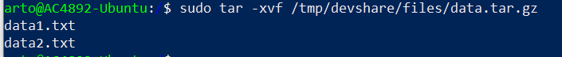

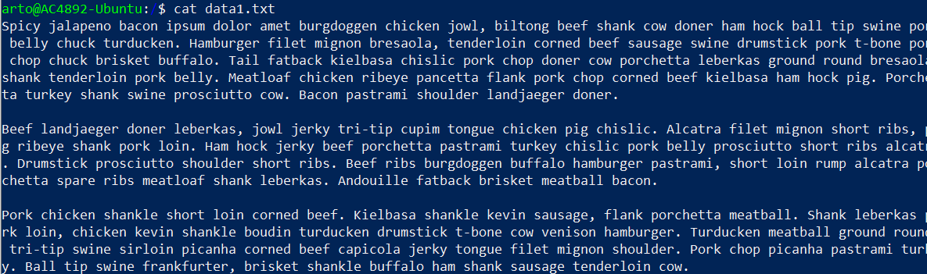

1. Find results for string **zulu** using apt package management and redirect the results to file *apt-listing.txt* in *arto’s* home directory using absolute path. [3p]



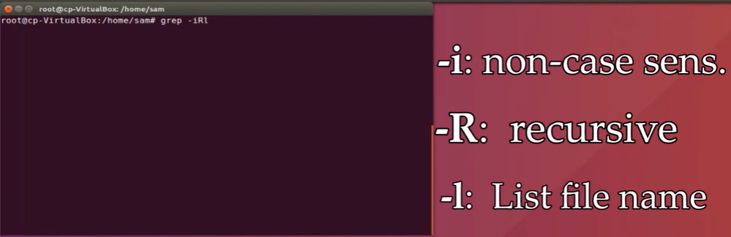





1. List the content from *files* directory using long listing format so that only objects (files, directories, links etc.) that have last been edited in year 1994 will be listed. [4p]

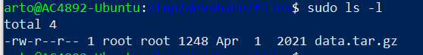

sudo find . -type f -newerat 1994-01-01 ! -newerat 1995-01-01 –ls

1. Create new permanent alias for user *arto*, which will print the current date to command line. Verify that yout alias works. [5p]
2. **Return to your previous user**. Use find command to find directories with name including the string **ap** inside */etc* directory using administrative privileges. [3p]



1. Use systemd timer to schedule a backup of *devshare* directory to your user’s home directory using tar command. Backup should be taken every Sunday at 15.30. [5p]
2. At what time, was the previous system boot? [3p]



1. List your user’s groups and write the output to file called *my_groups.txt*. Then create a tar archive called *group_package.tar* including that file. [3p]
2. Remove group *developers*, user *arto* and arto’s home directory from the system. [3p]