



**Linux Basics re-exam**

Write all answers here in this document. Use screenshots to support your answers. Screenshot must include the commands you used. For example a simple **ls** from a directory is not adequate. If screenshot won’t cover your answer or is missing some essential parts, you may add written answer as well in addition to screenshot.

Return the exam document before the given deadline into the Moodle return box in **PDF format**.

Maximum amount of points from the exam is 60 points. Question specific maximum points are marked after each question.

1. Create directory structure presented in the image below. [2p]

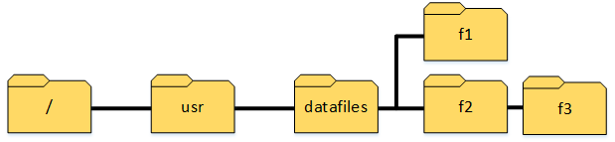

Go to Root Directory and then usr directory





Create datafiles directory



Go into datafiles directory and create f1 22 and then f3





1. Create two groups: *validators* and *confirmers*. [2p]



1. Create user *laura* with home directory and set bash as a default shell. Set new password of your choice for user *laura*. [3p]



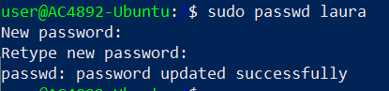

1. Set *validators* as owner group for directory f2 so that changes will be inherited to child objects. [3p]

Go to datafiles directory



Set the ownership



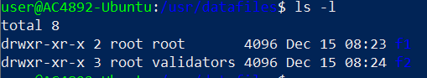

1. Give write permissions for *validators* for f2 directory so that changes will be inherited to child objects. [2p]

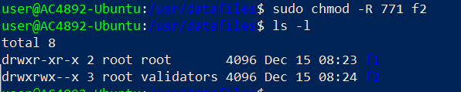

1. Set *confirmers* as owner group for directory f1 and set directory permissions using numeric format so that only group has permissions to directory. Group must have all permissions. [3p]

Change the ownership

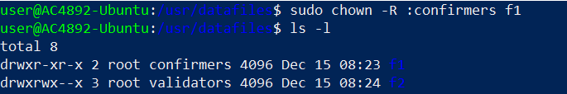

Change permissions so that only the group has permission

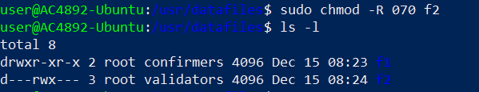

1. Add user *laura* to groups *validators* and *confirmers* so that *confirmers* will be user’s primary group. [3p]

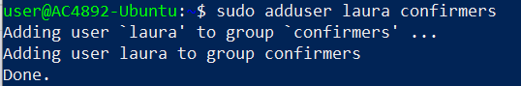

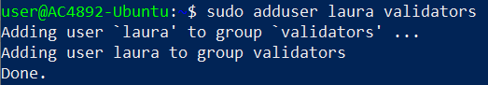



Confirm that it is added

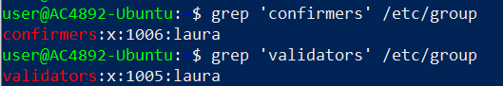

1. Switch to user *laura* so that the whole environment is changed (every environment variable is loaded etc.) (**the following exercises will be done with user laura**). [3p]



1. Create directory *restored* to *laura*’s home directory using absolute path. Create two new files inside *restored* directory using relative path: *backup_1.txt* and *backup_2.txt*. Redirect the output of command *ls –la /tmp* to the end of the *backup_2.txt* file. [4p]



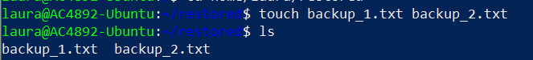



1. Copy the directory *restored* to previously created directory *f1*. [2p]



1. Download the package from the link below and move the package to directory *f3* with a new name *downloaded_data.tar.gz*. [3p] <http://student.labranet.jamk.fi/~hantt/exam/examdata.tar.gz>

Download the file



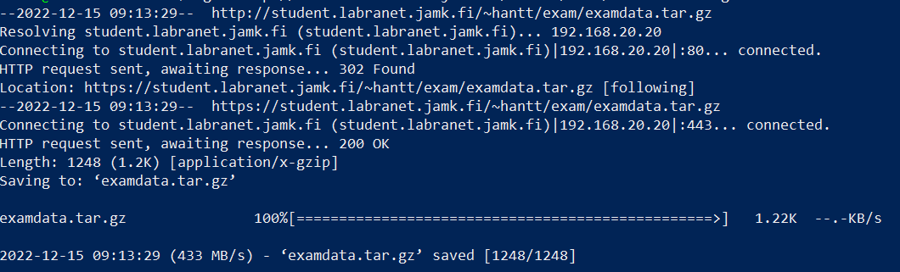

Move File



1. Extract *downloaded_data.tar.gz* package using only one command. Move *data1.txt* file from extracted directory to user’s home directory. Print the content of the file *data1.txt* to the command line. [3p]

Extract File



Move File

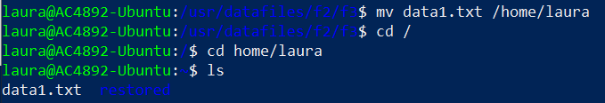

Print the content of the file

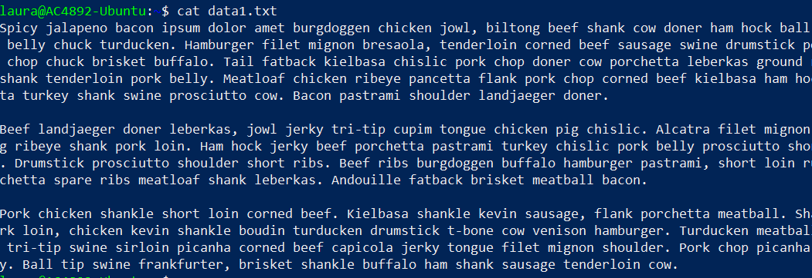

1. Search string *franela* with apt package management tool and redirect the output of the command to the file called *apt-search-results.txt* inside the directory *f2* using absolute path. [3p]



Confirm the output

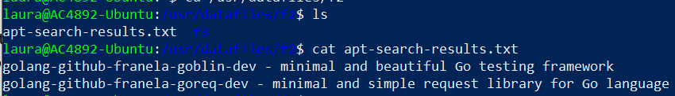

1. List the content of laura’s home directory using ls long listing format. Show only objects modified during this month (ls command). [4p]

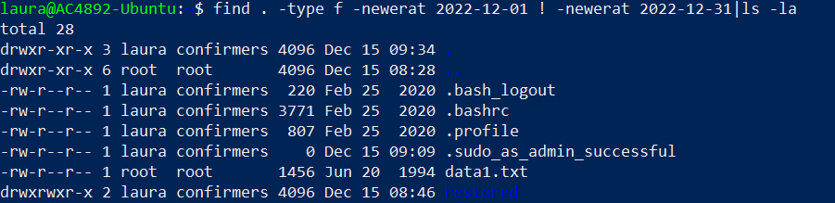

1. **Return to your previous user**. Find files with file name including the string *cloud* from */var/log* directory using administrative privileges (find command). [3p]

Returning to previous user





Screen shot of a section of the output

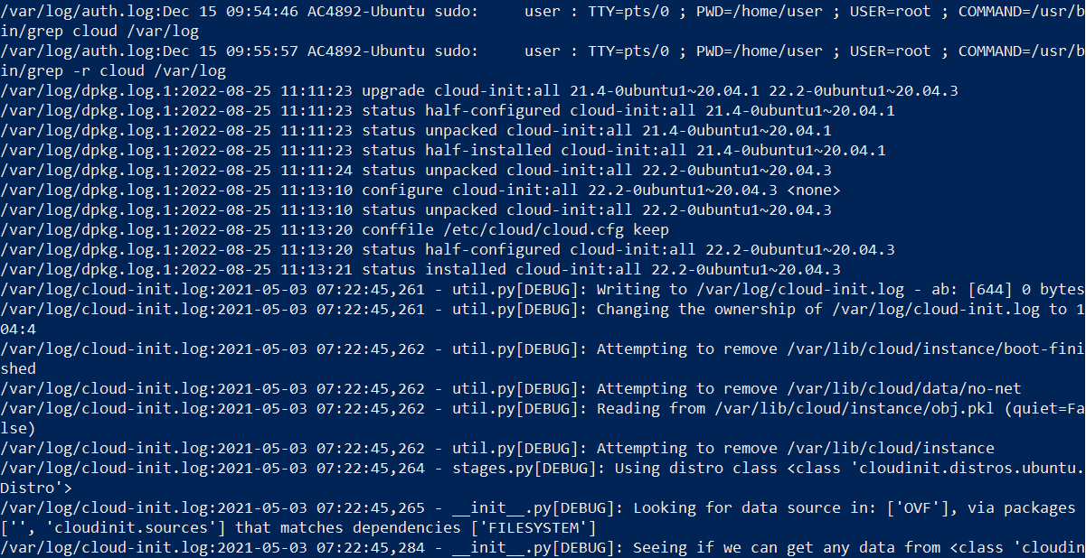

1. Create a new permanent alias for all users, which prints the content of user’s home directory. Verify that alias works on user *laura*. **Important:** command must work regardless where you run it in the file system! [5p]

To create a permanent alias for all users we need to create in /etc/bash.bashrc



Create the alias

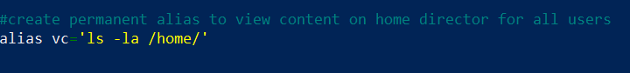

Then press ctrl+s and ctrl+x

Exit the current session and log in again

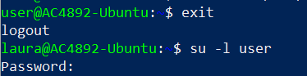

Check it works for the current user

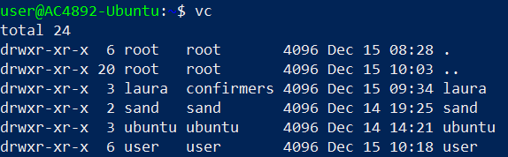

Log in with laura and check

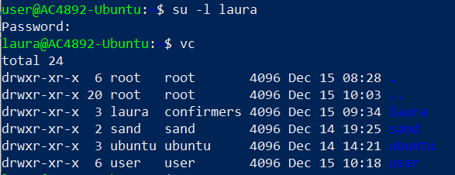

1. Delete *datafiles* directory using one command. [2p]



1. Use system to create a scheduled job that writes the following message into the file called *one-day-event.txt* in your user’s home directory: “***This message has been recorded in the Dec 2022***” (hint: echo command). This event will only occur once in 24.12.2022 at 6.30 PM. [5p]

Open Crontab 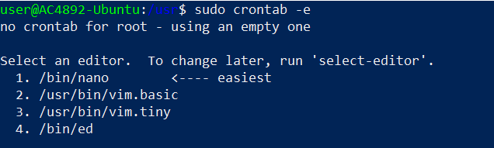

I used Nano to edit

According to crontab.guru website this is ok



Eg: 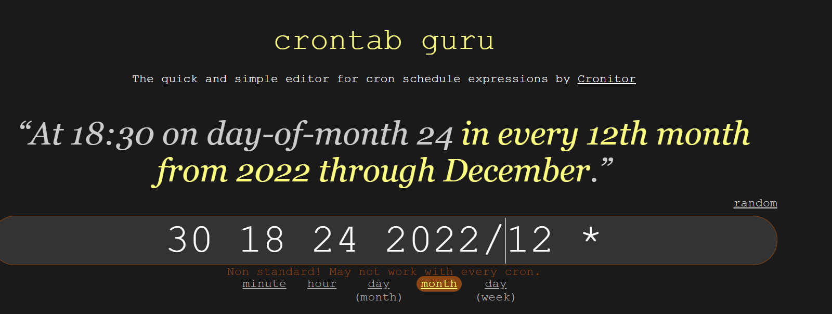

But once I try save it give an error on month value so I did the following





And we need to write a script to run this only once

1. Install *mariadb-server*, check the status of the service after the installation, stop the service if it is running and lastly disable unit from the boot. **Important:** If you receive the following error, please remove the ***mysql-common*** package from your system before the installation: ***mariadb-server : Depends: mariadb-server-10.3 (>= …)*** [5p]

Installing mariadb



Screenshot of a section output

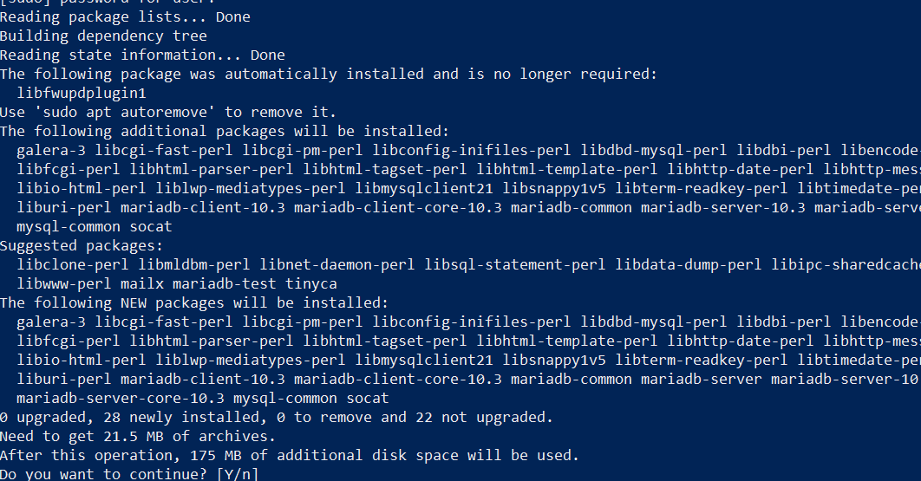

Check the status

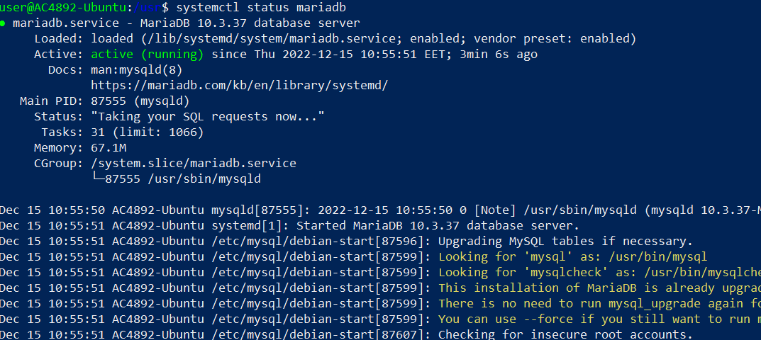

Stop Mariadb



Disable mariadb from boot

