**Portfolio**

1. **Synopsis**

* **Concept of the Web Site**

This is a web portfolio resume

* **Target audience is,**

JAMK professors, Recruiters and colleagues

* **Developer**

Sanka De Silva (Me)

* **Environment used to host the site**

JAMK labranet

* **Maintenance/ Update Policy**

This is will be updated in every spring

1. **Hierarchical Structure**

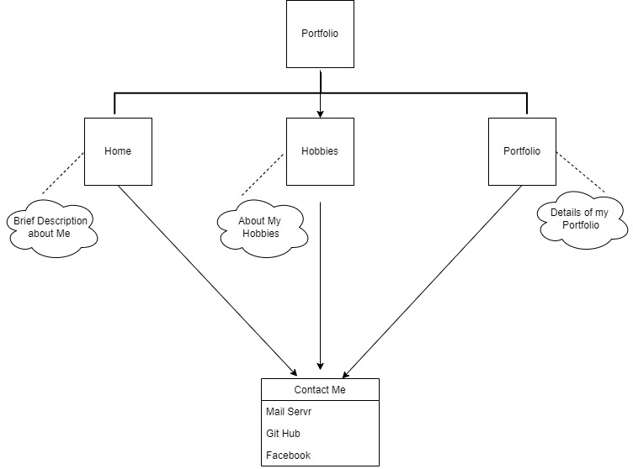

1. **Result of Testing**

Check with the Chrome and Firefox latest versions and there are no deviations

1. **Resources**

* Planning 1 Hour
* Designing wireframe 30 minutes
* Layout designing 30 minutes
* Content 30 minutes
* Testing 15 minutes