Data Analysis for purchase report of the “Black-Friday Dataset”

We were provided with the Black Friday dataset, which included customer purchase information split into train and test files. The raw data contained missing values, inconsistent entries, and incorrect data types, so the first step involved cleaning and preparing the dataset. After completing the data-preprocessing stage, I proceeded to Task 1: Visualisation, where the goal was to explore and present key relationships within the data using Tableau.

TASK 1 - “VISUALIZATION”.
- Percentage Distribution of Product Category

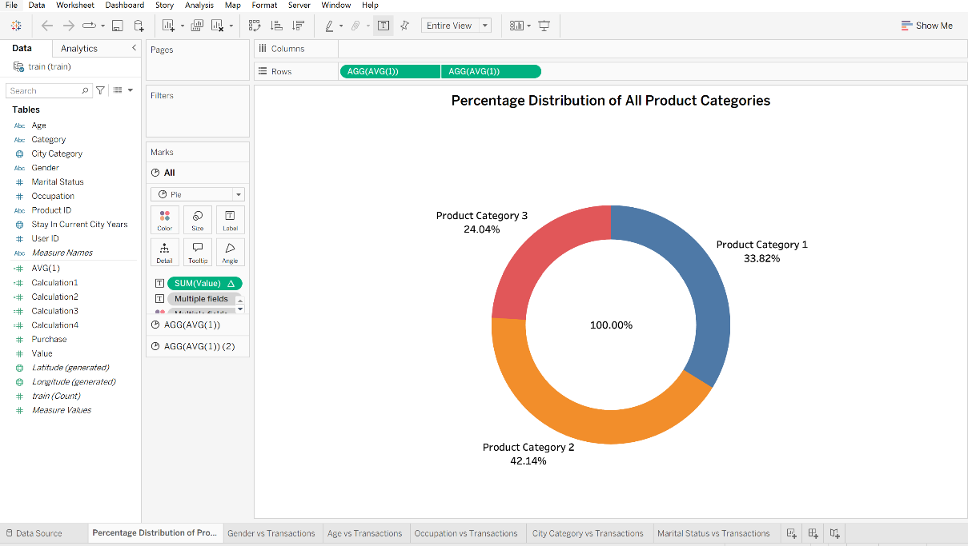

This Tableau donut chart shows how each product category contributes to overall sales. It gives a quick, visual snapshot of which categories are performing the best, helping the business understand where most purchases come from and where marketing efforts could be focused.

- Gender vs Transactions

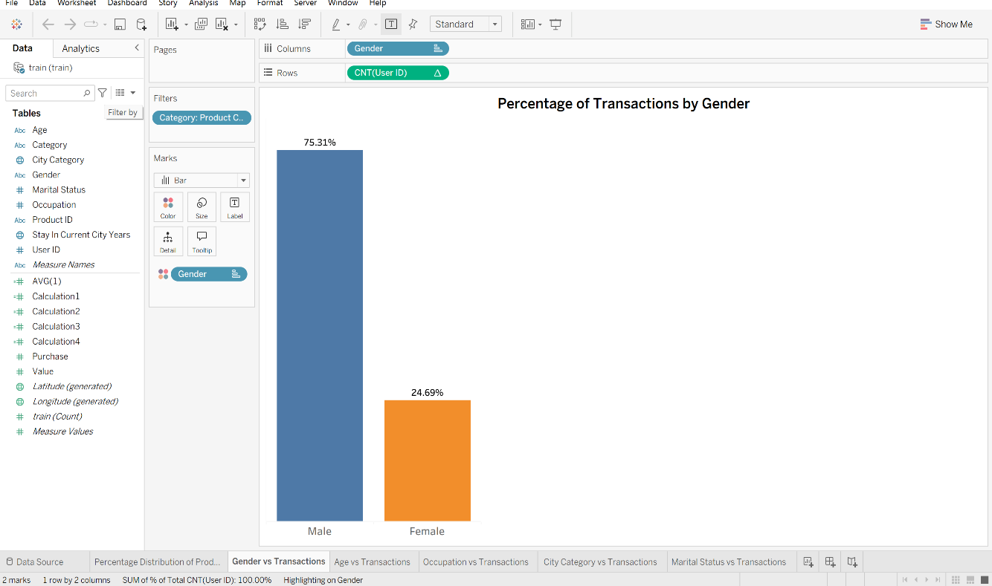

This Tableau bar chart shows how purchases vary by gender. It’s clear that most transactions were made by male customers, who account for about 75% of total sales, while female customers make up roughly 25%. The chart gives a quick visual insight into customer behaviour, showing that men are more active shoppers in this dataset and helping the business think about how to attract more female buyers.

- Age vs Transactions

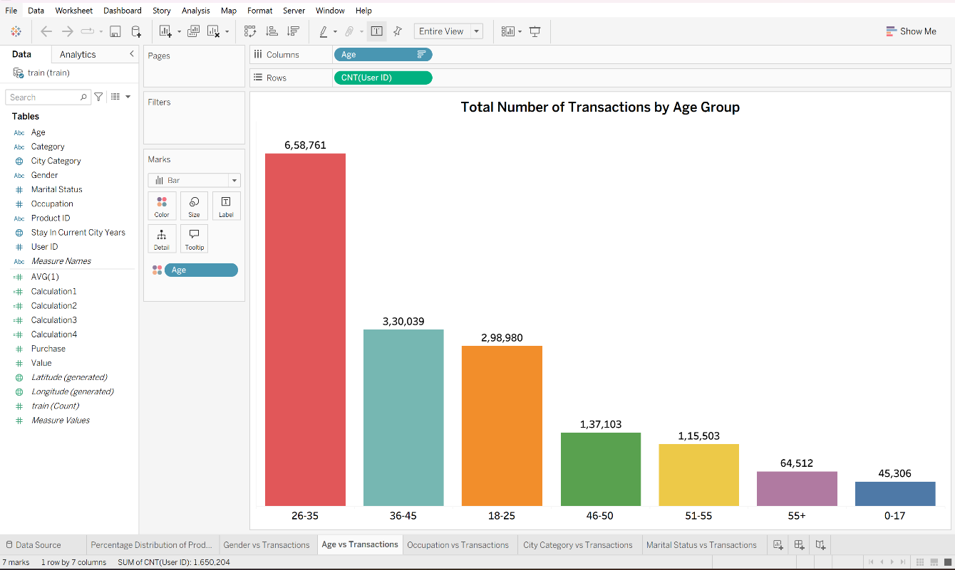

This Tableau chart shows how different age groups contribute to total transactions. People aged 26–35 make the most purchases, followed by those aged 36–45 and 18–25. It’s clear that younger and middle-aged adults are the most active shoppers, while older groups buy less. This helps the business understand which age ranges drive sales and where to focus promotions.

- Occupation vs Transactions

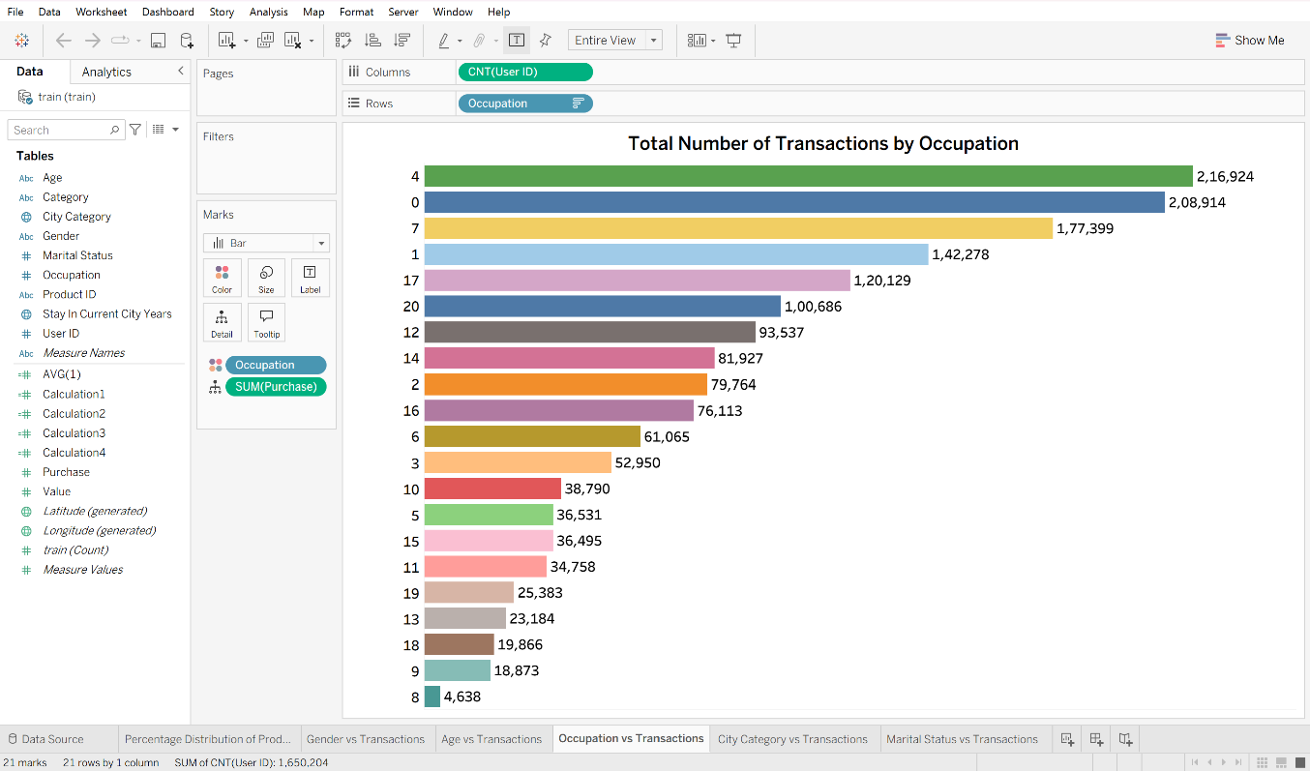

This chart shows how purchase activity varies across different occupation groups. A few occupations, like groups 4 and 0, make a noticeably higher number of transactions compared to others. Some occupations contribute very little, which creates a clear gap in buying behaviour. This helps the business understand which customer segments are most active and worth targeting with tailored offers.

- City Category vs Transactions

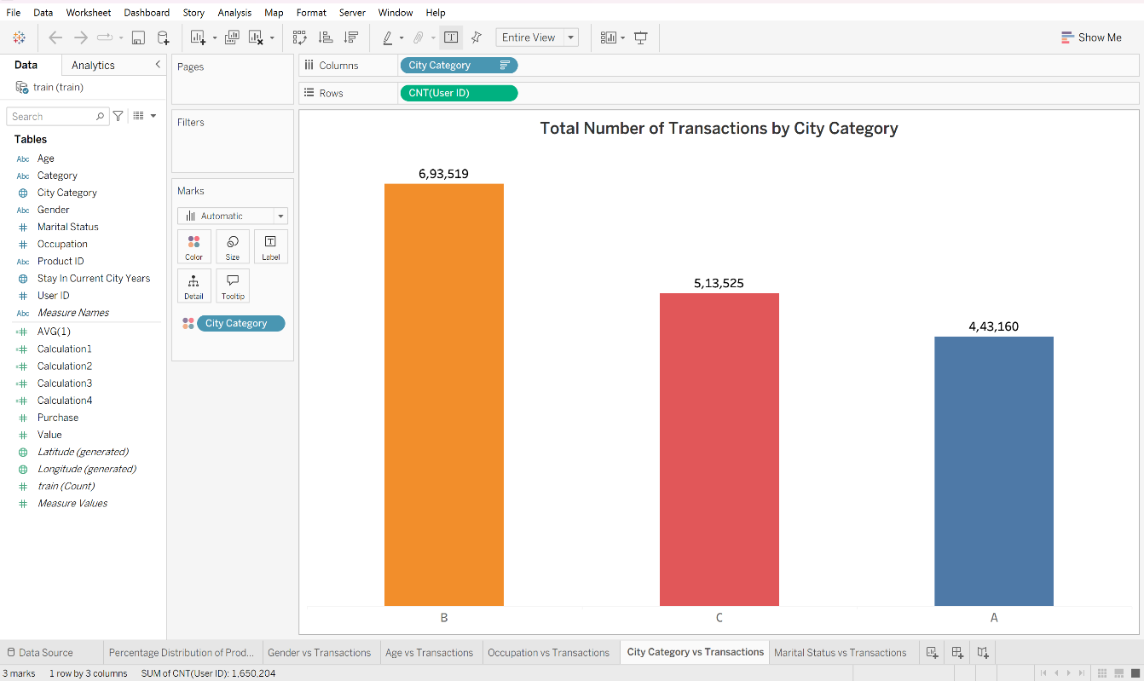

This chart compares how many transactions come from each city category. City B has the highest activity, followed by City C and then City A. It shows that customers from City B are the most engaged shoppers in this dataset. This helps the business understand where most of its buyers are located and which areas may need more targeted marketing.

- Marital Status vs Transactions

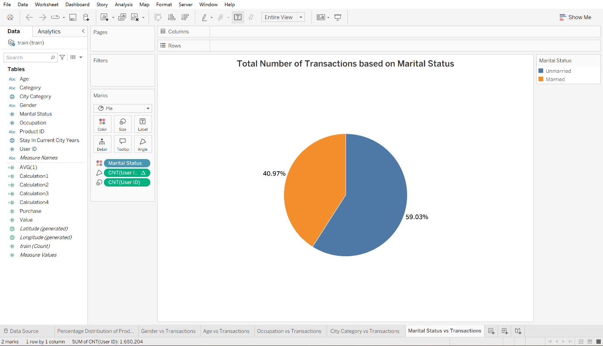

This pie chart shows how transactions differ between married and unmarried customers. Unmarried users make up the larger share of purchases, contributing around 59%, while married customers account for about 41%. This suggests that single customers are slightly more active shoppers in this dataset. The visual helps the business understand how marital status influences buying behaviour.

TASK 2 - “ANALYTICAL REPORT”
3.1 How does predicting the purchases for new customers help the business?
"Prediction" word has much value in any business in today's world. Predicting the purchases of new customer plays an important role in business success. It helps to understand the purchase pattern of the new customer, his likes, dislikes and targeted products, brands etc. Even if we do not have any new customer data the prediction can be done based on the historical data, old purchased data. It helps to find out the customer needs, improve customer experience. Based on that business can make good decisions which helps in business growth.
One of the biggest advantages of the predicting the purchases is personalisation. When a new customer walks in new store, visits any online platforms for shopping business will know very little about the customer need. But based on the purchase prediction model uses features like age, gender, occupations, city category and help the business to understand the customer better. For example, in given "Black-Friday" based on the visualization it was clear that "product category" was most sold item and also aged "26-35" bought items. Also, we get to know what are the less purchased items and also which age group did not do the purchases. According to that we can help customer to improve shopping experience, also eventually that helps in growing business.
Based on the prediction data business can target the customers. For example, women might like the apparel, beauty and men might be checking for new electronic items. Family might check for appliances which comes for longer durations. According to that the business can send notification on new offers, discounts which helps business to support the sales. It won’t use much resources of marketing.
Prediction model also helps business to plan the inventory planning. Business often struggles with stocking the right number of products. For example, if predictions show that a large number of new customers are likely to buy home appliances, the business can increase stock in that category. This reduces the risk of stockouts and ensures that customers find what they are looking for.
Predicting the customer needs and fulfilling them helps to win customer trust. It is important factor for business to get good sales and profit. If the business can recommend the right products from the beginning, the customer feels valued and understood. This increases trust and encourages them to come back for future purchases. Over time, this leads to stronger customer loyalty and higher lifetime value.
Prediction also helps the business to identify the high value customers early. For example, if the model predicts that a new customer is likely to make large purchases, the business can offer them special discounts, priority service, or loyalty rewards. This makes the customer feel appreciated and increases the chances that they will continue shopping with the company. Identifying high value customers early is extremely beneficial because it helps the business focus its efforts on the people who are most likely to bring long term profit. One the good example is "Amazon" using the prime to deliver the items faster than the normal customers.
Prediction models are not always correct; they work on historical data. But they help to reduce the uncertainty. Considering the few info of the new customers and old data it will predict and help to plan better. It helps to understand the customer better. Also, it helps all the departments like sales team to plan the promotions, inventory teams to stock the products based on the demand and customer service teams to be ready with the support if the new customers need. Since all departments use the same prediction model, the business becomes more coordinated and efficient.
Finally, predicting purchases helps the business stay competitive. Many companies today use data and machine learning to understand customer behaviour. If a business does not use prediction models, it may fall behind competitors who are able to offer better personalisation and faster service.
Overall, predicting purchases for new customers helps the business in many ways. It helps to plan the business better for promotions, sales, inventory planning. Alos, help to gain the customer trust, personalized sales promotions, discount offers etc. Most importantly, it allows the business to understand new customers even before they make their first purchase. This early insight gives the company a strong advantage and helps it build long-term relationships with customers. In a competitive market, being able to predict customer behaviour is not just helpful — it is essential for growth and success.

3.2 How could the result of your analysis help the company make better decisions?
Even though the prediction models won't give the 100 % accurate results the insights will be helpful for the business to plan further. The results analysis, including the visualisations and the linear regression model, can help the company make better decisions in many practical ways. Each chart reveals something different about the customer purchasing behaviour. The business can take the insights from that and use for marketing, improve customer experience, and manage resources more effectively.
One of the biggest advantages of the analysis is that it shows which customer groups are the most active in purchasing the products. For example, the age-group chart clearly shows that customers aged 26–35 make the highest number of purchases. Here business can plan the marketing for majority of the customers who buy more or plan to improve marketing strategy to attract the lowest spending customers. This helps the business use its marketing budget more wisely.
The gender-based chart also gives much information about the purchase pattern. If male customers make around 75% of the purchases, the company can use this information in two ways. First, it can design campaigns that appeal more to male shoppers, since they are already active. Also, business can deep dive and check why they are failing to attract the female customers for purchasing the items, if need improvements in brands, discounts, collections. Without this analysis, the company might not realise that such a gap exists, and it could miss opportunities to grow.
The occupation-based chart is another example of how the analysis supports decision-making. In chart occupation groups buy a lot, while others buy very little. This helps the company understand which types of customers have higher purchasing power or stronger interest in the products. For example, if occupation groups 4 and 0 make the most transactions, the company can create special promotions or loyalty programs for these groups. This analysis will also be useful to make better stocking decisions, as the pattern of buying and selling is different for various occupations as it depends on the income of the customer.
As we have city category transaction chart in the project it gives clarity about the sales, product types which city orders. Based on the orders we can plan the inventory, if noted less orders noted in A, B cities what is the problem in those areas. Maybe customers in that city prefer different products, or maybe the company needs to improve its presence there. When we know the place we can fulfil customer demands and also safeguard the products.
The marital status chart also provides valuable insight. If unmarried customers make more purchases than married customers, the company can adjust its marketing messages accordingly. For example, unmarried customers may respond better to promotions related to lifestyle, fashion, or electronics. Married customers might be more interested in-home appliances or family-oriented products. Knowing which group buys more helps the business design targeted campaigns that feel relevant to each customer segment.
Beyond the visualisations, we have the linear regression model which gives another set of analysis about the purchase prediction. Based on the provided “Train/Test” Data sets model produced an R² score of 0.1509 and an RMSE of about 4619. This means the model explains around 15% of the variation in purchase amounts.
Also, it gives the results of predicted vs actual values also show that the model captures the overall direction of spending, even if the exact numbers are not perfect. For example:
- Actual: 19,142 → Predicted: 13,261
- Actual: 15,513 → Predicted: 12,371
The predictions are not exact, but they are close enough to help the company understand general spending behaviour. This is useful because it allows the business to personalise its approach. For example, if the model predicts that a customer is likely to spend a higher amount, the company can offer premium products, special discounts, or loyalty rewards. If the predicted spending is lower, the company can offer entry-level products or incentives which are small in size so that they can make more sales. This step will help the business to improve the sales.
The regression model also helps the company understand which factors matter most. Even if the model is not perfect, it still shows that variables like age, occupation, and city category influence purchase behaviour. This helps the business avoid wasting time on factors that do not significantly impact sales. The model also helps the business forecast future revenue more accurately because it provides a data-driven estimate of customer spending patterns.
Another important benefit of the analysis is that it helps the company improve inventory management. When the business knows which customer groups buy more and what types of products are popular, it can stock the right items in the right quantities. This reduces the risk of overstocking products that do not sell well and prevents stockouts of high-demand items. Better inventory planning leads to higher customer satisfaction because customers are more likely to find what they want.
The analysis also supports better decision-making in customer experience. When the company understands who its customers are and what they prefer, it can design a smoother and more personalised shopping journey. For example, if younger customers prefer certain product categories, the company can highlight those items on the homepage or in promotional emails. If customers from certain cities prefer faster delivery, the business can improve logistics in those areas.
Overall, the results of the analysis depend on multiple factors like customers, cities, products, marital status etc. It helps to improve marketing strategies, supporting inventory planning, enhancing customer experience, guiding regional strategies, and providing useful predictions through the regression model. Even though the model is not perfect, it still offers valuable insights that help the business operate more efficiently, attract more customers, and increase sales in a smart and sustainable way.

