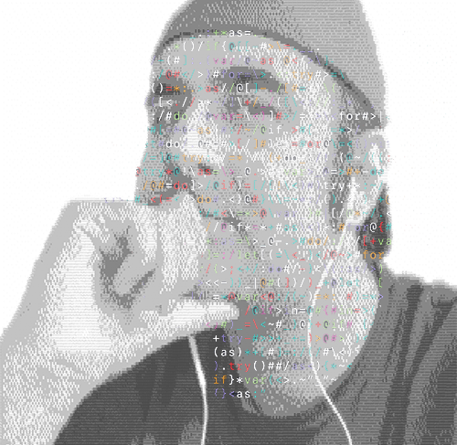M Y C V.19

/*Business Development Manager, Software Quality Assurance Engineer, Technical Recruiter, Technical Project Manager, Server-side applicator, Apps and Sites Optimizer, High-level Computer Programmer, UI-UX of apps and games designer*/

Print *name [“Syed Faisal Shah”];

{contact: “@” (callto: 03218415162), (email: faisaly2k1@gmail.com);}

- (**experience**)Business.Development.Manager {@total *years = [5];

[**profile**.upwork [click here](https://www.dropbox.com/s/dayiynvl6ohplw8/Screenshot%202018-12-05%2009.37.47.png?dl=0)];  
 [**recent sale**.to Google: @"2015 Chelsea NYC [click here](https://www.dropbox.com/s/7ahgennewjevegd/IMG_2042.JPG?dl=0)"];}

- (**experience**)Software.Quality Assurance.Engineer {@total *years = [6];

[**technology**.stack = New Relic, CircleCi, Jenkins, GitHub, Canary, qTEST];}

- (**experience**)Technical.Recruiter.Project Manager {@total *years = [4];

[**technology**.stack = Trello, GitHub, Dropbox Paper, Atlassian Stack];}

- (**experience**)Server side.Applicator.Securtiy Manager {@total *years = [2];

[**technology**.stack = npm, PARSE, AWS, IBM WATSON, LINUX, Windows Server 2012];}

- (**experience**)Apps Store.Applicatons.Search Engine Optimziation {@total *years = [3];

[**technology**.stack = Custom SEO Engine, Medium back linking, Black Hat, Ads, Luck];}

- (**experience**)Computer Programmer.Mobile Developer.Full Stack {@total *years = [20];

[**profile**.upwork [click here](https://www.dropbox.com/s/qalfkd5vj5e3s37/screenshot%202018-10-20%2020.53.18.jpg?dl=0)];  
 [**technology**.stack = Python, PHP, Objective-C, Swift, AngularJS, WPF, Unity3D, C++];}

- (**experience**)Interface Designer.3D Artist.General Animator {@total *years = [10];

[**profile**.deviant-art [click here](https://www.deviantart.com/sfsy2k1)];  
 [**technology**.stack = Photoshop, After Effects, Illustrator, inVision, Audition];}

*// Recent Work Experience:*

name.business = ('Merchant Account Solutions'); role.since = ('Chief Technology Officer' , 2015);

*// Ai Portfolio:* history.log("2 years"); result.Vimeo = SFS-ds.url(['click here'](https://vimeo.com/user25276730));

*// Sum-up Portfolio:* history.log("19 years"); result.Dropbox = iamsfs.url(['click here'](https://www.dropbox.com/s/wkcq8cuh3mihikr/CV-2018.pdf?dl=0));

*// Social Links:* user.id = LinkedinInfo.get(['click here'](https://www.linkedin.com/in/iamsfs/)) + FacebookInfo.get(['click here'](https://www.facebook.com/iamsfs1));

*Education(degree, year) {*

*if (!degree) {*

*life.log('Intermediate! in 1998');*

*response.success("Thanks if you ignore this drawback!");*

*} else {*

*life.log('Oops! This wasn’t you were looking for' + error);*

*response.error('Its ok, I can understand');*

*}*

**@end**

//------------------------------------------------------------------------------------

*I hope you enjoyed reading this CV as I have enjoyed writing it. This is just a quick note telling that I have what it got to get the Job done. No matter how big or small the task is, I always believe in smart working. I’ll close my argument with my saying;*

A Wise Man in the Mirror told me:

It's easy to give up and find more work and u will, but that will be just another work and u will be one of many who can do it. If u want to standout then stand up and finish what u started.

------------------------------------------------------------------------------------\\