**Problem Statement:-**

Electric vehicles are increasing in demand because of their eco-friendly and budget friendly. It is still in evolution stage and limited in number. So we explore Stockholm and propose to setup EV Charging station to maximize its utility. We use clustering and data science methodology to solve our problem of opening new charging station.

**Databases:-**

We use data provided by statistics Sweden and foursquare API to setup our station.

Average rent in rental apartment by region per sqm and year 2018

http://api.scb.se/OV0104/v1/doris/sv/ssd/START/BO/BO0406/BO0406E/BO0406Tab01

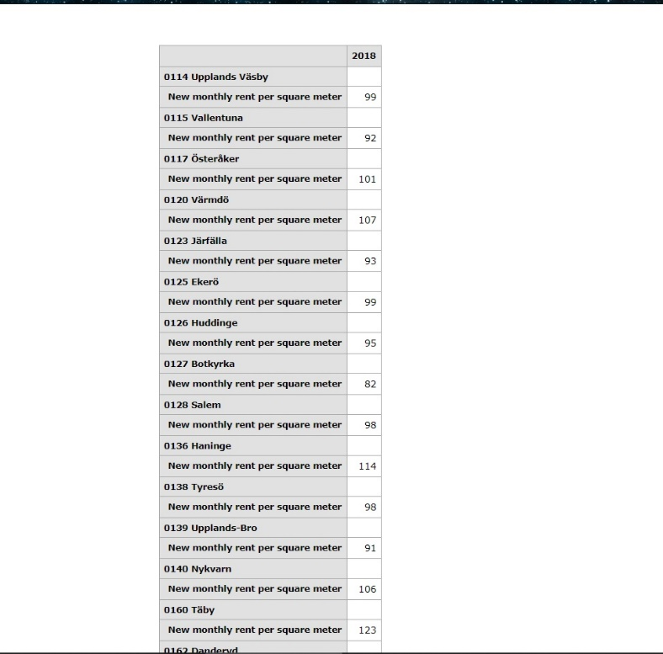

Population in the realm, counties and municipalities December 31, 2018 and population changes October 1 - December 31, 2018

<https://www.scb.se/hitta-statistik/statistik-efter-amne/befolkning/befolkningens-sammansattning/befolkningsstatistik/pong/tabell-och-diagram/kvartals--och-halvarsstatistik--kommun-lan-och-riket/kvartal-4-2018/>