

Department of Computer Science & Engineering (CSE)

# Lab Report

Course Code : CSE-212

Course Title : Data Structures Sessional

Submission Date : 21-01-2024

Submitted To:

Md. Imran Hossain Emu

(Lecturer) ,

Dept. of CSE , BAIUST.

Submitted By:

Name : Md. Shafin Ahammad Hredoy

ID : 0822220105101009

Level-Term : 2-1

Introduction/Objective:

The objective of this lab is to implement a C++ program to find prime numbers within a specified range. The program utilizes a function Check_prime to determine whether a given number is prime or not. The lab aims to strengthen understanding of prime numbers, functions, and loops in C++ programming.

Theory:

A prime number is a natural number greater than 1 that has no positive divisors other than 1 and itself. The function Check_prime in the provided code checks whether a given number is prime or not using a simple loop. The main program takes user input for the range and iterates through the specified range, identifying and displaying prime numbers using the Check_prime function.

Code:

#include <iostream>

using namespace std;

int Check_prime(int num) {

if (num <= 1) {

return 0;

}

for (int i = 2; i * i <= num; i++) {

if (num % i == 0) {

return 0;

}

}

return 1;

}

int main() {

int start, end;

cout << "Enter the for prime number : ";

cin >> start >> end;

if (start > end || start < 0) {

cout << "Invalid range. Please enter a valid range." << endl;

return 0;

}

cout << "Prime numbers between " << start << " and " << end << ": ";

for (int i = start; i <= end; i++) {

if (Check_prime(i)) {

cout << i << " ";

}

}

cout << endl;

return 0;

}

***Code Description:***

* The program defines a function Check_prime to determine if a given number is prime.
* The main function takes user input for the range and uses a loop to iterate through the range, calling the Check_prime function to identify prime numbers.
* Prime numbers are displayed as they are found within the specified range.

Input-Output :

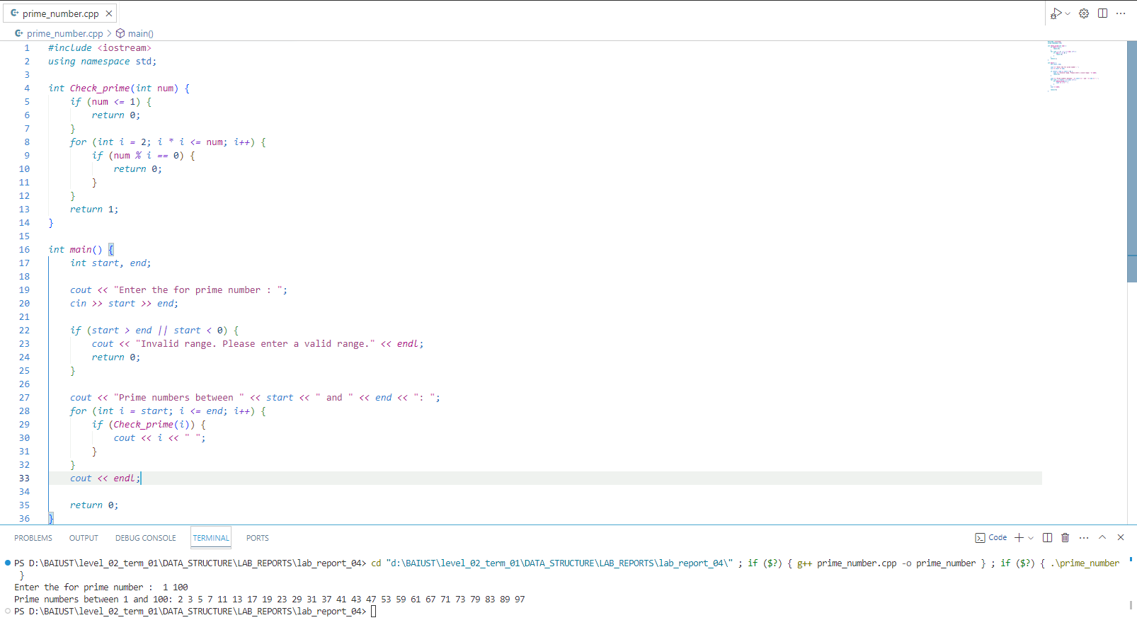

Conclusion/Discussion:

In conclusion, the C++ program successfully identifies and displays prime numbers within a user-specified range. The use of the Check_prime function adds modularity to the code, and the program provides a practical demonstration of loops, conditionals, and function usage in C++. The lab experience contributes to a deeper understanding of algorithmic implementation in programming.

References/Bibliography:

No external references were used for this report. The code is based on common C++ programming practices and algorithms