

Department of Computer Science & Engineering (CSE)

# Lab Report

Course Code : CSE-212

Course Title : Data Structures Sessional

Submission Date : 03-02-2024

Submitted To:

Md. Imran Hossain Emu

(Lecturer) ,

Dept. of CSE , BAIUST.

Submitted By:

Name : Md. Shafin Ahammad Hredoy

ID : 0822220105101009

Level-Term : 2-1

Introduction/Objective:

The objective of this lab is to explore two different implementations of the Fibonacci series generation in C++. The first implementation involves using iteration without recursion, while the second implementation utilizes recursion. Both programs prompt the user to input the length of the desired Fibonacci series and then generate and display the series accordingly.

Theory:

The Fibonacci sequence is a series of numbers where each number is the sum of the two preceding ones, usually starting with 0 and 1. Mathematically, it is defined by the recurrence relation: F(n) = F(n-1) + F(n-2). The series can be generated using iterative or recursive approaches.

Code_Fibonacci_(without_recursion):

#include <bits/stdc++.h>

using namespace std;

int main(){

int first = 0, second = 1, n, temp;

cout << "Enter the length of the Fibonacci series: ";

cin >> n;

if(n > 0){

for(int i = 0; i < n; i++){

cout << first << " ";

temp = first + second;

first = second;

second = temp;

}

cout << endl;

} else {

cout << "Invalid length." << endl;

}

return 0;

}

***Code Description Fibonacci_(without_recursion):***

This code initializes the first two numbers in the Fibonacci series, takes user input for the length of the series, and then iteratively generates and prints the series. It checks for a valid input length and handles invalid inputs appropriately.

Code_Fibonacci_(with_recursion):

#include <bits/stdc++.h>

using namespace std;

int fibonacci(int n){

if(n <= 1) return n;

else return fibonacci(n - 1) + fibonacci(n - 2);

}

int main(){

int n;

cout << "Enter the length of the Fibonacci series: ";

cin >> n;

for(int i = 0; i < n; i++){

cout << fibonacci(i) << " ";

}

return 0;

}

***Code Description Fibonacci_(with_recursion):***

This code defines a recursive function “fibonacci” to calculate the nth Fibonacci number. The main function takes user input for the length of the series and iteratively calls the recursive function to display the Fibonacci series

Input-Output Fibonacci_(without_recursion) :

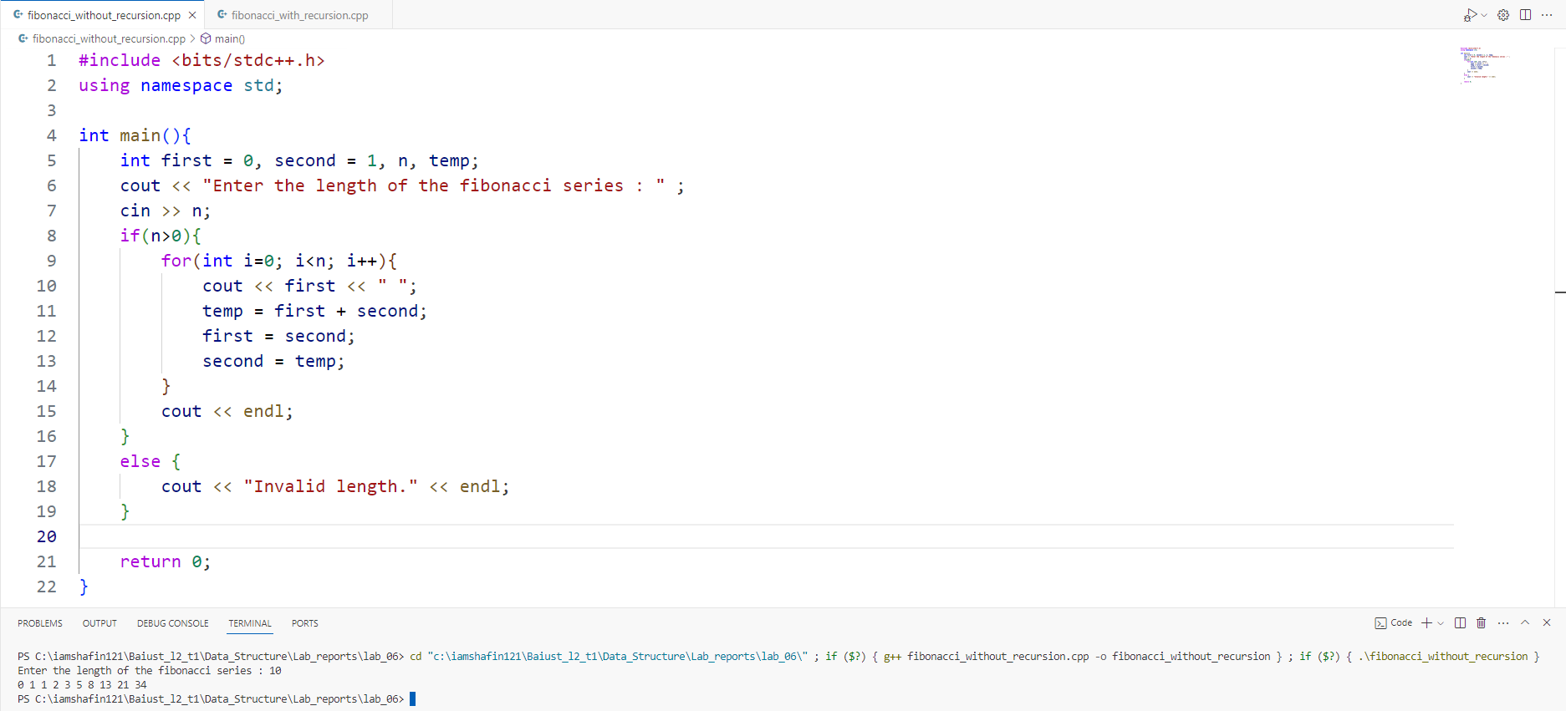

Input-Output Fibonacci_(with_recursion) :

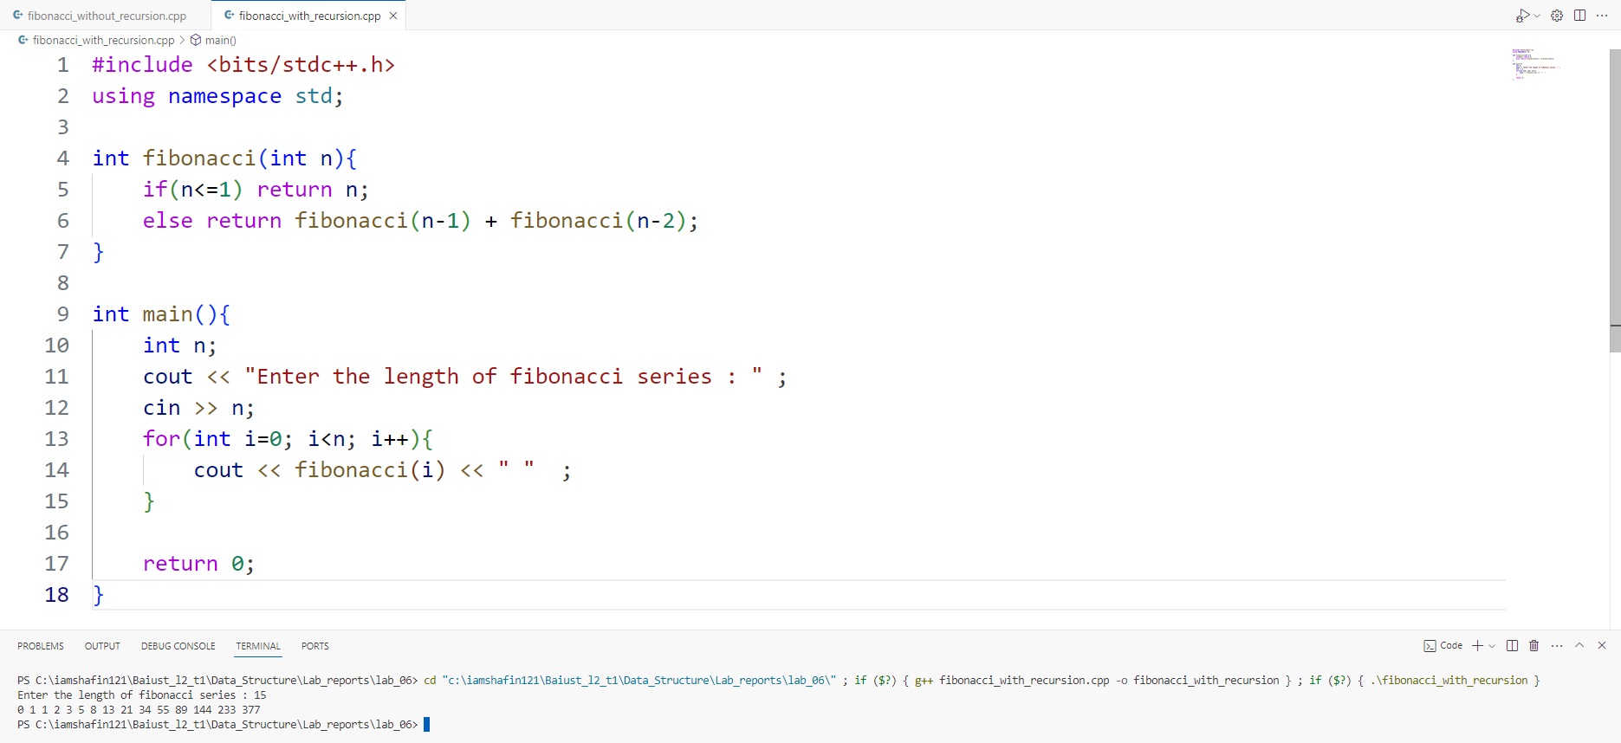

Conclusion/Discussion:

In conclusion, both implementations successfully generate the Fibonacci series based on user input. The iterative approach without recursion is efficient for smaller series, while the recursive approach tends to be less efficient for larger series due to redundant calculations. Understanding the trade-offs between these two methods is essential for choosing the appropriate approach based on the specific requirements and constraints of a given problem.

References/Bibliography:

No external references were used for this report. The code is based on common C++ programming practices and algorithms