**Smart Precision Agriculture**

Mohamed Sharbudeen

Computer Science and Engineering, RMK Engineering College

R.S.M. Nagar, Kavaraipettai-601 206

Gummidipoondi Taluk, Thiruvallur Dist.

iamsharbu@gmail.com

1. **Introduction**

Agriculture is one of the most vital component for living. Increasing food and water demand imposes a greater necessity to produce more. Food and Agriculture Organization estimated that global food production needs to be increased by 70% in order to face the growing demand. Farmers mostly rely on their field insight to manage their farm. With proper precision data and some calculations, a farmer could easily identify the aspects of his land which is far away and maintain it accordingly to yield higher production and quality from his place.

1. **Obstacles faced by previous models**

Talking about precision farming, it involves the usage of sensors to monitor the crop field and needs energy and manpower for operation and maintenance. A farmer's salary is between 3,000 to 15,000 INR depending upon seasonal changes. Some precision farming set ups which are being used in foreign countries are very expensive and a middle scale farmer cannot afford to buy it. So, to make a model which is affordable and carries out precise calculations to enhance productivity is the main aim of this Smart Precision Agriculture.

1. **Web of Things and Internet of Things**

The Web of Things (WoT) is a term used to describe approaches, software architectural styles and programming patterns that allow real-world objects to be part of the World Wide Web. The Web of Things aims to build the Internet of Things in a truly open, flexible, and scalable way, using the Web as its application layer. For the IoT to become a reality, we will need a single universal application layer protocol (think “language”) for devices and applications to talk to each other, regardless of how they are physically connected. Instead of creating yet another protocol from scratch (as many IoT projects have been – and keep – doing), why not simply reuse something that is already widely used for building scalable and interactive applications, such as the Web itself? This is what the Web of Things is all about: reuse and leverage readily available and widely popular Web protocols, standards and blueprints to make data and services offered by objects more accessible to a larger pool of (Web) developers.

1. **WeIO for Web of Things**

WeIO comes with full SW stack, an embedded IDE accessible by any browser and well-crafted development board which makes it easy to connect different types of electronic components. It also comes with well-prepared examples and documentation. WeIO SW exposes two API libraries to developers: Python and JavaScript. This way users can very fast do useful things with just a few lines of code. We have chosen these languages because they are powerful, easy to learn and well documented. Both languages expose their full set of functionalities, so any algorithm example, additional library or module from the web can be used in programming.

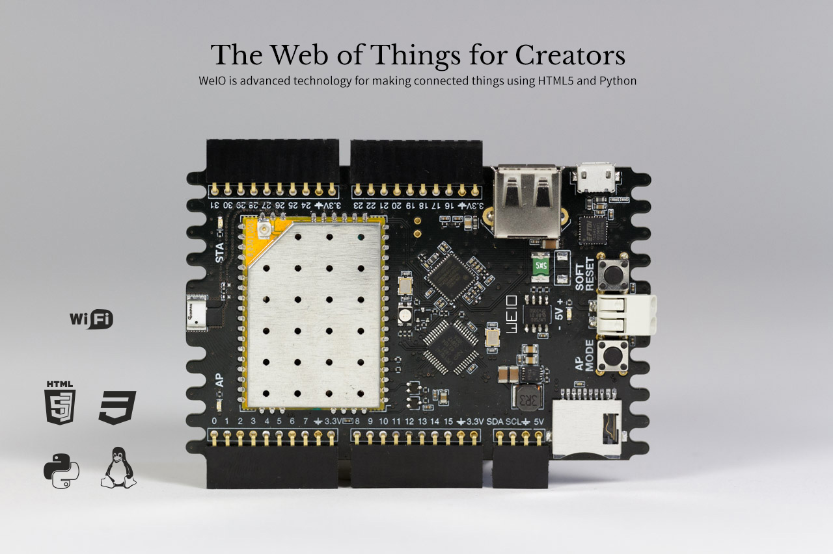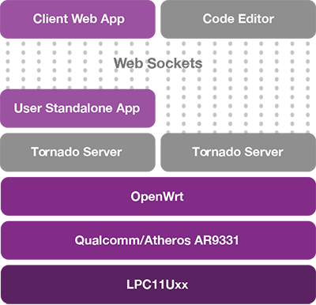

1. **Working Description**

The model description is designed to monitor a field of size 1 hectare which is the average field size that an Indian farmer owns. Sensors fixed at appropriate regions of the field collects data about the field and sends it the IoT node station. The station transmits the data wirelessly to a transceiver module named LoRa WAN (Long Range wireless Wide Area Network). It is a Low Power Wide Area Network (LPWAN) specification intended for wireless battery-operated Things in a regional, national or global network. LoRa WAN targets key requirements of Internet of Things such as secure bi-directional communication, mobility and localization services. The LoRa WAN specification provides seamless interoperability among smart Things without the need of complex local installations and gives back the freedom to the user, developer, businesses enabling the roll out of Internet of Things. The data is received at the user end by the WeIO module and it is converted into smart user interface where one could easily trigger some actions and assess the condition of the field by a simple click from the mobile device.

1. **Applications of Smart Precision Agriculture**

Monitoring agricultural parameters like temperature, sunlight, humidity, health of a crop, amount of fertilizers used, soil properties can be precisely calculated and necessary actions are taken automatically. Some of the actions performed are turning on the sprinkler when the temperature is high and humidity is low, calculating ph. levels in the soils and forming a quality map, control the location of tractors by tracing the paths using GPS thus reducing fuel consumption, maintaining optimum levels of fertilizers being used, generating predictive analysis based on the collected data which gives the farmer a greater insight of the positives and cons of his field.

1. **Architecture Planning for field**

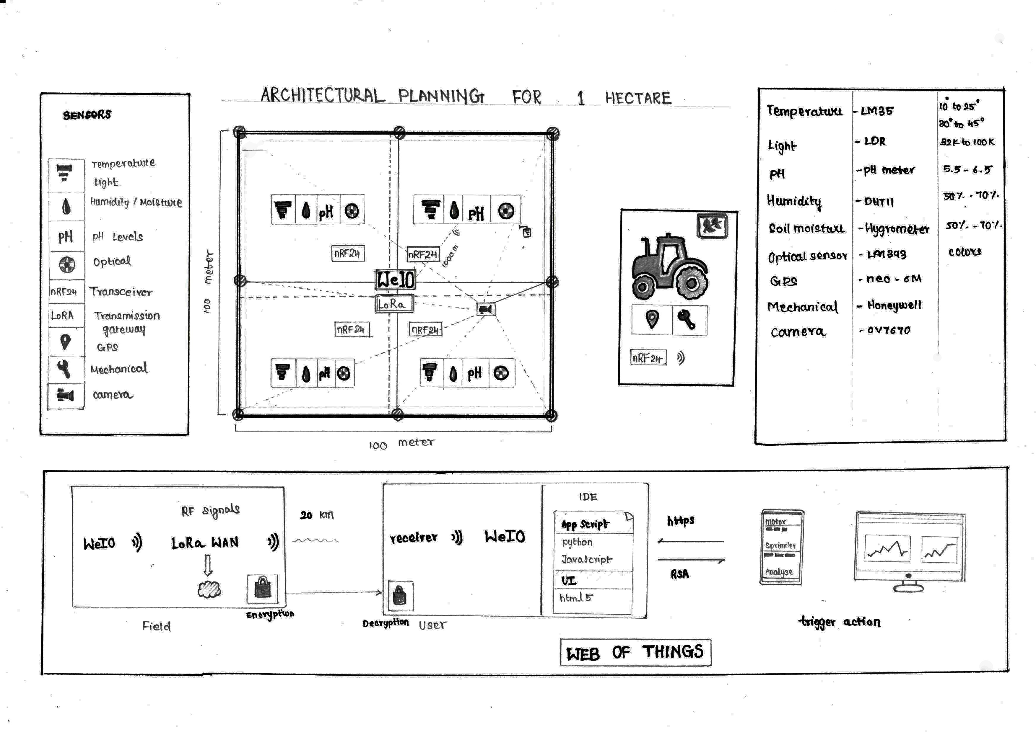 **VIII. Details of Sensors and Modules**

|  |  |  |
| --- | --- | --- |
| Software Requirements | Hardware Requirements |  |
| WeIO IDE | Temperature and humidity sensor(LM35/DHT11) | Optical sensor(LM393) |
| Thingspeak | Light Sensor(LDR) | GPS(Neo-6m) |
| Cloud platform | Ph Sensor (ph. meter) | Mechanical sensor |
| Python, JS | Soil moisture(Hygrometer) | Camera(ov7670) |
| Mobile Application | LoRa WAN | NRF24 transceiver |

**Sensor Parameters**

|  |  |
| --- | --- |
| Sensor | Parameter level |
| Temperature (LM35) | 10 to 25-degree Celsius (c3 plants)  30 to 45-degree Celsius (c4 plants) |
| Light (LDR) | 32000 to 100000 LUX |
| pH | 5.5-6.5 |
| Humidity | 50 – 70% |
| Soil moisture | 50 - 70% |

**IX. Safety and Privacy**

Hackers and government agencies can use vulnerabilities in IoT devices to gain access to a network to monitor users and potentially gain access to any other connected devices for any number of purposes. According to many security experts, our dependence on Internet-connected technology is outpacing our ability to secure it. *TLS* is a successor to Secure Sockets Layer protocol, or SSL. TLS provides secure communications on the Internet for such things as e-mail, Internet faxing, and other data transfers.The TLS Handshake Protocol allows the server and client to authenticate each other and to negotiate an encryption algorithm and cryptographic keys before data is exchanged. In a typical scenario, only the server is authenticated and its identity is ensured while the client remains unauthenticated. The mutual authentication of the servers requires public key deployment to clients. When a server and client communicate, TLS protocol ensures that no third party may eavesdrop, tamper with any message, and message forgery.

RSA algorithm is asymmetric cryptography algorithm. Asymmetric actually means that it works on two different keys i.e. **Public Key** and **Private Key.** As the name describes that the Public Key is given to everyone and Private key is kept private. The idea of RSA is based on the fact that it is difficult to factorize a large integer. The public key consists of two numbers where one number is multiplication of two large prime numbers. And private key is also derived from the same two prime numbers. So, if somebody can factorize the large number, the private key is compromised. Therefore, encryption strength totally lies on the key size and if we double or triple the key size, the strength of encryption increases exponentially. RSA keys can be typically 1024 or 2048 bits long, but experts believe that 1024-bit keys could be broken in the near future. But till now it seems to be an infeasible task.

**X. Existing Models and their drawbacks**

Some of the existing models which are available in the foreign markets costs more than a lakh and does only few smart farming applications.

|  |  |
| --- | --- |
| **Some existing models** | **Cost** |
| Standard sensor solution (basic sensoring interface) | Rs. 1,17,063 |
| Inversion measurement solution (basic sensors) | Rs. 1,00,395 |
| CropX (cloud data) | Rs. 58,304/ year |

The total rough estimated cost of the proposed model costs around 15,000 INR to 20,000 INR with all the monitoring factors and enabling the user to interact and trigger actions from his mobile device on the field even if the farmer is far away from the field.

**XI. Future Developments**

Compared to the available devices which are very expensive for a farmer to buy, the proposed system comes with an affordable amount which is even compensated by the increased production using smart farming within a year. Testing the first model on the field and proceeding with iterative development to increase efficiency and accuracy and also reducing the cost. Analytics in thingspeak platform using MATLAB produces predictive analysis which will be very beneficial to the farmer.

**XII. References**

1. Internet of Things Platform for Smart Farming: Experiences and Lessons Learnt

Prem Prakash Jayaraman 1,*, Ali Yavari 2,3, Dimitrios Georgakopoulos 1, Ahsan Morshed 1 and Arkady Zaslavsky 2

1. From the Internet of Things to the Web of Things: Resource-oriented Architecture and Best Practices

Dominique Guinard, Vlad Trifa, Friedemann Mattern, Erik Wilde