AI-Based Village Pond Planning System
Phase 2 Report — FastAPI Hydrology Backend & Live GIS Overlays

Name: Shashank Yadav

Id: 12342010

System running: Sys31 10.1.75.79:2202

1. GitHub Repository
The complete source code for the backend (FastAPI hydrology engine) and frontend (React + Leaflet GIS dashboard) is maintained in a public GitHub repository:
Repository link: https://github.com/iamshashankyadav/Ai-based-pond-detection
Repository structure:
- /backend — FastAPI hydrology core (elevation_service.py, hydrology_service.py, rainfall_service.py, runoff_pond_service.py, kml_service.py, main.py)
2. Working API Route URL
The backend is a FastAPI service exposing REST endpoints, with interactive Swagger documentation auto-generated at /docs. It has been verified running in two environments:
- Network-accessible test server: http://10.1.75.79:4202/api/kml/upload
- Accesable backend server : http://10.1.75.79:4202/
The React GIS frontend runs separately and consumes this API:
- Frontend dev server: http://localhost:5173
Example verified request (KML contour upload):
  - curl.exe -X POST "http://10.1.75.79:4202/api/kml/upload" `
  - >> -F "file=@contours_1m.kml" `
  - >> -F "target_capture_pct=25.0"
Example verified request (coordinate-based full analysis, tested at Bhilai, 21.2092° N, 81.4285° E):
POST /api/analyze/full
Content-Type: application/json
{ "lat": 21.2092, "lon": 81.4285 }
Both routes returned HTTP 200 OK during verification, with response payloads summarized in Section 4.

3. Catchment Estimation Approach
Catchment delineation is performed using an 8-directional (D8) steepest-descent flow routing model applied to a digital elevation model (DEM) raster. The pipeline supports two DEM sources depending on the input:

3.1 Synthesized DEM (coordinate / bounding-box input)
When a user supplies a latitude/longitude pour point or a bounding box, elevation_service.py fetches or synthesizes a high-resolution DEM grid for that area and generates elevation contour isolines (GeoJSON MultiLineString) using the Marching Squares algorithm, with elevation labels and colour-graded bands. The service also scans the grid for natural terrain depressions — cells with local-minimum elevation and slope below 5% — as candidate pond "sinks."

3.2 Contour-derived DEM (uploaded KML/KMZ input)
When a user uploads a real contour file (.kml or .kmz), kml_service.py parses the <Placemark> geometries and their elevation tags to recover a point cloud of (x, y, z) contour vertices. This irregular point cloud is interpolated into a regular high-resolution DEM raster using Delaunay triangulation, which fits a triangulated surface through the known contour points and samples elevation on a uniform grid. This lets the same downstream hydrology pipeline run on real, surveyed terrain instead of synthetic data.

3.3 D8 Flow Routing & Watershed Delineation
Regardless of DEM source, hydrology_service.py then:
- Computes the steepest-descent slope from each DEM cell to its 8 neighbours and assigns a flow-direction code (1, 2, 4, 8, 16, 32, 64, 128 — one per compass direction).
- Builds a flow-accumulation matrix across the grid, where each cell's value is the count of upstream cells that drain through it.
- Given a candidate pond point (pour point), traces all upstream cells whose flow direction ultimately leads into it — this traced set of cells is the catchment / watershed basin.
- Converts the traced cell-set into a catchment polygon (reported in m², ha and km²) together with the main stream flow vectors and average basin slope.

3.4 From Catchment to Pond Sizing
The delineated catchment area is combined with rainfall statistics (Section 4) to estimate annual runoff using two independent methods for cross-validation:
- Rational Method: Q = C · I · A, where C is a user-adjustable runoff coefficient (0.15–0.70), I is rainfall intensity, and A is the catchment area.
- SCS Curve Number Method: using S = 25400/CN − 254 to estimate effective retention before computing direct runoff depth.
The resulting runoff volume is then sized into a 3D trapezoidal frustum pond geometry: V = (h/3)(A₁ + A₂ + √(A₁·A₂)), solving for an optimal depth (typically 2.5–3.5 m), top and bed surface dimensions, and storage capacity, assuming a 1:1.5 (V:H) side slope.

4. Demonstration Using the Provided Contour Map
The system was demonstrated end-to-end using a real 1 m-interval contour file (contours_1m.kml), uploaded via the POST /api/kml/upload endpoint with target_capture_pct=25.0 (i.e. sizing the pond to capture roughly 25% of the delineated catchment's annual runoff). The backend parsed the contour placemarks, interpolated a DEM via Delaunay triangulation, ran the D8 catchment delineation, queried Open-Meteo for the file's centroid rainfall, and returned the full runoff and pond-sizing recommendation, which the frontend rendered as live map overlays.
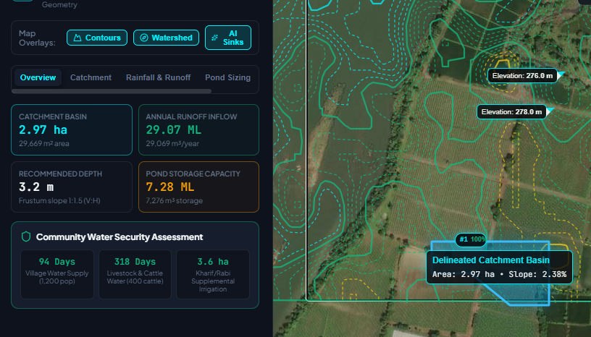
Fig. 1 — Hydrology dashboard for the uploaded contour: catchment basin (2.97 ha), annual runoff inflow (29.07 ML), recommended pond depth (3.2 m) and storage capacity (7.28 ML), plus the community water security assessment (94 days village supply, 318 days livestock water, 3.6 ha supplemental irrigation).
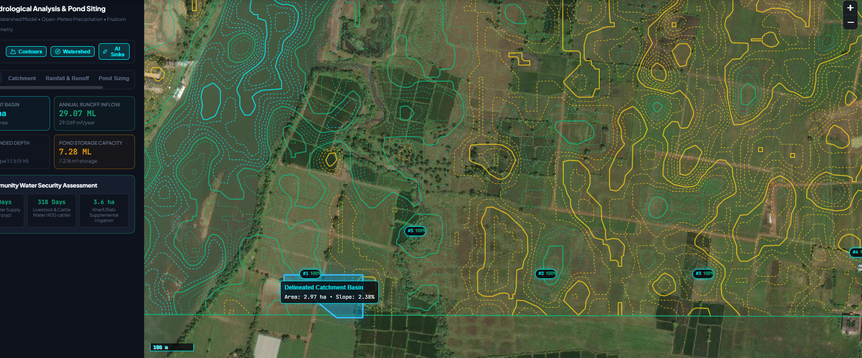
Fig. 2 — Map overlay of the same analysis: colour-coded elevation contour isolines, the delineated watershed/catchment basin (highlighted boundary, area 2.97 ha, slope 2.38%), and ranked AI-identified sink candidates (#1–#5) marked on the satellite base layer.
Verification metrics from both the coordinate-based test (Bhilai) and the uploaded-contour test are summarised below:
Metric | Test 1 — Bhilai coordinate analysis | Test 2 — Uploaded contour (KML) analysis
Catchment area | 13.93 ha (139,300 m²) | 2.97 ha (29,669 m²), slope 2.38%
Annual rainfall (Open-Meteo) | 1,543.9 mm/year | — (region default)
Annual runoff volume | 140,629.5 m³ (140.6 ML) | 29,069 m³/year (29.07 ML)
Recommended pond depth | 3.2 m | 3.2 m (side slope 1:1.5)
Recommended pond storage | 35,163.5 m³ (35.16 ML) | 7,276 m³ (7.28 ML)
Community impact | — | 94 days village supply (1,200 pop.); 318 days livestock water (400 cattle); 3.6 ha supplemental irrigation

5. API Documentation
Full interactive API documentation (request/response schemas, try-it-out console) is auto-generated by FastAPI from the route definitions and Pydantic models, and is available live at the /docs path of the running backend (e.g. http://localhost:8000/docs or http://10.1.75.79:4202/docs). A summary of the primary endpoints is provided below for reference.

Method & Path | Purpose | Request / Response Summary
POST /api/analyze/full | Runs the complete hydrological pipeline for a given coordinate: elevation & contour generation, D8 catchment delineation, Open-Meteo rainfall lookup, runoff modeling, and frustum pond sizing. | Request JSON: { lat, lon } (optionally a bounding box). Response JSON includes catchment_area_m2, annual_rainfall_mm, annual_runoff_m3, recommended_depth_m, pond_storage_m3, and GeoJSON layers for contours, watershed and sinks.
POST /api/kml/upload | Accepts a user-supplied .kml / .kmz contour file (multipart/form-data) and runs the same analysis pipeline using the uploaded terrain instead of a synthesized DEM. | Form fields: file (the .kml/.kmz), target_capture_pct (float, e.g. 25.0 — the target percentage of catchment runoff the pond should capture). Response mirrors /api/analyze/full.
POST /api/kml/analyze-file | Local-testing variant of the upload endpoint — points the server at a KML/KMZ file already present on disk instead of uploading bytes. | Request JSON: { "file_path": "<path to .kml/.kmz>" }. Response mirrors /api/analyze/full.
GET /docs | Interactive Swagger UI, auto-generated by FastAPI from the route signatures and Pydantic models. | No body. Renders a browsable, testable API reference in-browser.
GET /health (or root health check) | Basic liveness check used during verification. | Returns 200 OK when the service is up.
POST /api/pond/recommend | Runs the complete hydrological pipeline for a given coordinate: elevation & contour generation, D8 catchment delineation, Open-Meteo rainfall lookup, runoff modeling, and frustum pond sizing. | Internal/Modular pipeline endpoint.
POST /api/runoff/estimate | Calculates runoff volume based on catchment area and rainfall data. | Internal/Modular pipeline endpoint.
GET /api/rainfall/history | Fetches historical precipitation data from Open-Meteo API. | Internal/Modular pipeline endpoint.
POST /api/catchment/delineate | Performs D8 flow direction and watershed catchment delineation. | Internal/Modular pipeline endpoint.

Backend service modules referenced by these endpoints:
- elevation_service.py — DEM fetch/synthesis, Marching Squares contour generation, sink detection.
- hydrology_service.py — D8 flow direction, flow accumulation, watershed/catchment delineation.
- rainfall_service.py — Open-Meteo Historical Weather API integration; annual/monthly rainfall, monsoon share, peak intensity.
- runoff_pond_service.py — Rational Method & SCS-CN runoff volume; frustum pond geometry sizing.
- kml_service.py — KML/KMZ parsing, Delaunay-triangulation DEM interpolation, end-to-end analysis for uploaded contour files.

6. LLM usage:
Currently I have used llm:
- Documentation management, Assisting in prototyping, and refining UI/UX components
- Api integrations schema management and validation the flow

