Muhammad Shayan Ilyas

19F-0976

SE-7B

DevOps

Task-02 Project Phase-02

Installed docker on ubuntu

Installed jitsu on ubuntu

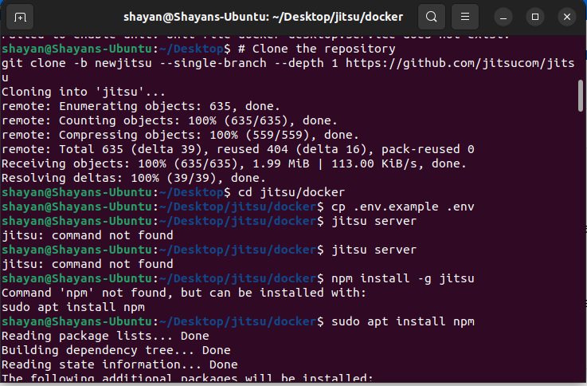

Jitsu installed.

Account created on jitsu.

