GitHub Repo Link: https://github.com/iamsheraz/csd-340

Local Repo:

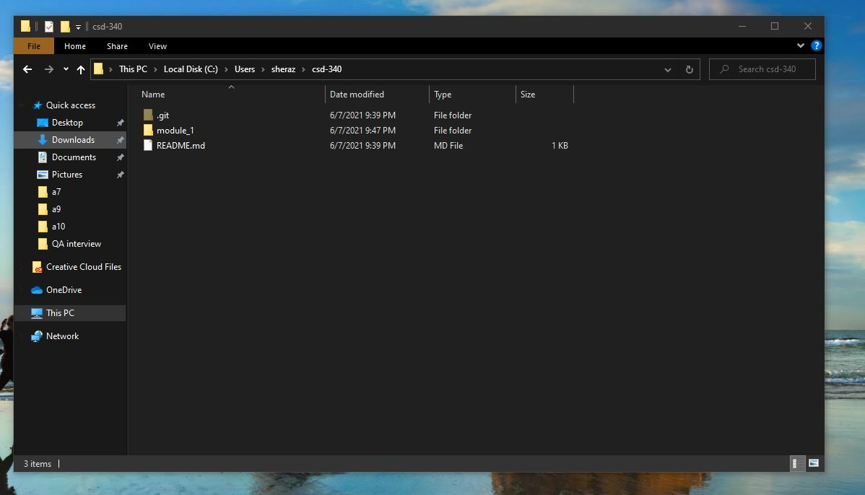

GitHub csd-340:

