GitHub Link: https://github.com/iamsheraz/csd-340

Final Code:

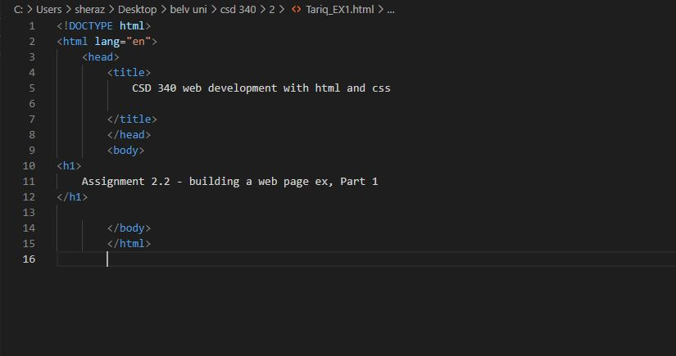

Browser Display of Code:

