**Coding Conventions**

**Naming**

* **Packages Name:** Starting with uppercase letter then followed by lowercase letters.

C:\Users\mehrnosh\AppData\Local\Microsoft\Windows\INetCache\Content.Word\packagesName.png

Example:

* **Classes Name:** using UpperCamelCase.

Example:



* **Methods Name:** using lowerCamelCase.

C:\Users\mehrnosh\AppData\Local\Microsoft\Windows\INetCache\Content.Word\MethodName.pngExample:

* **Variables Name:** using lowerCamelCase.

C:\Users\mehrnosh\AppData\Local\Microsoft\Windows\INetCache\Content.Word\VariableName.png

Example:

**Code Layouts**

* Methods have their opening braces on the same line separated by a space, and the ending brace of a block is in a full line alone.

C:\Users\mehrnosh\AppData\Local\Microsoft\Windows\INetCache\Content.Word\MethodLayout.png

Example:

* The braces are omitted for a control statement with only a single statement in its scope.

C:\Users\mehrnosh\AppData\Local\Microsoft\Windows\INetCache\Content.Word\CodeLayout2.png

Example:

* No blank line between member variables in a class.

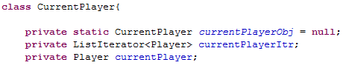

Example:

* One blank line between methods in a classes.

Example: 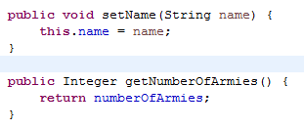

* A single blank line between classes in a java file.

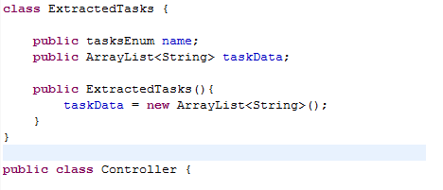Example:

* No blank line after comments that relate to methods or a block of code.

**Comments**

* **File Header Comments:** a brief header block comment provides information helpful for understanding the program.
* **Single-Line Comments:** Use single-line comments to provide brief summary commentsfor chunks of code.
* **Documentation of Classes and Methods:** Providing JavaDoc comments for each classes and methods including @param and @return.