**REFACTORING OPERATIONS – BUILD 3**

1. **Renamed attackCountry() in IPlayer to normalAttack().**

Refactoring Technique – Rename method

This refactoring is done to make the code more consistent than build2.

1. **Renamed package name**

Refactoring Technique – Rename package name

We renamed Controller to Runner and Model to GameLogic because remove the ambiguity that it is a MVC model.

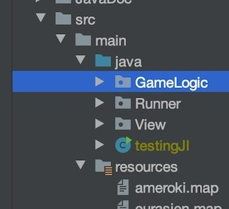

1. **Renamed MapReadWriteAdaptter**

Refactoring Technique – Rename method

Renamed MapReadWriteAdaptter to MapReadWriteAdapter

This refactoring is done to improve code readability. A typo was fixed here



