Lists are basically a collection of ordered and mutable elements. In python lists are treated as arrays. Lists are identified with [ ] brackets. Let’s create a simple list containing 5 items:

|  |
| --- |
| lst = [10,6,50,56,77]  print(lst) |

Let’s see some of list’s different examples:

|  |
| --- |
| # list of strings  lst2 = ["brian","dom","mia","tez"]  print(lst2)  # list of dis-similar items  lst3 = ["brian",30,"mia",21,True,56.7,None]  print(lst3) |

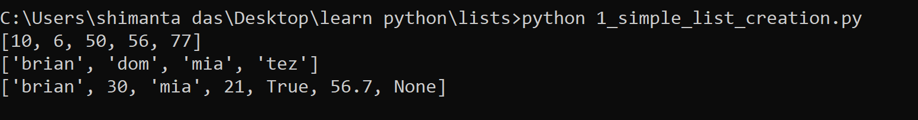

**Topic (insert new element into list):** we can add new element into list using **.append()** method or using (+) operator. Note: whenever you add new elements externally it will add at the end of the list. Let’s see the code:

|  |
| --- |
| # using append() method  lst = [10,60,70]  print(lst)  lst.append(600)  print(lst)  # using + operator  lst2 = ["brian","dom","mia"]  print(lst2)  lst2 = lst2 + ["letty"]  print(lst2) |

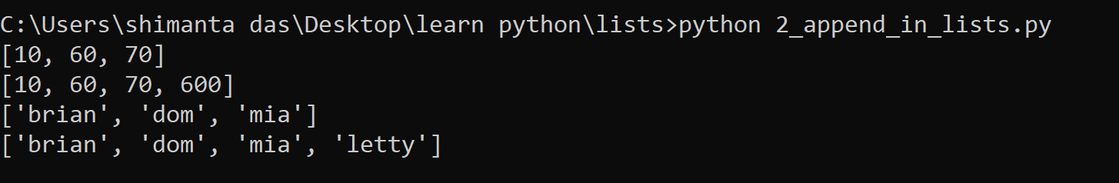

**Topic (remove existing element from list):** we can remove existing element from list using **.remove()** method. We can also use ‘**del’** keyword also or even using **pop()** method which we familiar with stack data structure. Note: when we applying pop() method we will remove last index element from the list.

|  |
| --- |
| # remove items using append() method  lst = [10,60,55,-90,400]  print(lst)  lst.remove(55)  print(lst)  # remove items using pop() method  lst2 = ["tez","cypher","dante"]  print(lst2)  lst2.pop()  print(lst2)  # remove element using 'del' keyword  lst3 = [12.4,34.5,67.8,90.89]  print(lst3)  del lst3[1]  print(lst3) |

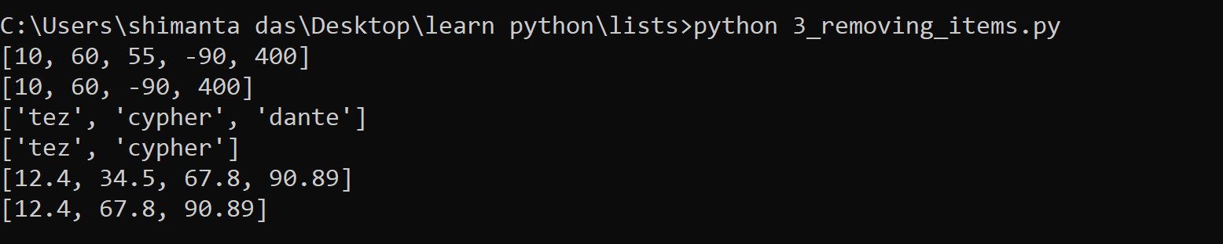

**Let’s see some of the list methods and their usages:**

1. **len()** - we can get the length of list using len() method.
2. **type()** - it helps to get the datatype of the list.

|  |
| --- |
| lst = [10,50,"mia","tez"]  print(lst)  print(len(lst))  print(type(lst))  # adding or removing item's of list  lst.append(45.6)  print(lst," length now:",len(lst))  lst.remove("mia")  print(lst," length now: ",len(lst)) |

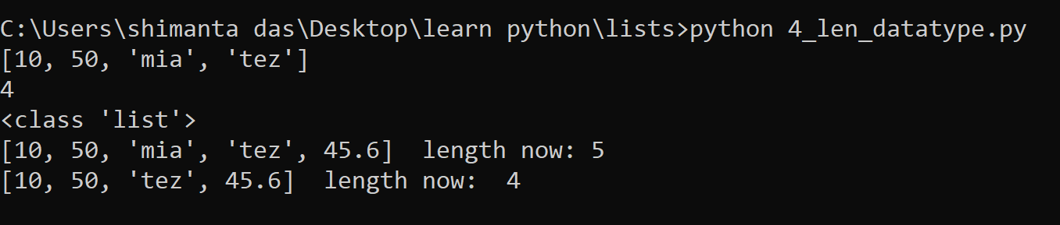

1. **insert()** – we can add new element at specified index of the list. When we use append() method it basically insert element at the end.
2. **index()** – this method helps to get element’s index in the list.

|  |
| --- |
| lst = [10,50,"mia","tez","domnick"]  print("list is => ",lst)  for x in lst:  print("item: ",x,"index: ",lst.index(x))  # let's add element "tez" into index 1  lst.insert(1,"tez")  print("list now => ",lst)  for x in lst:  print("item: ",x,"index: ",lst.index(x)) |

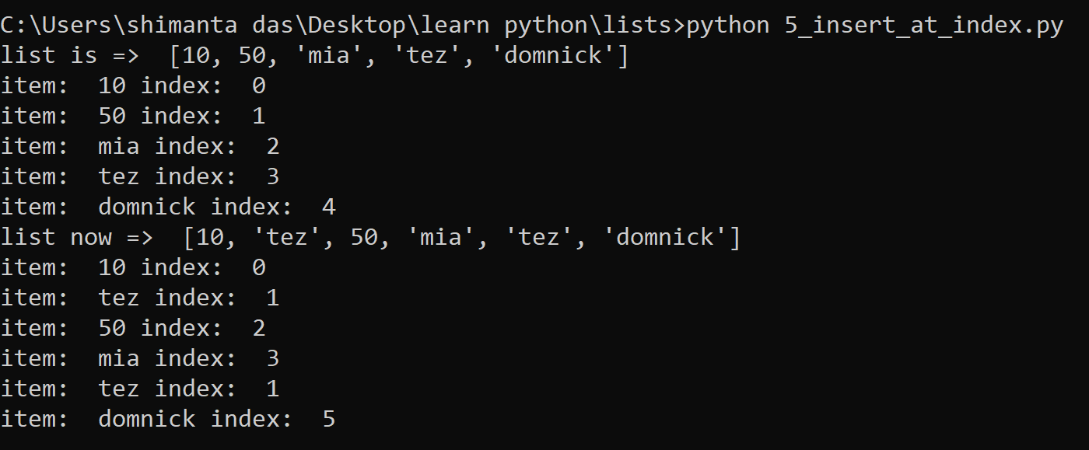

1. **sort()** - we can sort list items using sort() method, which can sort list’s items in ascending order.
2. **reverse()** – this method helps to reverse the whole list.

|  |
| --- |
| # let's sort list in ascending order  lst = [-70,67,33,12,34,3]  print(lst)  lst.sort()  print(lst)  # reverse list  lst2 = ["mia","brian","tez","domnick","letty"]  print(lst2)  lst2.reverse()  print(lst2) |

