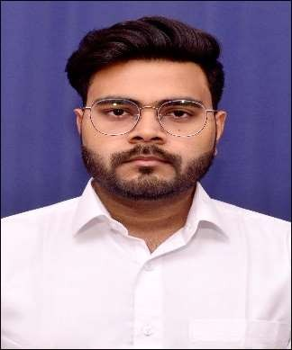

Registration Number:20BCE10338

Email:[abhiprajapati761@gmail.com](mailto:abhiprajapati761@gmail.com)

Phone: +91 8938059761

<https://www.linkedin.com/in/abhisurendraprajapati/>

<https://github.com/Abhisurendra>

Abhisurendra Prajapati

**Technical Skills:** C++, Java, Python, HTML, CSS, JavaScript, NodeJS, MongoDB, Bootstrap

**Certification:** Certificate of Excellence-Introduction to Java, Career Camp- Coding Ninjas, Certificate of Excellence-Data Structure in Java, Career Camp- Coding Ninjas

|  |  |  |  |  |  |
| --- | --- | --- | --- | --- | --- |
| **EDUCATION** | | | | | |
| **Board** | **Tenure** | | | **Educational institution** | **CGPA/Percentage** |
| B. Tech (CSE) | Sept 20 –Ongoing | | | Vellore Institute of Technology, Bhopal | 8.22/10 |
| Class XII | May 20 | | | St. Mary’s Inter College, Etawah | 85.2% |
| Class X | May 18 | | | St. Mary’s Inter College, Etawah | 89.2% |
| **ACADEMIC PROJECTS** | | | | | |
| Web based Project | * **Agri Tech** (Jan 22– Apr 22)   -Description: It is an E-Commerce website to provide reasonable price to the farmers for their crops directly from the buyers without involving the vendors.  -Technology: HTML, CSS, JavaScript, NodeJS, MongoDB, Bootstrap  -Role: designed the page where the crops for sale will be displayed, seller page, database and other backend functionality of the website.  -Link: <https://github.com/Shreyansh-8/E-Commerce>   * **Sorting Visualizer** (Jun 21-Dec21)   -Description: A sorting visualizer is a software system that allows users to visualize how different sorting algorithms work. The system takes an input array of numbers, sorts them using a selected sorting algorithm, and displays the sorting process in a graphical format.  -Technology: HTML, CSS, JavaScript.  -Role: Front End Developer.  -Link: <https://github.com/Abhisurendra/sort-visualizer> | | | | |
| Software Development | * **Library Management-System** (Jan20)   + Description: A library management system is a software system designed to manage the day-to-day operations of a library. It helps librarians to manage their resources efficiently and effectively. The system will allow librarians to manage books, patrons, and loans.   + Technology: C++   + Role: Software Developer   -Link: <https://github.com/Abhisurendra/library-management-system> | | | | |
| **CO-CURRICULARS** | | | | | |
| Coding | | | * Solved 100+ problems on Leetcode. | | |
| **ADDITIONAL INFORMATION** | | | | | |
| **EXTRA-CURRICULARS AND ACHIEVEMENTS** | | | | | |
| Achievements | | * Participated in Flipkart GRiD 5.0 - Software Development Track and Geek Week: Local 2021. * Participated in Industry Oriented Training on Embedded, IoT & Matlab conducted by Cranes Varsity. | | | |
| Hobbies | | * Online Gaming * Playing Cricket | | | |
| Languages | | * English, Hindi | | | |