**PROJECT 3 REPORT**

**GROUP 2**

Names and contribution-

1. Shounak Sural, Roll no. 16EC10063, Q1,Q2,Q3,Q4,Q5,Q6

Q1. Initially data is separated into training and test data

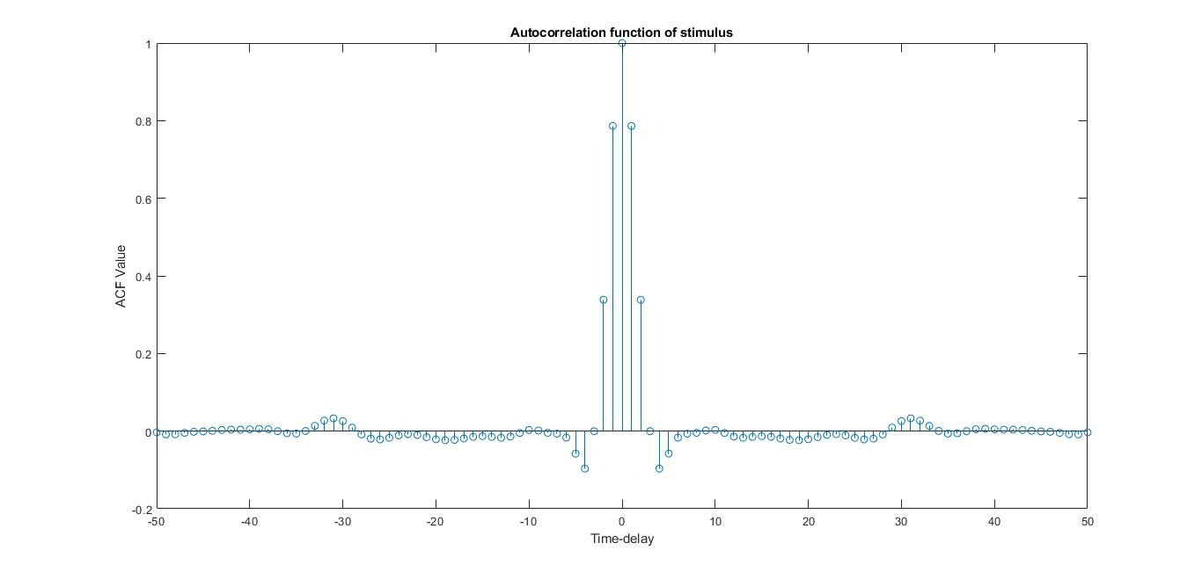

NORMALISED ACF OF STIMULUS

Q2.

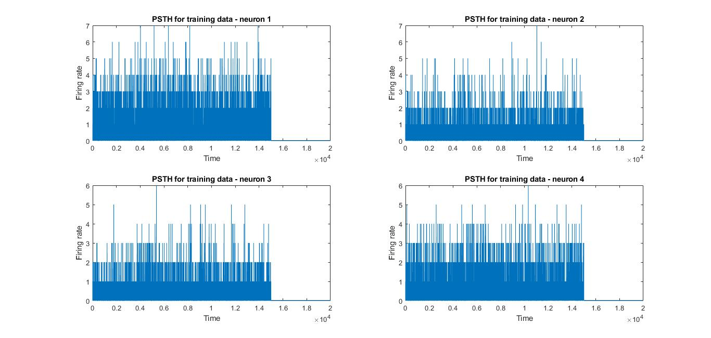

PSTH FOR TRAINING DATA (FIRST 15 SECONDS)

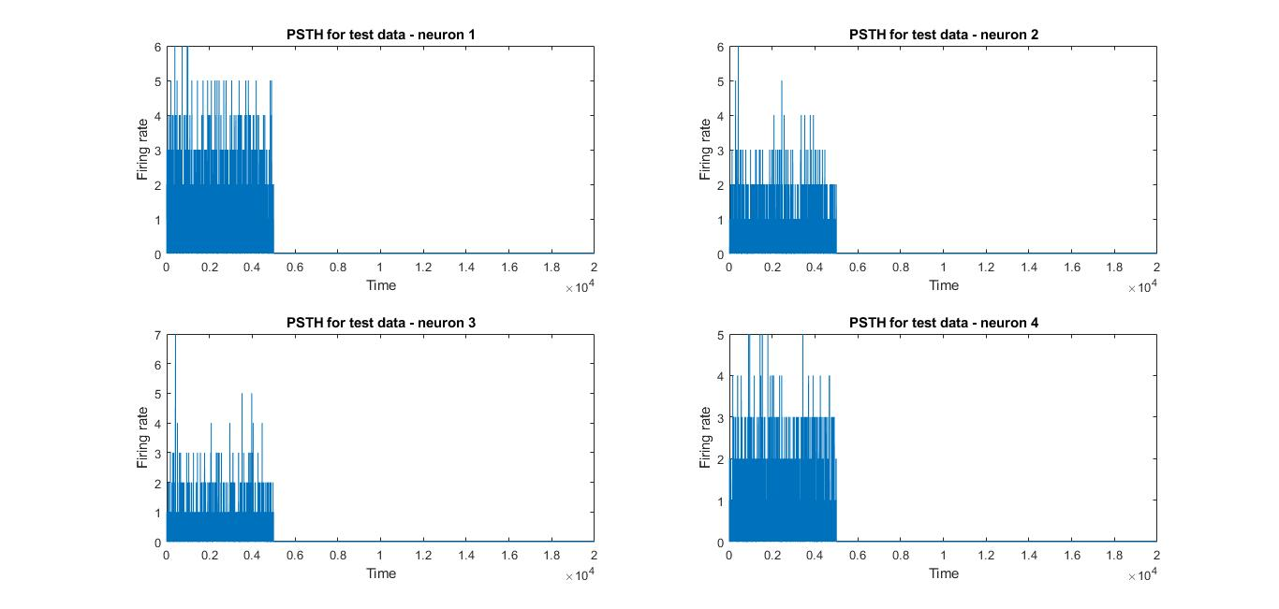

PSTH FOR TRAINING DATA

Q3.

MEAN VS VARIANCE SCATTER PLOTS FOR BIN SIZES VARYING FROM 0.01 to 0.5

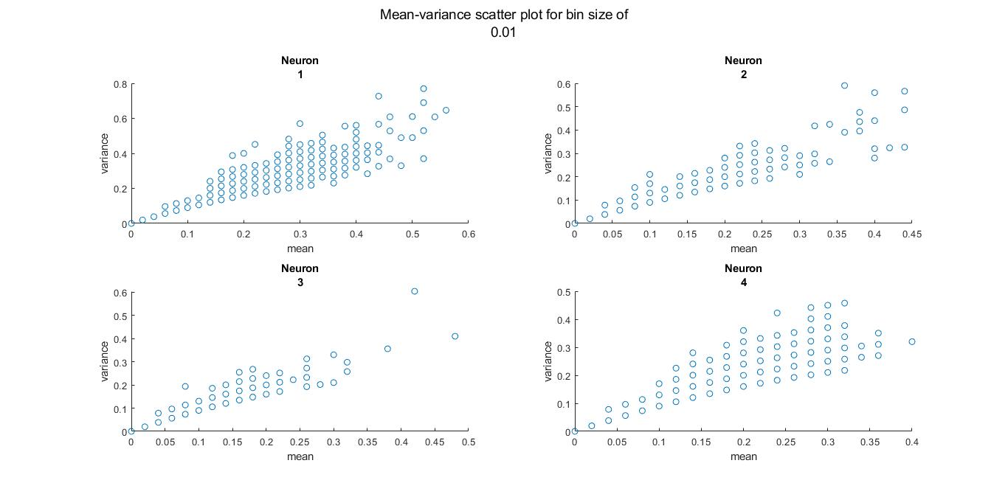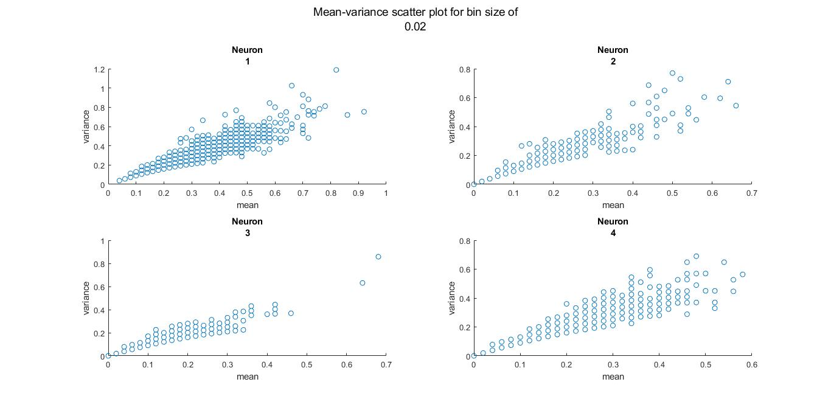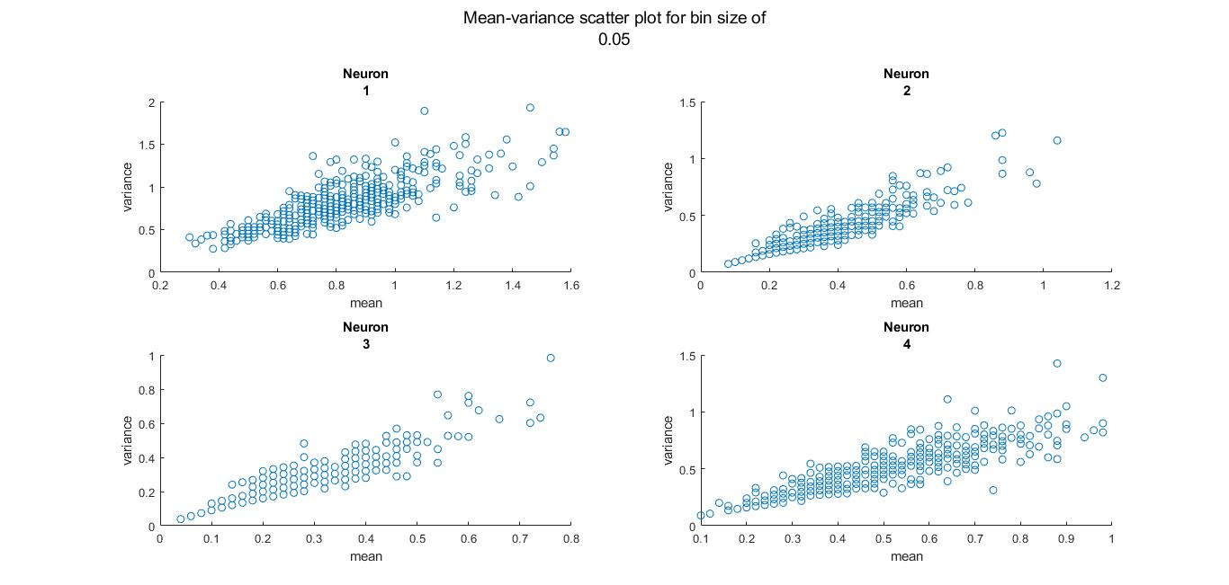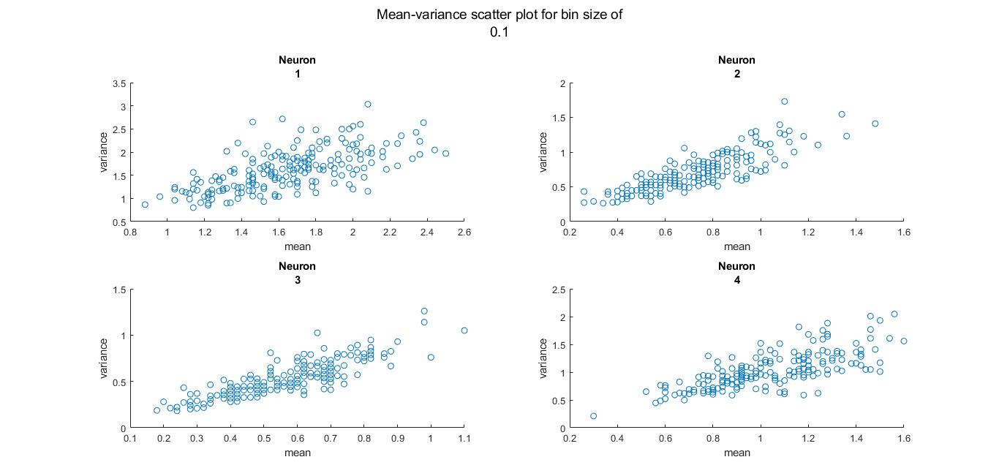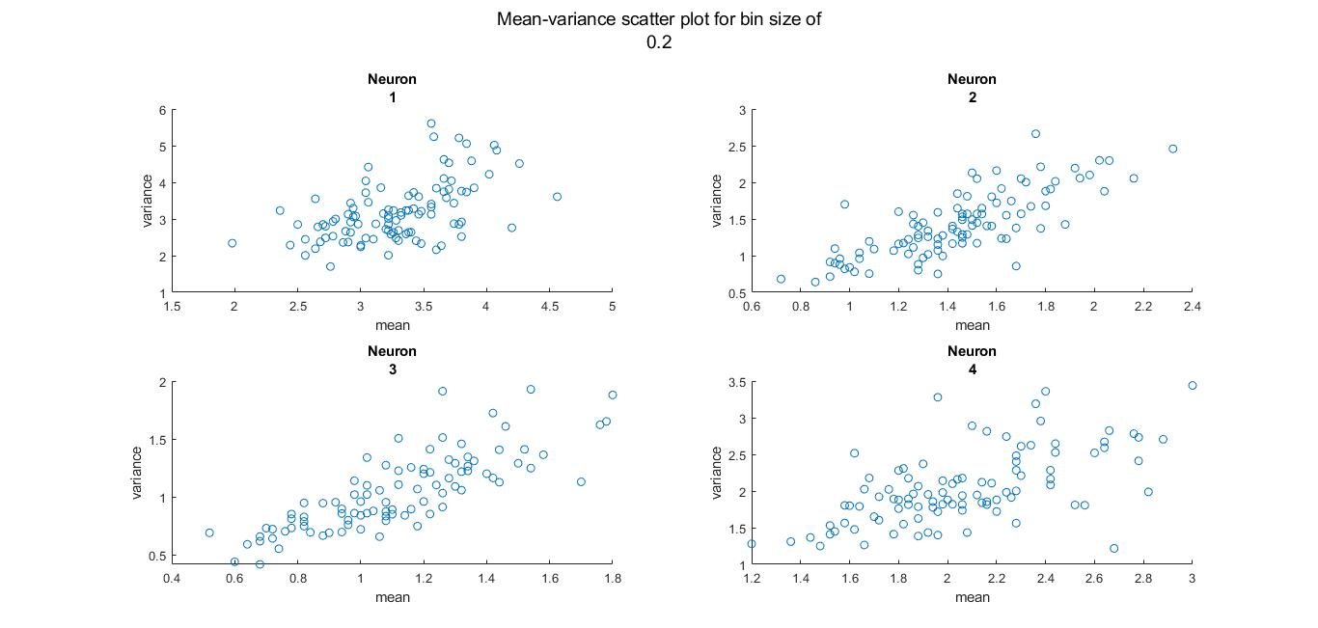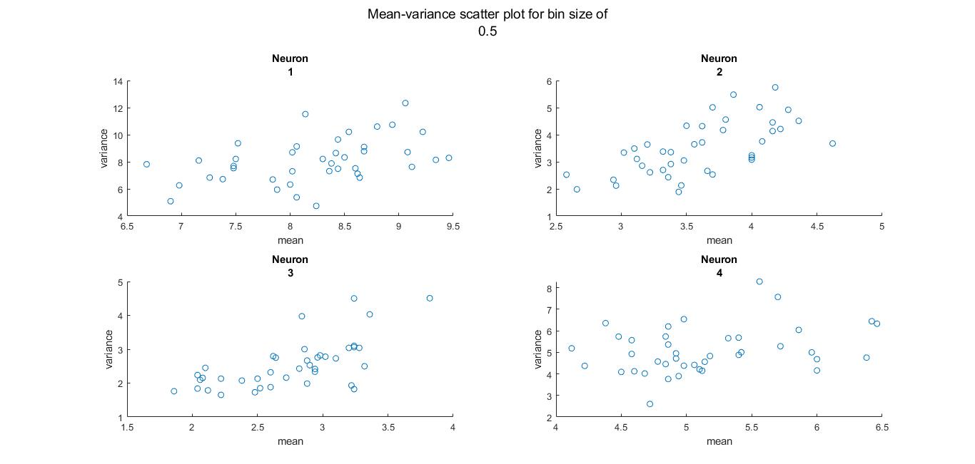

Q4.

STA FOR FOUR NEURONS

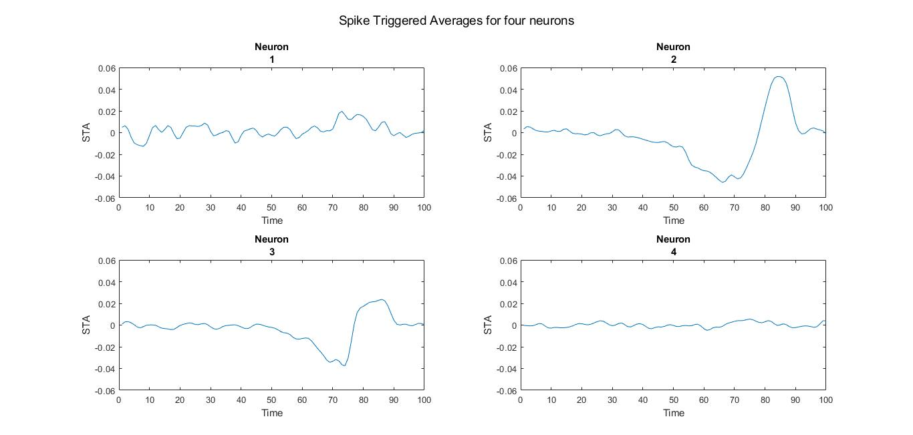

STA AFTER CORRECTION USING CSS-INVERSE MATRIX

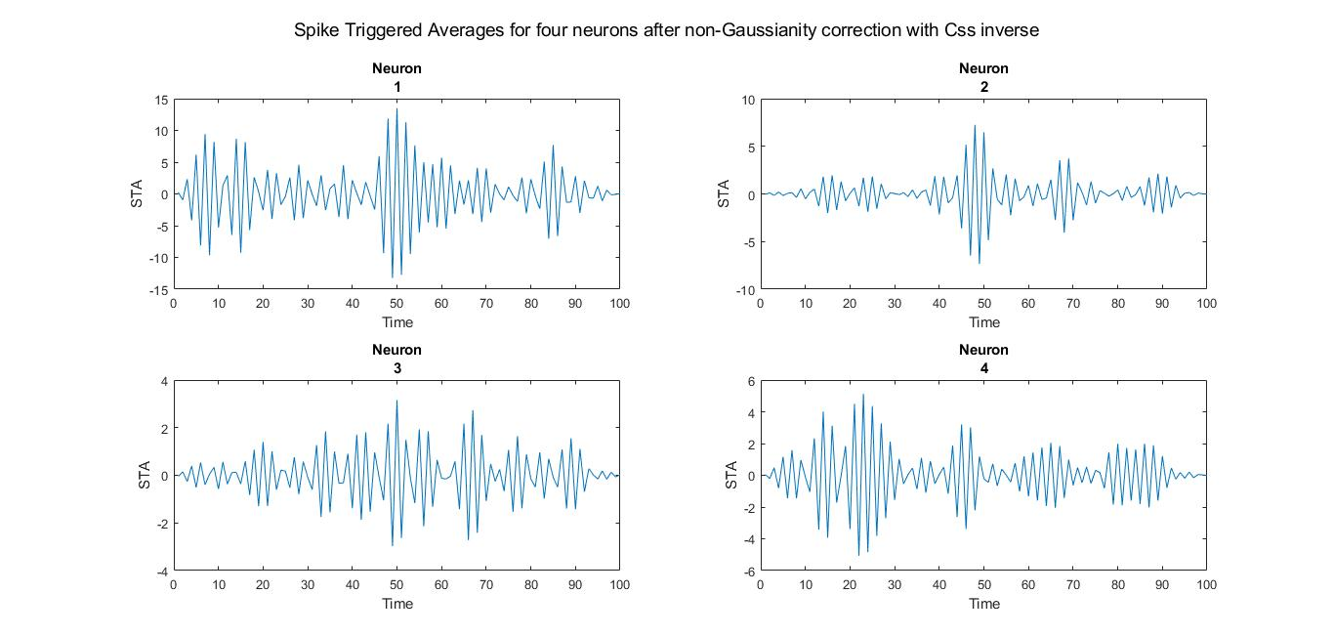

Since results got worse with the use of inverse(CSS) as input was already Gaussian, the original waveform is considered for the rest of the project

Q5.

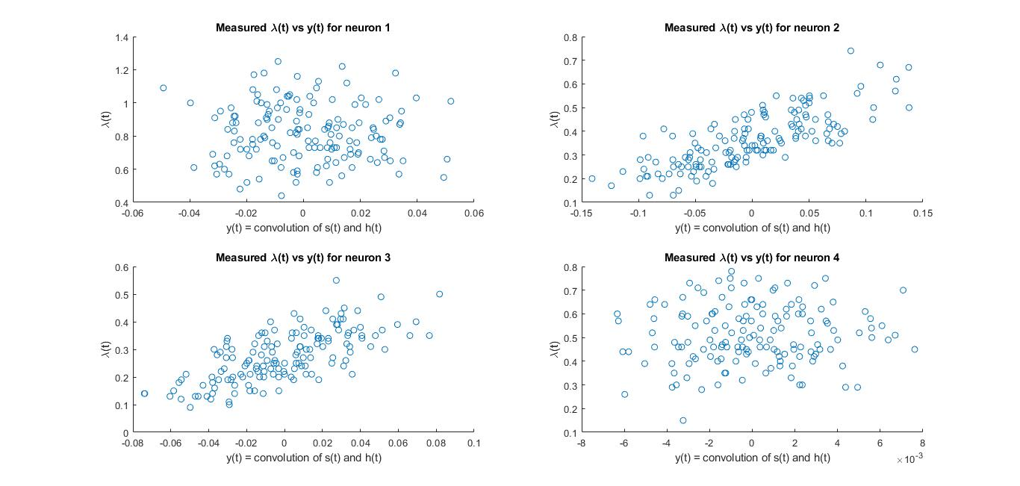

SCATTER PLOT FOR lambda vs y

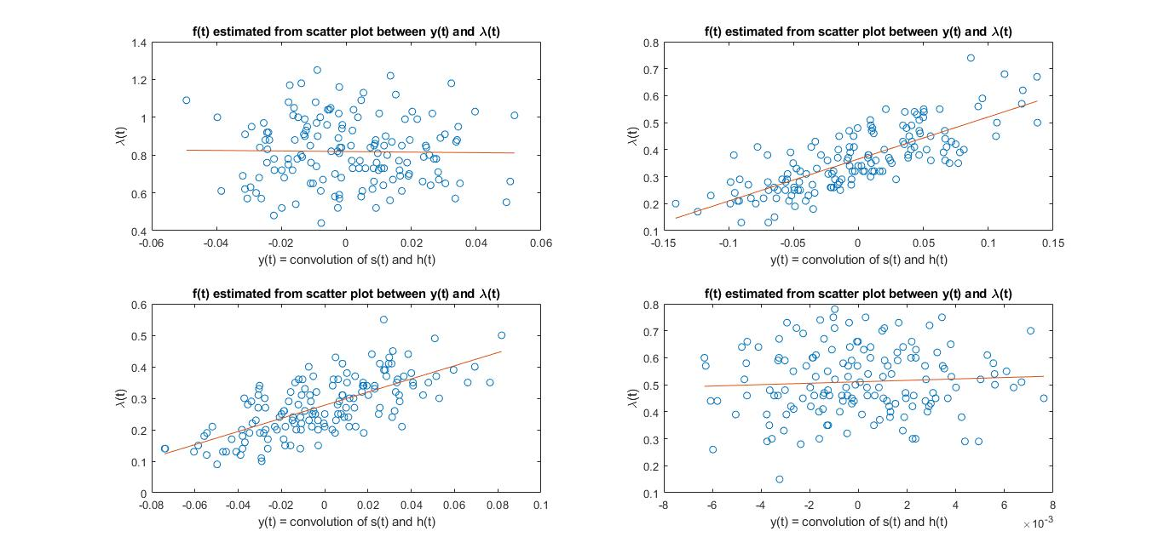

f(t) ESTIMATED FROM SCATTER PLOT FOR lambda vs y WITH LINEAR FIT

On fitting Sigmoid function using a freely-available sigmoid-fiiting code, the results were worse mainly due to the neuron 1 which has a slight negative slope in linear fit and has huge errors for sigmoidal fit

Q6. 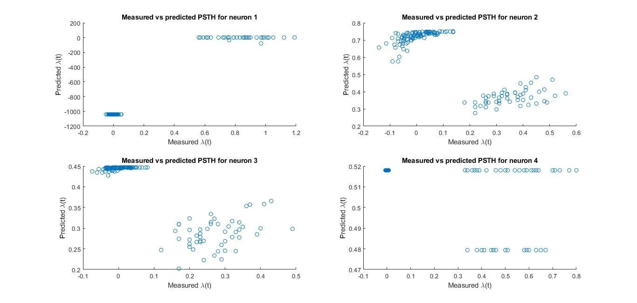

MEASURED VS PREDICTED LAMBDA VALUES (PSTH) FOR 4 NEURONS USING SIGMOIDAL FIT

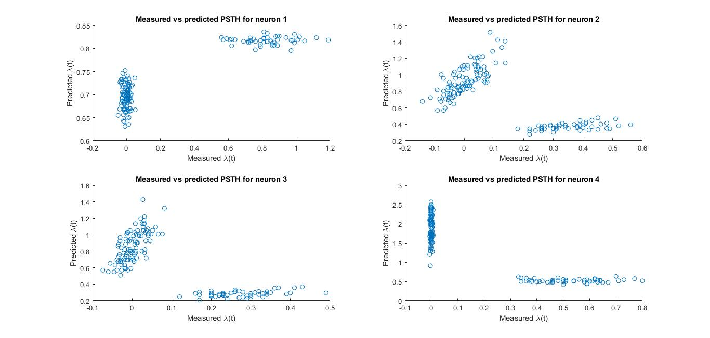

MEASURED VS PREDICTED LAMBDA VALUES (PSTH) FOR 4 NEURONS USING LINEAR FIT

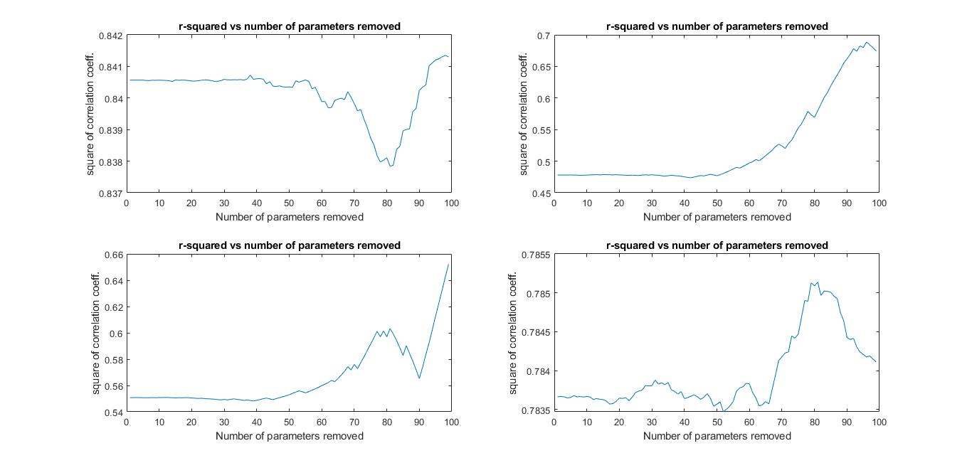

PLOT OF SQUARE OF CORRELATION COEFFICIENT VS NUMBER OF PARAMETERS REMOVED FROM h(t)

Q7.