**Computational Neuroscience**

**Project 2**

**Group 2**

Name: Shounak Sural

Roll no. 16EC10063

Contribution: Q1 to Q11

1. Units chosen:

Current/area -> microamps/cm2

Voltage ->millivolts

Time -> milliseconds

Conductance/area -> millisiemens/cm2

Capacitance/area -> microfarads/cm2

To verify ohms law with respect to dimension,

Current = conductance x voltage

Millisiemens/cm2*millivolts = 10^-3 siemens/cm2 x 10^-3 volts = 10^-6 amps/cm2= 1 microamps/cm2

Units are consistent.

If conductance was microsiemens/cm2, voltage could be in volts and current in microamps/cm2 OR voltage in millivolts and current in nanoamps/cm2

The solution is not unique as any common factor in units involved in the Ohm’s law will get cancelled.

1. Morris Lecar equations –

dv/dt = -gCa x m_inf(V) x (V-VCa) / C - gK x w x (V-VK) /C – gL x (V-VL)/C + I/C ----- (1)

dw/dt = phi x (w_inf(V) – w)/ tau_w(V) ------ (2)

At equilibrium,

dv/dt=dw/dt=0

Solving the equation in Matlab, we get equilibrium at v=-60.8554 mV and w=0.01491

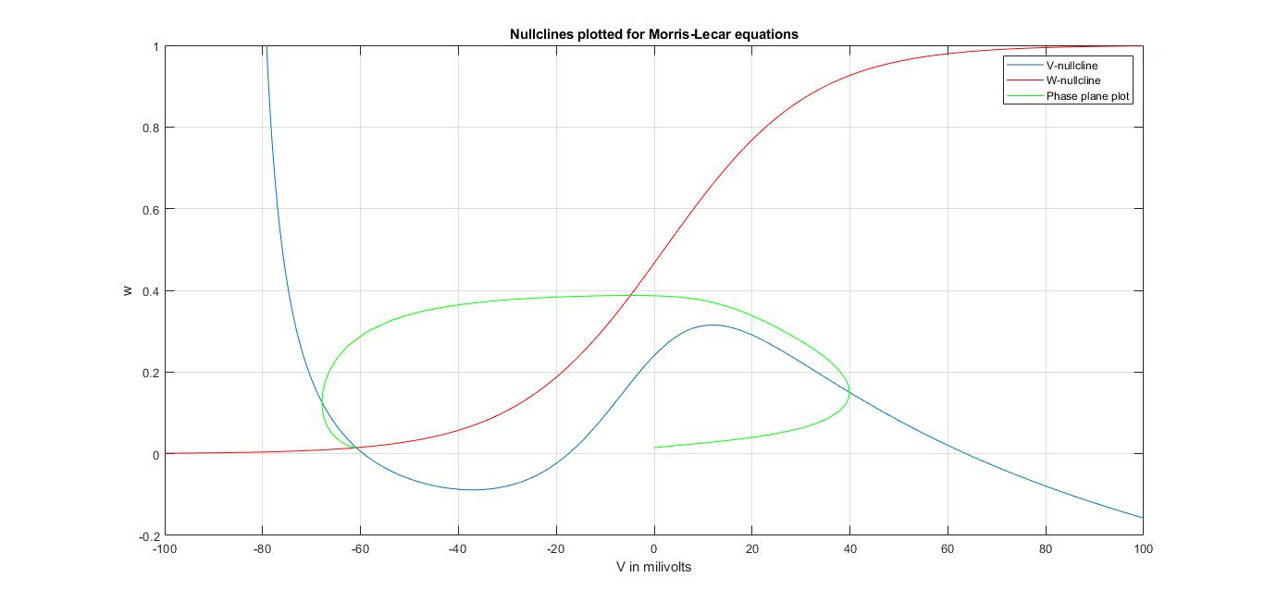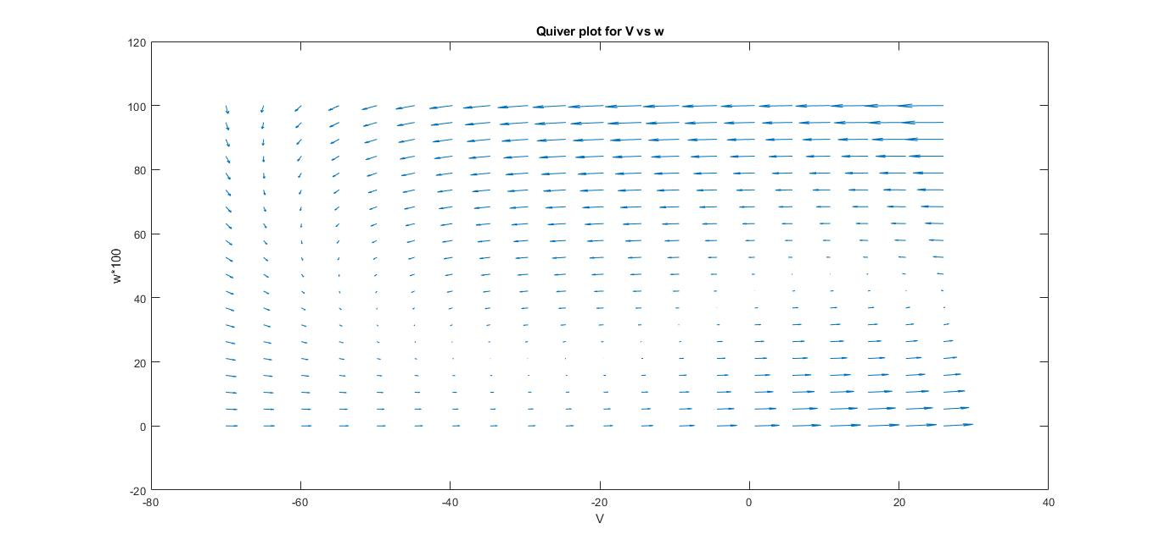

1. Eigenvalues from Jacobian matrix are (- 0.09146 + 0.0258i)

and (- 0.09146 - 0.0258i). Stable equilibrium as real parts of eigenvalues are negative.

1. At each step of the ode45 or ode15s algorithm, an error is approximated. If yk is the approximation of y(xk) at step k, and ek is the approximate error at this step, then MATLAB chooses its partition to ensure ek ≤ max(RelTol · |yk|, AbsTol), where the default values are RelTol = 10−3 = 0.001 and AbsTol = 10−6 = 0.000001. Notice that with this convention, if the magnitude of the solution |yk| gets large then the error can be quite large and RelTol should be reduced. On the other hand, if the magnitude of the solution is smaller than 10−6 then AbsTol must be reduced. As the voltages are of the order of 100 mV, for sufficient precision in solutions of the MLE, these values are appropriate. If the value of voltage is changed to the order of Kilovolts, we need to make the AbsTol value much lower (changed to about 10^-12) because the voltages are of the order of few mV and say 60mV = 6*10^-5 kV. Now, precision of the order 10^-6 will produce larger errors especially as precise voltage values are needed for threshold calculations.
2. The phase plane plots in this case were started from the point (W=0.0149, V=-20mV). This is point is taken such that action potential is being generated for all three phi values as observed from the V-t plot. From the plot, we can see than on increasing the value of phi, the onset of action potential is faster, i.e., it occurs at a smaller positive value of V. This means that W becomes around 0.4 faster corresponding to faster potassium channel activation and spikes.

The change in phi in the differential equations leads to change in the solution and therefore a new (higher) minimum Iext value at which action potential occurs. Physically phi is a temperature factor and this shows that the required current impulse magnitude for spiking changes with temperature.

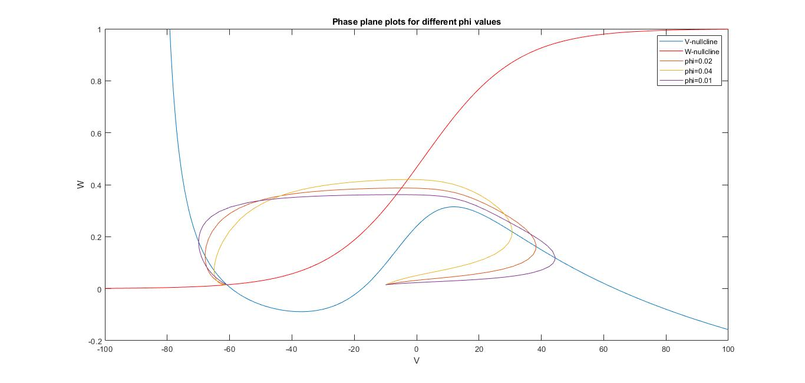

1. At around -15 mV of initial voltage V, we find there is a threshold and above this, spiking occurs as seen by a huge jump in peak voltage. 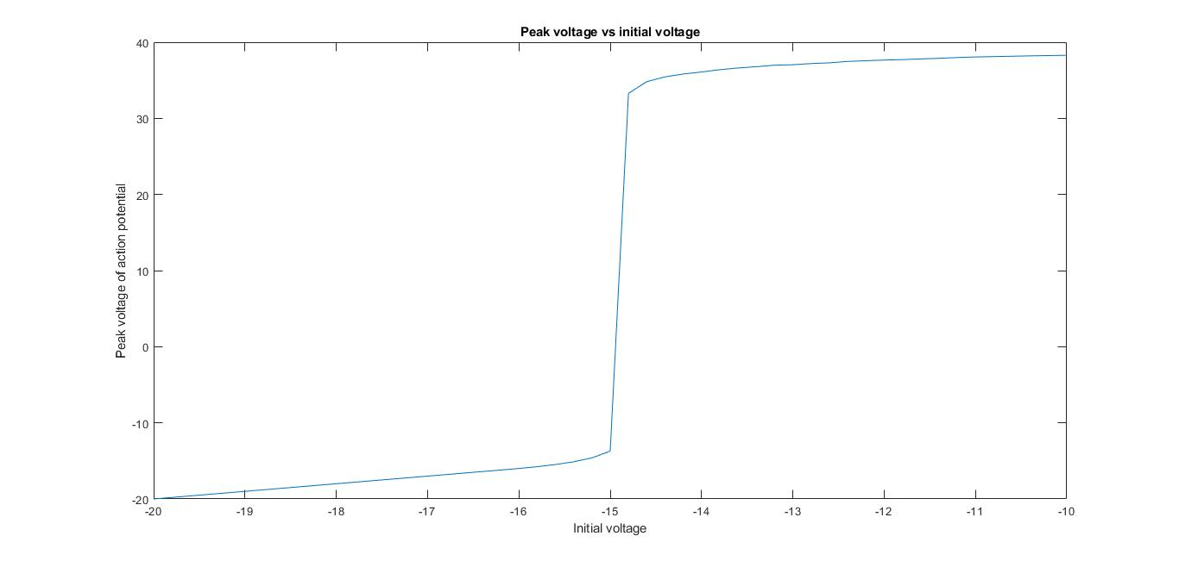
2. In the first case, on starting the new system from the equilibrium point of the initial system, it spirals and converges to a limit cycle. On starting the system at the new equilibrium point, a plot is not visible because it stays at the equilibrium point and doesn’t change. In the third and final case, the new system is started from a point that has same V value as the equilibrium and a larger w value. Here, the system has a converging spiral path that leads to the equilibrium point of the new system eventually. The difference between parts 1 and 2 is that on changing Iext, the equilibrium point of the system shifts. Therefore, only on starting the system at the newly found equilibrium point, it stays there. It is also observed that the new equilibrium point is also stable based on its eigenvalues (-0.011+0.067i) and (-0.011-0.067i).

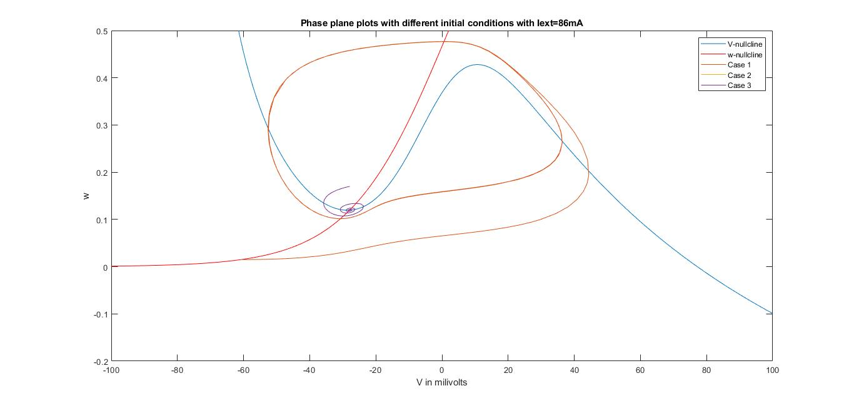

1. On running the system backwards in negative time, we find a periodic unstable orbit shown by the green plot. In positive time period, any point outside of UPO ends up in a limit cycle and any point inside it converges to the stable equilibrium point in positive time. This can be seen by comparing cases 3 and the green plot for negative time in the zoomed in version of the plot around the equilibrium point. The UPO is a true threshold because on one side of the threshold which has no thickness, the phase plane plot converges to the equilibrium point implying there will not be an observed spike. On the other side of the UPO, there is a limit cycle showing spikes can occur. Since the UPO boundary does not have a middle ground, this is a true threshold signifying all or none events of spiking.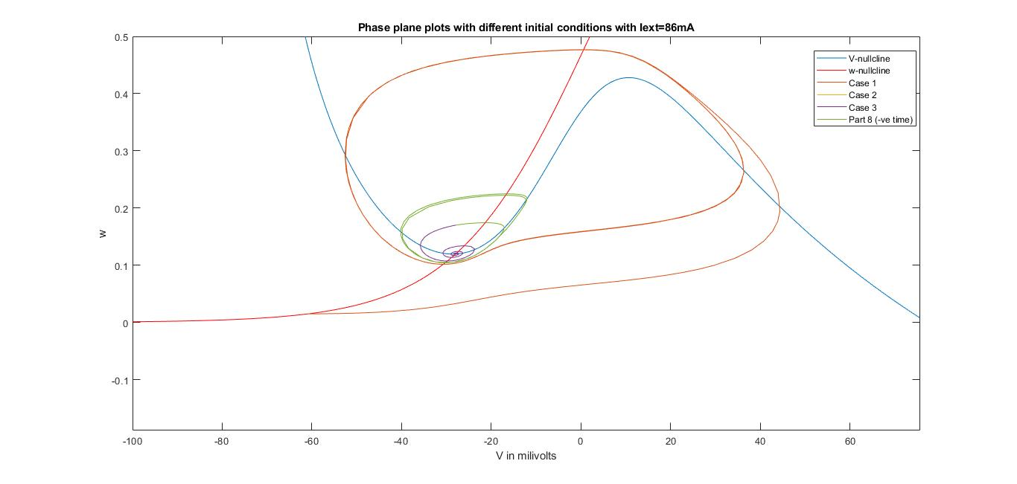

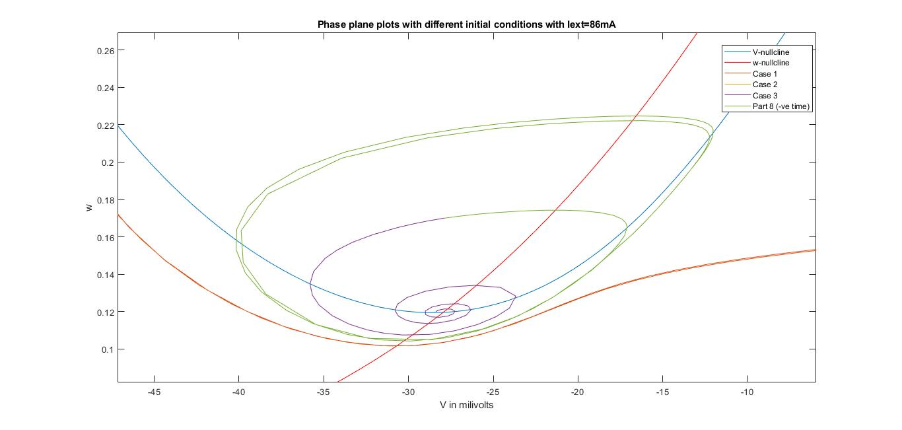

1. Eigenvalues corresponding to Iext =80mA, 86mA and 90mA are: (0.0225 + 0.0659i) and (0.0225 - 0.0659i) ; (-0.0109+0.06i) and (-0.0109-0.06i); (-0.0198-0.066i) and (-0.0198+0.066i). All these equilibrium points correspond to stable converging spirals.

For Iext ranging from 80mA to 96mA, there is no firing of action potentials as seen from the plot. In each case, the system has been started from the equilibrium point corresponding to that Iext value. Beyond that, it has rates of 1, 2, 4 or 6 spikes/second but sometimes drops to zero for intermediate values of Iext.

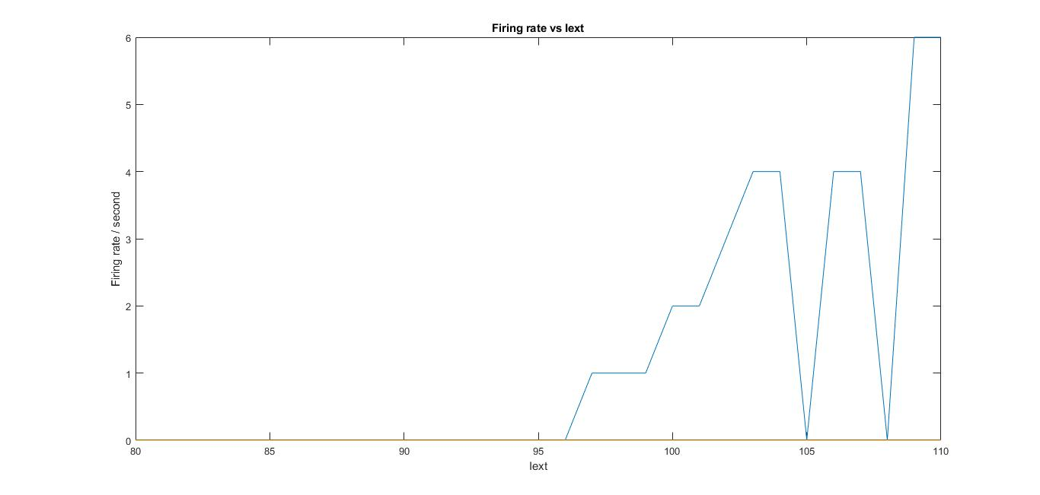

10. Corresponding to three equilibrium points,

eigenvalue 1 = -0.7336 ; -0.0689

eigenvalue 2= -0.1648 ; 0.1373

eigenvalue 3= 0.0910 - 0.1827i ; 0.0910 + 0.1827i

Hence, the equilibrium points are stable node, saddle point and unstable spiral respectively.

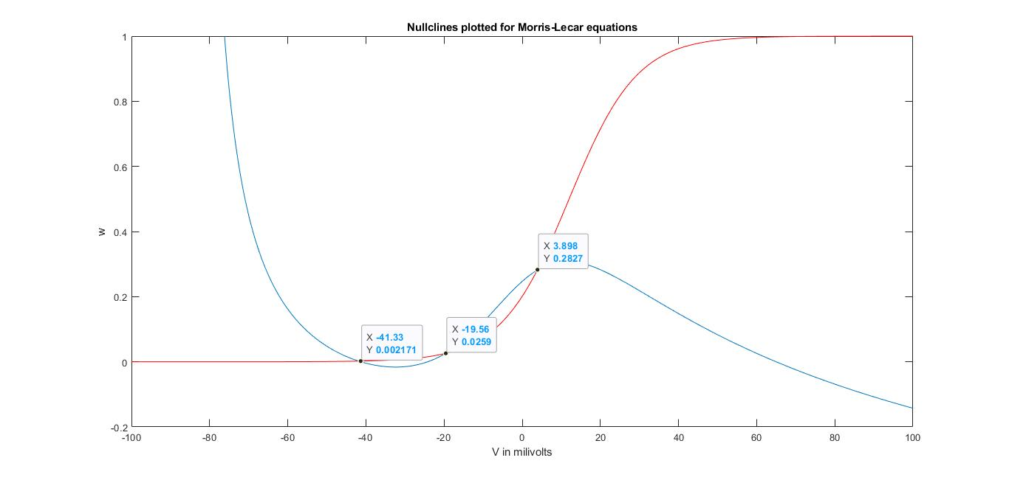

The manifold is plotted about the saddle point with slight variation in values of W and V from the equilibrium points.

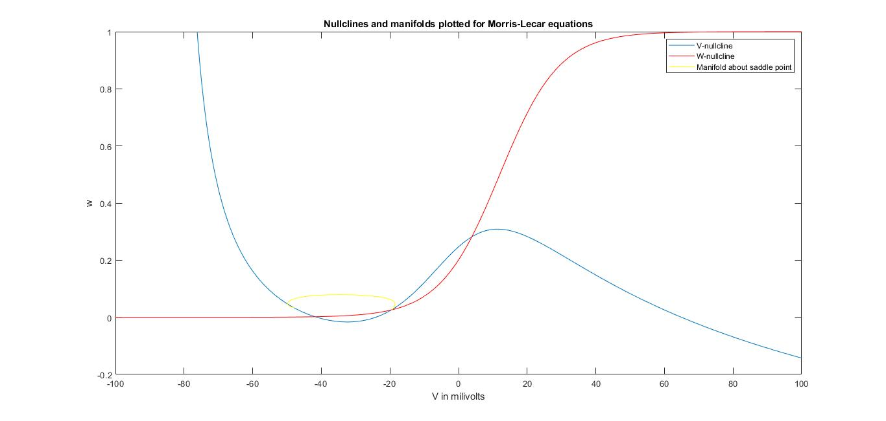

1. The number of equilibrium points for this system changes on changing the value of Iext. For Iext=30 mA to 50mA, the V-nullcline moves up and results in changing the number of equilibrium points from 3 to 2 to 1 eventually. The firing action potential rate gets changed significantly as well due to change in number and nature of equilibrium points.