
American International University-Bangladesh (AIUB)
Faculty of Science & Technology (FST)
Department of Computer Science

Introduction to Data Science
Mid-Term Project Report
Spring 2025-2026

Section: E
Group: 11

Project Contributions

SL  # | Student Name & ID | Contributions (mention every part of the project where you contributed)
1. | Name:Rafi Ul Islam Rafi  ID:22-49568-3 | Coding ,preparing what things to do,graphs  Handling missing values
2. | Name: Shuvo Chandra Mali  ID: 21-45971-3 | Coding,selecting topic,normalizing,Checking invalid values
3. | Name: Sadia Afrin Moumita  ID: 22-49830-3 | Loading the dataset,Removing duplicates
4. | Name: Israt Jahan Dristi  ID: 22-49816-3 | Creating subsets,Group comparisons,Train/test split

Dataset Description

It’s a dataset that shows data of 918 patients of different ages and gender who have heart failure issues,used to study and predict heart disease.
Theres a total of 12 coloumns of different sets of informations .they are :
Age - Patient’s age (integer).
Sex - Gender of the patient (factor with levels “M” and “F”).
ChestPainType -Type of chest pain (categorical: ATA, NAP, ASY, TA).
RestingBP -Resting blood pressure (numeric).
Cholesterol - Serum cholesterol level (numeric).
FastingBS - Fasting blood sugar (integer, usually 0 or 1).
RestingECG - Resting electrocardiogram results (categorical: Normal, ST, LVH).
MaxHR - Maximum heart rate achieved (integer).
ExerciseAngina - Exercise-induced angina (categorical: Y/N).
Oldpeak - ST depression induced by exercise relative to rest (numeric).
ST_Slope - Slope of the peak exercise ST segment (categorical: Up, Flat, Down).
HeartDisease - Target variable (factor with levels “0” = no disease, “1” = disease).
These features provide a mix of numerical and categorical data, making the dataset suitable for preprocessing, statistical analysis, and classification tasks.
Project Implementation Detail

Loading and Inspecting the Dataset
Description of the task1:
the dataset was loaded into R using the read.csv() function.
Code for task1
data <- read.csv("heart.csv")
head(data)
Sample output of your code for task1
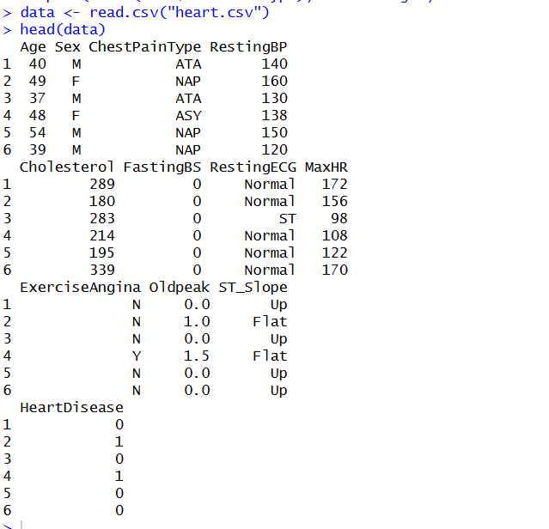

Output description of task1: The output loads the first six rows of the dataset proving the dataset is working.

Handling Missing Values
Description of the task2: check for missing values in the dataset and handle them.

Code for task2
colSums(is.na(data))
data$Cholesterol[is.na(data$Cholesterol)] <- mean(data$Cholesterol, na.rm=TRUE)

Sample output of your code for task2
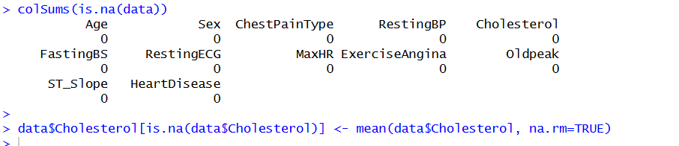
Output description of task2: The output shows that all columns have zero missing values. For Cholesterol, if missing values were present, they would be replaced with the mean. This ensures the dataset is complete and ready for analysis.
Title of Task 3
Normalization of Continuous Variables
Description of Task 3: we normalize the continuous variable that are restingBP,Choleesterol,MaxHR, Oldpeak by min -max scaling process and bring all the values within range of 0 and 1 so that we can compare the values
Code for Task 3:
data$RestingBP <- (data$RestingBP - min(data$RestingBP)) / (max(data$RestingBP)-min(data$RestingBP))
data$Cholesterol <- (data$Cholesterol - min(data$Cholesterol)) /
(max(data$Cholesterol) - min(data$Cholesterol))
data$MaxHR <- (data$MaxHR - min(data$MaxHR)) /
(max(data$MaxHR) - min(data$MaxHR))
data$Oldpeak <- (data$Oldpeak - min(data$Oldpeak)) /
(max(data$Oldpeak) - min(data$Oldpeak))

Sample output of your code for task3
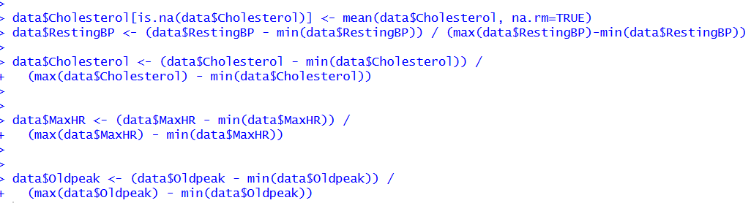

Output Description of Task 3 :
The code normalizes the coloumn values and sets them within 0and 1
Title of Task 4
Showing noramlized values
Description of Task 4
Here we are sowing the normalized values of the normalized coloumns
Code for Task 4
summary(data$RestingBP)
summary(data$Cholesterol)
summary(data$MaxHR)
summary(data$Oldpeak)
Sample output of your code for task4

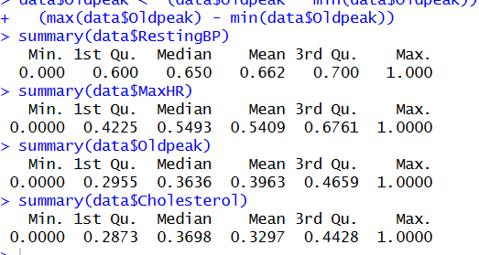
Output Description of Task 4
Here we see the min ,1st quitile,median,mean ,3rd quantile and max of all the normalized groups
Title of Task 5
Converting Categorical Variables
Description of Task 5
We convert categorical variables (Sex, HeartDisease) into factors so R treats them as categories instead of numbers.
Code for Task 5
data$Sex <- as.factor(data$Sex)
data$HeartDisease <- as.factor(data$HeartDisease)

Sample output of your code for task 5
Output Description of Task 5
The output shows that Sex and HeartDisease are now factors with two levels.
Title of Task 6
Visualization
Description of Task 6
Making histograms and barplots to visualize distributions of Age and Chest Pain Types
Code for Task 6
hist(data$Age, col="lightgreen", main="Age Distribution")
barplot(table(data$ChestPainType), col="orange", main="Chest Pain Types")
boxplot(data$Cholesterol)
Sample output of your code for task 6
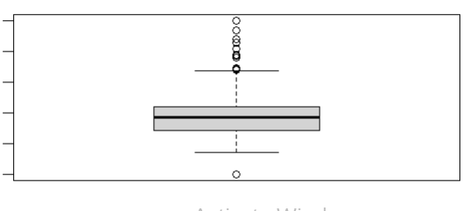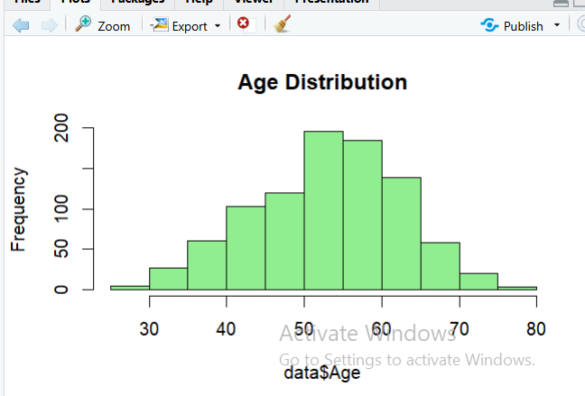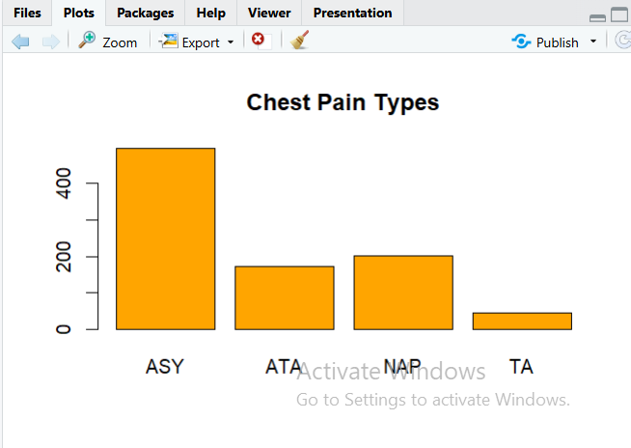
Output Description of Task 6
The histogram reveals the age distribution of patients, while the barplot shows the frequency of different chest pain types. These visualizations help us understand the dataset better.

Task 7: Bar Plot of Heart Disease Count
Description of Task 7:
This graph shows how many patients have heart disease and how many do not.
Code:
library(ggplot2)
ggplot(data, aes(x = HeartDisease)) +
geom_bar(fill = "steelblue") + labs(title = "Heart Disease Count", x = "Heart Disease", y = "Count")
Code Description of Task 7:
geom_bar() counts the number of observations in each category (0 = No disease, 1 = Disease). This helps understand class distribution.
Task 8: Pie Chart of Gender Distribution
Description of Task 8:
This graph shows the proportion of male and female patients.
Code:
gender_count <- table(data$Sex)
pie(gender_count,
main = "Gender Distribution",
col = c("lightblue", "pink"))
Code Description of Task 8:
table() counts frequency of each gender, and pie() visualizes their proportions.

Task 9: Scatter Plot (Age vs Cholesterol)
Description of Task 9:
This graph shows the relationship between age and cholesterol level.
Code:
ggplot(data, aes(x = Age, y = Cholesterol)) +
geom_point(color = "blue") +
labs(title = "Age vs Cholesterol")
Code Description of Task 9:
Each point represents a patient. This helps identify patterns or relationships between age and cholesterol.
Task 10: Calculating Mean, Median, and Standard Deviation
Description of Task 10:
This task calculates the mean, median, and standard deviation of important numerical variables such as Age, Cholesterol, and Max Heart Rate. These measures help to understand the central tendency and variability of the dataset.

Code:
mean(data$Age)
median(data$Age)
sd(data$Age)
mean(data$Cholesterol)
median(data$Cholesterol)
sd(data$Cholesterol)
mean(data$MaxHR)
median(data$MaxHR)
sd(data$MaxHR)
Code Description of Task 10:
The mean() function calculates the average value of a variable.
The median() function finds the middle value when data is sorted.
The sd() function computes the standard deviation, which shows how much the data varies from the mean.
- For Age, these values show the average age and how spread out the ages are.
- For Cholesterol, they indicate the typical cholesterol level and variation among patients.
- For MaxHR, they show the average maximum heart rate and its distribution.
These statistics help summarize the dataset and provide insights into the overall characteristics of patients.

Task 11: Correlation Between Variables
Description of Task 11:
Find the relationship between Age, Cholesterol, and MaxHR.

Code:
cor(data$Age, data$Cholesterol)
cor(data$Age, data$MaxHR)
cor(data$Cholesterol, data$MaxHR)

Code Description of Task:
cor() measures strength and direction of relationships between variables.

