REACTJS

1. **What is React?**

* An open-source JS library, made by Facebook for creating Single Page Applications.
* It is used to create component based mobile and desktop apps.

1. **What are Single Page Applications?**

* Single Page Applications (SPAs) are a type of web application or website that operates on a single HTML page
* Instead of loading entire new pages from the server in response to user actions, SPAs dynamically update the content on the existing page by using JavaScript to manipulate the Document Object Model (DOM).
* This approach provides a smoother and more responsive user experience by avoiding full-page reloads.

1. **List some important features of React.**

* It supports server-side rendering.
* It will make use of the virtual DOM rather than real DOM (Data Object Model) as RealDOM manipulations are expensive.
* It follows unidirectional data binding or data flow.
* It uses reusable or composable UI components for developing the view.

1. **What is useState() in React?**

* The useState() is a built-in React Hook that allows you for having state variables in functional components
* It should be used when the DOM has something that is dynamically manipulating/controlling.

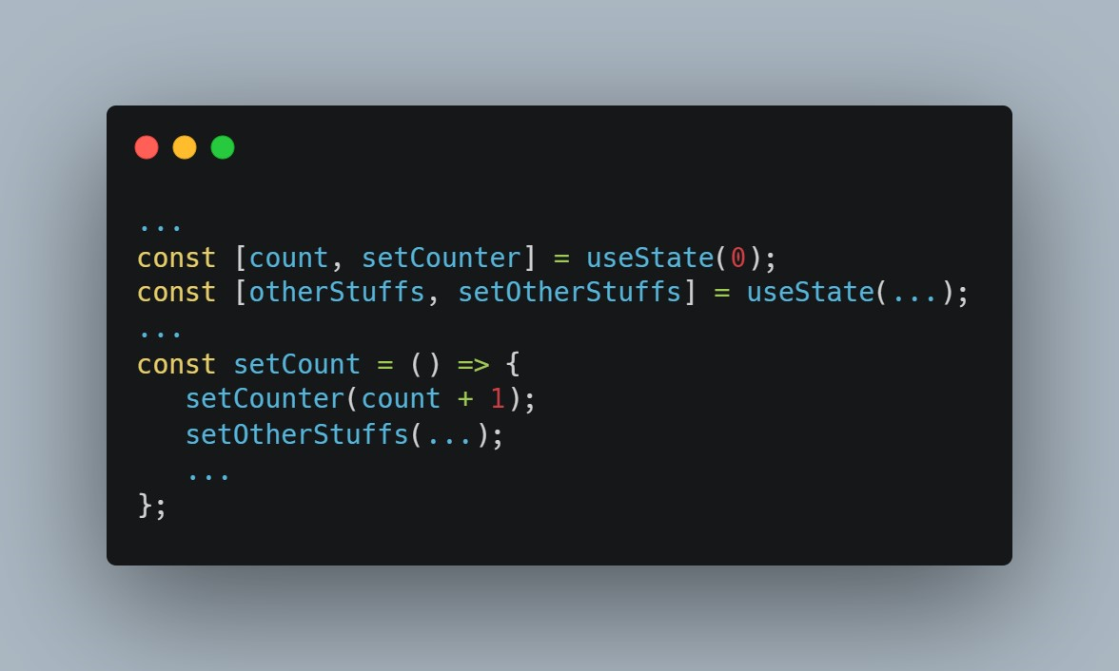

1. **What is JSX?**

* JSX stands for JavaScript XML.
* It allows us to write HTML inside JavaScript and place them in the DOM without using functions like appendChild( ) or createElement( ).
* An example of JSX: 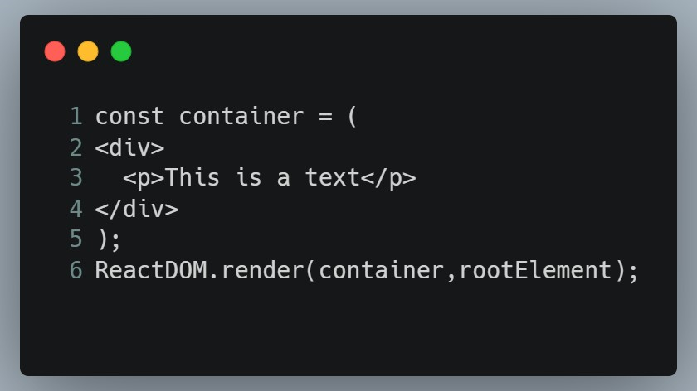

1. **What are the differences between functional and class components?**

* Before the introduction of Hooks in React, functional components were called stateless components and were behind class components on a feature basis.
* After the introduction of Hooks, functional components are equivalent to class components.
* Although functional components are the new trend, the react team insists on keeping class components in React. Therefore, it is important to know how these components differ.

|  |  |
| --- | --- |
| Functional Component Syntax | Class Based Component Syntax |
|  |  |