AMRUTAM TELEMEDICINE: Architecture Document
System Design · Booking Saga · Concurrency & Consistency Strategy
Prepared by: Shubham Dubey
Stack: Node.js, TypeScript, Express, PostgreSQL, Prisma, Redis, BullMQ

1. Overview
Amrutam provides a scalable telemedicine backend managing patient/doctor accounts, scheduling, consultation lifecycles, prescriptions, search, admin analytics, and compliance audit trails. This document details the high-level architecture, data flow strategies, concurrency models, and operational posture (caching, scaling, backup).

Metric | Value
Scale | 100k consultations/day (~1.2 bookings/sec avg, with higher peak volume)
Latency | p95 < 200ms reads, < 500ms writes
Availability | 99.95%

2. High-Level Architecture
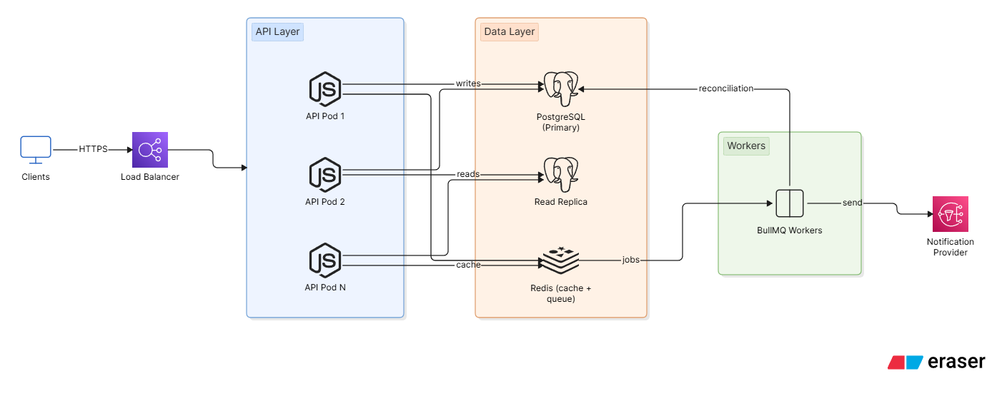
The system employs a stateless API layer (Express.js) horizontally scalable behind a load balancer. Authentication and session state are managed via signed JWTs and rotating refresh tokens stored in PostgreSQL, eliminating the need for sticky sessions.
Primary Infrastructure:
- Database: PostgreSQL (Primary + Read Replicas) for robust relational integrity.
- Cache/Queue: Redis for non-critical transient data (idempotency keys, search cache, job queues).
- Background Jobs: BullMQ for asynchronous tasks (notifications, reconciliation).

Why Postgres
Booking integrity is critical; we utilize relational constraints (FKs) to ensure atomicity. Redis is reserved for performance-critical, reconstructible data.

3. Core Data Flow: Booking Saga
The booking process (inventory, payment, consultation creation) is handled as an orchestrated saga within a single service call.

- Request: POST /bookings (includes idempotency-key).
- Idempotency Check: API queries Redis and the DB to verify existing consultation records.
- Optimistic Lock: The slot is held in PostgreSQL using an optimistic lock (status='OPEN' -> 'HELD').
- Transaction: A Consultation record is created.
- Payment: The payment gateway is triggered.
  - Success: Consultation status updates to 'BOOKED'; audit log is generated; notifications are enqueued.
  - Failure: The Consultation row is deleted, and the slot is released (compensation).

Unrecoverable Errors
In cases where payment succeeds but slot confirmation fails (e.g., DB blip), a critical reconciliation event is logged for manual/background resolution to prioritize consistency over automation.

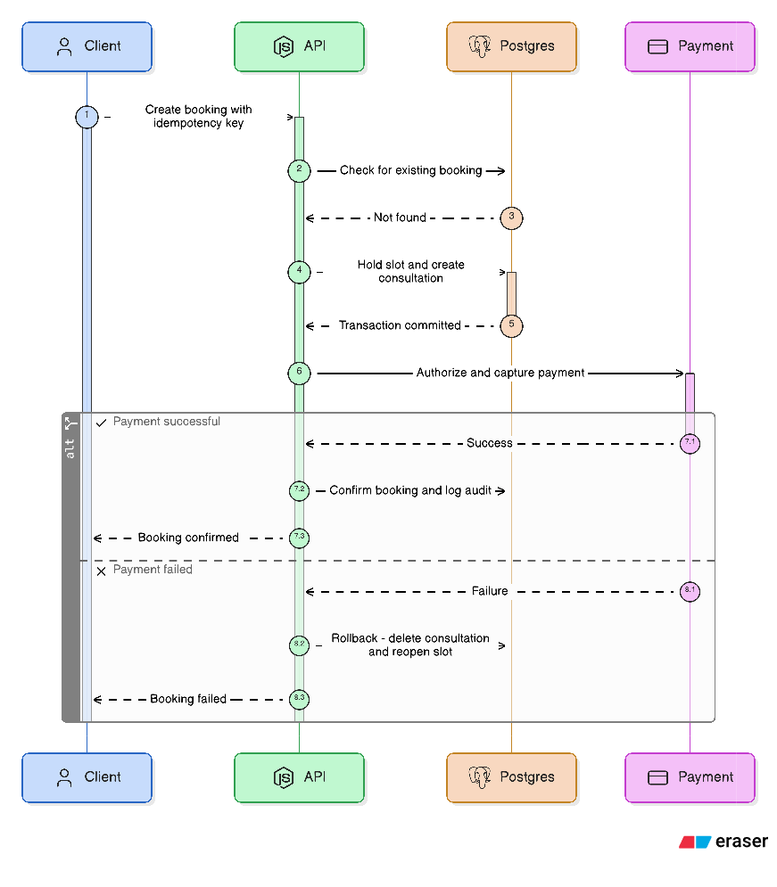

4. Data Model (ER Summary)
Core tables include: users, profiles, doctors, availability_slots, consultations, prescriptions, payments, refresh_tokens, and audit_logs.
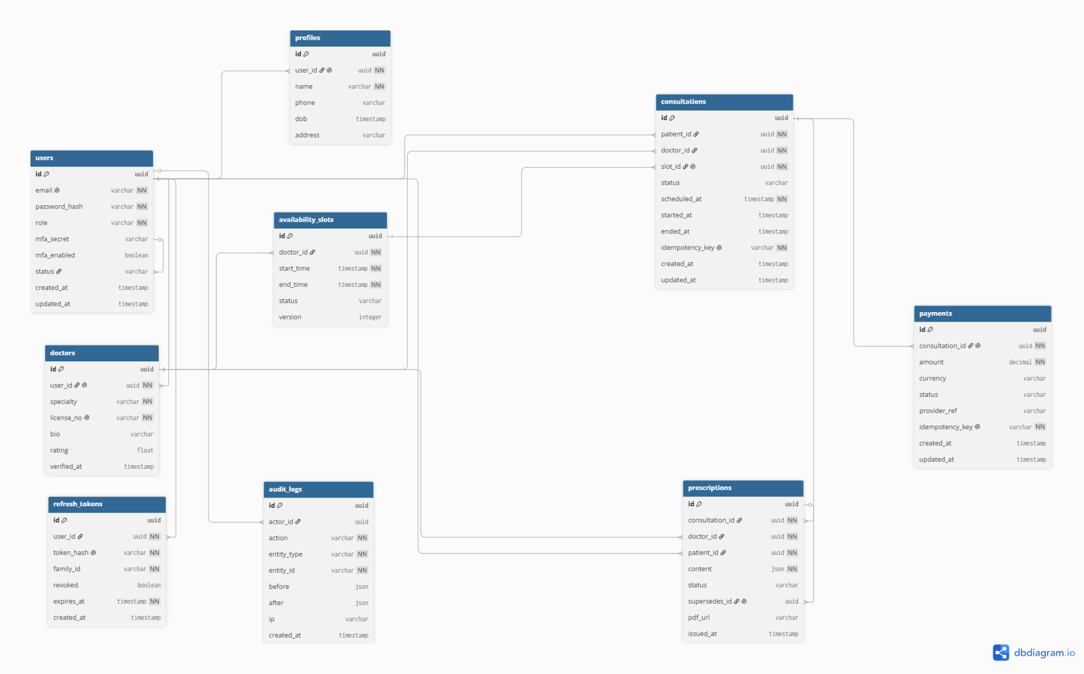

Key integrity decisions
- Consultation.slotId: Marked @unique to prevent double-booking at the schema level.
- Payment.consultationId: Unique FK ensuring strict 1:1 mapping between payments and consultations.
- Prescription.supersedesId: Self-referential FK to track version history (ACTIVE vs. SUPERSEDED).
- Optimistic Concurrency: Availability slots utilize a version column for safe updates.

5. Retry & Backoff Strategy
- Client-Facing Writes: Idempotency-key protection allows safe client retries for network timeouts.
- Async Jobs: BullMQ utilizes exponential backoff with jitter for downstream API failures.
- Optimistic Lock Conflicts: 409 Conflict responses are returned to the client; these are not retried automatically as the underlying state has changed.

6. Concurrency Handling
Slot holding implements optimistic concurrency control (OCC).
UPDATE availability_slots
SET status = 'HELD', version = version + 1
WHERE id = :id AND status = 'OPEN' AND version = :readVersion
If zero rows are updated, a race condition occurred, and a 409 error is returned. This approach minimizes lock-wait latency compared to pessimistic locking.

7. Caching Strategy
- Doctor Search: Cached in Redis (60s TTL). Prioritizes speed over absolute real-time data.
- Idempotency Keys: Cached for 24 hours.
- Writes: Strictly served from PostgreSQL to guarantee consistency.

8. Data Partitioning (Scaling Path)
To support projected scale, the following roadmap is established:
- Time-Based Partitioning: Monthly range partitioning for consultations and audit_logs.
- Read Scaling: Offloading read traffic to replicas.
- Caching: Buffering search queries via Redis.

9. Backup & Disaster Recovery
- Postgres: WAL archiving + daily backups (Point-in-time recovery). RPO: minutes; RTO: < 1 hour.
- Redis: Disposable; rebuilt from DB state if necessary.
- Audit Logs: Append-only; backed up via primary DB cadence.

10. Security Posture Summary
Full details are maintained in the separate Security Checklist & Threat Model.
- Input validation via Zod
- Structured logging (Pino)
- RBAC and CORS implementation
- Rate limiting
- Audit logging
- Token-based auth (JWT)

