Hyper Text Markup Language(HTML5)

- Demonstrate all the text formatting tags in a single HTML page.

CODE
<!DOCTYPE html>
<html lang="en">
<head>
<meta charset="UTF-8">
<meta name="viewport" content="width=device-width, initial-scale=1.0">
<title>Document</title>
<link rel="preconnect" href="https://fonts.googleapis.com">
<link rel="preconnect" href="https://fonts.gstatic.com" crossorigin>
<link href="https://fonts.googleapis.com/css2?family=Oswald:wght@200..700&display=swap" rel="stylesheet">
<link rel="preconnect" href="https://fonts.googleapis.com">
<link rel="preconnect" href="https://fonts.gstatic.com" crossorigin>
<link href="https://fonts.googleapis.com/css2?family=Oswald:wght@200..700&family=Space+Grotesk:wght@300..700&display=swap" rel="stylesheet">
<style>
.abr {
font-family: 'Oswald', sans-serif;
margin: 20px;
line-height: 1.6;
}
section {
margin-bottom: 20px;
}
hr {
margin: 30px 0;
}
body{
font-family: 'Space Grotesk', sans-serif;
margin: 20px;
line-height: 1.6;
}
</style>
</head>
<body>
<section>
<h1>this is heading 1</h1>
<h2>this is heading 2</h2>
<h3>this is heading 3</h3>
<h4>this is heading 4</h4>
<h5>this is heading 5</h5>
<h6>this is heading 6</h6>
</section>
<hr>
<section>
this is <b>bold</b> text <br>
this is <strong>strong</strong> text <br>
this is <i>italic</i> text <br>
this is <em>emphasized</em> text <br>
this is <u>underlined</u> text <br>
this is <s>strikethrough</s> text <br>
this is <del>deleted</del> text <br>
this is <ins>inserted</ins> text <br>
this is <mark>marked</mark> text <br>
this is <small>small</small> text <br>
this is <large>large</large> text <br>
</section>
<hr>
<section>
this is superscript tect E=mc <sup>2</sup> <br>
this is subscript text H<sub>2</sub>O <br>
</section>
<hr>
<section>
this is for code <code>int x=20-10</code> <br>
this is for keyboard input <kbd>ctrl + s</kbd> <br>
this is for sample output <samp>hello world</samp> <br>
this is for variable text <var>x + y = z</var> <br>
this is for deleted text <del>this text is deleted</del> <br>
this is for inserted text <ins>this text is inserted</ins> <br>
</section>
<hr>
<section class="abr">
<abbr title="hyper text markup language">HTML</abbr><br>
maths symbol for submission &sum; <sup>i=1</sup><br>
&hslash; - symbol for reduced plank constant <br>
&trade; - symbol for trademark <br>
&copyright; - symbol for copyright <br>
&reg; - symbol for registered <br>
<pre>
<small>i=n</small>
<strong><large>&sum;</large></strong>
<small>i=1</small>
</pre>
</section>
</body>
</html>
OUTPUT
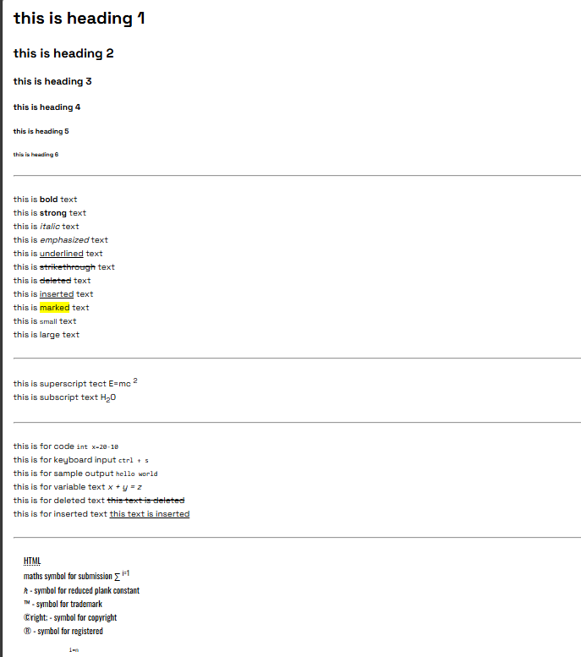

- Write a HTML code to draw the following Figure :
*
* * *
* * * * *
* * * * * * *
CODE :
<!DOCTYPE html>
<html lang="en">
<head>
<meta charset="UTF-8">
<meta name="viewport" content="width=device-width, initial-scale=1.0">
<title>Document</title>
</head>
<body>
<p>The Given Pattern is </p>
<pre>
*
* * *
* * * * *
* * * * * * *
</pre>
</body>
</html>

OUTPUT :
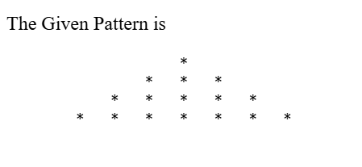

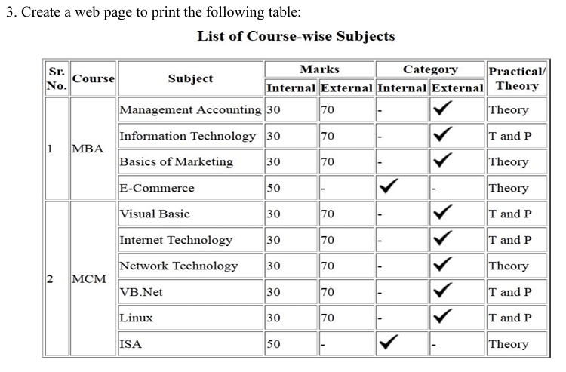
CODE:
<!DOCTYPE html>
<html lang="en">
<head>
<meta charset="UTF-8">
<meta name="viewport" content="width=device-width, initial-scale=1.0">
<title>table</title>
</head>
<body>
<table border="1px">
<tr>
<th rowspan="2">Sr.No.</th>
<th rowspan="2">Course</th>
<th rowspan="2">Subject</th>
<th colspan="2">Marks</th>
<th colspan="2">Category</th>
<th rowspan="2">Practical/ <br>Theory</th>
</tr>
<tr>
<th>Internal</th>
<th>External</th>
<th>Internal</th>
<th>External</th>
</tr>
<tr>
<td rowspan="4">1</td>
<td rowspan="4">MBA</td>
<td>Management Accounting</td>
<td>30</td>
<td>70</td>
<td>-</td>
<td>&#10004;</td>
<td>Theory</td>
</tr>
<tr>
<td>Information Technology</td>
<td>30</td>
<td>70</td>
<td>-</td>
<td>&#10004;</td>
<td>T and P</td>
</tr>
<tr>
<td>Baiscs of Marketing</td>
<td>30</td>
<td>70</td>
<td>-</td>
<td>&#10004;</td>
<td>Theory</td>
</tr>
<tr>
<td>E-Commerce</td>
<td>50</td>
<td>-</td>
<td>&#10004;</td>
<td>-</td>
<td>Theory</td>
</tr>
<tr>
<td rowspan="6">2</td>
<td rowspan="6">MCM</td>
<td>Visual Basic</td>
<td>30</td>
<td>70</td>
<td>-</td>
<td>&#10004;</td>
<td>T and P</td>
</tr>
<tr>
<td>Internet Technology</td>
<td>30</td>
<td>70</td>
<td>-</td>
<td>&#10004;</td>
<td>T and P</td>
</tr>
<tr>
<td>Linux</td>
<td>30</td>
<td>70</td>
<td>-</td>
<td>&#10004;</td>
<td>T and P</td>
</tr>
<tr>
<td>ISA</td>
<td>50</td>
<td>-</td>
<td>&#10004;</td>
<td>-</td>
<td>Theory</td>
</tr>
</tr>
</table>
</body>
</html>

OUTPUT:
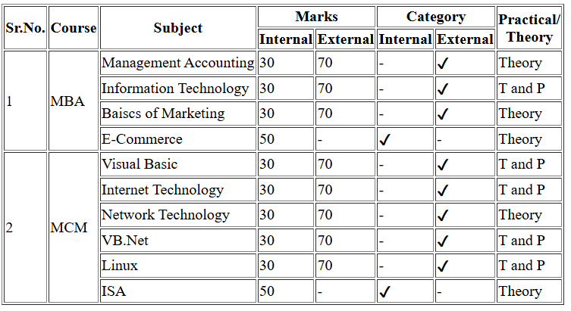
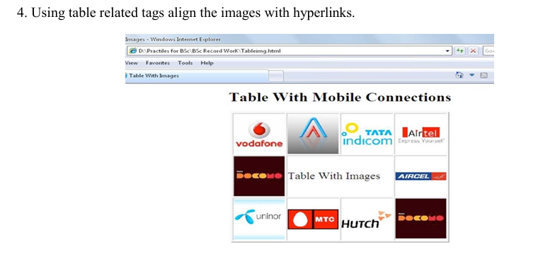
CODE :
<!DOCTYPE html>
<html lang="en">
<head>
<meta charset="UTF-8">
<meta name="viewport" content="width=device-width, initial-scale=1.0">
<title>Table With Links and images</title>
</head>
<body>
<table align="center" border="1px" shadow="10px">
<legend align="center">TABLE WITH MOBILE CONNECTIONS</legend>
<br>
<tr>
<td><a href="https://1000logos.net/vodafone-logo/" target="_blank"><img src="https://1000logos.net/wp-content/uploads/2017/06/Vodafone-Logo-2006.jpg" alt="" height="60px" width="80px"></a></td>
<td><a href="https://www.logo.wine/logo/Aircel" target="_blank"><img src="https://www.logo.wine/a/logo/Aircel/Aircel-Logo.wine.svg" alt="" height="60px" width="80px"></a></td>
<td><a href="https://logoeps.com/tata-indicom-vector-logo/25461/" target="_blank"><img src="https://logoeps.com/wp-content/uploads/2012/12/tata-indicom-vector-logo.png" alt="" height="60px" width="80px"></a></td>
<td><a href="https://logoeps.com/tata-indicom-vector-logo/25461/" target="_blank"><img src="https://logoeps.com/wp-content/uploads/2013/07/airtel-eps-vector-logo.png" alt="" height="60px" width="80px"></a></td>
</tr>
<tr>
<td><a href="https://commons.wikimedia.org/wiki/File:Tata_Docomo_Logo.svg" target="_blank"><img src="https://upload.wikimedia.org/wikipedia/commons/thumb/b/b0/Tata_Docomo_Logo.svg/500px-Tata_Docomo_Logo.svg.png" alt="" height="60px" width="80px"></a></td>
<td colspan="2" align="center">Table with Images</td>
<td><a href="https://www.logo.wine/logo/Aircel" target="_blank"><img src="https://www.logo.wine/a/logo/Aircel/Aircel-Logo.wine.svg" alt="" height="60px" width="80px"></a></td>
</tr>
<tr>
<td><a href="https://commons.wikimedia.org/wiki/File:Tata_Docomo_Logo.svg" target="_blank"><img src="https://encrypted-tbn0.gstatic.com/images?q=tbn:ANd9GcQJgdoNLGpRCftKDOqZKN0XHVWsfvDY31VNrw&s" alt="" height="60px" width="80px"></a></td>
<td><a href="https://commons.wikimedia.org/wiki/File:Tata_Docomo_Logo.svg" target="_blank"><img src="https://encrypted-tbn0.gstatic.com/images?q=tbn:ANd9GcS11WOJYImmas_i6_ZgbyqHLgfg4FPR6KOG0Q&s" alt="" height="60px" width="80px"></a></td>
<td><a href="" target="_blank"><img src="https://upload.wikimedia.org/wikipedia/en/e/e3/Hutch_India_old_logo.gif" alt="" height="60px" width="80px"></a></td>
<td><a href="https://commons.wikimedia.org/wiki/File:Tata_Docomo_Logo.svg" target="_blank"><img src="https://upload.wikimedia.org/wikipedia/commons/thumb/b/b0/Tata_Docomo_Logo.svg/500px-Tata_Docomo_Logo.svg.png" alt="" height="60px" width="80px"></a></td>
</tr>
</table>
</body>
</html>

OUTPUT :
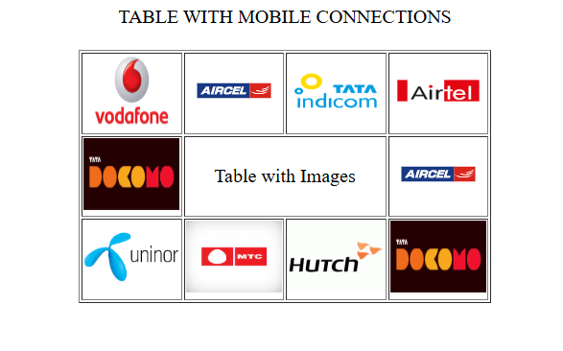

6. Write a HTML code for the following snapshot.
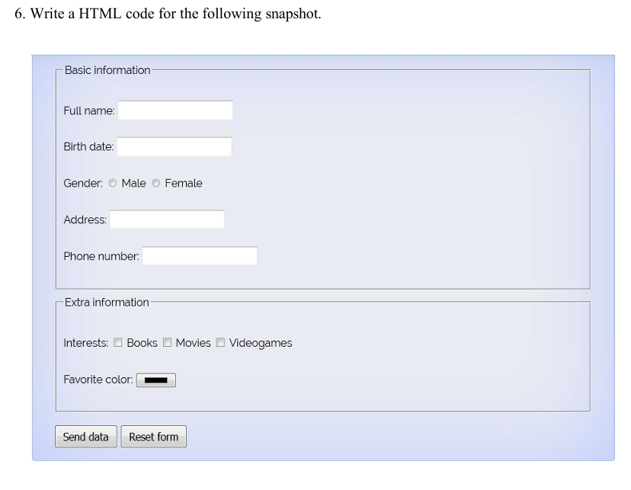
CODE :
<!DOCTYPE html>
<html lang="en">
<head>
<meta charset="UTF-8">
<meta name="viewport" content="width=device-width, initial-scale=1.0">
<title>FORM</title>
</head>
<body>
<form >
<h2>Form Example</h2>
<fieldset>
<legend>Basic Information</legend>
<label for="">Full Name</label>
<input type="text">
<br> <br>
<lABEL>Birth Date</lABEL>
<input type="date"><br> <br>
<label >Gender</label>
<input type="radio" name="abc">Male
<input type="radio" name="abc"> Female <br> <br>
<label > Address</label>
<input type="text"> <br> <br>
<label > Phone Number</label>
<input type="tel"><br><br>
</fieldset>
<fieldset>
<legend>Extra Information</legend>
<label for="">Interests</label>
<input type="checkbox"> Books
<input type="checkbox" name="Movies" id="Movies"> Movies
<input type="checkbox" name="VG" id="VG">VideoGames <br><br>
<label for="">Favourite Color</label>
<input type="color" name="" id="">
</fieldset>
<br>
<input type="submit" value="Send Data">
<input type="reset" value="Reset Form">
</form>
</body>
</html>
OUTPUT : 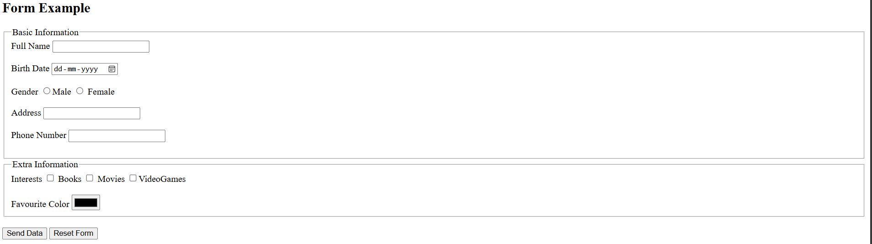

7.Create a web page of customer profile for data entry of customer’s in a Hotel, The profile should include Name, Address, Age, gender, Room Type (A/C, Non-A/C or Deluxe), Type of payment (Cash, Credit/Debit Card or Coupons).
CODE :
<!DOCTYPE html>
<html lang="en">
<head>
<meta charset="UTF-8">
<meta name="viewport" content="width=device-width, initial-scale=1.0">
<title>Document</title>
</head>
<body>
<h2>CUSTOMER PROFILE</h2>
<form action="" method="post">
<fieldset>
<legend>Personal Details</legend>
<label for="nm">NAME : </label>
<input type="text" name="name" id="nm" > <br><br>
<label for="address"> Address : </label>
<input type="text" name="address" id="address"> <br><br>
<label for="age">Age:</label>
<input type="number" name="age" id="age"> <br><br>
<label for="gender">Gender</label>
<input type="radio" name="gender">Male
<input type="radio" name="gender"> Female
<br><br>
</fieldset>
<br>
<fieldset>
<legend>Additional Information</legend>
<fieldset>
<legend>Booking Details</legend>
<label for="rt">Room Type:</label>
<input type="radio" name="rt"> A/C
<input type="radio" name="rt"> Non-A/C
<input type="radio" name="rt"> Deluxe <br><br>
<label for="checkin"> Check-In Date:</label>
<input type="date" name="checkin" id="checkin"> <br><br>
<label for="checkout"> Check-Out Date:</label>
<input type="date" name="checkout" id="checkout"> <br><br>
</fieldset>
<fieldset>
<legend>Contact Details</legend>
<label for="email"> Email:</label>
<input type="email" name="email" id="email"> <br><br>
<label for="phone"> Phone Number:</label>
<input type="tel" name="phone" id="phone"> <br><br>
</fieldset
<br><br>
<fieldset>
<label for="payment"> Type of Payment</label> <br>
<select name="" id="">
<option value="select">select</option>
<option name="pay">Cash</option>
<option name="pay"> Credit/Debit card</option>
<option name="pay"> Coupons </option>
</select>

</fieldset>
<br>
<input type="submit" value="submit form">
<input type="reset" value="reset form">
</fieldset>
</form>
</body>
</html>
OUTPUT :
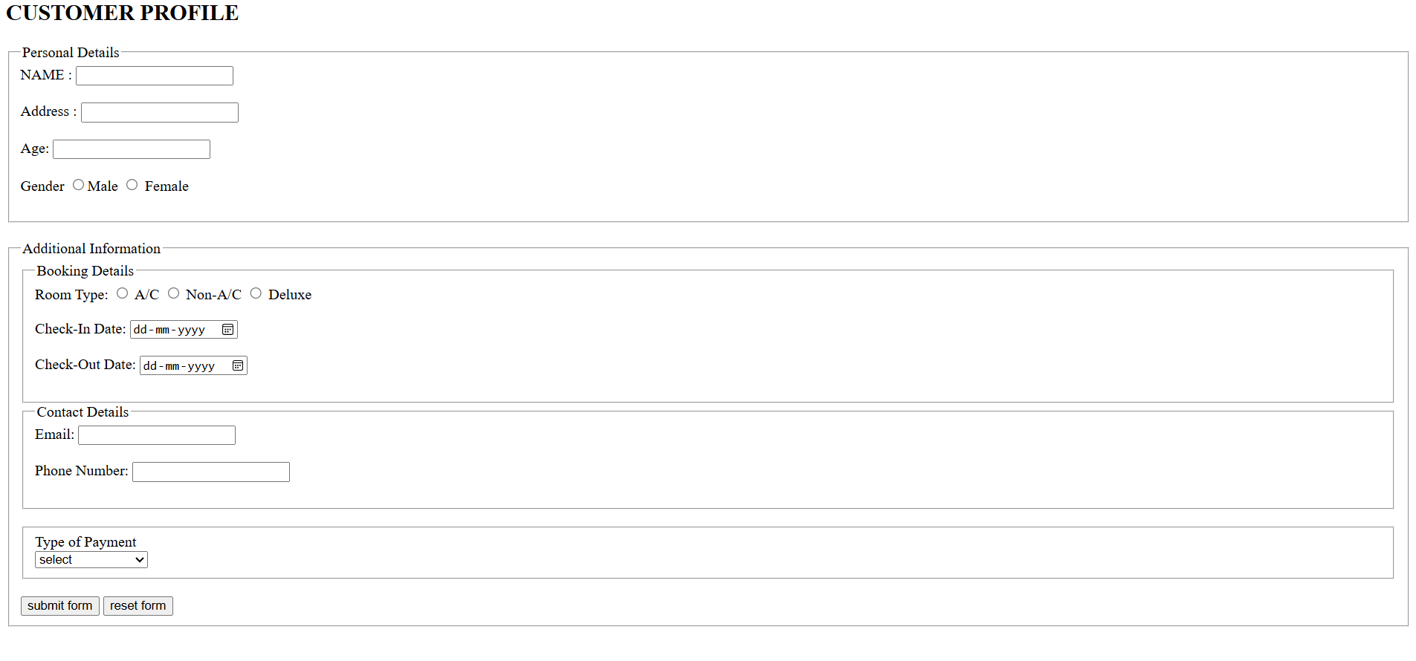

8.Demonstrate the use of following HTML5 Tags.
I. <Video>
II. <Audio>
III. <Header>
IV. <Footer>
V. <Nav>
VI. <Embed>
VII. <Datalist>
VIII. <Bdi>
IX. <Article>
X. <Output>
CODE :
<!DOCTYPE html>
<html lang="en">
<head>
<meta charset="UTF-8">
<meta name="viewport" content="width=device-width, initial-scale=1.0">
<title>Document</title>
</head>
<body>
<header>
<marquee behavior="slide" direction="left to right" scrollamount="30"><h1>HTML5 Tags Demonstration during lab</h1></marquee>
</header>
<h2>Nav Bar Demo</h2>
<nav>
<a href="#">home</a>
<a href="#video">video</a>
<a href="#audio">audio</a>
<a href="#embed">embed</a>
<a href="#datalist">datalist</a>
<a href="#bdi">bdi</a>
<a href="#article">article</a>
</nav>
<h2 id="video">Video Tag Demo</h2>
<video controls>
<source src="sample.mp4" type="video/mp4">
Your browser does not support the video tag.
</video>
<h2 id="audio">Audio Tag Demo</h2>
<audio controls>
<source src="sample.mp3" type="audio/mpeg">
Your browser does not support the audio tag.
</audio>
<h2 id="embed">Embed tag Demo</h2>
<embed src="https://drive.google.com/file/d/1ceZ1Pfo2AJ3t8IATiy84P3ge8vMAM0wh/view?usp=drive_link" type="application/pdf" width="600" height="500">
<h2 id="datalist">Datalist demo</h2>
<input list="languages" placeholder="Choose a language">
<datalist id="languages">
<option value="C">
<option value="C++">
<option value="Java">
<option value="Python">
<option value="JavaScript">
</datalist>
<h2 id="bdi">Bdi Demo</h2>
<p>User Ali scored 90</p>
<p>User <bdi>علي </bdi> 90</p>
<h2 id="article">Atricle Demo</h2>
<article>
Lorem ipsum dolor sit amet consectetur adipisicing elit. Quidem laudantium, error ea reprehenderit
harum laboriosam ex odio ab quod veritatis, dolores vero. Exercitationem rerum alias
odio hic asperiores aliquam, iure magnam nam non sit quisquam doloremque qui enim
aperiam animi. Harum sapiente blanditiis quo perspiciatis aliquid
eos facilis veniam ipsum. Eum deleniti illo nostrum, repellendus sit ob
caecati sapiente debitis. Odit maxime doloremque repellat necessi
tatibus. Nemo impedit dignissimos earum? Et, odit quam? Voluptatibus ab ipsum
nemo. Quidem animi vel ducimus placeat, ratione eligendi quaerat commodi alias dolores reprehenderit nihil molestiae aut maiores fugit ab facere minus porro
nemo voluptate similique quis. <br><br>
</article>
<footer>
created for learning purpose &copy;2026
</footer>
</body>
</html>

OUTPUT :
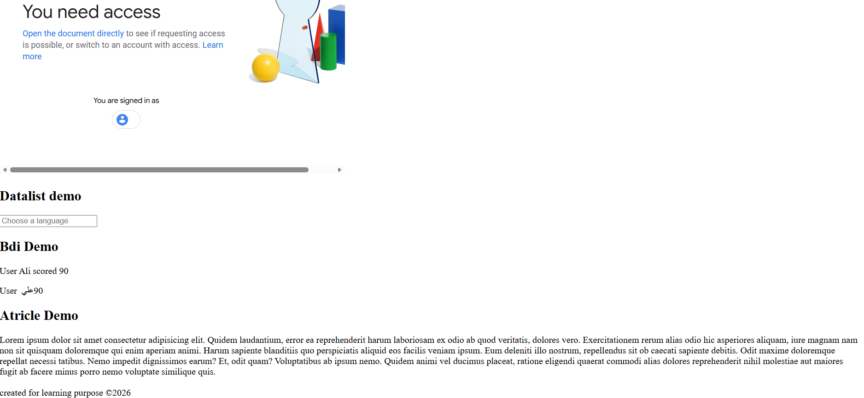
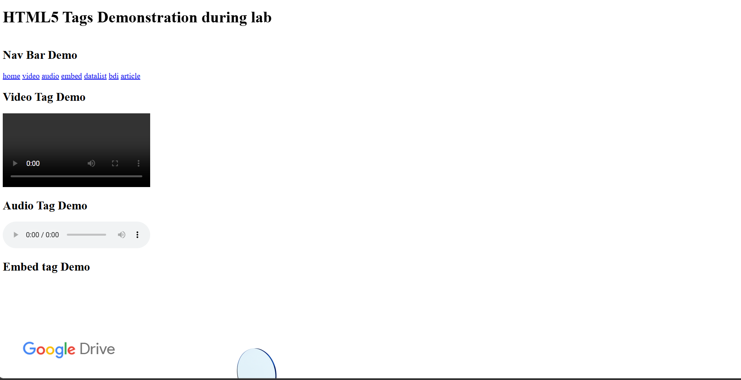

9.Design an HTML page to create the following list.
1. Programming Languages
o Python
▪ Frameworks
1. Django
2. Flask
▪ Libraries
▪ NumPy
▪ Pandas
▪ Matplotlib
o Java
▪ Core Concepts
▪ OOP
▪ Multithreading
▪ Exception Handling
▪ Frameworks
1. Spring
2. Hibernate
2. Web Development
1. Frontend
▪ HTML
▪ CSS
▪ JavaScript
▪ React
▪ Vue.js
▪ Angular
2. Backend
▪ Node.js
▪ PHP
▪ Ruby on Rails

CODE :
<!DOCTYPE html>
<html lang="en">
<head>
<meta charset="UTF-8">
<meta name="viewport" content="width=device-width, initial-scale=1.0">
<title>List Demo</title>
</head>
<body>
<ol type="1">
<li><b>Programming Languages</b></li>
<ul type="circle">
<li> <b> Python</b></li>
<ul>
<li>
Frameworks
<ol>
<li>Django</li>
<li>Flask</li>
</ol>
</li>
<li>
Libraries
<ul>
<li>Numpy</li>
<li>Pandas</li>
<li>Matplotlib</li>
</ul>
</li>
</ul>
<li><b>Java</b></li>
<ul>
<li>
Core Concepts
<ul>
<li>OOP</li>
<li>Multithreading</li>
<li>Exception Handling</li>
</ul>
</li>
<li>
Frameworks
<ol>
<li>Spring</li>
<li>Hibernate</li>
</ol>
</li>
</ul>
</ul>
<li><b>Web Development</b></li>
<ol type="1">
<li><b>Frontend</b></li>
<ul type="square">
<li>HTML</li>
<li>CSS</li>
<li>JavaScript
<ul>
<li>React</li>
<li>Vue.js</li>
<li>Angular</li>
</ul>
</li>
</ul>
<li><b>Backend</b></li>
<ul>
<li>Node.js</li>
<li>PHP</li>
<li>Ruby or Rails</li>
</ul>
</ol>
</ol>
</body>
</html>
OUTPUT :
