CaptureFirst Prototype Designer Handoff
Low-fidelity sketches and mid-fidelity shadcn/ui + Tailwind screen specification for S1-S6

1. Design intent
- Preserve the capture-first principle: a doctor can start capturing before selecting or searching for a patient.
- Treat unassigned sessions as a safe temporary state, not an error.
- Use calm, minimal UI that feels like a lightweight clinical workbench, not an HIS replacement.
- Make matching explicit and reversible to reduce wrong-patient risk.
- Avoid visible technical AI details unless they directly affect trust, status, or user control.

2. Design system recommendation
Use shadcn/ui + Tailwind CSS. Recommended primitives: Button, Card, Badge, Input, Tabs/filters, Dialog, Sheet/Drawer, ScrollArea, Separator, Toast, Alert, Skeleton, DropdownMenu, Command/Combobox, and Tooltip. Use a neutral theme, restrained blue accent, generous whitespace, and rounded cards. Avoid dense tables unless absolutely necessary.

3. Screen map
Screen | User job | Primary CTA | Next screen
S1 Today / Capture Home | Start capturing quickly | Start capture | S2
S2 Active Capture Session | Capture voice/photo/note | Save session | S3
S3 Session Saved | Continue or review | Start another capture / Review queue | S2 or S4
S4 Unassigned Inbox | Find an unassigned session | Find patient to match | S5
S5 Patient Match | Assign to correct patient | Confirm match | S6
S6 Patient Visit Session | Review organized material | Open source / Undo match | Source preview or S4

4. Low-fidelity sketches
These sketches define layout hierarchy and navigation. They are intentionally rough and should be used to validate flow before visual polish.
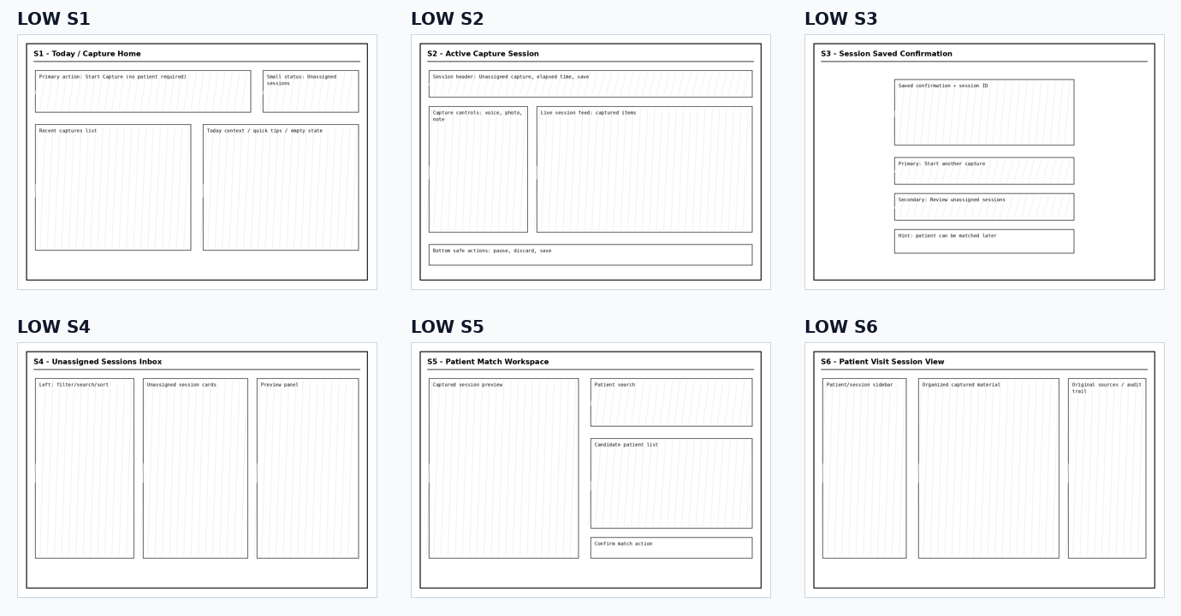

5. Mid-fidelity UI direction
The mid-fidelity screens translate the same flow into shadcn/ui + Tailwind conventions: cards, rounded controls, neutral surfaces, restrained accent colors, and clear primary/secondary actions.
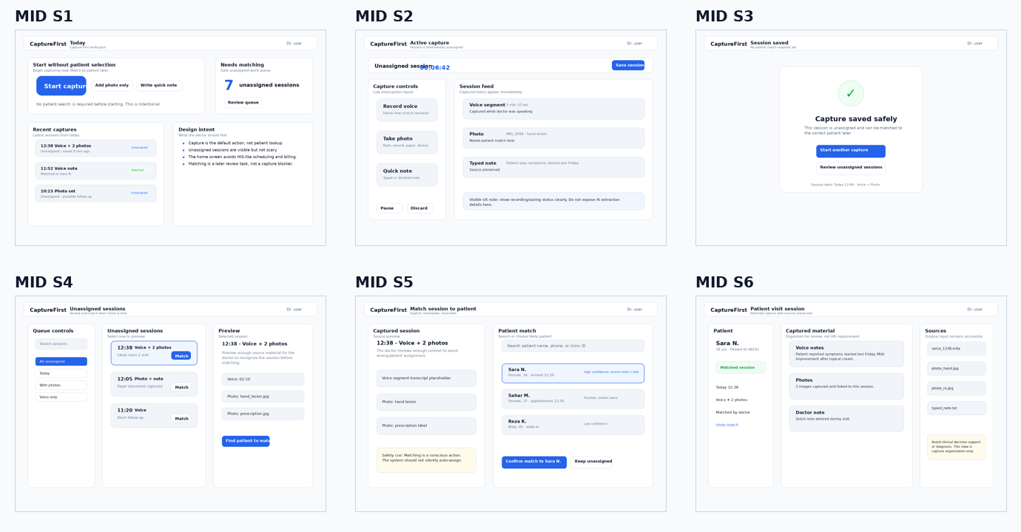

S1. Today / Capture Home

Low-fidelity sketch
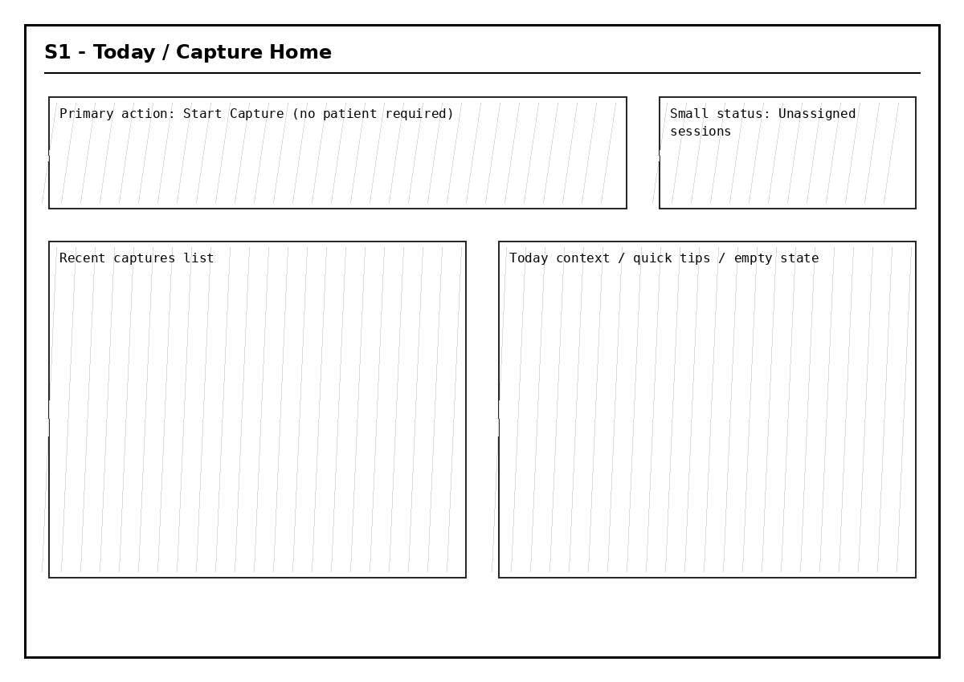

Mid-fidelity UI
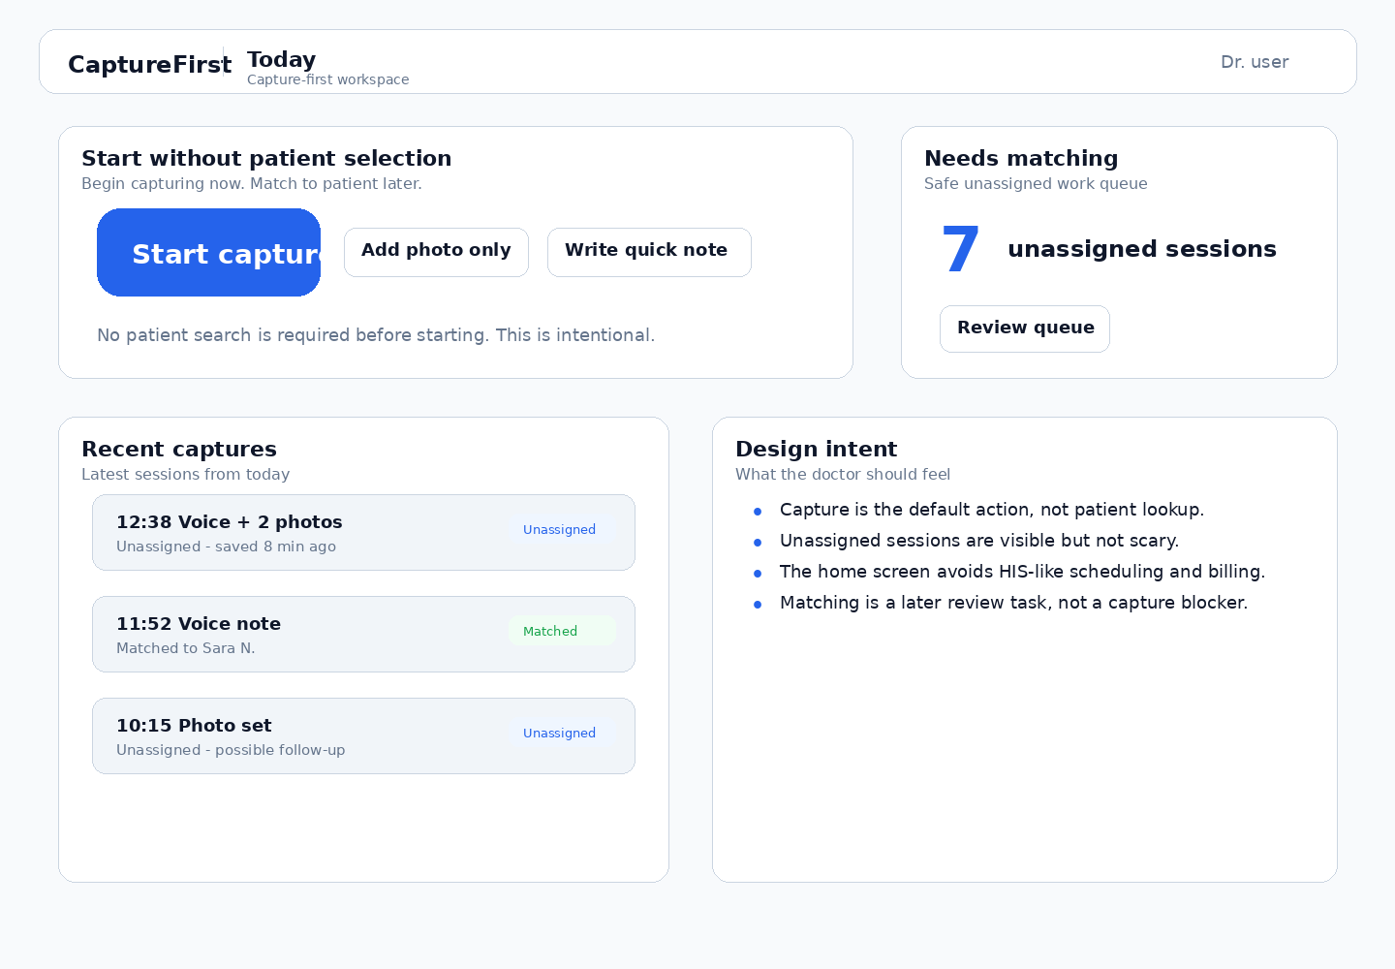

Screen specification
Purpose | Make capture the default action and make unassigned sessions visible without making them feel like a blocker.
Components | • Top bar with product name and doctor identity  • Primary Start Capture CTA  • Secondary quick actions: Add photo only, Write quick note  • Unassigned sessions counter  • Recent captures list  • Design intent helper card
States | • Empty state: no recent captures, 0 unassigned  • Normal state: recent captures and unassigned count  • Warning state: many unassigned sessions with gentle review prompt  • Saving state: disabled Start Capture only if the app cannot safely start a session
Interactions | • Start Capture opens S2 immediately, without patient selection.  • Review queue opens S4.  • Recent capture click opens S6 if matched, S5/S4 path if unassigned.

S2. Active Capture Session

Low-fidelity sketch
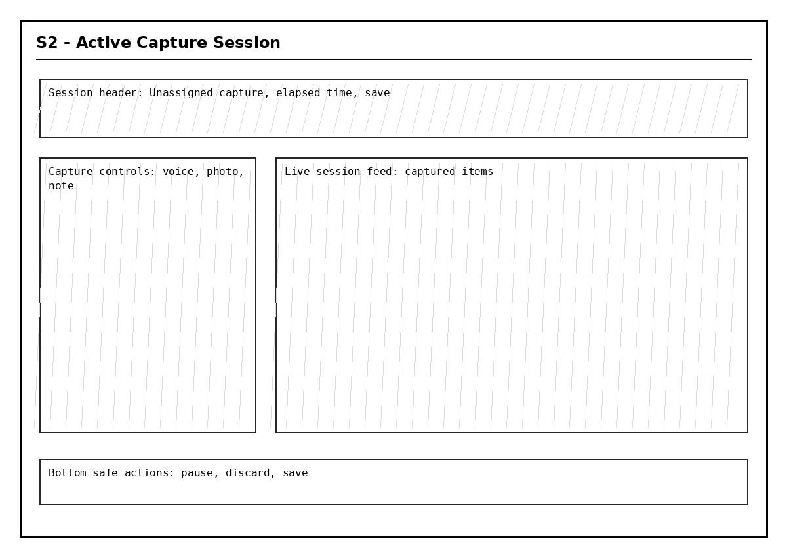

Mid-fidelity UI
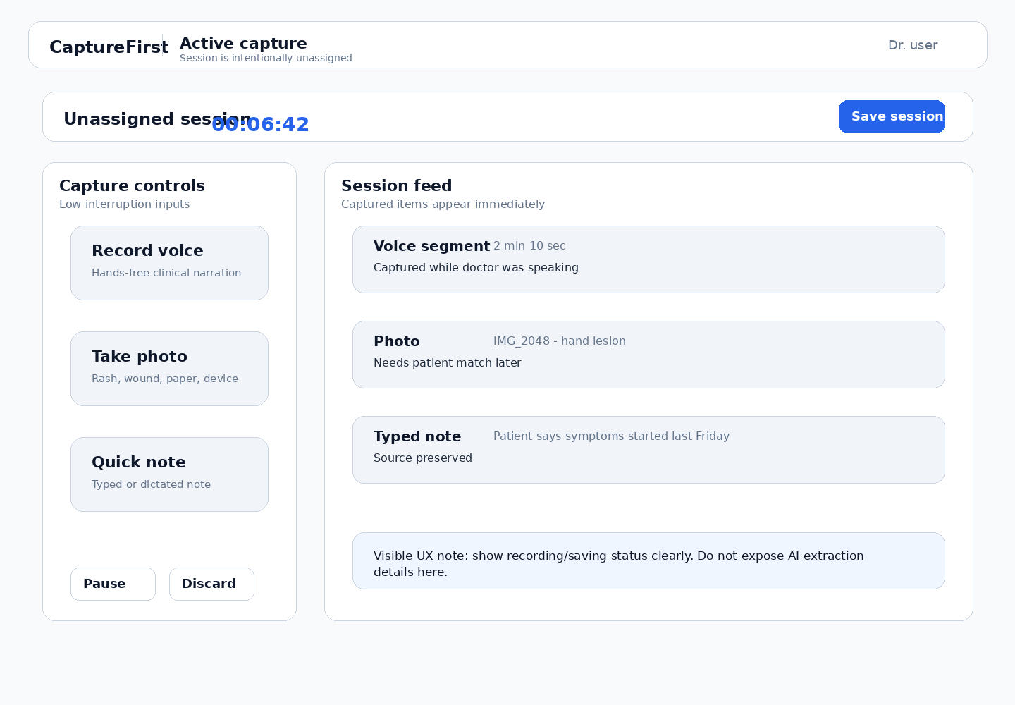

Screen specification
Purpose | Support low-friction capture during the visit while keeping patient assignment intentionally separate.
Components | • Unassigned session header  • Elapsed timer and status indicator  • Save Session primary action  • Voice/photo/note capture controls  • Session feed of captured items  • Pause/discard secondary actions
States | • Idle active session  • Recording voice  • Photo captured / upload pending  • Saving  • Network or device error  • Discard confirmation
Interactions | • Doctor can add multiple items to one session.  • Save moves to S3.  • Discard requires confirmation because captured source material may be lost.  • No patient search appears on this screen.

S3. Session Saved Confirmation

Low-fidelity sketch
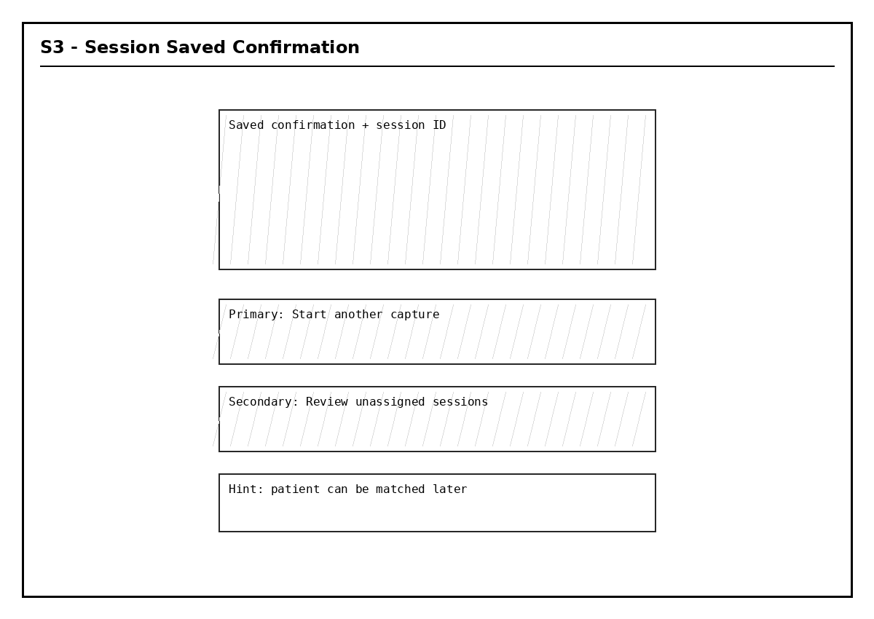

Mid-fidelity UI
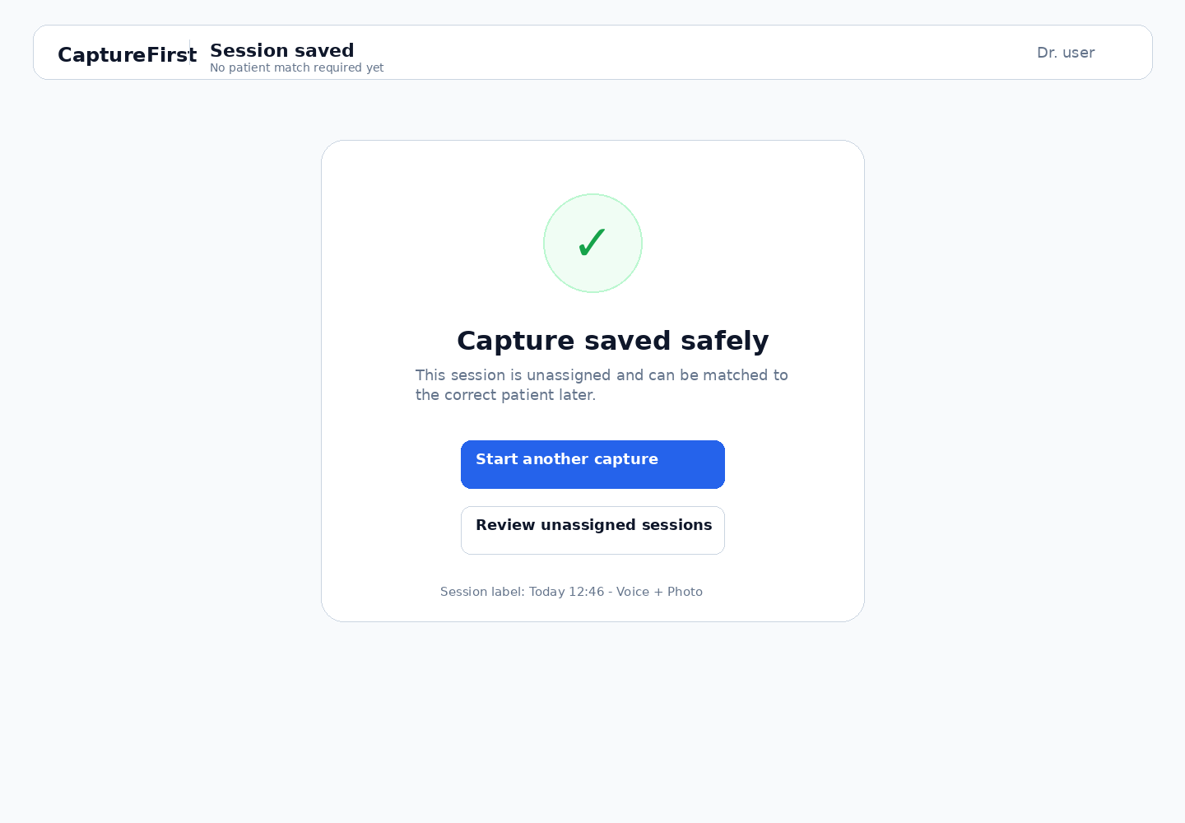

Screen specification
Purpose | Reassure the doctor that unassigned capture is safe and offer the next natural action.
Components | • Success confirmation  • Session summary label  • Start another capture primary action  • Review unassigned sessions secondary action  • Short reassurance copy
States | • Saved successfully  • Saved but sync pending  • Save failed retry state
Interactions | • Start another capture opens S2 with a new session.  • Review unassigned opens S4.  • Back returns to S1.

S4. Unassigned Sessions Inbox

Low-fidelity sketch
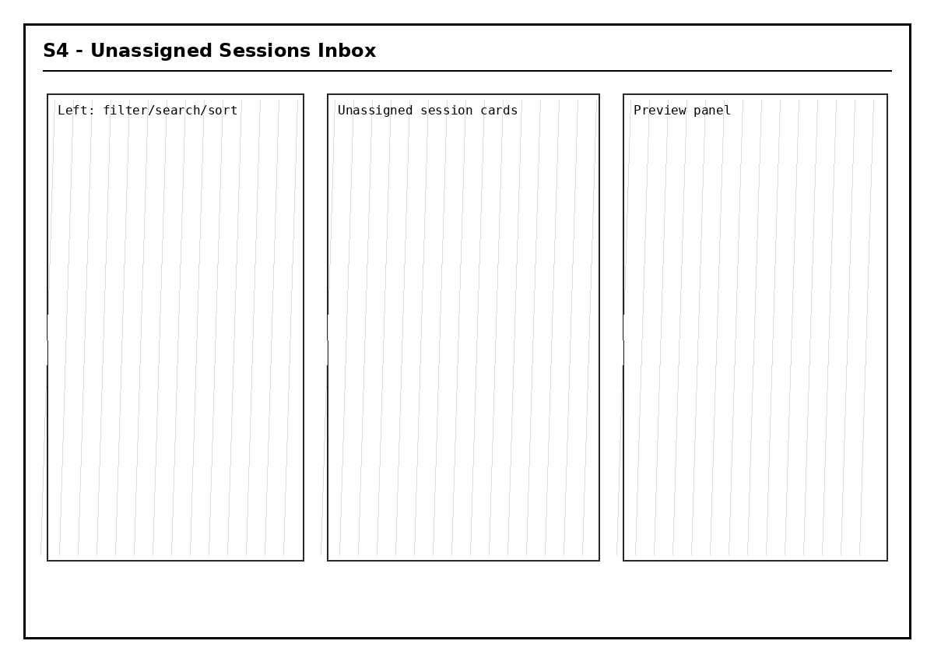

Mid-fidelity UI
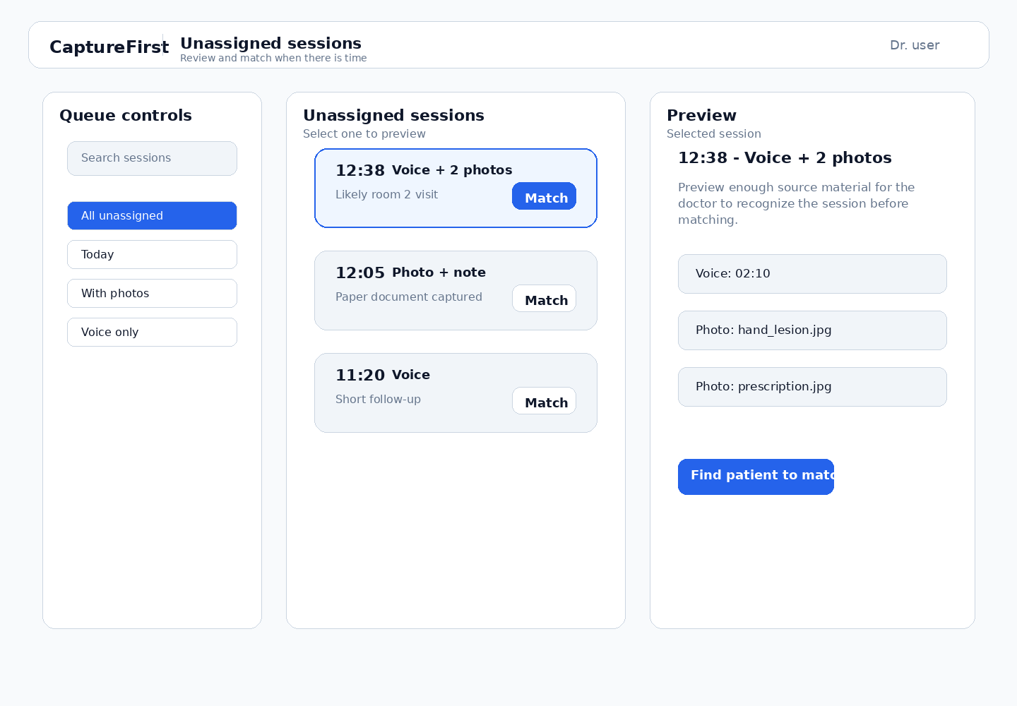

Screen specification
Purpose | Let the doctor review unassigned captures when there is time, without turning the product into scheduling software.
Components | • Queue filters  • Session search  • Unassigned session cards  • Preview panel  • Find patient to match CTA
States | • Empty queue  • Queue with selected item  • Search/filter results  • Preview loading  • Preview unavailable
Interactions | • Selecting a session updates preview.  • Match opens S5.  • Filters narrow the queue but do not expose full clinic scheduling.

S5. Patient Match Workspace

Low-fidelity sketch
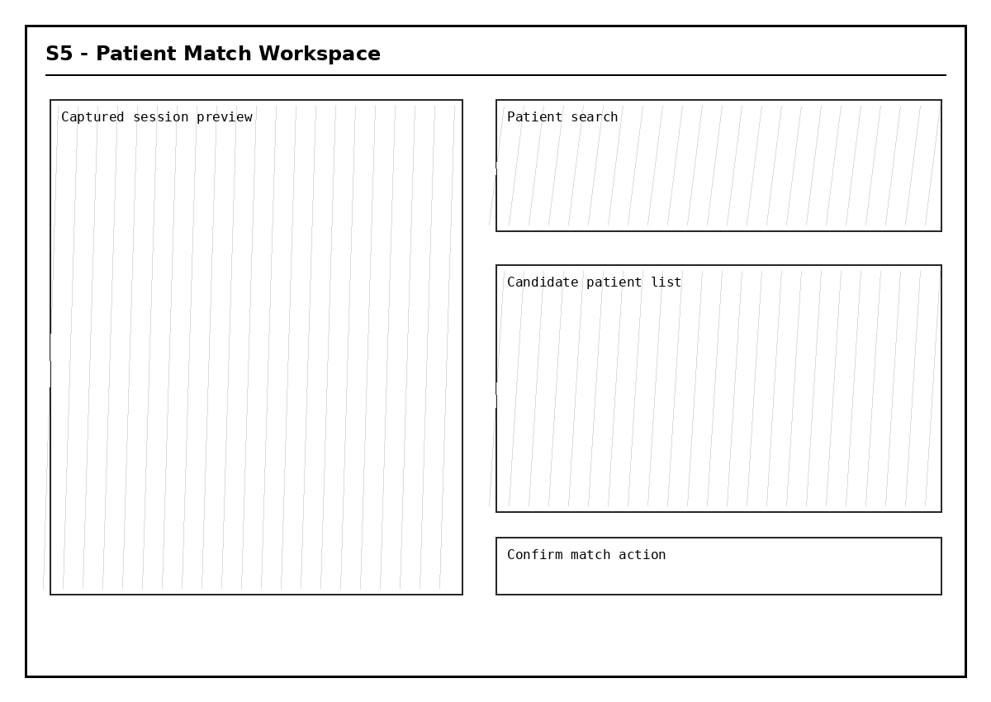

Mid-fidelity UI
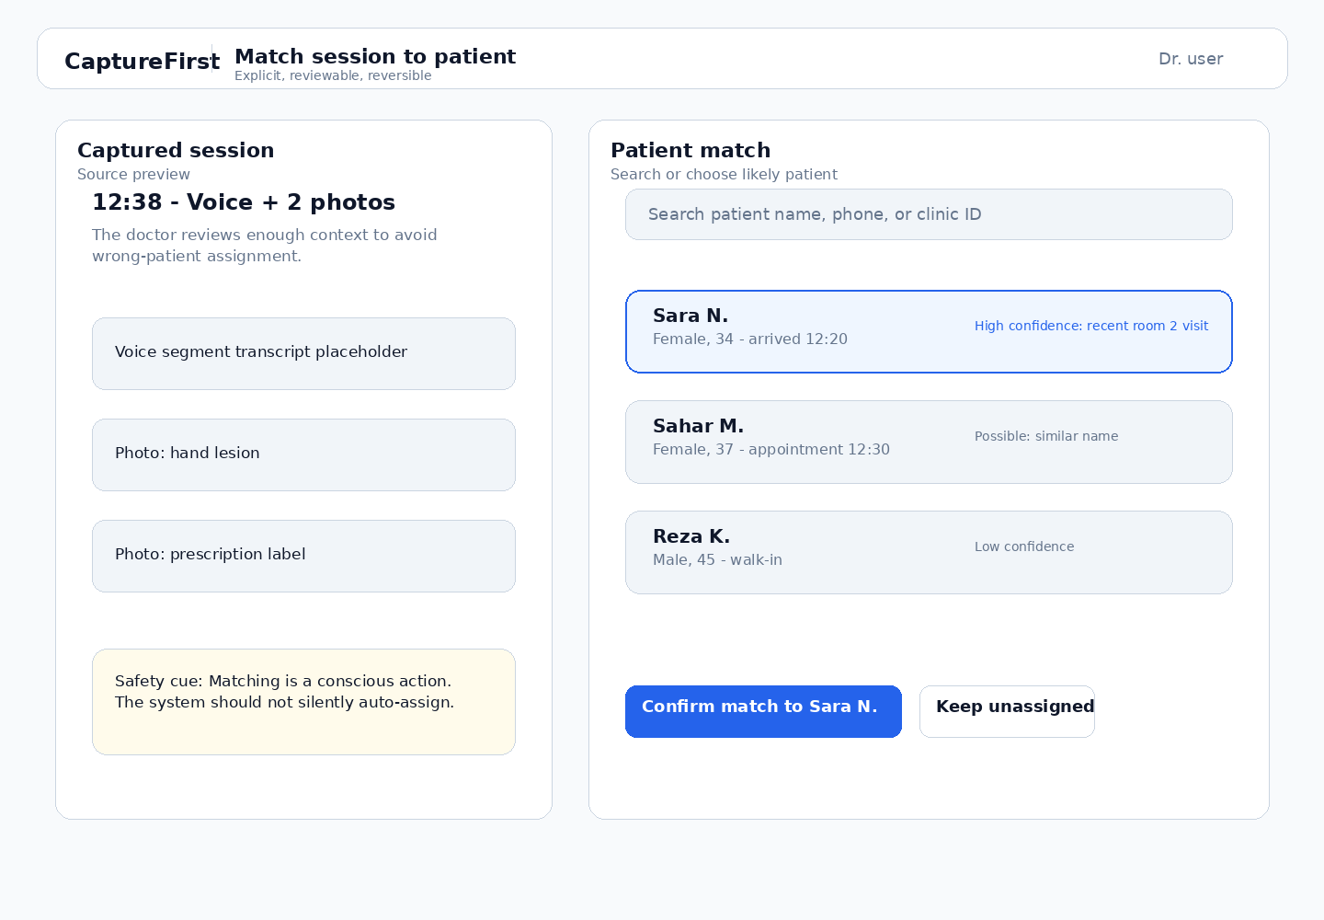

Screen specification
Purpose | Make patient assignment explicit, safe, and reversible.
Components | • Captured session preview  • Patient search input  • Candidate patient list  • Confidence/reason hints as UX copy  • Confirm match CTA  • Keep unassigned action  • Safety cue
States | • No search entered  • Candidate list available  • No candidate found  • Selected candidate  • Confirming match  • Possible duplicate warning
Interactions | • Doctor reviews captured context and chooses a candidate.  • Confirm match leads to S6.  • Keep unassigned returns to S4.  • System may suggest candidates, but never silently assigns.

S6. Patient Visit Session View

Low-fidelity sketch
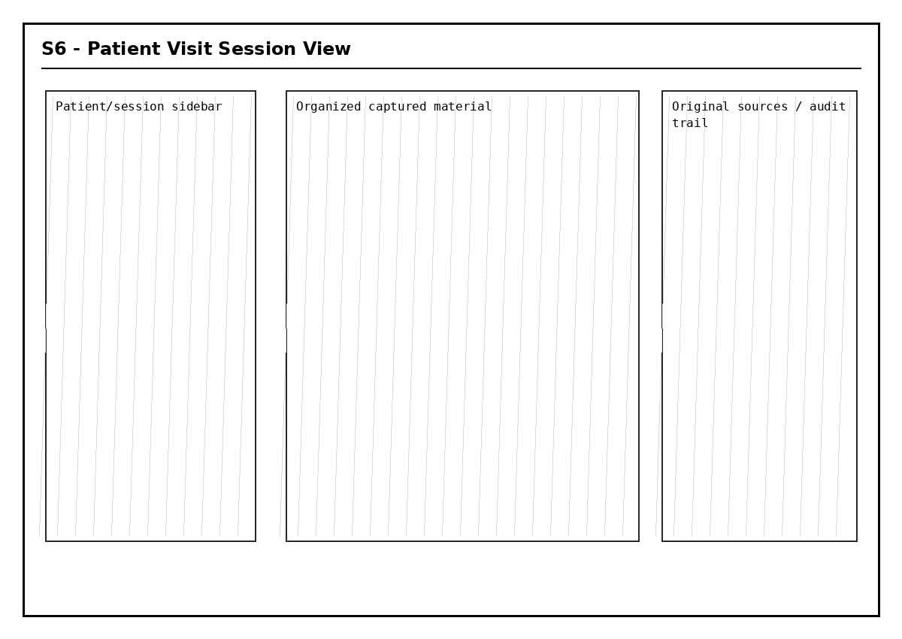

Mid-fidelity UI
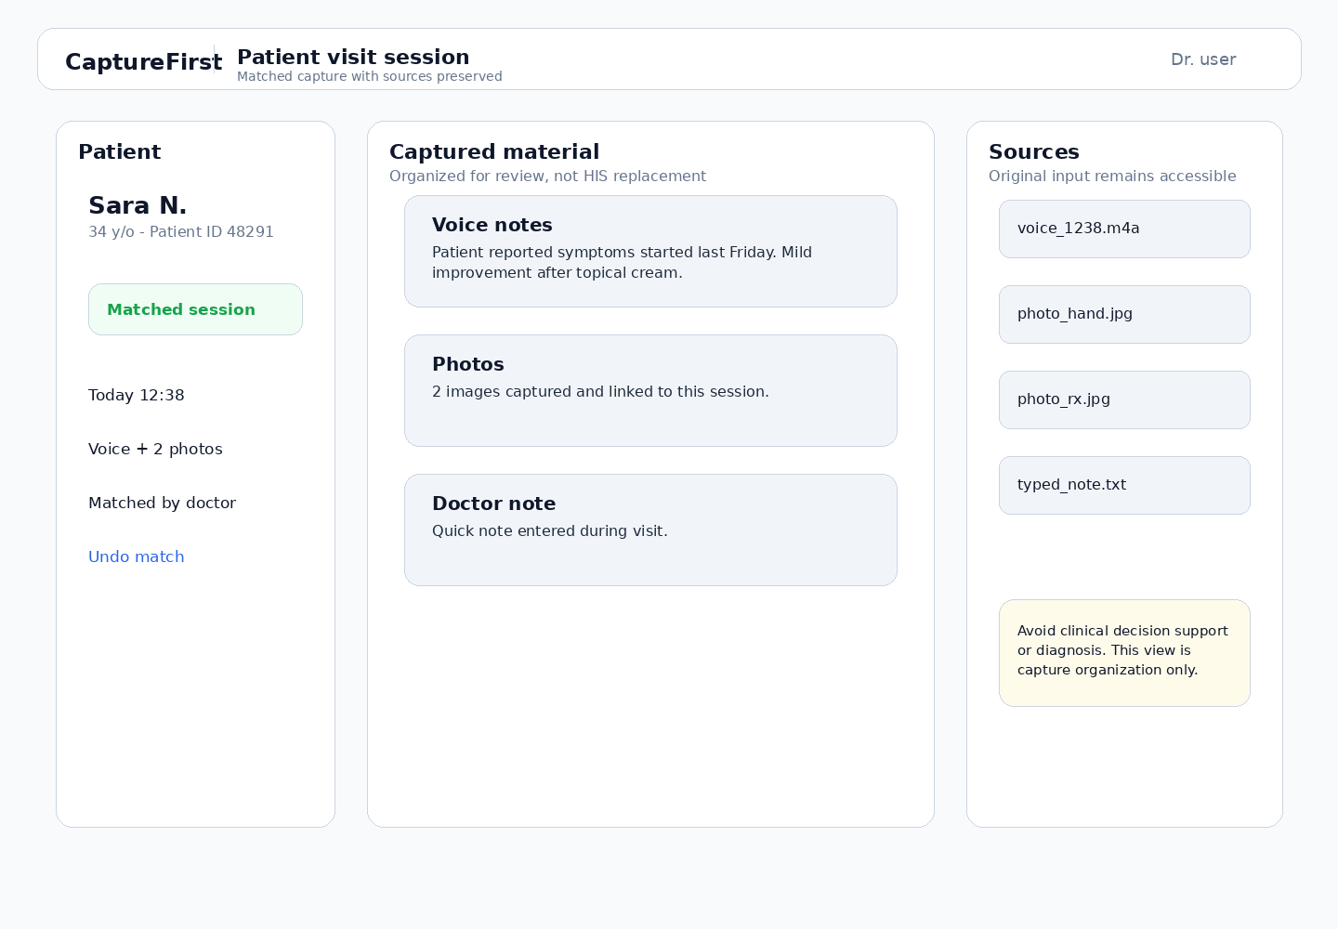

Screen specification
Purpose | Show matched captured material organized around the visit, while preserving original sources and avoiding HIS-like scope.
Components | • Patient summary card  • Matched session metadata  • Captured material sections  • Original source list  • Undo match link  • Scope boundary notice
States | • Matched session loaded  • Source preview opened  • Undo match confirmation  • Missing source warning
Interactions | • Source click opens original capture preview.  • Undo match returns the session to S4.  • No billing, invoicing, insurance, or diagnosis workflow appears here.

6. Frontend implementation order
- Build the AppShell and reusable Card/Button/Badge/Input patterns first.
- Implement S1-S3 as the primary capture loop before any matching workflow.
- Implement S4-S5 as the review-and-match loop with a mock session dataset.
- Implement S6 as the matched session review surface with original sources preserved.
- Add empty, loading, error, saving, and confirmation states before visual polish.

7. Acceptance checks for designer/developer review
- Can the doctor start capture in one click from S1?
- Does S2 avoid all patient lookup UI?
- Can a session be saved safely as unassigned?
- Is the unassigned queue visible but not alarming?
- Is patient matching explicit and reversible?
- Does S6 show original captured sources?
- Are HIS-like workflows absent?

