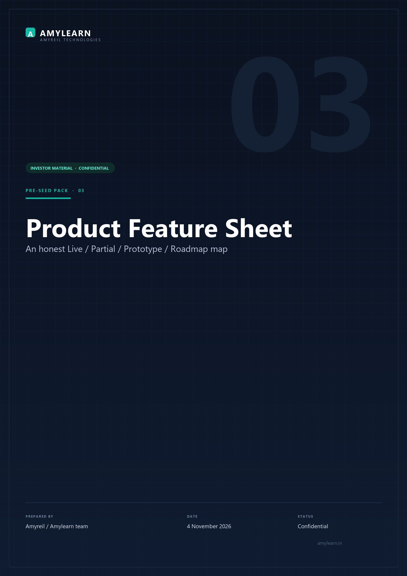

Document control
DOCUMENT | 03_Product_Feature_Sheet.docx
COMPANY | Amyreil Technologies (proposed)
PRODUCT | Amylearn
PREPARED BY | Amyreil Technologies / Amylearn team
VERSION / DATE | 4 November 2026
STATUS | Ready
CONFIDENTIALITY | Confidential
PREPARED FOR | Investor and partner review

At a glance
80  CAPABILITIES MAPPED | 28  LIVE | 23  PARTIAL | 10  ROADMAP

Contents

This is our own audit of the product, not a marketing list. We use it to keep the demo honest: every row below is something we can either show from the database, label as a prototype, or mark as not built.

Status definitions
Label | Meaning
Live | The UI calls an existing backend endpoint and the data persists.
Partial | A real endpoint exists, but the data is synthesized, writes are local-only, or key sub-features are missing.
Prototype | Fully interactive UI with mock/local data; lost on refresh.
Roadmap | Not built.
We use these labels in the demo. We do not present prototype data as live.

1. Student portal
Module | What the student can do | Status
Overview | Attendance, CGPA, credits, fees, today’s classes, notices, AI shortcuts | Partial
My Courses | Browse subjects, modules, lectures, notes, assignments; open PDFs and videos | Partial
Assignments | Filter pending/submitted/graded | Prototype
Attendance | Subject-wise history, filters, attendance simulator | Partial
Digital Library | Browse e-books, PYQs, notes; bookmark; in-app PDF reader | Partial
Departmental Notices | Read notices, like, comment, open attachments | Live
Final Year Project | Edit synopsis, GitHub/live URLs, artifacts | Live
Timetable | Day/week view, lesson tracker, personal calendar | Prototype
AI Study Hub | Chat, suggested prompts, quiz | Prototype (canned response today)
Campus Notices | Read notices and attachments | Live
Organisation Calendar | Academic milestones and holidays | Prototype (local storage)
Payment Details | Transaction history and printable receipt | Partial
Dues & Pay Fees | Semester fee ledger and payment flow | Partial (no gateway)
University Marks | SGPA/CGPA, subject marks, grade card | Prototype
Semester Feedback | Rate courses and submit comments | Live
Exam Form | Select subjects, declare, submit | Live
Admit Card | Printable hall ticket with paper schedule | Partial (needs an exam session seeded)
My Profile | Enrolment details and password change | Prototype

2. Faculty portal
Module | What the faculty member can do | Status
Faculty home | Classes, attendance, notices, AI widget | Partial
Attendance marking | Roster, present/absent/excused, submit | Partial (backend writes attendance)
Class content | Modules, notes, videos | Partial
Lesson tracker | Weekly delivery log | Prototype
Leave application | Apply and track approval | Live
Marks entry | Enter and publish marks | Prototype
AI study companion | Real tutor chat | Live

3. Campus Admin portal
Module | What the dean/registrar can do | Status
Overview | Enrolment, faculty, departments, attendance, fees, notices | Partial
Manage Users | Search, filter, add, edit, suspend, delete | Partial (reads live; writes local)
Account Creation | Student/faculty/staff provisioning, bulk CSV | Prototype
Departments | Departments, streams, semester scheme, batches, labs | Partial (reads live; edits local)
Attendance Hub | Institution attendance, defaulters, filters, export | Partial
COE Manage | Exam sessions, question bank, moderation, hall allotment, evaluation, grade publishing | Prototype
Exam Management | Schedules, subject allocation, exam forms, admit cards, re-evaluation, invigilation | Prototype
Faculty Leave | Approve/decline leave, balances, substitutes | Prototype
University Marks | Semester results, SGPA, pass metrics, export | Prototype
Fees & Payments | Collection, transactions, reminders, receipts | Prototype (no fee model)
Campus Notices | Compose, pin, like, comment, attachments | Partial (reads live; writes local)
Staff Notices | Staff-only board | Partial
Organisation Calendar | Academic calendar, publish PDF | Prototype (local storage)
Campus Settings | Institution details, branding, attendance threshold | Prototype
Timetable | Day/week, workload, add/edit slots, clash detection | Partial (clash logic is real; data is sample)
Digital Library | E-books, PYQs, publisher credentials, physical circulation, approvals | Prototype
Feature Manager | View module flags, request activation | Partial

4. IT Admin portal
Module | What the platform team can do | Status
Overview | Institutions, requests, managers, health | Partial
Institutions | 7-step onboarding wizard, edit drawer, suspend/activate, generated subdomain and credentials | Partial (reads live; final submit partly local)
Campus Management | Per-campus users, departments, feature flags, white-labelling, theme, API key | Partial
Requests | Approve/reject onboarding requests | Prototype (backend returns empty)
Manage Users | IT manager directory, permissions | Partial (reads live; edits local)
Platform Settings | Brand, support email, session timeout, capacity | Prototype

5. AI capabilities
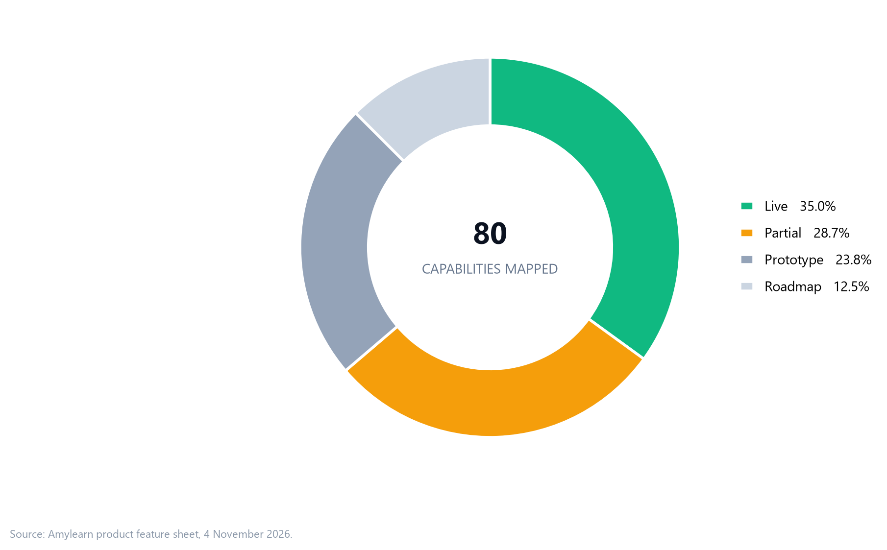
Figure 1. Feature status across all 80 catalogued capabilities.
Capability | Status | Notes
Tutor chat | Live | Qwen 2.5 3B on Modal
Socratic tutor | Live | Guided questioning
Mind map | Live | Returns Mermaid syntax
Document summary | Live | PDF/DOCX/XLSX/PPTX/TXT, 16k-character input cap
Step-by-step solving | Live | Math/science
Quiz generation | Live prompt, no dedicated UI | 3 conceptual + 2 numerical questions
Image/handwritten OCR | Live | SmolVLM2 vision
Scanned PDF OCR | Live | OCR.space + Tesseract fallback
Video study notes | Live but not transcription | Sends URL to chat model; no speech-to-text
Streaming responses | Roadmap | Single JSON response today
Per-tenant AI quotas | Roadmap | Not metered
Agentic exam scheduling and seating | Roadmap | 12–16 week build; LLM planner + OR-Tools solver + human-approved publish
Agent tool permissions and audit | Roadmap | Role/tenant checks at the tool layer; student helper isolated from exam tools

6. Platform capabilities
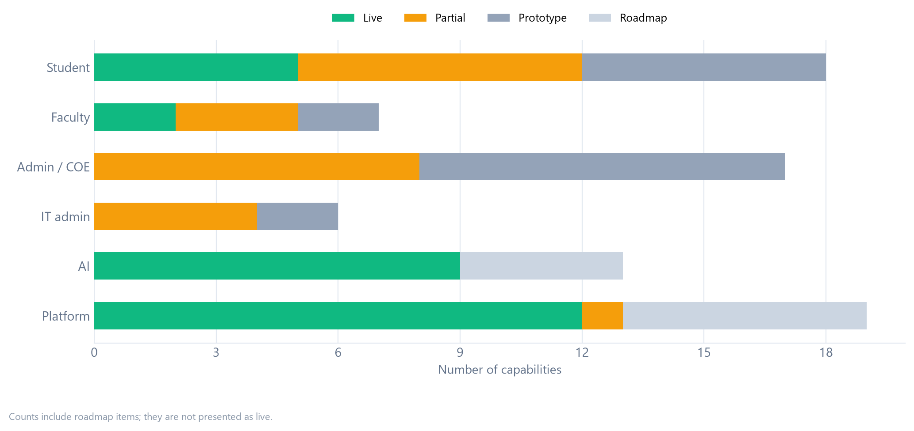
Figure 2. Status mix by portal.
Capability | Status
Multi-tenant data model | Live
JWT authentication + tenant claims | Live
Email OTP verification | Live (signup does not enforce it)
Campus admin and IT admin login | Live (mock fallback if backend down)
Departments, streams, subjects | Live
Batches and classrooms | Live (enrollment stubs)
Notices, comments, reactions | Live
Faculty leave workflow | Live
Attendance marking and records | Live (analytics partly hardcoded)
Digital and physical library | Live
LMS modules and content | Live (no progress table)
Exam sessions and result storage | Live (many COE flows stubbed)
Fee/invoice/payment | Roadmap
Audit logging | Roadmap
Server-side RBAC enforcement | Partial
Rate limiting, Helmet, CSP | Roadmap
NAAC/NBA export engine | Roadmap
Mobile app / PWA | Roadmap
Data migration tooling | Roadmap

7. What we will demo live
- Student login with a seeded tenant account
- Exam form submission → refresh → still submitted
- Semester feedback submission → refresh → still submitted
- Capstone project edit → save → reload → persists
- Notices and digital library read from the database
- AI chat and PDF summary
- Campus admin users and departments read
- Timetable conflict detection
- IT admin institution list

8. What we will explicitly label as prototype
- COE and exam management screens
- Fees and payments
- University marks
- Admit card (unless an exam session is seeded)
- Student AI Study Hub
- Account creation / bulk CSV
- IT onboarding requests and platform settings

9. What we will not claim
- “450+ campuses” — there is one seeded pilot environment
- “99.99% uptime” — no monitoring evidence; target 99.5%
- “AES-256 at rest” — not implemented for live data
- “Gemini” or “GPT-4o” — we use Qwen 2.5 3B and SmolVLM2
- “QR / biometric / geo-fence attendance” — not implemented
- “Payment gateway integrated” — not implemented
- “NAAC/NBA ready” — roadmap
- “Mobile app” — responsive web only
- “100% paperless” — digital exam operations, not end-to-end paperless
- “7-day migration guarantee” — onboarding playbook, not a guarantee

We verified this sheet against Eduspace-deploy-main commit 6ff5f7e on 23 October 2026. We re-verify it after any merge.

Footnote Text.

