CapacityIQ Demo Runbook
One hour walkthrough for the freight capacity optimisation application
This runbook prepares you to present CapacityIQ in a one hour demo. It explains the business problem, the app flow, the current optimiser calculation, the AI engine roadmap, competitor positioning, likely questions, and what to do if localhost stops during the session. Use it as a speaking guide rather than a script to read line by line.
Core thesis. Main message: CapacityIQ increases freight and retail revenue from existing assets by improving utilisation, reducing empty capacity, and matching demand with underused transport capacity.

Before The Meeting
Check | What To Do | Expected Result
Frontend | Open http://localhost:3000 | Application dashboard loads
Backend | Open http://127.0.0.1:8000/api/health | Status is ok and dataset counts appear
Dataset | Confirm health response shows shipments, corridors, hubs and partners | 2400 shipments and 12 corridors in the current dummy dataset
Browser | Keep one browser tab on Freight and one on Airport retail | Fast switching during demo
Recovery | Keep a terminal open in the project root | You can restart with npm run dev if needed

If the app is currently running, keep the terminal window open. Closing that terminal will usually stop both the frontend and backend development servers.

One Hour Demo Agenda
Time | Segment | What You Should Cover
0 to 5 min | Opening | State the empty capacity problem and the asset utilisation thesis.
5 to 12 min | Market context | Explain why freight is fragmented and why backhaul is a high value use case.
12 to 22 min | Freight workspace | Show Network Inputs, KPIs, route panel, Recommended Matches, Capacity Inventory and Guardrail Queue.
22 to 35 min | Run optimiser | Change one or two inputs, run the optimiser, and explain how accepted matches produce KPIs.
35 to 42 min | Airport retail extension | Show route cluster selection, passenger signal and assortment/revenue uplift.
42 to 50 min | AI engine roadmap | Explain how the current scoring engine evolves into rules plus solver plus ML.
50 to 58 min | Competitor comparison | Position CapacityIQ against Delhivery, Freight Tiger, TMS platforms and rail.
58 to 60 min | Close | Summarise business value and next steps for a production pilot.

Opening Talk Track
Use this in the first two minutes:
- Problem. Freight demand and transport capacity are fragmented across shippers, transporters, lanes and modes. Trucks often go full in one direction and return partially empty or fully empty.
- Example. In the Northeast corridor, a Britannia distribution movement can create predictable loaded forward trips. CapacityIQ then looks for compatible backhaul cargo so the return journey also earns revenue.
- Solution. CapacityIQ is an optimisation and marketplace layer. It decides what cargo should move, on which asset, through which route, and in combination with which other shipments.
- Business outcome. The platform improves load factor, reduces empty kilometres, reduces freight cost per unit and generates incremental transporter revenue without buying more vehicles.

How To Use The Freight Workspace
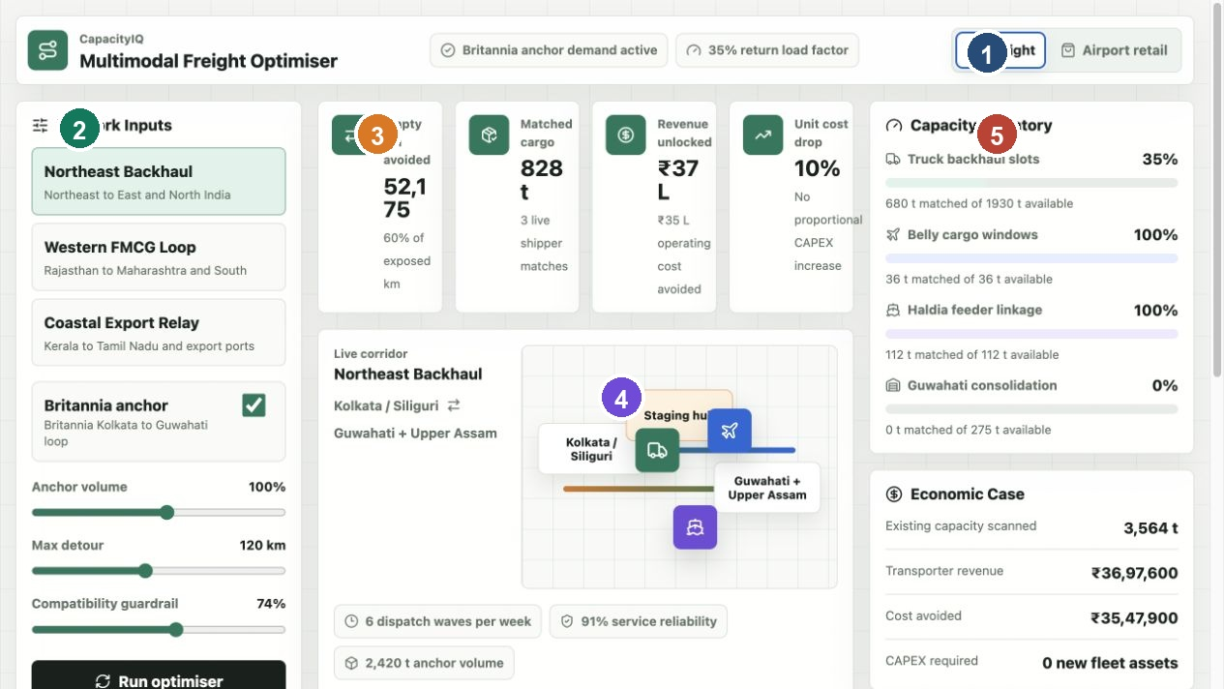
Figure 1 Freight workspace with network inputs, KPIs, route map and capacity inventory.
1. Select a corridor. Start with Northeast Backhaul because it directly supports the Britannia anchor story.
2. Confirm Britannia anchor. Keep the anchor enabled first. Explain that predictable anchor demand gives the network a base load around which other cargo can be matched.
3. Change anchor volume. Move the slider to show what happens when the predictable demand base grows or shrinks.
4. Change max detour. Lower values make the optimiser stricter. Higher values allow more matches but may introduce operational risk.
5. Change compatibility guardrail. Higher values reject more risky cargo. This protects service quality and product compatibility.
6. Click Run optimiser. This applies the selected scenario and sends it to the backend optimiser.

What Each Freight Feature Means
Feature | What It Shows | How To Explain It
Network Inputs | Corridor, anchor demand, detour policy and compatibility strictness | These are the business levers that shape the optimisation scenario.
KPI Cards | Empty km avoided, matched cargo, revenue unlocked and unit cost drop | These are calculated from the accepted shipment matches, not manually entered numbers.
Route Panel | Forward and return lane relationship | This tells the corridor story: loaded movement in one direction and monetised capacity in the other.
Recommended Matches | Accepted shipments ranked by score | The engine has chosen these because they fit the route, mode, capacity and guardrails.
Capacity Inventory | Used and remaining capacity by mode | This prevents unrealistic 100 percent utilisation by preserving an operating reserve.
Guardrail Queue | Rejected or deferred cargo | The system explains why a shipment was not accepted, such as detour or compatibility risk.

What Run Optimiser Does Today
The current application uses a deterministic heuristic optimiser. That means it is not random and it is not yet a trained machine learning model. It loads backend CSV data, scores shipments, sorts them, applies rules, accepts the best matches until capacity is used, and calculates KPIs from the accepted matches.
Step | Current Logic
1 Load data | Backend reads corridors, shipments, capacity, hubs, partners and retail profiles from CSV files.
2 Build capacity | Available capacity equals total capacity multiplied by available percent and the anchor factor.
3 Keep reserve | Only a target fill percentage is bookable. The rest is held back as operating buffer.
4 Score shipments | Each shipment receives a score based on route fit, reliability, compatibility, revenue and urgency.
5 Apply rules | Reject shipments that exceed detour policy, lack capacity, fall below the score threshold or violate strict guardrails.
6 Match tonnes | Accepted shipments receive full or partial tonnage depending on remaining mode capacity.
7 Calculate KPIs | Matched tonnes, revenue, empty km avoided, cost saved, load factor and unit cost drop are calculated from accepted matches.

The current scoring formula is:
shipment score =
route fit * 32
+ reliability fit * 24
+ compatibility fit * 22
+ revenue fit * 15
+ urgency fit * 7
- guardrail penalty
The demo-friendly explanation is: the engine rewards cargo that is close to the return route, reliable, compatible, economically attractive and urgent. It penalises risky cargo more when the guardrail is strict.

How The KPI Cards Are Calculated
KPI | Calculation Logic | Meaning In The Demo
Matched cargo | Sum of tonnes accepted by the optimiser | How much third party or complementary freight is placed into available capacity.
Revenue unlocked | Accepted matched tonnes multiplied by revenue per tonne | Incremental transporter revenue created from otherwise underused capacity.
Empty km avoided | Vehicle equivalent multiplied by usable corridor distance after detour | How much empty return movement is converted into productive movement.
Cost avoided | Empty km avoided multiplied by a per km operating cost assumption | Estimated operating cost avoided by reducing empty running.
Load factor | Matched tonnes divided by adjusted available capacity | How much of the available network capacity is being used.
Unit cost drop | Load factor improvement converted into a bounded saving percentage | Directional impact on cost per unit without adding new fleet assets.

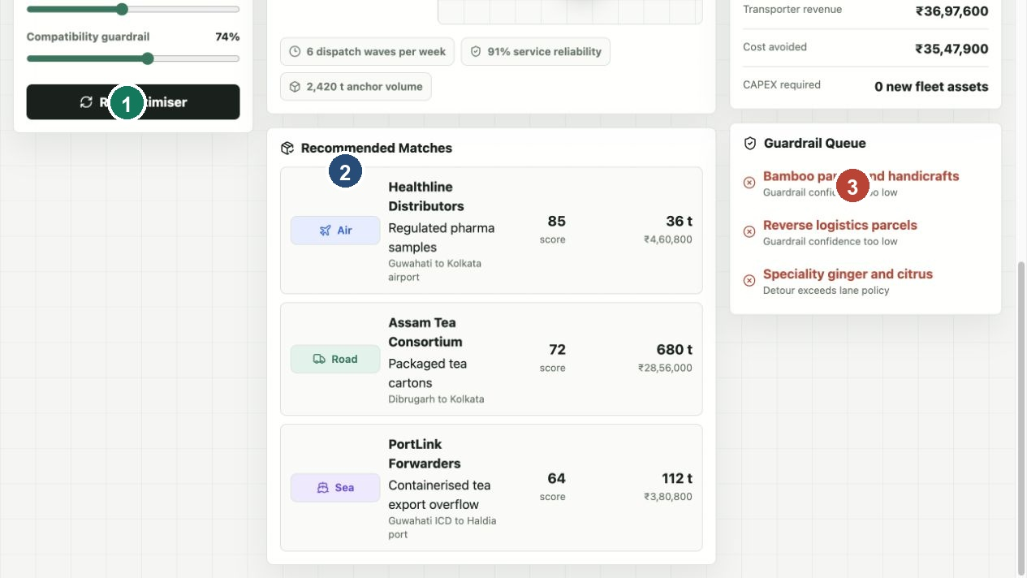
Figure 2 Recommended matches and capacity decisions after optimisation.

How To Talk About The AI Engine Roadmap
Position the current app as version one of the decision engine. It already demonstrates the logic pattern: data in, rules and scores applied, matches accepted, KPIs produced. The production AI engine would make this deeper by adding mathematical optimisation, prediction models and real time re-planning.
Layer | Production Role | Example
Data layer | Stores shipments, vehicles, hubs, routes, rates, GPS and carrier history | PostgreSQL plus PostGIS instead of CSV files
Rule engine | Blocks impossible or unsafe matches | Do not mix food cargo with hazardous cargo
Scoring engine | Ranks feasible matches by business value and risk | Higher score for lower detour and higher reliability
Optimisation solver | Selects the best portfolio of assignments | Google OR Tools for vehicle routing and capacity assignment
Prediction models | Forecast demand, ETA, cancellation risk and price | Predict Northeast backhaul cargo availability next week
Explainability layer | Explains each accepted or rejected recommendation | Rejected because detour exceeds lane policy
Learning loop | Improves scores using actual execution outcomes | Carrier cancellations reduce future reliability score

Recommended production architecture:
Frontend React app
-> FastAPI backend
-> data repositories
-> compatibility rules
-> feature builder
-> scoring engine
-> optimisation solver
-> KPI calculator
-> explanation service
-> response returned to KPI cards, route map and match list

Airport Retail Extension
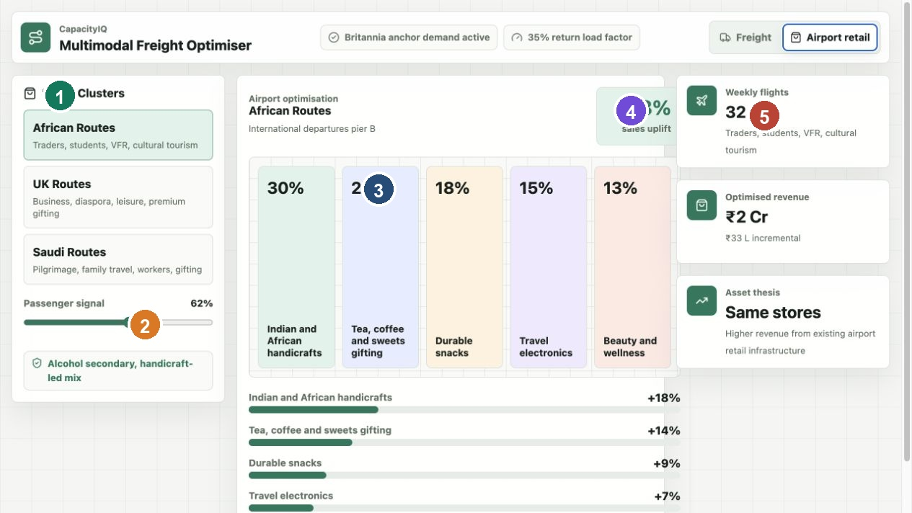
Figure 3 Airport retail workspace with route clusters, passenger signal and assortment allocation.
This part of the app uses the same asset utilisation idea in a different setting. Instead of freight capacity, the underused asset is existing airport retail infrastructure. The app changes route clusters, passenger signals and assortment allocation to estimate revenue uplift from the same stores.
- Select a route cluster, such as African routes, UK routes or Saudi Arabian routes.
- Move the passenger signal slider to show how higher passenger confidence changes expected uplift.
- Point to the store layout to explain that shelf space and assortment are being rebalanced, not expanded through heavy CAPEX.
- State that compliance still matters. The right assortment depends on passenger profile, route, destination rules and product legality.

Competitor Positioning
Company Or Category | How They Work | How CapacityIQ Is Positioned
Delhivery | Integrated logistics operator with parcel, truckload, part truckload, warehousing and network execution | CapacityIQ is not trying to be only a logistics operator. It is a capacity optimisation and matching layer across operators.
Freight Tiger | Indian freight management and freight intelligence platform | Closest local comparison. CapacityIQ should differentiate through anchor demand, backhaul monetisation and multimodal expansion.
BlackBuck | Digital trucking and fleet ecosystem | CapacityIQ focuses on decisioning across shipper demand, capacity and multimodal movement rather than only trucking operations.
Uber Freight | Digital freight marketplace and TMS with shipper and carrier network | CapacityIQ has a similar marketplace idea, adapted to Indian anchor demand and fragmented backhaul corridors.
Flexport and Freightos | Global freight forwarding, booking, procurement and visibility platforms | CapacityIQ can borrow the digital freight platform model but focus more on utilisation of existing domestic and multimodal assets.
Oracle SAP Blue Yonder TMS | Enterprise transportation management systems | CapacityIQ can be lighter, more marketplace oriented and more focused on empty capacity monetisation.
Indian Railways | High volume rail freight infrastructure | CapacityIQ can complement rail by deciding when cargo should move by truck, rail, air, sea or a combination.

Questions You Are Likely To Get
Question | Best Answer
Is this real AI today? | Today it is a rules and scoring optimiser using backend data. That is the correct MVP foundation. The next step is adding OR Tools and ML models for ETA, demand, pricing and cancellation risk.
Are KPI cards real or random? | They are calculated from accepted shipment matches. The data is dummy CSV data for the demo, but the calculations are deterministic and traceable.
Why does the URL stay localhost:3000? | The browser serves the frontend at localhost:3000. The frontend calls the backend API at 127.0.0.1:8000 in the background using fetch requests.
Why do we need Britannia as anchor? | Anchor demand creates predictable base movement. That makes it easier to plan backhaul and attract complementary shippers and transporters.
What is the business model? | Commission on matched freight, SaaS subscription for optimisation, premium analytics, carrier marketplace fees and enterprise integrations.
What data is needed for production? | Shipment orders, vehicle capacity, GPS, carrier history, lane rates, transit times, hub capacity, service constraints and settlement data.
How is this different from Delhivery? | Delhivery executes logistics through its network. CapacityIQ optimises unused capacity across many networks and can work with multiple operators.
What is the first pilot? | Start with one anchor corridor, such as Northeast Backhaul, integrate real shipments and transporter capacity, then measure empty km avoided and revenue unlocked.

If Localhost Stops During The Demo
Use this as the fast recovery sequence. Do not spend more than two minutes debugging live; switch to screenshots and continue the story if needed.
1. Keep the terminal running. If it was closed, open a terminal in the project root.
2. Run npm run dev.
3. Open http://localhost:3000 for the app.
4. Open http://127.0.0.1:8000/api/health for backend health.
5. If the frontend loads but says browser fallback optimiser, refresh once after confirming the backend health endpoint is ok.
6. If the app still does not load, use the screenshots in this document and explain that the prototype is a local development build.
Useful checks from the project root:
npm run dev
lsof -nP -iTCP:3000 -sTCP:LISTEN
lsof -nP -iTCP:8000 -sTCP:LISTEN
curl http://127.0.0.1:8000/api/health

Close The Demo With This
CapacityIQ is built around a simple commercial thesis: do not buy more assets first, make existing assets work harder. Britannia can anchor predictable demand, the platform can find compatible return cargo, transporters earn more from the same vehicles, and shippers get better utilisation and cost efficiency. The current application proves the workflow with dummy backend data; the production path is to connect real data, replace greedy matching with a solver, add predictive models, and run a measured pilot on one corridor.

Suggested Next Steps After The Meeting
- Confirm the first pilot corridor and the anchor demand owner.
- Collect real shipment, capacity, route and rate data for four to eight weeks.
- Define success metrics: empty km reduction, load factor, revenue unlocked, service reliability and cost per tonne.
- Replace the heuristic optimiser with an OR Tools assignment and routing model.
- Add production integrations for shipment orders, carrier capacity, GPS, rates and settlement.

Appendix Current Technical Flow
File | Function In The Application
app/page.tsx | Main UI orchestration. Stores draft inputs, applies inputs when Run optimiser is clicked, renders KPIs and panels.
app/lib/api.ts | Calls backend endpoints for initial data and optimisation result.
app/lib/optimizer.ts | Browser fallback optimiser with the same scoring pattern as the backend.
backend/server.py | Local HTTP API. Serves health, data tables and POST /api/optimise.
backend/repository.py | Loads CSV files and shapes them into corridors, shipments, capacity, hubs, partners and retail profiles.
backend/optimizer.py | Scores shipments, applies guardrails, accepts matches and calculates KPI output.
backend/data/*.csv | Dummy but realistic dataset used for the demo.

