CapacityIQ Study Guide And FAQ
How to explain the application, the optimiser, action recommendations and the AI roadmap
This guide is written for a one hour meeting. It explains what the application does, how the new Action Recommendations panel answers the practical questions of product, quantity and route, how the current optimiser calculates outputs, and how to explain the production AI engine roadmap without overstating the prototype.
Main point. CapacityIQ is a decision support and capacity marketplace prototype. The application does not simply show numerical KPIs. It now turns the optimiser output into recommended operating actions: what cargo to move, how many tonnes to move, which mode to use, what route sequence to follow at corridor level, why the match was selected, and what impact it creates.

One Hour Study Plan
Time | What To Study | What You Should Be Able To Say
0 to 10 min | Business problem | Freight capacity is fragmented; empty return journeys create avoidable cost and lost revenue.
10 to 20 min | Application flow | The app starts with a corridor, anchor demand and policy inputs, then runs the optimiser.
20 to 35 min | Action recommendations | The app recommends product, quantity, route sequence, mode, reason and expected impact.
35 to 45 min | Calculation logic | The current engine uses data, scoring, rules, capacity limits and KPI calculations.
45 to 55 min | AI roadmap | Production AI adds routing engines, OR Tools, prediction models and live replanning.
55 to 60 min | FAQs | Prepare honest answers about what is real today and what needs production integration.

What The Application Is For
The application demonstrates how an anchor shipper such as Britannia can create predictable freight demand, and how that predictable demand can be used to discover complementary cargo for return journeys. The goal is to increase utilisation of existing transport assets instead of buying more assets.
- For Britannia. Reduce freight cost per unit, improve distribution efficiency and monetise unused capacity around existing movements.
- For transporters. Reduce empty running and earn incremental revenue from the same vehicles.
- For other shippers. Access available capacity on corridors where compatible vehicles are already moving.
- For the platform. Create a network effect as more shippers and transporters improve matching density.

How The App Now Suggests What To Do
The new Action Recommendations panel converts optimiser results into operational instructions. This is the part to point to when someone asks whether the app only takes numeric inputs and gives numeric outputs.
Question | Where The App Answers It | How It Is Calculated
What product should move? | Action headline and cargo name | Selected from accepted shipment demand after scoring and guardrails.
How much should move? | Quantity in tonnes | Minimum of shipment demand and remaining capacity in that mode.
Which mode should be used? | Road, air, sea or staging chip | Taken from shipment mode and constrained by available mode capacity.
Which route should be followed? | Route sequence | Generated from shipment origin, corridor return lane nodes and shipment destination.
Why was it selected? | Why bullets | Score, detour, compatibility, service window and reliability.
What is the impact? | Impact metrics | Revenue, empty km avoided and mode capacity share calculated from the selected match.

Example operating recommendation:
Move 680 t of packaged tea cartons by road
Route: Dibrugarh -> Guwahati -> Siliguri -> Kolkata
Instruction: Assign the load to return truck capacity on the Northeast return lane.
Why: high score, acceptable detour, dry/ambient compatibility, reliable pickup window.
Impact: incremental revenue, reduced empty km and measurable capacity utilisation.
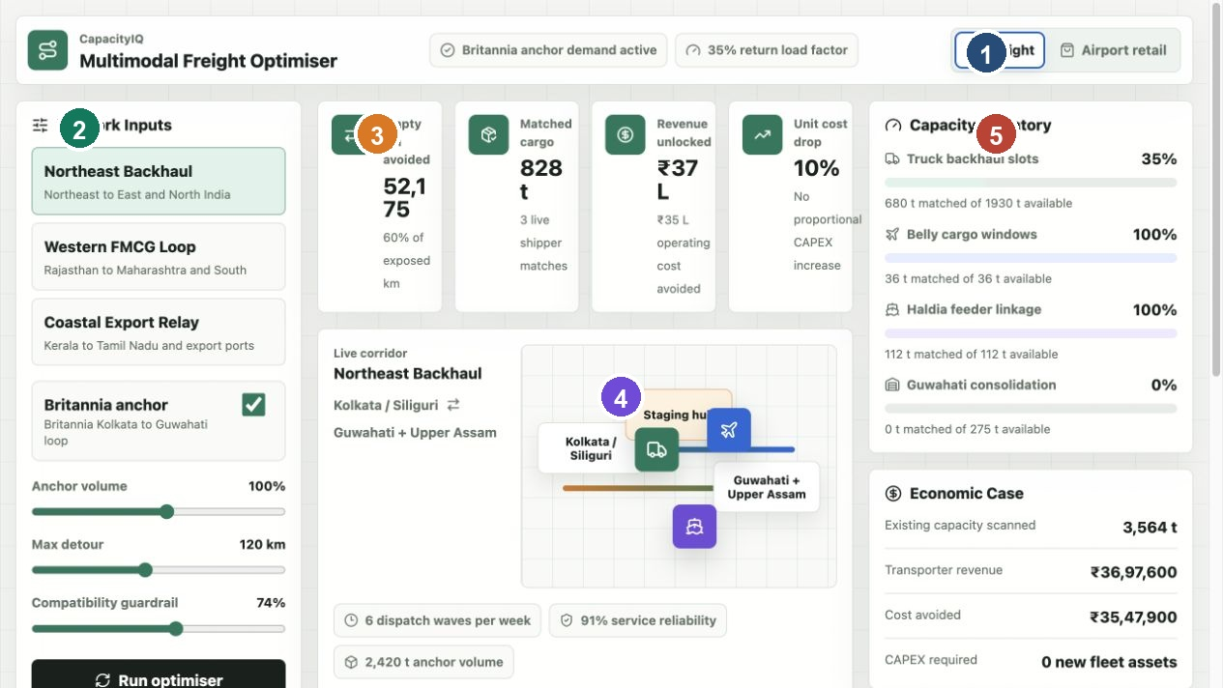
Freight workspace showing corridor inputs, KPI cards, route map and capacity inventory.
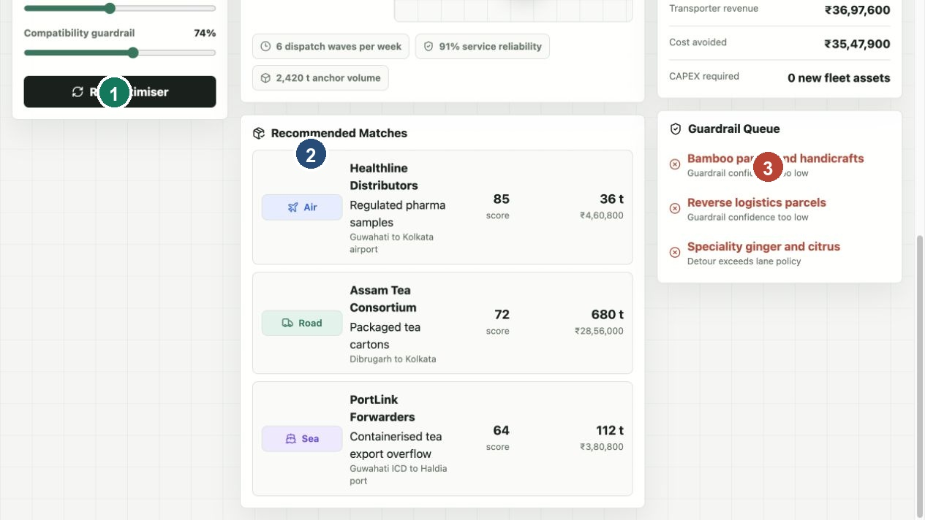
Recommended matches and guardrail decisions used by the action recommendation layer.

Current Optimiser Logic In Simple Language
1. Load backend data. The backend reads CSV tables for corridors, capacity, shipments, hubs, partners and retail profiles.
2. Apply scenario inputs. The selected corridor, anchor volume, detour policy and compatibility guardrail define the run.
3. Calculate available capacity. The optimiser calculates available tonnes by mode and keeps an operating reserve.
4. Score each shipment. Every candidate shipment receives a score based on route fit, reliability, compatibility, revenue and urgency.
5. Reject bad matches. Cargo can be declined if there is no capacity, if detour exceeds policy, or if compatibility confidence is too low.
6. Accept best matches. The engine sorts by score and accepts full or partial tonnes until bookable capacity is used.
7. Build action recommendations. The accepted matches become operating instructions with route sequence, quantity, reason and impact.
8. Calculate KPIs. The KPI cards are calculated from accepted matches, not manually typed numbers.
Current scoring formula:
score =
route fit * 32
+ reliability fit * 24
+ compatibility fit * 22
+ revenue fit * 15
+ urgency fit * 7
- guardrail penalty

How Quantity And Route Are Chosen
Decision | Current Prototype Method | Production Upgrade
Quantity | matched tonnes equals the lower value between shipment tonnes and remaining mode capacity | Use SKU volume, pallet count, axle limits, cube utilisation and vehicle level constraints.
Route | corridor level route sequence built from shipment origin, corridor nodes and destination | Use OSRM, Google Maps, Mapbox or OR Tools to produce exact roads, distance, tolls, ETA and stops.
Mode | shipment mode and mode capacity determine road, air, sea or staging | Optimise mode choice dynamically based on cost, SLA, emissions and capacity.
Reason | score, detour, compatibility, reliability and service window | Add learned cancellation risk, carrier performance, traffic, weather and predicted delay.
Impact | revenue, empty km avoided and capacity share | Add margin, carbon impact, service penalty, detention and settlement outcomes.

What To Say In The Demo
- The left panel controls the scenario: corridor, anchor volume, detour tolerance and compatibility strictness.
- The KPI cards summarise the economic result of the selected assignments.
- The route map is currently a corridor level visual, not a turn by turn GPS map.
- The Action Recommendations panel is the operating answer: product, quantity, mode, route sequence, reason and impact.
- The Recommended Matches list is the lower level shipment evidence behind the action cards.
- The Guardrail Queue shows that the app rejects risky or unsuitable cargo instead of accepting everything.

Production AI Engine Roadmap
Layer | Purpose | Examples
Data platform | Bring all logistics signals into one model | Orders, trucks, GPS, hubs, rates, SLAs, invoices and historical outcomes.
Rules engine | Protect hard business constraints | No hazardous cargo with food, cold chain only for chilled goods, legal and route restrictions.
Prediction models | Forecast uncertain variables | ETA, demand, price, cancellation risk, delay risk and capacity shortage.
Optimisation solver | Choose best portfolio of assignments | Google OR Tools or Pyomo for assignment, routing and scheduling.
Routing engine | Produce actual route paths | OSRM, Mapbox, Google Maps, toll APIs and traffic feeds.
Marketplace layer | Match shipper demand to transporter capacity | Tendering, pricing, booking confirmation and dispute workflow.
Explanation layer | Make decisions understandable | Accepted because revenue is high, detour is low and cargo is compatible.

Competitor Positioning
Category | Examples | Positioning
Logistics operators | Delhivery and other network operators | They execute logistics. CapacityIQ is positioned as a capacity optimisation layer that can work across multiple operators.
Indian freight platforms | Freight Tiger, BlackBuck, Porter, LetsTransport | Closest comparison. CapacityIQ should emphasise anchor demand, backhaul monetisation and multimodal routing.
Global freight platforms | Uber Freight, Flexport, Freightos | Similar digital freight ambition, but CapacityIQ is framed around Indian corridor utilisation and anchor shippers.
Enterprise TMS | Oracle, SAP, Blue Yonder | Heavier enterprise systems. CapacityIQ can be lighter, marketplace led and focused on unused capacity.
Rail and multimodal infrastructure | Indian Railways, ports and air cargo networks | Not a replacement. CapacityIQ can decide when to use truck, rail, air, sea or a combination.

FAQs For The Meeting
Question | Answer
Is this production AI today? | No. It is a working MVP with backend data, deterministic scoring, guardrails, matching and KPI calculations. Production AI would add route engines, solvers and ML models.
Does it actually suggest what to do? | Yes. The new Action Recommendations panel says what cargo to move, how much to move, which mode to use, which route sequence to follow, why it was selected and what impact it creates.
Is the route exact? | Today it is corridor level. It is good for demoing the decision logic. Exact road paths, hub stops, tolls and ETAs require map and routing integration.
Where does the quantity come from? | The backend shipment data contains tonnes. The optimiser matches the lower of shipment demand and remaining capacity.
Are KPI cards random? | No. They are calculated from accepted matches. The dataset is dummy demo data, but the calculation is deterministic.
Why do numbers change after Run optimiser? | Inputs are draft until Run optimiser is clicked. Clicking applies the scenario and calls the backend optimiser.
What does compatibility guardrail mean? | It is a risk control. A stricter guardrail rejects more cargo types that may be incompatible with the corridor or anchor freight.
Why is Britannia important? | Britannia creates predictable base demand. Predictability makes it easier to find backhaul cargo and attract transporters.
How is this different from Delhivery? | Delhivery executes logistics through its own and partner network. CapacityIQ optimises unused capacity across many networks.
What is the first pilot? | Use one corridor, such as Northeast Backhaul, connect real shipment and vehicle data, and measure empty km avoided, revenue unlocked and service reliability.
What data is needed for production? | Shipment orders, vehicle availability, GPS, rates, lane history, hubs, loading constraints, service windows and carrier performance.
Can it handle air and sea? | The prototype includes air, sea and staging modes. Production would need integrations with air cargo capacity, ports, sailing schedules and booking systems.
How does the business make money? | Possible models include SaaS fee, transaction fee, marketplace commission, premium analytics and enterprise integration fees.
What is the biggest limitation today? | The current route map is not a real map engine and the optimiser is heuristic rather than a mathematical solver.
What is the next technical step? | Replace greedy matching with OR Tools, connect live data, and add real routing APIs for exact route recommendations.

Strong Closing Statement
The core idea is simple: do not buy more assets first, make existing assets work harder. CapacityIQ uses anchor demand, shipment data, capacity data and optimisation logic to convert unused freight capacity into actionable recommendations. The prototype proves the decision flow. The production product would connect real data sources, exact routing, mathematical optimisation and machine learning to make the recommendations operational at scale.

Appendix Technical File Map
File | Role
app/page.tsx | Renders the application and the new Action Recommendations panel.
app/lib/types.ts | Defines the RecommendedAction and optimisation response shape.
app/lib/optimizer.ts | Browser fallback optimiser and recommendation builder.
backend/optimizer.py | Backend scoring, matching, KPI calculation and recommendation builder.
backend/server.py | Local API server exposing POST /api/optimise.
backend/repository.py | CSV data loading and shaping.
backend/data/*.csv | Dummy but realistic demo dataset.

