CapacityIQ Complete Application Walkthrough Architecture And FAQ
A practical study manual for using the freight and airport retail optimisation application, explaining the product purpose, every major screen, backend APIs, code architecture, function responsibilities, and common questions for a one hour meeting.
Prepared for product demonstration and technical review. Generated on 22 September 2026.
Reader Need | Where To Look
Quick demo | Sections 4 to 9
Explain business value | Sections 2, 3, 10 and 18
Explain how the optimiser works | Sections 11, 12 and 13
Explain APIs and code | Sections 14 to 17
Prepare answers | Sections 19 and 20
Main conclusion: the application is a local full stack prototype that shows how existing transport and retail assets can produce more output when demand, capacity, constraints and recommendations are matched by software instead of being handled in isolated spreadsheets.

1 How To Use This Manual
This manual is written for a business and technical walkthrough. It can be read from start to finish before a meeting, or used as a live reference while demonstrating the app.
Time Available | Study Path
10 minutes | Read purpose, freight workflow, Run optimiser, and FAQs 1 to 8.
30 minutes | Read the freight workspace, airport retail workspace, AI engine, API map, and demo script.
60 minutes | Read the complete manual and practise the meeting flow in Section 18.

What You Should Be Able To Explain
- Why the platform exists and what business problem it solves.
- How the freight workspace turns capacity and demand into recommended actions.
- Why the browser URL remains localhost port 3000 while the backend still fetches data from port 8000.
- How the current optimiser scores shipments, allocates capacity and creates route instructions.
- Which parts are real code today and which parts are future production AI enhancements.

2 Purpose Of The Application
CapacityIQ is a prototype for an AI powered freight and capacity optimisation marketplace. The core idea is simple: many freight assets already exist, but their capacity is not always used fully. Trucks may return empty, flights may have unused belly cargo space, staging hubs may have available buffer capacity, and sea feeder capacity may be underused.
The application demonstrates a platform layer that can match cargo demand with available capacity across road, air, sea and staging modes. Britannia is modelled as an anchor demand partner because recurring base freight creates a predictable network that other shipments can attach to.
Problem | Application Response
Empty truck return journeys | Find compatible backhaul cargo after the anchor delivery.
Fragmented cargo demand | Bring shipper demand into one corridor level marketplace.
Mode specific spare capacity | Compare road, air, sea and staging availability in one place.
No clear operating instruction | Show action cards with cargo, quantity, route and reason.
CAPEX pressure | Improve utilisation before buying new fleet or infrastructure.

3 Business Value And Strategic Utility
The application is useful because it connects business outcomes to operational decisions. Instead of only showing a dashboard of numbers, it shows what the user should do next: which cargo should move, by which mode, how much capacity should be used, and which route sequence should be followed.
Stakeholder | Utility
Anchor shipper | Reduces freight cost per unit and improves return lane economics.
Third party shipper | Gets access to available capacity that might otherwise be hard to discover.
Transporter | Earns additional revenue from return or partial capacity.
Airport retailer | Uses passenger route signals to improve product allocation.
Leadership team | Sees a CAPEX light route to top line and margin improvement.
The thesis to communicate in a demo is not that the current prototype is already a production TMS. The thesis is that a marketplace and optimisation layer can sit above existing assets and make them work harder.

4 Application Landing And Main Navigation
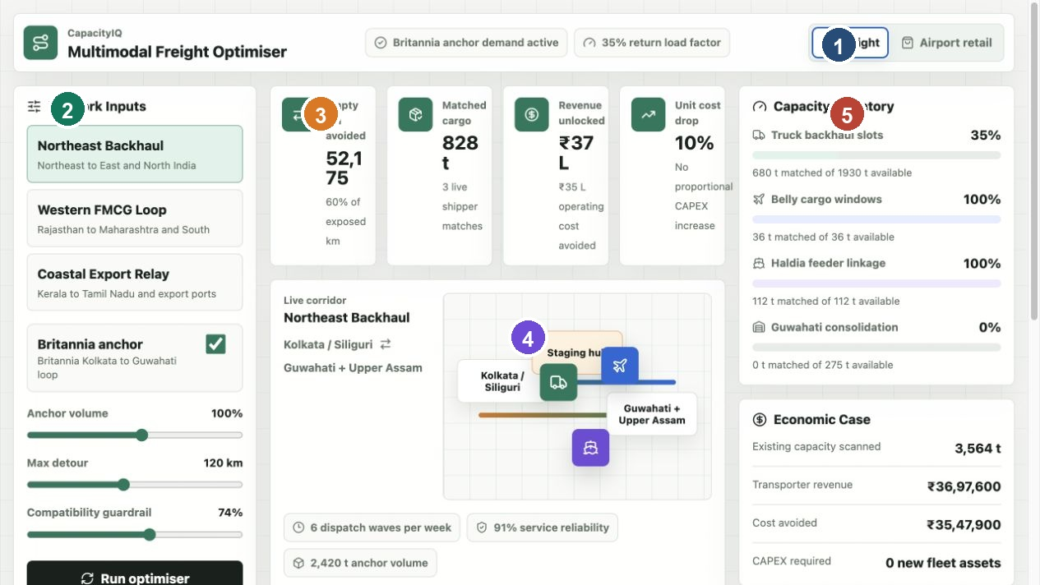
Figure 1 Freight workspace with navigation, network inputs, KPI cards, route map and right rail
The top of the application has a command bar. On the left it identifies the product. On the right it shows live status such as whether Britannia anchor demand is active, the current return load factor, the number of CSV shipments loaded, and whether the backend optimiser is active.
Screen Area | How To Use It
Freight tab | Use this for multimodal freight and backhaul optimisation.
Airport retail tab | Use this for route based product assortment optimisation.
Network Inputs | Change the corridor, anchor demand, volume, detour and guardrail assumptions.
Run optimiser | Applies the visible draft inputs and calls the backend optimiser.
Right rail | Reads capacity utilisation, economics and exception queue.

5 Freight Workspace Walkthrough
The freight workspace is the main demonstration area. It uses the selected corridor and backend CSV data to calculate matches, metrics, recommended actions and capacity utilisation.

Step By Step Usage
1. Open localhost port 3000 and confirm the top status says the backend optimiser is active.
2. Stay on the Freight tab.
3. Choose a corridor from the Network Inputs list. For the Northeast demo, choose Northeast Backhaul.
4. Keep Britannia anchor enabled to show the anchor demand story.
5. Move Anchor volume to model stronger or weaker recurring Britannia demand.
6. Move Max detour to make the optimiser more or less flexible on route deviation.
7. Move Compatibility guardrail to make the optimiser more or less strict about cargo compatibility.
8. Click Run optimiser after changing inputs.
9. Read the KPI cards, route map, action recommendations, matches, capacity inventory and guardrail queue.
Important behaviour: sliders are draft inputs. They do not become the committed optimisation scenario until Run optimiser is selected. This prevents accidental changes from being confused with the last official scenario.

6 Network Inputs Explained
Input | Meaning | What Happens When Changed
Corridor | The operating lane being analysed. | Changes the source capacity, shipment pool, route map and anchor assumptions.
Britannia anchor | Whether the anchor demand base is active. | Enabled uses normal anchor factor; disabled reduces the model to a smaller demand base.
Anchor volume | Multiplier for base anchor tonnes. | Higher volume increases adjusted capacity and anchor tonnes in the scenario.
Max detour | Maximum route deviation allowed for most modes. | Lower values reject more shipments; higher values allow more flexible matching.
Compatibility guardrail | Confidence and cargo compatibility strictness. | Higher values reject more risky cargo and reduce accepted matches.
Run optimiser | Scenario submission action. | Copies draft inputs into applied inputs and posts them to the backend.
For a live demo, change one input at a time. This makes it easier to explain why the output changed. For example, first lower Max detour and show that more shipments move into the guardrail queue. Then raise it again and show that accepted matches increase.

7 KPI Cards Explained
The four KPI cards translate optimisation into business outcomes. They are not manually typed values. They are produced from the optimiser response.
KPI | How To Interpret It
Empty km avoided | Estimated empty kilometres reduced by assigning cargo into otherwise unused capacity.
Matched cargo | Total tonnes accepted from candidate shipments into available bookable capacity.
Revenue unlocked | Matched tonnes multiplied by shipment revenue per tonne.
Unit cost drop | Estimated drop in freight unit cost based on better load factor versus baseline.
These cards answer the senior level question: is the platform increasing utilisation and economics without buying new assets?

8 Route Map And Live Corridor
The route map is a visual summary of the selected corridor. It is not a real GPS map in the current prototype. It shows the flow pattern between origin, staging hub and destination, with road, air and sea symbols moving across the corridor.
Element | Meaning
Origin node | Where anchor or corridor freight starts.
Staging hub | Consolidation or resting area where cargo may be buffered.
Destination node | Where anchor delivery or return lane demand is represented.
Moving icons | Visual indication that multiple transport modes are considered.
Route facts | Dispatch frequency, service reliability and anchor volume.
For production, this section can be connected to a real routing service that calculates roads, tolls, travel time, fuel, weather risk, hub cut off time and GPS based ETA.

9 Action Recommendations
Action Recommendations are the most important improvement because they answer the earlier concern that the app only showed numerical input and output. The backend now converts accepted shipments into operating instructions.
Question | How The App Answers
What should move? | The headline states the cargo type and matched tonnes.
How much should move? | The quantity is the accepted matched tonnes after capacity and guardrail checks.
Which mode? | The mode chip identifies truck, air cargo, sea feeder or staging.
Which route? | Route chips show a sequence from shipment origin through corridor nodes to destination.
Why this move? | Reason lines show score, detour fit, compatibility and service window.
What is the impact? | Revenue, empty kilometres avoided and capacity share are shown on the action card.
Example explanation in a demo: the optimiser has selected this cargo because it fits the corridor, clears the guardrail, uses available mode capacity, stays within detour policy and creates revenue from a capacity slot that might otherwise be wasted.

10 Recommended Matches And Guardrail Queue
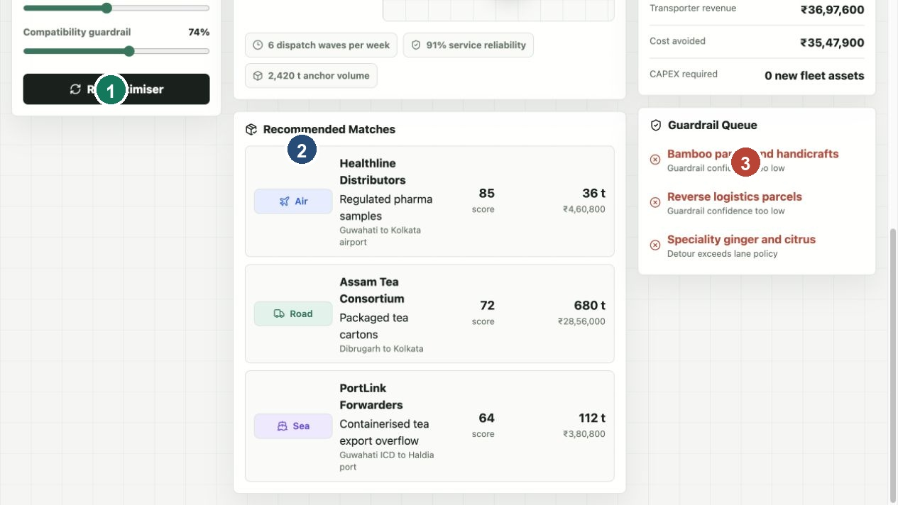
Figure 2 Recommended matches and guardrail queue
Recommended Matches show the strongest accepted shipments from the active dataset. Each row includes mode, shipper, cargo, origin to destination, score, matched tonnes and revenue.
Area | Purpose
Recommended Matches | Shows accepted cargo opportunities ranked by score.
Score | A compact indication of route fit, reliability, compatibility, revenue and urgency.
Economics | Shows matched quantity and revenue for each shipment.
Guardrail Queue | Shows shipments that did not pass capacity, detour or confidence rules.
Rejected reason | Explains why a shipment is not selected, such as no capacity or detour too high.

11 Capacity Inventory And Economic Case
The right rail shows how the active scenario uses available capacity. This is where you can explain why all capacity should not be forced to 100 percent. Real operations need reserve capacity for slot variance, loading uncertainty, service failures, exceptions and last minute priority freight.
Right Rail Component | Explanation
Truck backhaul slots | Road capacity available for return or compatible loads.
Belly cargo windows | Urgent or premium air cargo capacity.
Port feeder linkage | Sea or coastal feeder capacity for bulk and export oriented moves.
Consolidation buffer | Staging capacity for cargo that needs timing alignment.
Economic Case | Shows total scanned capacity, transporter revenue, cost avoided and CAPEX required.
Guardrail Queue | Shows rejected or reviewable shipments for governance.
When asked why capacity is not always fully used, explain that the optimiser uses bookable capacity below total available capacity. The difference is an operating reserve.

12 Airport Retail Workspace
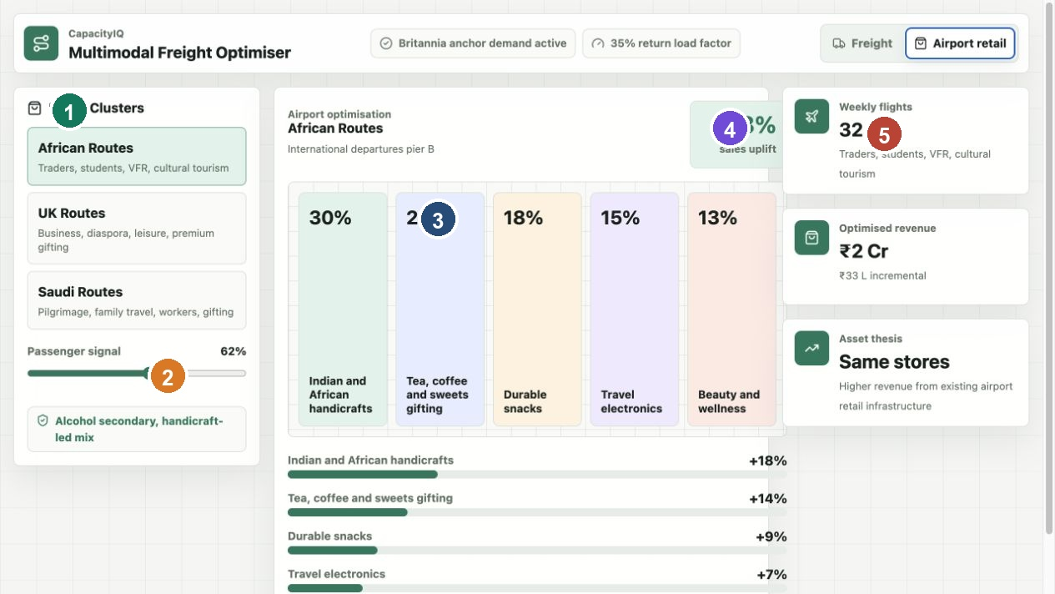
Figure 3 Airport retail workspace with route clusters, product allocation and uplift metrics
The airport retail workspace applies the same optimisation idea to retail infrastructure. Instead of buying more stores, the application changes product mix based on passenger routes, route clusters and demand signals.
Functionality | How To Use It
Route clusters | Select the passenger group, such as African routes, UK routes or Saudi Arabian routes.
Passenger signal | Move the slider to model stronger or weaker passenger demand.
Product allocation | Review recommended space share by product category.
Sales uplift | Read the expected uplift from better assortment matching.
Compliance text | Read the compliance note for destination appropriate assortment decisions.
In a demo, position airport retail as a second proof of the core principle: increase output from existing assets through better matching of demand and capacity.

13 How Run Optimiser Works
Run optimiser is not just a visual refresh. It commits the draft network inputs and sends them to the backend endpoint. The frontend then waits for the backend result and updates the KPI cards, action recommendations, matches, capacity inventory and guardrail queue.
1. The user changes draft controls in the left panel.
2. The app compares draft inputs to the last applied inputs using sameNetworkInputs.
3. The Run optimiser button becomes active only when there is a difference.
4. On click, page.tsx copies draftNetworkInputs into appliedNetworkInputs.
5. The backend optimisation effect calls fetchBackendOptimization.
6. fetchBackendOptimization posts the inputs to /api/optimise.
7. backend/server.py validates the request and finds the corridor.
8. backend/optimizer.py scores shipments, allocates bookable capacity and builds action recommendations.
9. The frontend renders the returned result.
If the backend is unavailable, the browser fallback optimiser in app/lib/optimizer.ts produces a smaller local result so the UI still works for demonstration.

14 Current AI Engine Logic
The current engine is a deterministic optimisation heuristic. It is AI shaped in product behaviour because it makes recommendations from data, but it is not yet a machine learning model or mathematical solver. This is appropriate for a prototype because it is explainable and easy to demo.
Stage | What Happens
Capacity preparation | Available capacity is calculated per mode from capacity tonnes, available percent and anchor factor.
Reserve setting | Bookable capacity is set below available capacity using mode target fill.
Shipment scoring | Each candidate shipment gets a score from route fit, reliability, compatibility, revenue and urgency.
Guardrail filtering | Shipments are rejected if confidence is too low, cargo is too risky, or detour exceeds policy.
Allocation | Accepted shipments consume remaining bookable capacity by mode.
Metrics | The engine calculates matched tonnes, revenue, empty kilometres avoided, cost saved and load factor.
Action building | Accepted matches are converted into route and operating instructions.
A future production AI engine can replace or extend this heuristic with a solver, prediction models and live integrations while keeping the same output contract.

15 Backend API Reference
Method | Endpoint | Utility
GET | /api/health | Checks service health and returns dataset counts and endpoint list.
GET | /api/tables | Returns row counts and total capacity across CSV tables.
GET | /api/corridors | Returns all corridors with nested capacity and shipment rows.
GET | /api/corridors/{id} | Returns one corridor by ID.
GET | /api/shipments?corridor_id=northeast&limit=50 | Returns paginated shipments, optionally filtered by corridor.
GET | /api/capacity?corridor_id=northeast | Returns capacity rows by corridor or across all corridors.
GET | /api/retail-profiles | Returns airport retail profiles and assortment rules.
GET | /api/hubs?limit=50 | Returns hub, staging, dock and reliability rows.
GET | /api/partners?limit=50 | Returns partner records for transporters, warehouses, shipping and air cargo.
POST | /api/optimise | Runs the freight optimiser using selected network inputs.
POST | /api/optimize | Same optimiser endpoint with US spelling.
The app normally stays on localhost port 3000 because React fetches API data in the background. The browser does not navigate to port 8000 during API calls.

16 Optimiser Request And Response
A typical optimiser request includes corridorId, anchorEnabled, anchorMultiplier, maxDetour and guardrail. These values come from the left control panel in the freight workspace.
Request Field | Purpose
corridorId | Selects the corridor, such as northeast.
anchorEnabled | Controls whether Britannia anchor demand is active.
anchorMultiplier | Scales base anchor tonnes.
maxDetour | Sets detour policy in kilometres.
guardrail | Sets matching strictness and compatibility threshold.
Response Field | Meaning
accepted | Accepted shipment matches.
declined | Rejected or reviewable shipments.
recommendedActions | Business readable cargo, quantity, route, mode and reason instructions.
remaining | Remaining capacity by mode.
modeUtilisation | Mode level available, bookable, used, reserve and utilisation values.
matchedTonnes | Total accepted tonnes.
revenue | Matched tonnes times revenue per tonne.

Response Fields Continued
Response Field | Meaning
emptyKmAvoided | Estimated empty kilometres avoided by using capacity.
costSaved | Empty kilometres avoided times assumed operating cost per kilometre.
loadFactor | Matched tonnes divided by adjusted capacity.
unitCostDrop | Estimated unit cost improvement.
anchorTonnes | Effective anchor tonnes in the scenario.

17 Data Model And Dummy Data
The backend data lives in CSV files so it is easy to inspect and replace. The seed script creates enough rows to feel like a realistic pilot dataset.
CSV File | Rows | Utility
corridors.csv | 12 | Defines lanes, anchor assumptions, distance, vehicles and reliability.
capacity.csv | 48 | Defines road, air, sea and staging capacity by corridor.
shipments.csv | 2400 | Defines candidate cargo loads to match into capacity.
hubs.csv | 42 | Defines consolidation hubs, docks, staging tonnes and reliability.
partners.csv | 144 | Defines transporters, 3PLs, air cargo partners, warehouses and shipping partners.
retail_profiles.csv | 8 | Defines airport route clusters and base revenue.
retail_assortments.csv | 40 | Defines product allocation and uplift assumptions.
The seed script is deterministic. Running npm run seed:data regenerates the same style of dataset so demos are repeatable.

18 Project Architecture
The application is split into a React TypeScript frontend and a Python CSV backed API. The frontend owns interaction and display. The backend owns data loading, endpoint routing and freight optimisation.
Folder Or File | Utility
app/page.tsx | Main screen orchestration, state, data loading, tabs and rendered dashboard sections.
app/components/Metric.tsx | Reusable KPI card component.
app/data/fallback-data.ts | Small browser fallback dataset.
app/lib/api.ts | Frontend API client for initial data and backend optimiser.
app/lib/config.ts | API base URL, default network inputs and mode target fill settings.
app/lib/formatters.ts | Indian rupee formatting helpers.
app/lib/mode-meta.ts | Mode labels, icons and CSS class names.
app/lib/optimizer.ts | Browser fallback scoring and optimisation logic.
app/lib/types.ts | Shared TypeScript domain types.
app/globals.css | Dashboard layout, styling and responsive rules.
backend/server.py | HTTP API server and endpoint routing.
backend/repository.py | CSV loading and data shaping.
backend/optimizer.py | Backend scoring, allocation, metrics and action recommendations.
backend/config.py | Data directory, compatibility weights, reserve settings and endpoint list.
backend/utils.py | Parsing and pagination utilities.
scripts/seed_dummy_data.py | Dataset generator.
scripts/start-local.sh | Starts backend and frontend together.

19 Frontend Function Utility
Function Or Object | File | Utility
Home | app/page.tsx | Owns app state, tabs, data loading, optimiser calls and layout rendering.
loadBackendData | app/page.tsx | Calls initial backend data fetch and stores corridors, retail profiles and summary.
draftNetworkInputs | app/page.tsx | Collects current visible controls before they are applied.
hasPendingNetworkInputs | app/page.tsx | Determines whether Run optimiser should be enabled.
fallbackOptimization | app/page.tsx | Runs browser fallback optimisation when backend is not available.
loadBackendOptimization | app/page.tsx | Posts applied inputs to backend and stores optimisation result.
modeUtilization | app/page.tsx | Builds right rail capacity rows from backend mode utilisation.
recommendedActions | app/page.tsx | Feeds the Action Recommendations panel.
fetchInitialDashboardData | app/lib/api.ts | Fetches corridors, retail profiles and health in parallel.
fetchBackendOptimization | app/lib/api.ts | Posts freight controls to /api/optimise and returns result.
sameNetworkInputs | app/lib/config.ts | Compares draft and applied inputs.
formatCurrency | app/lib/formatters.ts | Formats rupee amounts.
formatShortCurrency | app/lib/formatters.ts | Formats lakh and crore values.
Metric | app/components/Metric.tsx | Displays a KPI card with icon, label, value and delta.

20 Optimisation Function Utility
Function | Location | Utility
routeAnchorNode | app/lib/optimizer.ts and backend/optimizer.py | Extracts the primary corridor node from labels such as Kolkata / Siliguri.
routeAnchorNodes | app/lib/optimizer.ts and backend/optimizer.py | Splits compound corridor labels into route nodes.
routeNodesFor | app/lib/optimizer.ts and backend/optimizer.py | Builds route sequence for road, air, sea or staging recommendations.
instructionFor | app/lib/optimizer.ts and backend/optimizer.py | Creates mode specific operating instructions.
buildRecommendedActions | app/lib/optimizer.ts and backend/optimizer.py | Creates recommendation cards from accepted shipments.
scoreShipment | app/lib/optimizer.ts and backend/optimizer.py | Calculates score from route fit, reliability, compatibility, revenue and urgency.
optimizeCorridor or optimise_corridor | app/lib/optimizer.ts and backend/optimizer.py | Allocates capacity, accepts or declines shipments, calculates metrics and returns result.
The backend implementation is the source of truth when the API is running. The TypeScript version exists so the UI can still demonstrate behaviour without the backend.

21 Backend Function Utility
Function Or Class | File | Utility
read_csv_table | backend/repository.py | Reads one CSV table from backend/data.
load_dataset | backend/repository.py | Loads and shapes all CSV data into nested API objects.
dataset_summary | backend/repository.py | Returns counts and total scanned capacity.
find_corridor | backend/repository.py | Finds one corridor by ID.
CapacityIQHandler | backend/server.py | HTTP request handler class.
_send_json | backend/server.py | Serialises responses and adds CORS headers.
do_OPTIONS | backend/server.py | Handles browser preflight requests.
do_GET | backend/server.py | Routes read endpoints.
do_POST | backend/server.py | Routes optimiser endpoints.
log_message | backend/server.py | Controls request logging.
run | backend/server.py | Starts ThreadingHTTPServer.
main | backend/server.py | Parses host and port CLI arguments.
as_int | backend/utils.py | Safely converts input to integer.
as_float | backend/utils.py | Safely converts input to float.
parse_limit | backend/utils.py | Parses and caps API limit parameter.
apply_limit | backend/utils.py | Applies offset and limit to row lists.

22 Data Generation And Test Utility
Function Or Command | Utility
write_csv | Writes generated rows to CSV with stable headers.
make_capacity_rows | Creates mode capacity for every corridor.
make_shipments | Creates candidate cargo records with realistic variation.
make_hubs | Creates staging and consolidation hub rows.
make_partners | Creates partner records for the marketplace.
make_retail_rows | Creates retail route clusters and assortment rules.
npm run test:backend | Runs backend tests for health, data and optimiser output.
npm run lint | Checks frontend code quality.
npm run build | Verifies the production frontend build.
These utilities make the demo repeatable. If a CSV is changed manually, rerun backend tests to confirm the optimiser still returns expected fields.

23 One Hour Demo Flow
Minute | Talking Point
0 to 5 | Introduce the thesis: do not buy more assets first, use existing capacity better.
5 to 10 | Explain Britannia as anchor demand and the Northeast backhaul example.
10 to 20 | Walk through Freight tab, network inputs and KPIs.
20 to 30 | Change detour or guardrail and click Run optimiser.
30 to 40 | Explain Action Recommendations, matches, capacity inventory and guardrail queue.
40 to 48 | Switch to Airport retail and explain route based assortment optimisation.
48 to 55 | Open API and architecture discussion.
55 to 60 | Close with production roadmap and business value.

Suggested Opening
This application shows how a company can increase output from existing logistics and retail assets. The freight side matches shipments into underused road, air, sea and staging capacity. The retail side applies the same idea to airport store assortment.

Suggested Closing
The prototype proves the operating logic. The next step is to connect live transporter, TMS, ERP, GPS, route, flight, port and POS data so the engine can move from scenario recommendation to operational execution.

24 Frequently Asked Questions
1 What is the app trying to solve?
It solves underused capacity across freight and retail. In freight, it reduces empty or partially used movements. In retail, it improves product allocation based on passenger route demand.
2 Why is Britannia shown as an anchor customer?
Britannia represents predictable recurring demand. Anchor demand creates a stable base corridor that makes it easier to attract complementary third party cargo.
3 Does the current app use real live data?
No. It uses a large dummy CSV dataset for demonstration. The architecture is designed so real ERP, TMS, GPS, airline, port and POS data can replace the CSV tables.
4 Is the backend actually used?
Yes. The frontend fetches corridors, retail profiles and health data at startup, then posts optimisation scenarios to /api/optimise. The browser URL stays on port 3000 because API calls happen in the background.
5 What does Run optimiser do?
It applies the visible freight inputs and calls the backend optimiser. The response updates KPIs, recommendations, matches, capacity inventory and queue results.
6 Why do metrics change when inputs change?
Draft values update the visible control state. The official backend result changes after Run optimiser applies the draft inputs. If fallback logic is active, the browser can calculate locally.
7 Why should capacity not always show 100 percent?
Real networks need operating reserves for delays, loading variance, cancellations, premium exceptions and service reliability. The optimiser uses bookable capacity below total available capacity.
8 How does the app decide what product should move?
It scores candidate shipments by route fit, reliability, compatibility, revenue and urgency, then accepts shipments that clear capacity and guardrail rules.
9 How does the app decide quantity?
Quantity is the matched tonnes accepted into remaining bookable capacity for that mode. If a shipment is larger than remaining capacity, it can be partially matched.
10 How does the app decide route?
The route is built from shipment origin, corridor nodes and shipment destination. Different route patterns are used for road, air, sea and staging.

25 More Frequently Asked Questions
11 Is this a replacement for Delhivery or other logistics operators?
No. It is a capacity marketplace and optimisation layer. Operators can become supply partners, while shippers use the platform to discover and allocate capacity.
12 How is this different from a normal logistics dashboard?
A normal dashboard reports what happened. This app also recommends what should happen next: cargo, quantity, mode, route and reason.
13 What is the guardrail queue?
It is a governance list for shipments that were rejected or need review because capacity was unavailable, detour was too high or confidence was too low.
14 What is the airport retail connection?
The same optimisation principle is applied to shop space. Passenger route demand influences product mix and expected sales uplift.
15 Can this become a real AI engine?
Yes. The current heuristic can evolve into a production engine with forecasting models, solver based optimisation, real time routing and live integrations.
16 Which optimisation libraries could be used later?
OR Tools, Pyomo, PuLP, NetworkX and specialised routing APIs can be used depending on vehicle routing, time windows and multimodal constraints.
17 What are the biggest production integrations?
ERP for orders, TMS for loads, GPS for vehicle status, WMS for inventory, airline cargo systems, port systems, payment systems and POS data.
18 What are the biggest business risks?
Data quality, transporter adoption, liability, cargo compatibility, service failures, contract terms and governance around third party cargo.
19 What should be the pilot?
Start with one anchor corridor such as Northeast backhaul, onboard selected transporters and shippers, and measure empty km avoided, matched tonnes, load factor and revenue.
20 What is the simplest way to explain the product?
It is an Uber like capacity optimiser for freight and adjacent assets. It matches unused capacity with demand and tells operators what to move, where, when and why.

26 Troubleshooting And Demo Readiness
Issue | What To Do
Browser says fallback data | Start backend with npm run dev or npm run dev:backend.
Port 3000 does not open | Check whether another frontend server is already running and restart the app.
Port 8000 does not respond | Start backend and test /api/health.
Run optimiser does not enable | Change at least one network input first.
Metrics look unexpected | Explain that guardrail, detour, anchor volume and mode reserves change accepted matches.
Capacity is not 100 percent | Explain operating reserve and reliability buffer.
No real map appears | Explain the prototype uses corridor visualisation and can be integrated with a routing engine later.

Final Demo Checklist
- Open localhost port 3000 before the meeting.
- Confirm the status bar says backend optimiser active.
- Start on Freight and select Northeast Backhaul.
- Practise changing Max detour and Compatibility guardrail.
- Point to Action Recommendations before discussing KPIs in depth.
- Switch to Airport retail only after the freight story is clear.
- Keep the architecture section ready for technical questions.

