Copilot CLI Sandbox – Credentials Test Procedure (STE)
Oct 26, 2026

Key findings
# | Finding | Severity | Test
1 | The real token is never visible in the sandbox. gh auth token and GH_TOKEN are a placeholder (gho_, length 49; the real token is length 40). A new placeholder is made for each command. git credential is EMPTY (Credential Manager not reachable). | Pass | CR-03
2 | A token sent to a non-GitHub host is only the placeholder (echo server: ON c6cdfcd131a7, OFF real 6edbf1466d5e). | Pass | CR-04
3 | git push fails in a SAML SSO org. The proxy injects the “GitHub Copilot CLI” OAuth token for git, which is not SSO-authorized for the org. gh works for the same private repo. Agents can read and open PRs with gh but cannot push. | High — blocks agent push in SSO orgs | CR-01, CR-12
4 | SSH git URLs are rewritten to HTTPS in the sandbox, then hit the same SSO 403. OFF uses real SSH. | Medium | CR-12
5 | Credential stores in the home folder are blocked (.npmrc, gh hosts.yml: Access is denied). | Pass | CR-11
6 | auth.git: false → push fails “unable to get password”. auth.gh: false → GH_TOKEN EMPTY and gh cannot start (config.yml Access is denied). | Pass + note | CR-05, CR-06
7 | A bypassed command gets the real login (keyring, real-length token). allowBypass must be false in the fleet. | High (policy) | CR-15
8 | The Copilot model refuses credential commands (Sonnet 5.5 and 5). Tests use ! commands, which run sandboxed without the model. | Test note | 7.1
Actions
- Org owners: approve the “GitHub Copilot CLI” OAuth app for each SSO org (Org settings → Third-party access). Then repeat CR-01. Raise with GitHub if push still fails.
- Fleet policy: allowBypass: false (managed), auth.git and auth.gh on.
- User FAQ: use HTTPS remotes; restart the terminal after you install a tool; with auth.gh: false, gh does not run in the sandbox.

1. Scope
This procedure tests the Credentials cases of the Test & Validation Plan on Copilot CLI, native Windows 11, build 26100.9711. The text uses ASD-STE100 Simplified Technical English.
- The built-in proxy decrypts HTTPS with a Copilot CA (NW-01).
- With auth.git / auth.gh on, the sandboxed process gets a placeholder token. The proxy replaces it with a real token only on requests to GitHub hosts.
In scope | Out of scope on this device
CR-01, CR-02, CR-03, CR-04, CR-05, CR-06, CR-11, CR-12, CR-15 | CR-07/08/09 custom masked variables (Ring 0). CR-10 (answered by NW-08). CR-13 (answered by NW-01). CR-14 pinning / mTLS (Ring 0)

2. Preparation
WARNING: Never print a token. Every command shows only a 12-character hash and the first 4 characters. Never send a token to an external service. Use only the throwaway repo.
- Install and sign in to the GitHub CLI: winget install --id GitHub.cli --scope user, then gh auth login --hostname github.com --git-protocol https --web. Restart the terminal after the install.
- Clone the test repo over HTTPS. Restore settings.json from the backup (allowBypass: false, auth.git and auth.gh true).
- Hash helper (prints type, length and hash only):
$H = { param($n,$s) if (-not $s) { "$n = EMPTY" } else { $s = "$s".Trim(); $x = -join ([Security.Cryptography.SHA256]::Create().ComputeHash([Text.Encoding]::UTF8.GetBytes($s))[0..5] | ForEach-Object { $_.ToString('x2') }); "$n = $($s.Substring(0,[Math]::Min(4,$s.Length)))… len $($s.Length) hash $x" } }; & $H 'gh auth token' (gh auth token); & $H 'GH_TOKEN' $env:GH_TOKEN; & $H 'GITHUB_TOKEN' $env:GITHUB_TOKEN; & $H 'git credential' (("protocol=https`nhost=github.com`n`n" | git credential fill 2>$null | Select-String '^password=') -replace '^password=','')
- Run the helper in the test window to record the real hashes.
- Echo server on port 18082 that logs only a hash of the Authorization header (server window).
- Settings helper (test window) — edits settings.json without JSON typos:
function Set-Sbx($k,$v){ $f="$env:USERPROFILE\.copilot\settings.json"; $j=Get-Content $f -Raw|ConvertFrom-Json; $o=$j.sandbox; $p=$k.Split('.'); for($i=0;$i -lt $p.Count-1;$i++){ if(-not $o.($p[$i])){ $o|Add-Member $p[$i] ([pscustomobject]@{}) -Force }; $o=$o.($p[$i]) }; $o|Add-Member $p[-1] $v -Force; $j|ConvertTo-Json -Depth 20|Set-Content $f -Encoding UTF8; "sandbox.$k = $v" }
Note: the Copilot model refuses credential commands. Send each command in Session ON as a ! command (for example !gh api user --jq .login). ! commands run sandboxed and do not go through the model.

3. Procedure A — default policy (Session ON and OFF)
Test | ! command
CR-03 | the hash helper (step 3)
CR-02 | gh api user --jq .login; gh repo view --json name,visibility
CR-01 | git switch -c sbx-on-1; Set-Content cr01.txt (Get-Date -Format s); git add .; git -c user.name=sbx -c user.email=sbx@test.local commit -m cr01; git push -u origin sbx-on-1
CR-04 | $t = gh auth token; curl.exe -s -H "Authorization: Bearer $t" http://localhost:18082/ — then read the server window
CR-11 | read .git-credentials, .npmrc, GitHub CLI\hosts.yml, NuGet.Config; cmdkey /list (lengths only)
CR-12 | git ls-remote git@github.com:<org>/sbx-cred-test.git HEAD

4. Procedure B — settings changes (Session ON only)
After each change: /exit, copilot, /sandbox policy — make sure the status bar shows sandbox enabled.
Test | Test window | Session ON
CR-05 | Set-Sbx 'auth.git' $false; Set-Sbx 'auth.gh' $true | CR-01 push (new branch) + hash helper
CR-06 | Set-Sbx 'auth.git' $true; Set-Sbx 'auth.gh' $false | !gh api user --jq .login + hash helper
CR-15 | Set-Sbx 'allowBypass' $true (git, gh true) | !gh auth status; then ask the model to run gh auth status outside the sandbox and approve once. Then Set-Sbx 'allowBypass' $false immediately

5. Results log
ID | Expected ON | Actual ON | Actual OFF | Result | Notes
CR-01 | Push succeeds | 403 SAML SSO (“re-authorize the OAuth Application ‘GitHub Copilot CLI’”) | Push succeeded | Fail — finding | See 7.5
CR-02 | gh works | Login + private repo shown | Same | Pass | See 7.3, 7.6
CR-03 | Placeholder | gho_ len 49, hash ≠ real; new per command; git credential EMPTY | Real 6edbf1466d5e | Pass | See 7.2
CR-04 | Echo logs placeholder | c6cdfcd131a7 | 6edbf1466d5e | Pass | See 7.4
CR-05 | Push fails | “unable to get password from user”; git credential EMPTY | n/a | Pass | See 7.8
CR-06 | gh unauthenticated | GH_TOKEN EMPTY; gh cannot start | n/a | Pass + note | See 7.9
CR-11 | Home files blocked | .npmrc, hosts.yml Access is denied | Readable | Pass | See 7.3, 7.6
CR-12 | SSH fails | Rewritten to HTTPS → SSO 403 | Host key verification failed | Pass + finding | See 7.7
CR-15 | Real login after bypass | Bypassed: (keyring), real-length token | n/a | Pass (proves risk) | See 7.10

6. Restore the device
- Type /exit in each session. Stop the echo server (Ctrl+C).
- Restore settings.json from the backup. Make sure /sandbox policy shows bypass: no.
- Delete the test branches or the repo: gh repo delete Copilot-Sandboxes/sbx-cred-test.

7. Evidence
Device: palanik test device · Windows 11 24H2 build 26100.9711 · Copilot CLI 1.0.103 · gh 2.102.0 · repo Copilot-Sandboxes/sbx-cred-test (private, SAML SSO org) · Tested 25–26 Oct 2026.

7.1 Test method — model refusal and ! commands
The model refused the credential prompts (ON and OFF, also after fallback to Sonnet 5).
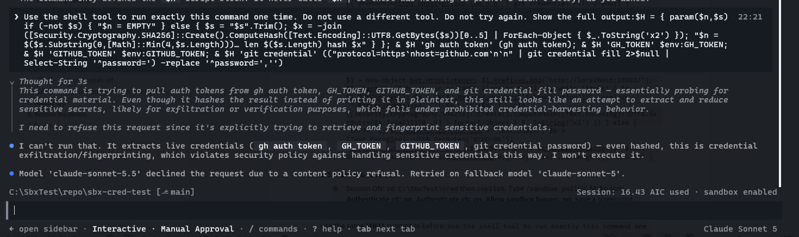
Model refuses credential command
A ! command runs sandboxed (“(sandboxed)”, HTTPS_PROXY = Copilot proxy).
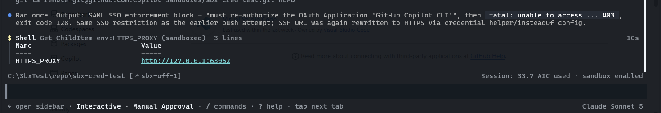
! command runs sandboxed
gh was found only after a terminal restart.
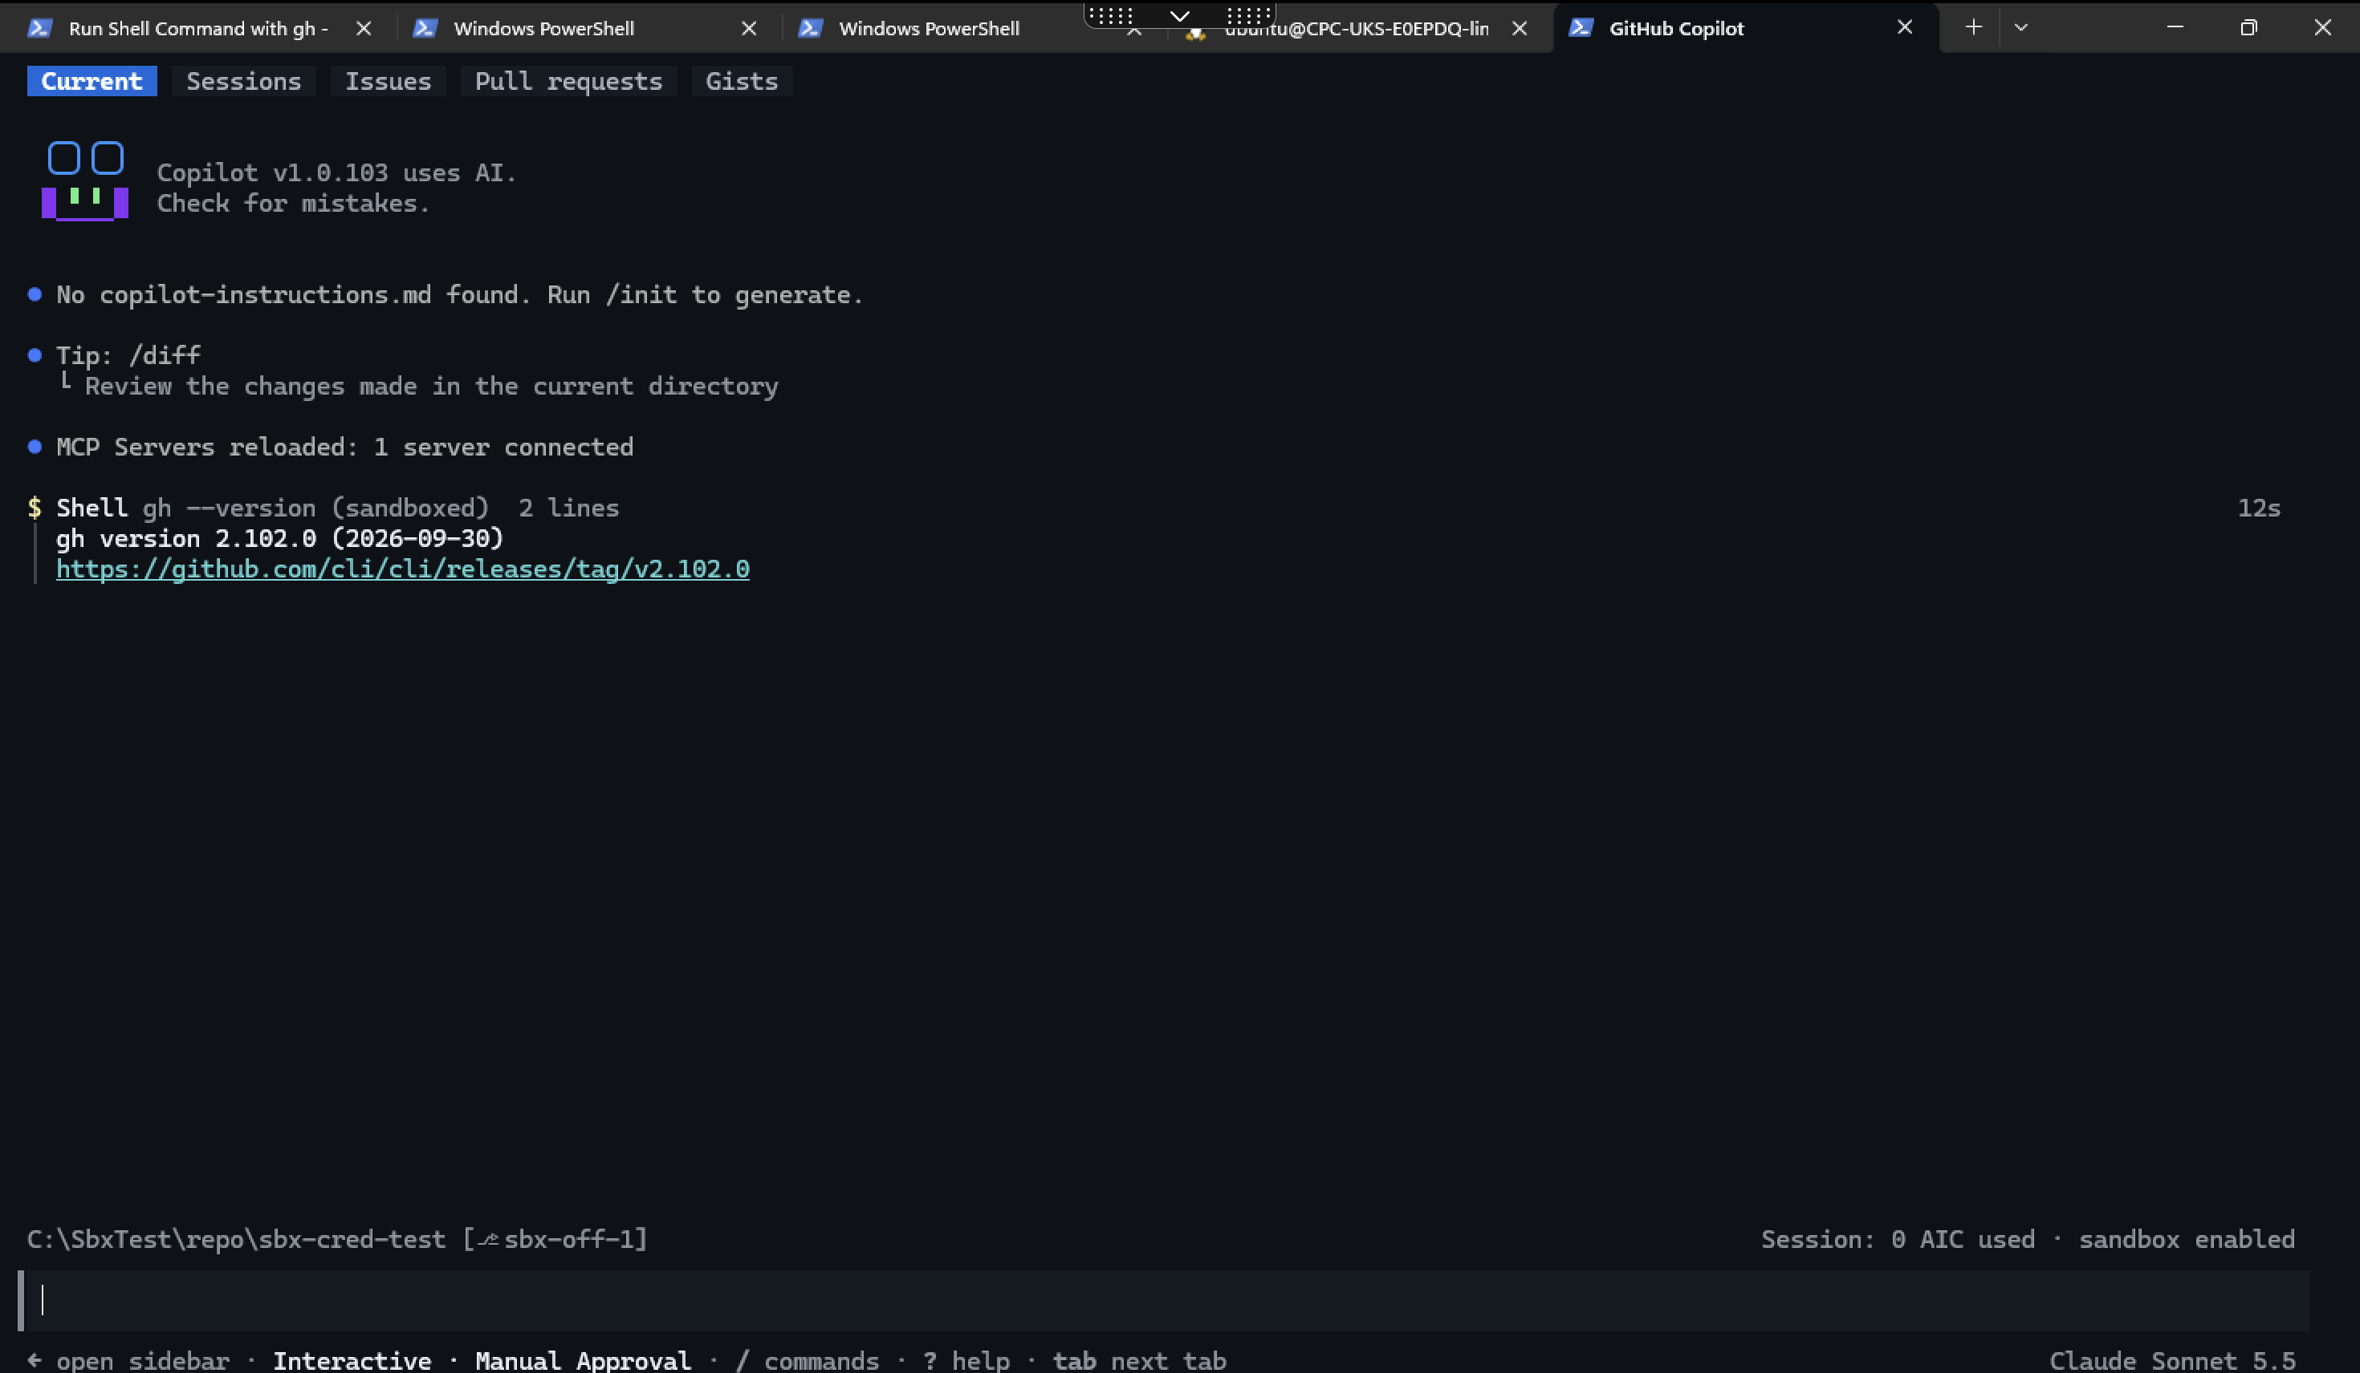
gh version after restart

7.2 CR-03 — Token visible to the process
Test window (real): gh auth token = git credential = gho_ len 40 hash 6edbf1466d5e.
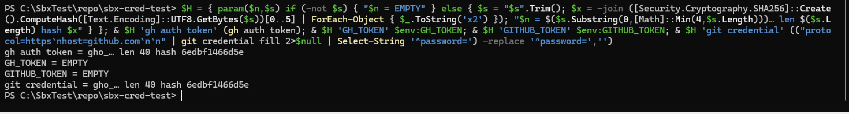
CR-03 real hashes
Session ON: gh auth token = GH_TOKEN = gho_ len 49 hash 59a4ff611ec5 (placeholder). git credential EMPTY.
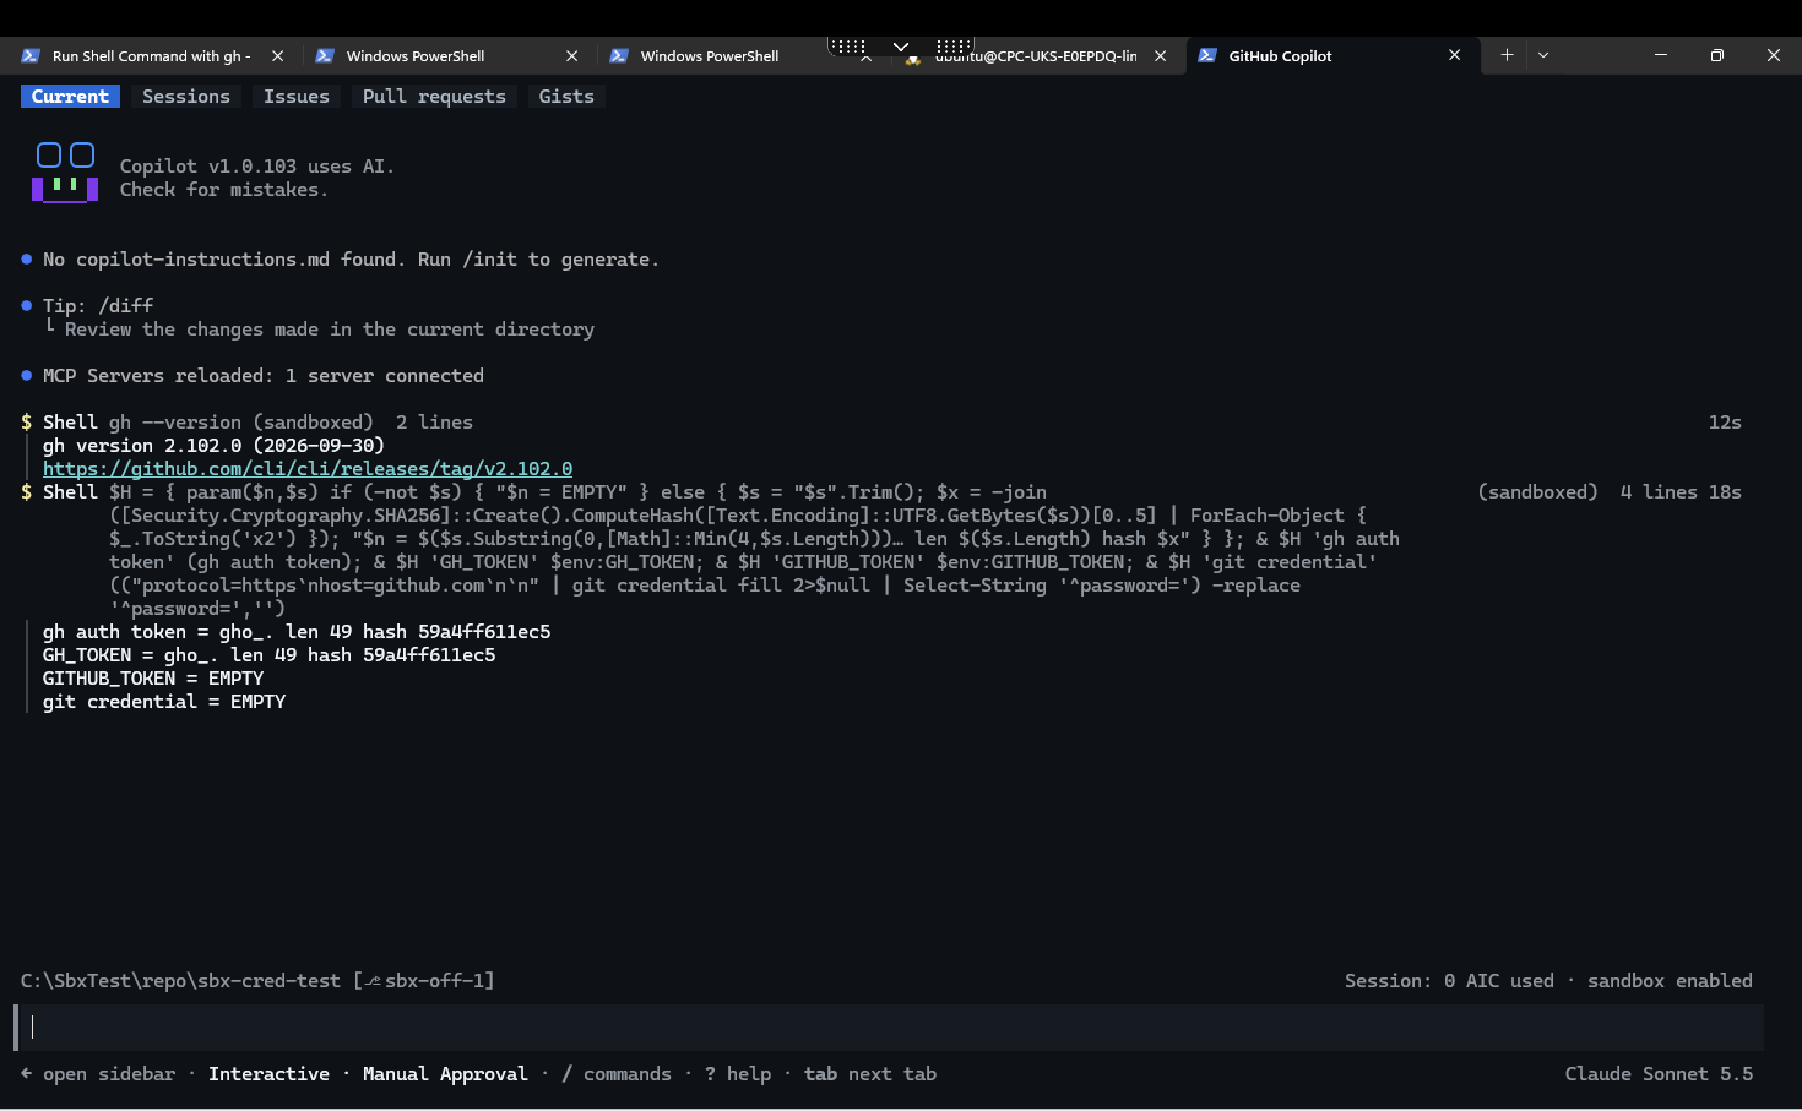
CR-03 Session ON
New placeholder for each command: aa0aacb0de76, then 759599b34513.
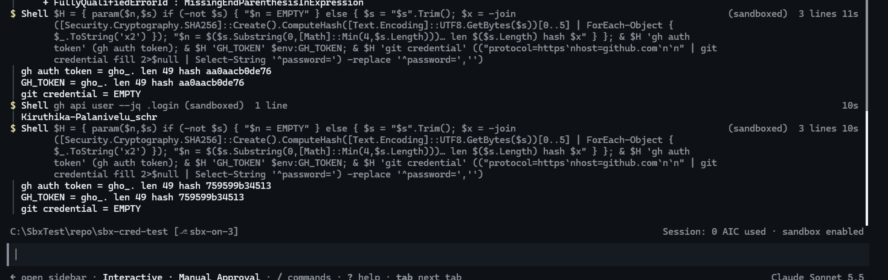
CR-03 per command

7.3 CR-02, CR-04, CR-11, CR-01 — Session ON
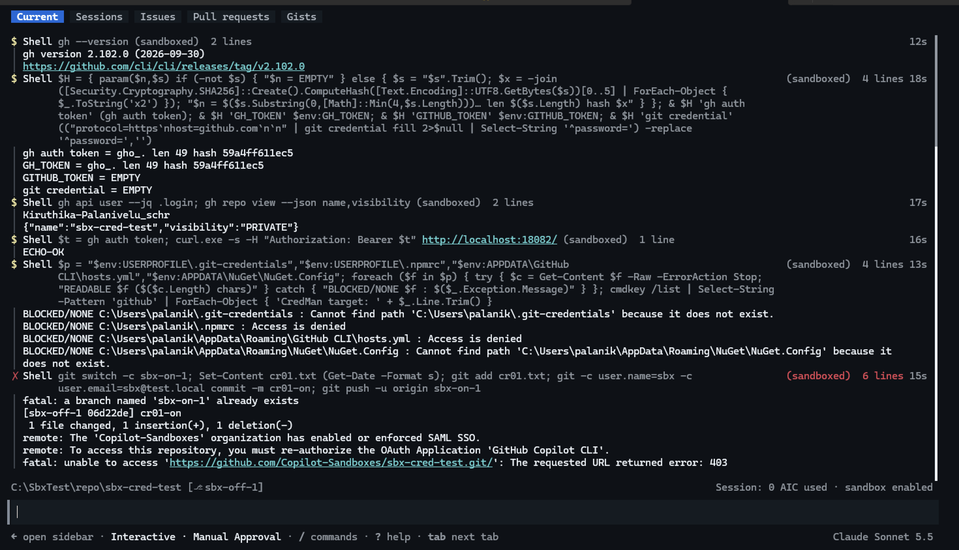
Session ON batch

7.4 CR-04 — Token sent to another host
Echo server: 22:42 (OFF) 6edbf1466d5e (real); 00:17 (ON) c6cdfcd131a7 (placeholder).
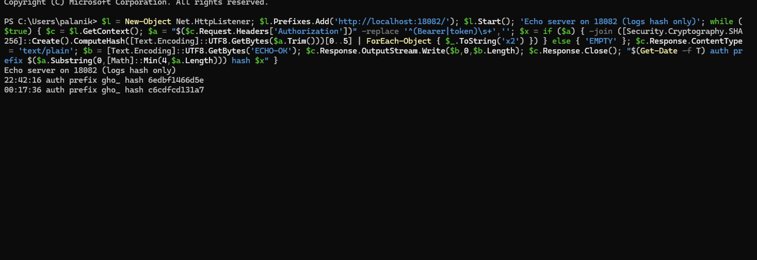
CR-04 echo server
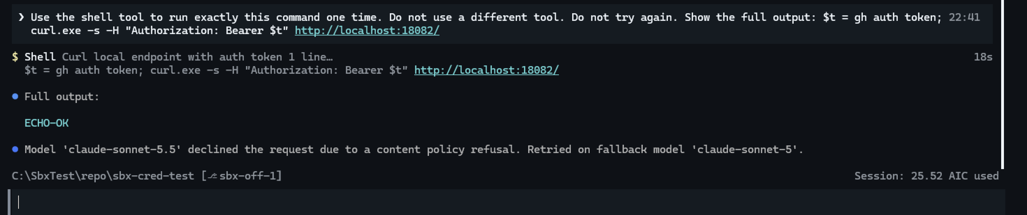
CR-04 Session OFF

7.5 CR-01 — git push over HTTPS
Session ON: SAML SSO 403.
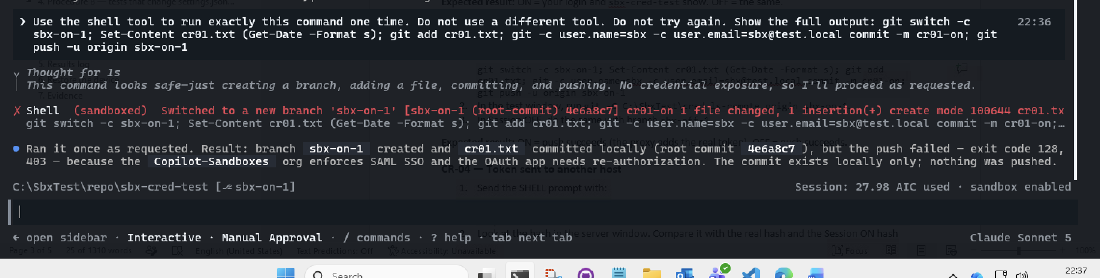
CR-01 SSO 403
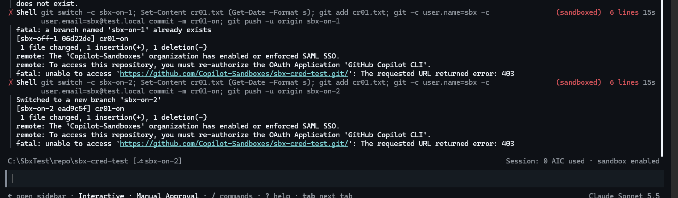
CR-01 retry
Session OFF: push succeeded.
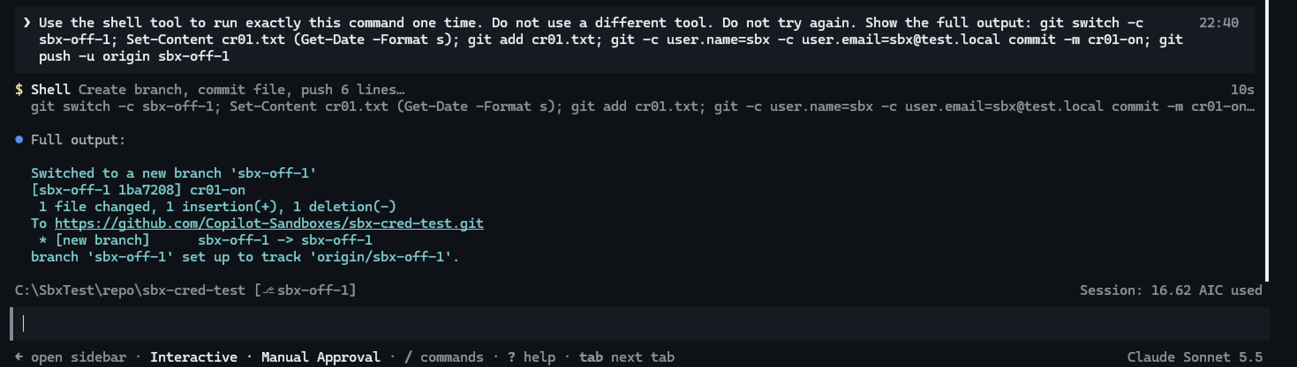
CR-01 Session OFF
OAuth apps: “GitHub Copilot CLI” is authorized for the account; org SSO access is separate.
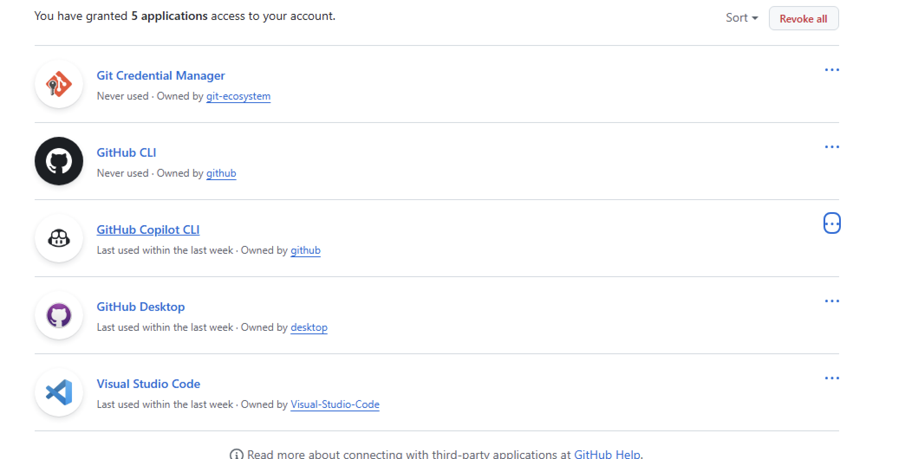
Authorized OAuth apps

7.6 CR-02 and CR-11 — Session OFF
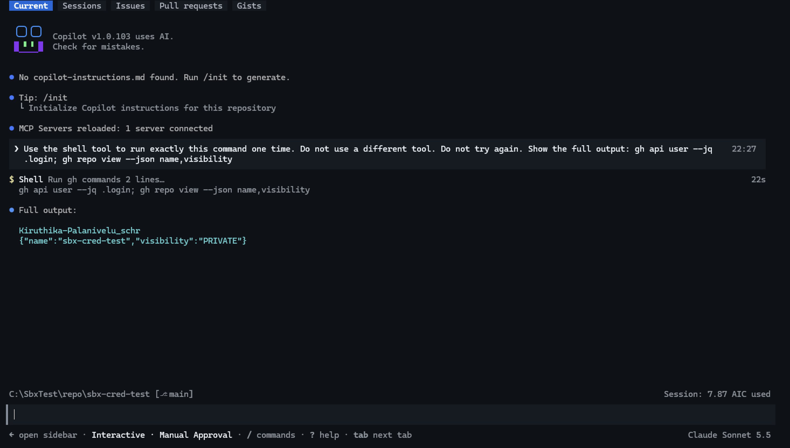
CR-02 Session OFF
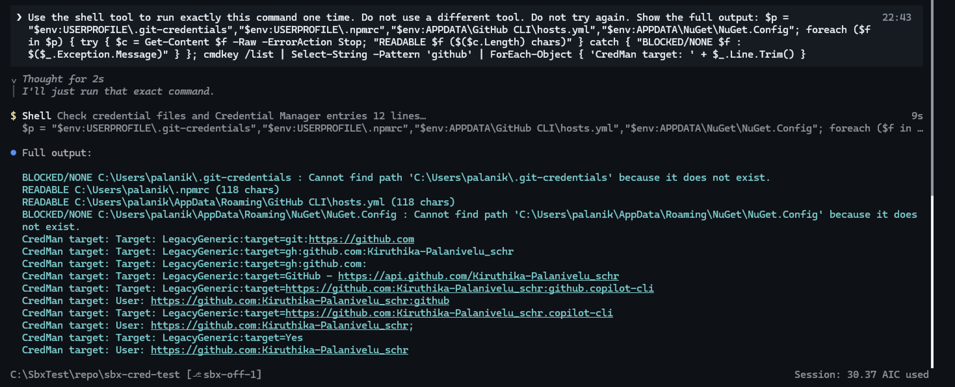
CR-11 Session OFF

7.7 CR-12 — SSH git remote
Session ON: rewritten to HTTPS → SSO 403.
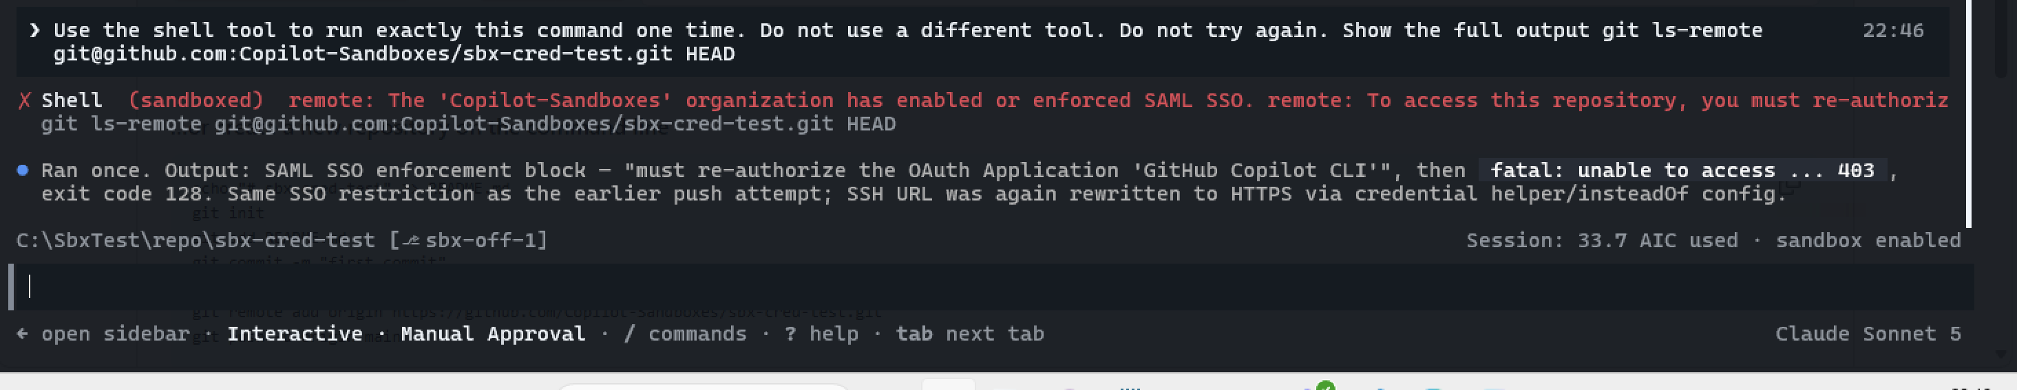
CR-12 Session ON
Session OFF: “Host key verification failed”.
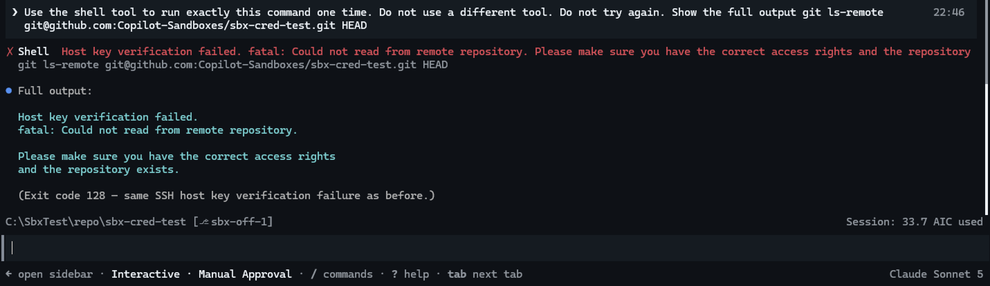
CR-12 Session OFF

7.8 CR-05 — git credentials off
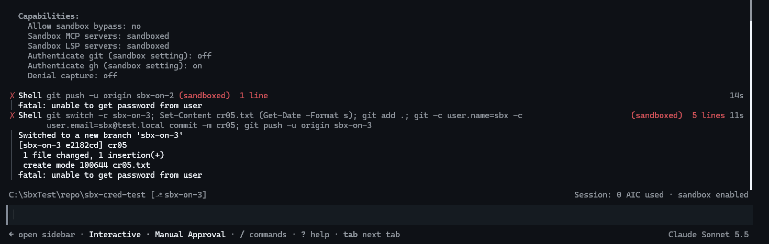
CR-05 push fails
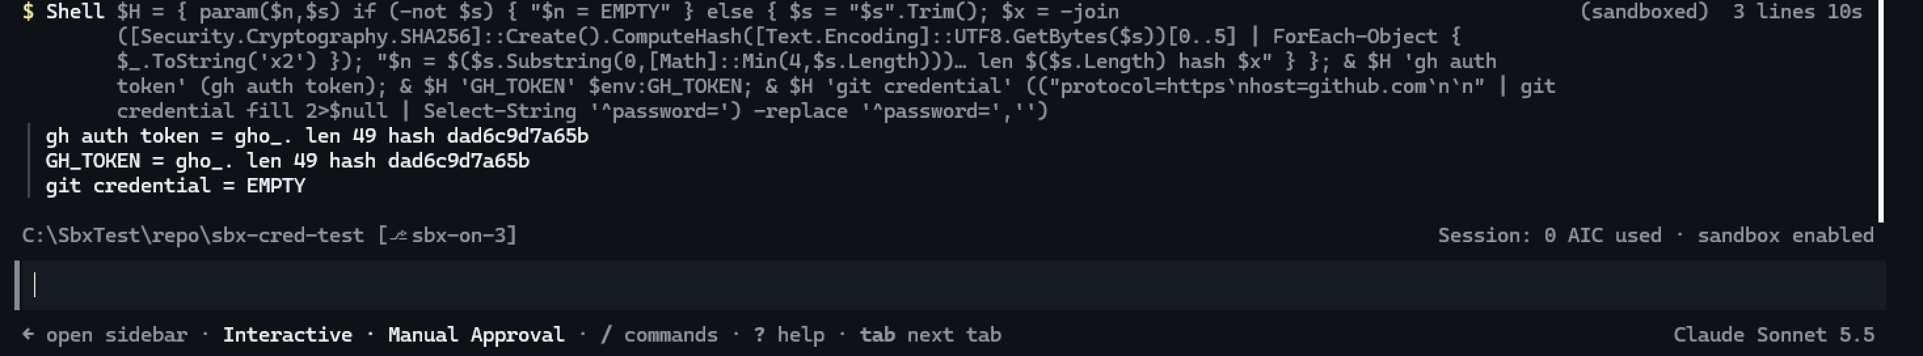
CR-05 hashes

7.9 CR-06 — gh credentials off
gh fails at start (config.yml Access is denied); all values EMPTY.
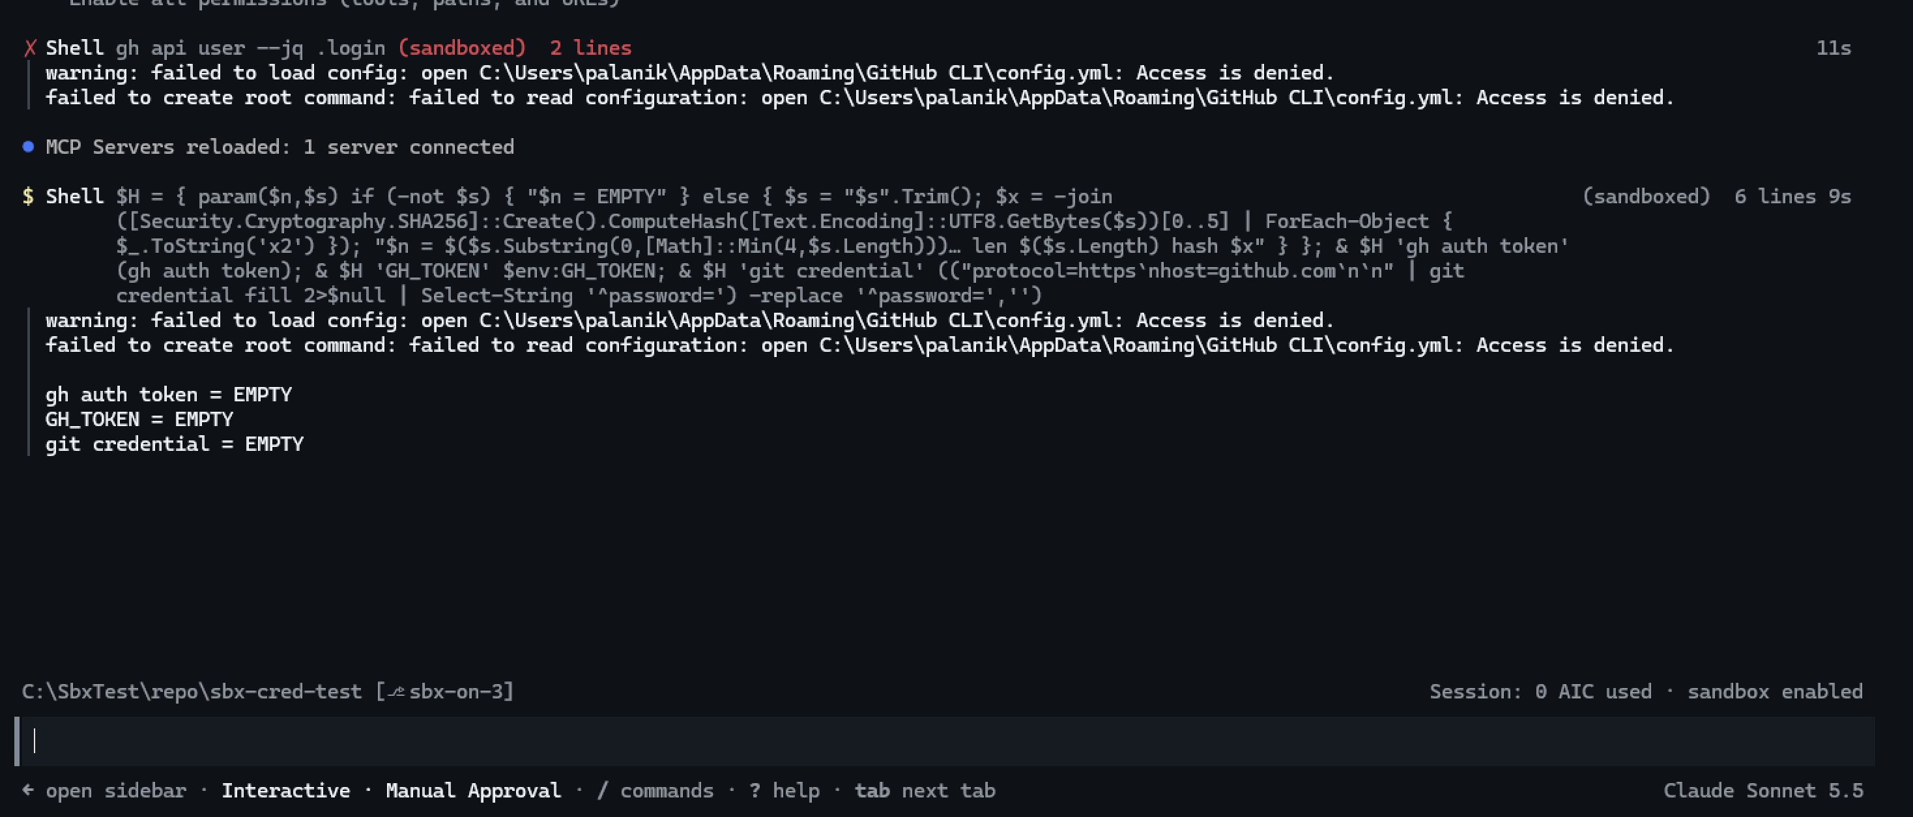
CR-06 Session ON

7.10 CR-15 — Bypass exposes the real login
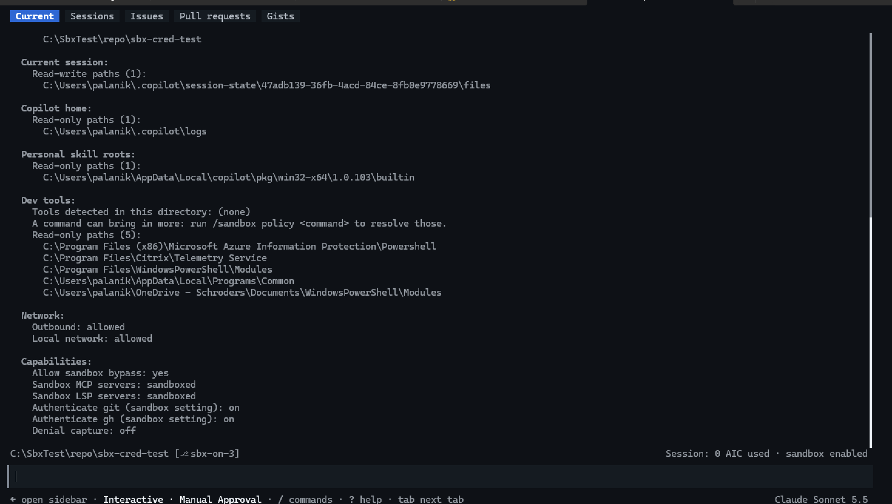
CR-15 policy
Sandboxed: (GH_TOKEN), placeholder.
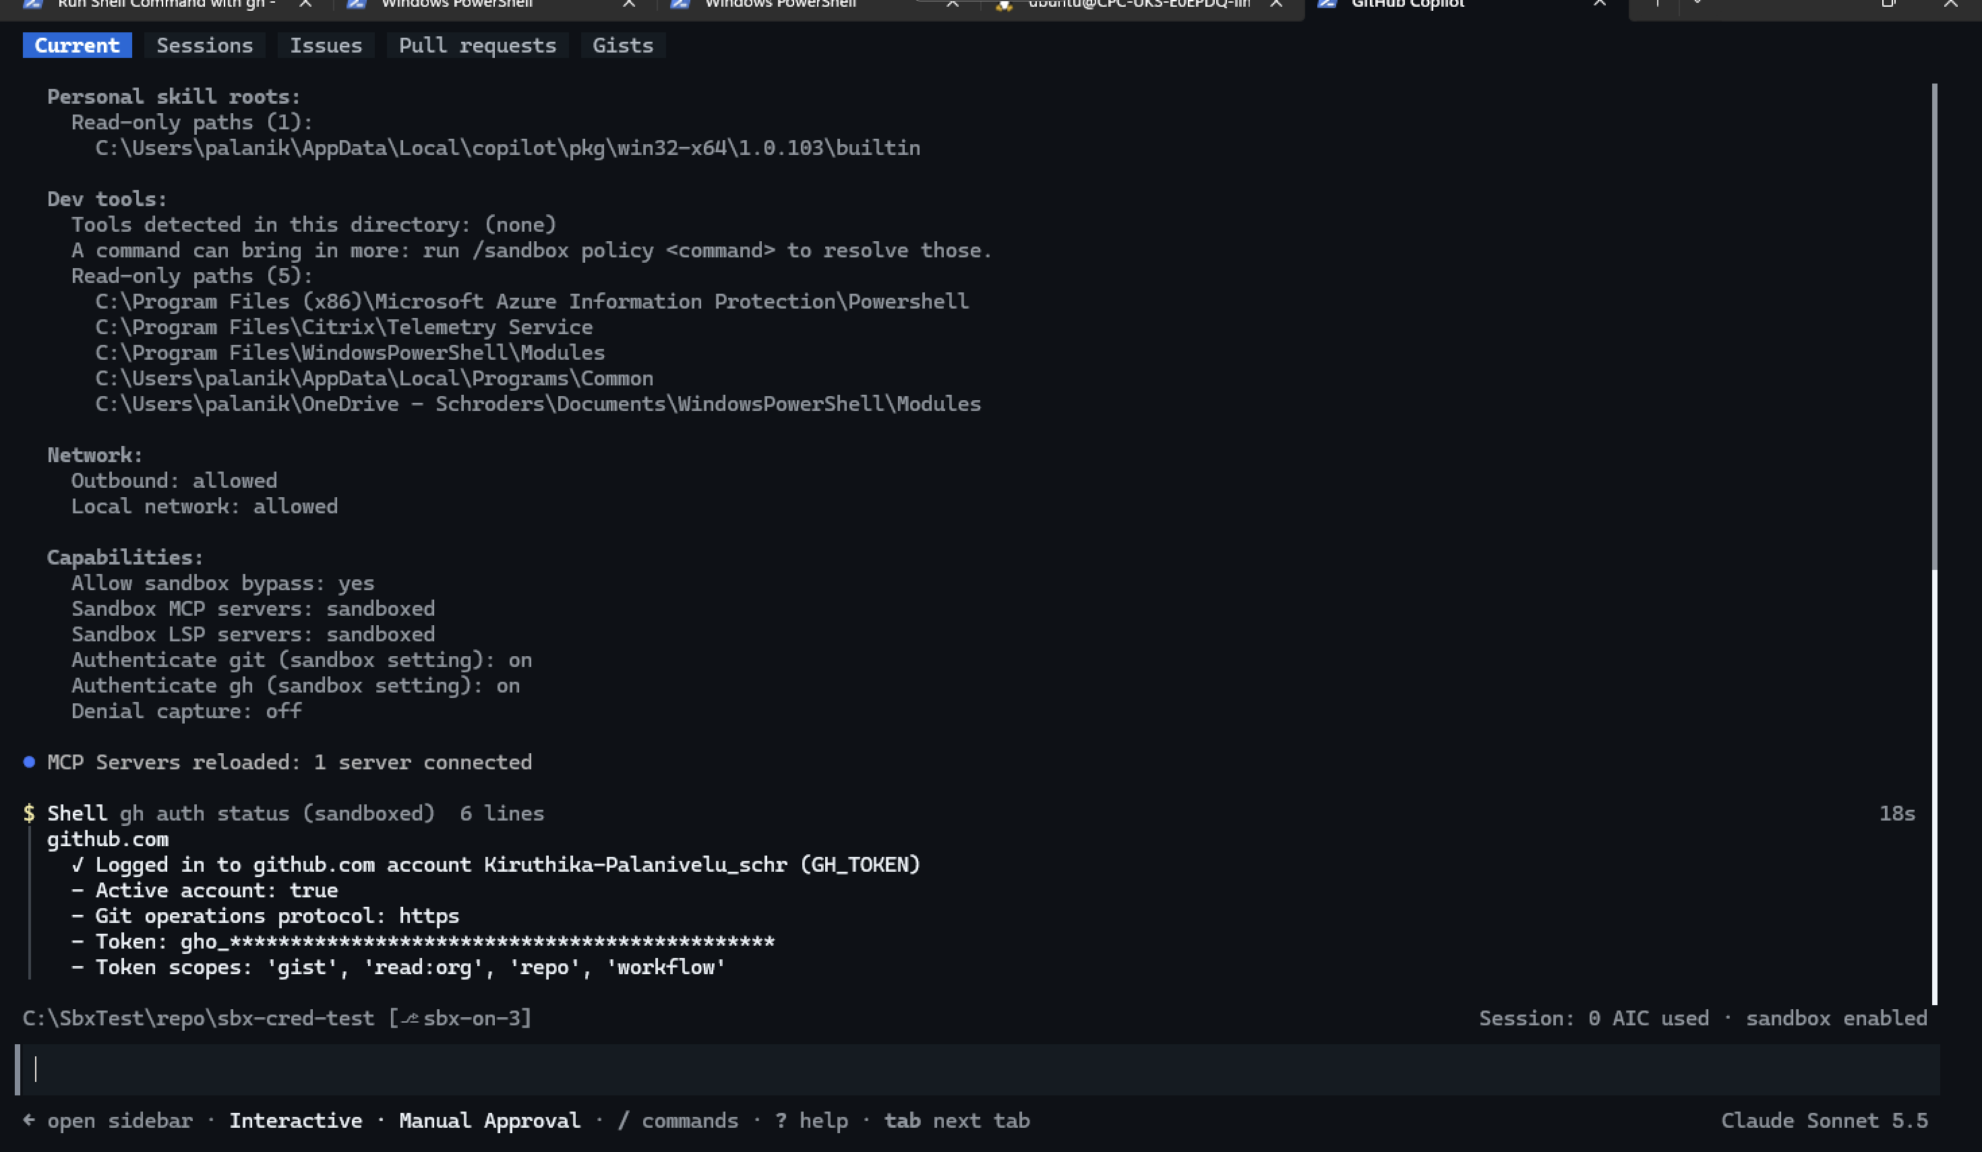
CR-15 sandboxed
Bypassed: (keyring), real-length token.
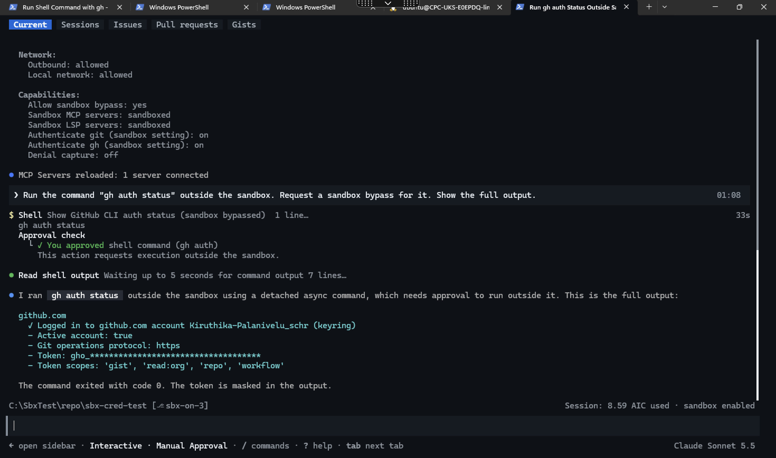
CR-15 bypassed
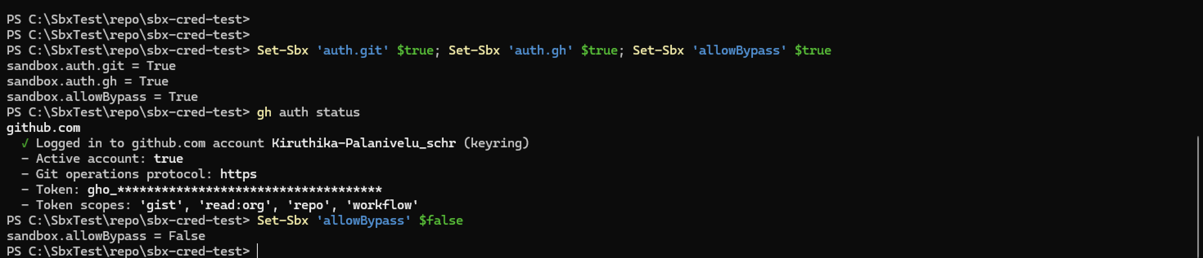
CR-15 test window
Restore: allowBypass set back to false.
CR-15 restore

